


Building Construction

Prerequisite Skills Check
- Determine the missing side length in the triangle below.
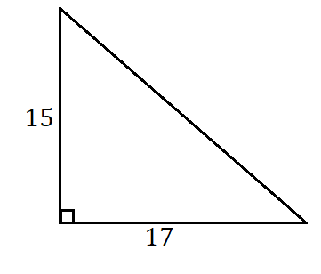
- Alex wants to replace the carpet in a room that is 8’-3” by 12’-6”. The carpet she wants to buy comes in 18”x18” squares at a cost of $3.25 per square. How much will it cost to carpet the entire room?
- Consider the equation $a=\frac{2b^{2}}{cd^{3}}$. Determine $a$ if $b=3, c=-2,$ and $d=5.$

