Important Dates in American History

Lesson Overview: Students identify important dates in American history, construct a group time line, and give individual written and oral presentations.

Level: Mixed (Beginner – Advanced)

Lesson Objectives: During this lesson students will
- demonstrate the ability to do an internet search using both a tablet and a laptop
- find and use three important dates in American history to construct a time line
- demonstrate an understanding of each date’s importance by submitting a brief written summary and giving an oral report

Time Allotted: 6 hours (two classes of three hours each)

Vocabulary
The preliminary vocabulary for this lesson consists of a few terms--such as search engine and time line---that your students say are unfamiliar as you are showing them how to use the ACERs as tablets.

The primary vocabulary words for this lesson are picked by the students as they do their internet searches. My class picked these words:
establish settling matter brought
maintaining statement themselves portrayed
unauthorized weaves however conscious
summarize justify complete cherished
declaration booming suffering

Materials Used: Laptops, ACER tablets (without keyboard), chalk board, handout, dual language dictionaries or online dictionaries

Procedure

Preparation: Before starting this two-day lesson, introduce students to the ACERs without the keyboard dock attached. (My students had already used laptops, so I only needed to show them how to use the ACERs as tablets.) Teach your class to use the keyboard that is on the ACER screen. Work with your students until they seem to have a fair grasp of this new technology. Explain any technology-related vocabulary as you demonstrate how to use the tablets.

In the lesson that follows, students have a chance to use both tablets and laptops. Eventually each student can make an individual decision as to which they prefer. This lesson takes place over two classes of three hours each.

Day 1. Give the handout “Important Dates in American History” from the end of this lesson. Work through the handout with the class, explaining as you go.

- Have a time line on the chalkboard for students to see. Each student will eventually add a date with a brief summary of its significance.
- Point out that item #6 on the handout gives students a place to record new words, which they should look up and define as they arise. Take time to share, discuss, define, and clarify new words throughout the class.

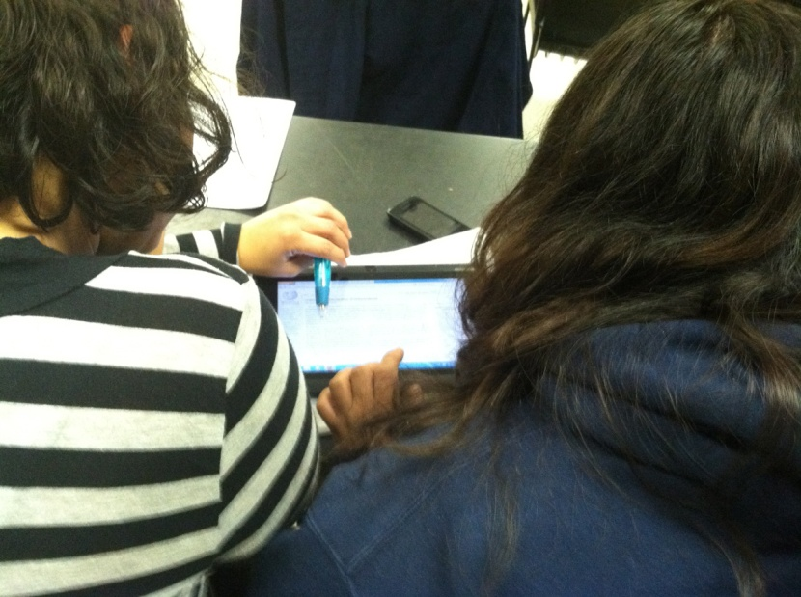

- The objective is to use internet search engines via tablets or laptops to find no less than three important dates in American history. While students search, guide them-- individually and collectively--in determining which events are, in fact, relevant to American history. Get each of them to find at least three dates so your class will garner as many unique events as possible to use/discuss for a class time line.

- Let students begin putting “their” dates on the time line. Involve the class in discussing (1) unfamiliar words and (2) the pivotal significance of each date in American history.

Day 2. Continue from the point you reached on Day 1.

- Complete the class time line. Then let students complete their own timelines.
- Next let each student write and give a short oral presentation on the reason s/he selected her/his chosen dates and the significance of those dates. (These written and oral reports give two measures of success and let students practice reading, writing, listening, and speaking.)
- Finally, ask students to share their preference for laptops vs. tablets.

Results/Evaluation
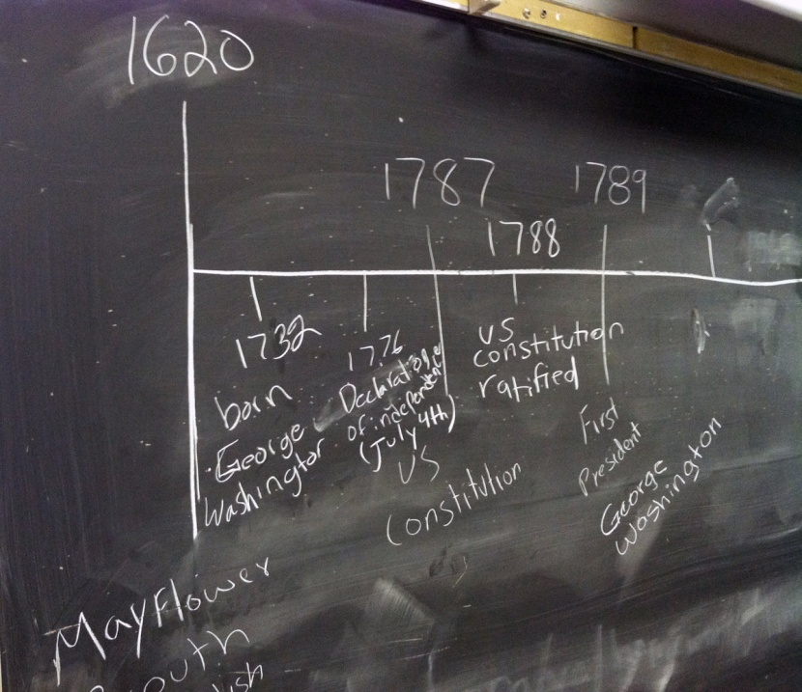
The time line is the backbone of this project, but it is also an excellent team building skill.

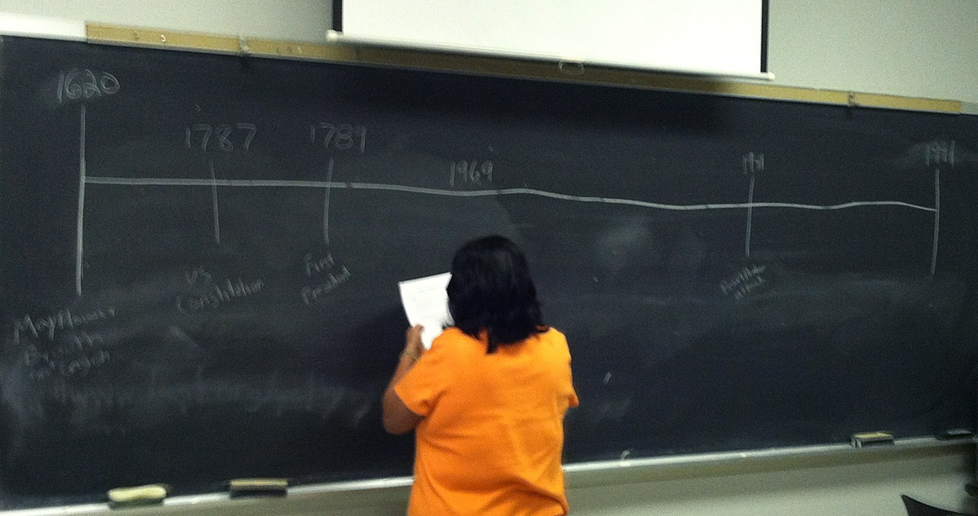

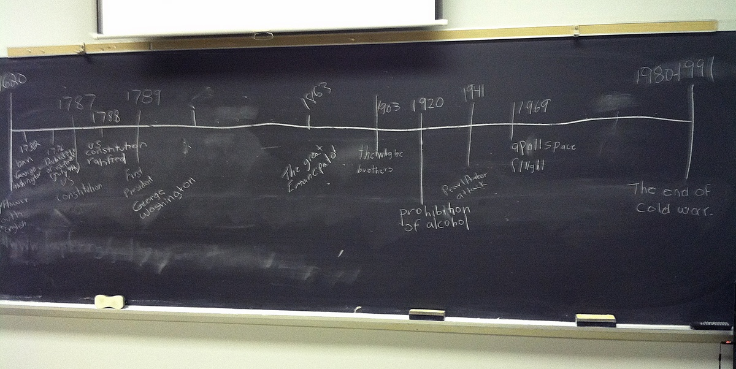

This lesson exceeded all of my expectations. Students responded very favorably to the subject matter and to using the ACERS. It was not the first time they had used laptops, but it was the first time they had used tablets. The one thing I would change before executing this lesson again is to let the students have their hands on the tablets for just a little bit longer. In the beginning, the touch screen on the tablets frustrated many users; however, once they got used to it they seemed to enjoy it. By the end of the lesson, when asked their preference, students were essentially neutral.

I have 11 students. This lesson took only 5 hours, rather than the allotted 6. However, I could easily see taking 6+ hours with a larger number of students.

Important Dates in American History

This week we will be using technology to learn important dates in American History.

Steps to follow:
- Open your web browser (internet explorer – it looks like a big “e” on your computer or tablet.
- Use a search engine such as www.google.com, www.yahoo.com, www.bing.com to find important dates in American history.
Example: In 1492, Christopher Columbus discovered America. This is important because it led to the colonization of America and the states we have today.
All of the dates you select must be AFTER 1492.
- Choose 3-5 dates in American history that you think are important. Write the dates and why you think these dates are important here:

- Once you have chosen your 3-5 dates, discuss them with your fellow students and teacher. As a group, we will decide if they are significantly important to American history or not..
- Place one date on the timeline on the chalkboard like I did: “1492, Christopher Columbus discovers the new world.”
- Use the space below to write any new vocabulary words as you hear them in class or see them in your internet search:

- Create your own timeline using the 3-5 dates that you have selected.

1492 2012
|_____________________________________________________________________

- Tell your classmates! Use the space below to write why the dates you selected are important.
Example: I might say 1492 was important because Christopher Columbus discovered the new world that would someday become the United States of America. He also proved that the world was round, and not flat as many people thought.
Share with your classmates and teachers.

