The Executive Branch of Government

Lesson Overview: This lesson on the Executive Branch of the U.S. government focuses on the President.

Level: Low Intermediate

Lesson Objectives: Students will:
- Describe the president’s duties using Appendix B (see Procedures).
- Describe the requirements to be eligible to be elected president using Appendix D (see Procedures).
- Research and describe the roles of the leaders in their native countries by completing a written report (using Appendix E) in order to make comparisons between the duties and powers of the U.S. president and their countries’ leaders.

Time Allotted: 3 hours class time (includes time for the students to present their reports to the class).
2 hours computer lab time
(We used a total of 2 classes of 2.5 hours each.)

Vocabulary and concepts:
Executive Branch execute duties veto Constitution
The Vice President bills laws eligible

Materials: Laptop, data projector and document camera
Screen or screen substitute, such as a whiteboard or clear wall space (On a
whiteboard, you can add notes around the displayed document.)
Handouts from the Appendix. These were developed from the Teacher
Resources at www.uscis.gov/citizenship
Computer lab or classroom computers
Internet Link to http://www.youtube.com/watch?v=mfoOyi8JGxY
(If this URL fails, use your favorite search engine to look for Origins of the Three Branches You Tube Executive. This video was uploaded by teachertubeMS on October 19, 2009.)

Procedure
1. Show the YouTube video explaining the Executive Branch.
2. Display Appendix A, “The Executive Branch,” using the document camera and data projector. (Also hand out copies of this article for students to make notes on and study.) Students take turns reading aloud from the article. Ask students to point out vocabulary that they do not understand. Explain vocabulary and concepts. Include class members in discussing the vocabulary and concepts to ensure comprehension of the article.
3. Hand out Appendix B to assess students’ comprehension of the material. Students write their answers to the five questions in the exercise and then share their answers with the rest of the class. Lead the class in discussing their responses.
4. Display Appendix C, “Presidential Elections,” and follow the same procedure outlined in 2 and 3. Appendix D is the complementary exercise for the article in Appendix C.
5. Summarize what the students have just learned. Answer any questions.
6. Distribute copies of Appendix E and explain that the class will now go to the computer lab to research the role of leaders in their native countries and write brief reports answering the Appendix E questions. Students will present their reports to the class the following class. (Students use the computer to gain more experience in research techniques as well as report writing structure.)
7. Accompany the class to the computer lab:
The Lab instructor demonstrates using Google for searching online.
Students look for the answers to the following Appendix E questions (with assistance from lab instructor and classroom teacher):
  - Who is the leader of your country? (Look for both name and title.)
  - What are his/her duties?
  - Who is eligible for the position of leader in your country?
8. At the next class meeting, each student explains his or her findings to the class using the document camera and projector to display his or her completed Appendix E paper.
9. Between student presentations, pull the lesson together by recapping the duties of the US president and comparing the duties of the US president to duties of leaders in students’ native countries.
Results/Evaluation:
This lesson worked well in our class, which has students from several Spanish-speaking countries as well as students from Thailand, Pakistan, Sudan, and Korea. This mix facilitated spontaneous and interesting discussion and comparison.

Some additional learning points could be added to expand this topic into more of a unit:
- Incorporate a grammar lesson such as the use of modal verbs, for example: “If something should happen to the president...”, “A president might resign if...”
- Incorporate a grammar lesson on present tense verbs, for example: “The president appoints, the president meets, the president signs, the president enforces and executes, the Cabinet advises.”
- Put the students in small groups and assign different questions to each group and have the group discuss and answer the question and present the answers to the class.
- Allow more time for the computer research and report composition so that students can learn research and essay writing techniques.

Appendix A

The Executive Branch

The U.S. Constitution sets up our government with three separate branches: executive, legislative, and judicial. The largest branch of the federal government is the executive branch. This branch is made up of the President, Vice President, and many departments and agencies.

As the leader of the United States, the President is in charge of the executive branch. The President has many duties. The President is the Commander in Chief of the U.S. military. In this role, he gives orders to the armed forces. Another important responsibility is to sign bills to become laws or to veto bills. The President also represents the United States to other countries. When there are important issues that involve other countries, the President meets with world leaders to discuss solutions.

Text for this lesson is taken directly from the Intermediate Level Executive Branch lesson plan under Teacher Resources at www.uscis.gov/citizenship
Information presented on this WWW site is considered public information and may be distributed or copied.

Appendix B
Answer the following questions:

- Q: Which branch is the largest branch of the U.S. government?
A: The ______________________ branch is the largest branch of the U. S. government.

- Q: Who is in charge of the executive branch?
A: The _______________________ is in charge of the executive branch.

- Q: Who is the Commander in Chief of the military?
A: The ________________________ is the Commander in Chief.

- Q: Who signs bills to become laws?
A: The ________________________ signs bills into law.

- Q: Who vetoes bills?
A: The ________________________ vetoes bills.

Appendix C

Presidential Elections
In the United States, we elect the President and Vice President every four years. Presidential elections are held in November. During the next January, the President takes the Oath of Office in an inauguration ceremony. After one four-year term, a President can decide to run for re-election. The President cannot serve more than two terms.

The Constitution lists three special requirements for a presidential candidate. First a candidate must be a natural born citizen of the United States. Second, he or she must be at least 35 years old. Third, the candidate must have been a U.S. resident for 14 years.

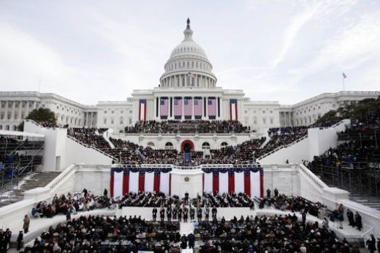
This is the swearing-in ceremony of President George W. Bush at the U.S. Capitol Jan. 20, 2005.
Credit: White House public domain photo taken by Paul Morse.

Text for this lesson is taken directly from the Intermediate Level Executive Branch lesson plan under Teacher Resources at www.uscis.gov/citizenship
Information presented on this WWW site is considered public information and may be distributed or copied.

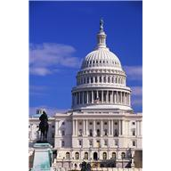
Appendix D
Answer the following questions:

- Q: What are the three requirements for becoming a U.S. President?
A: A candidate must be a _____________________________ citizen of the United States.

He or she must be at least ___________ years old.

He or she must have been a U.S. resident for ________ years.

- Q: In the United States, how often do we elect a President and Vice
President?
A: We elect a President and Vice President every _______ years.

- Q: In the U.S., how long is a presidential term?
A: A Presidential term is _________ years.

- Q: How many terms can a U.S. President serve?
A: A U.S. President can serve for ____________ terms.
United States Presidential Oath of Office:
"I do solemnly swear (or affirm) that I will faithfully execute the office of President of the United States, and will to the best of my ability, preserve, protect, and defend the Constitution of the United States."

Appendix E
My country:

My native country is __________________________.

The leader of my country is:

The duties of my country’s leader are:

The requirements to be the leader of my country are:

