Branches of Government

Lesson Topic: The three branches of government

Level: Advanced

Lesson Objectives
- Students will learn keywords on the three branches of the government.
- Students will create a written presentation on the government branch they like best and/or would like to work in.
- Students will read their presentations aloud and explain their choices
- Students will keep a log of the branches of government their classmates like best.

Time Allotted
Three hours were allocated for this lesson, which proved to be insufficient.
Check the Recommendations at the end of this lesson plan.

Vocabulary
Senate Senator Vice President Executive branch
Legislative branch Representatives Justice laws
House of Representatives Congress Judicial branch President.

Materials (web resources and technology)
wireless internet
5 iPad2s with a drawing app (We used Doodle.)
a laptop, a projector
whiteboard, pencils, paper, markers,
a PowerPoint presentation accessible online for students to follow and browse.

Procedure
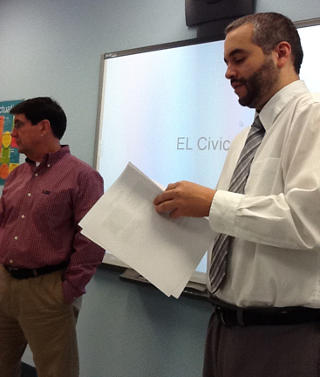
Project the PowerPoint presentation on the whiteboard. The PowerPoint serves as a guide for students, who use their iPad2s to access the same presentation by typing http://tinyurl.com/7gxaxvx in Safari. (Safari is the internet browser that comes on the iPad2.) The students now follow your lead. They can surf the presentation as needed to check facts.

Slide 1: State the title of the lesson

Slide 2: Introduce lesson by letting students brainstorm what “members of the government” means. Write their responses on the board.

Slide 3: Introduce the US Government briefly: “The US government has 3 parts. Each part has a different role.” State the lesson objectives: Students will
(1) learn keywords on the branches of government,
(2) create a written presentation on the government branch they like best and/or would like to work in,
(3) read their presentations aloud and explain their choices.

Slide 4: Show the vocabulary for all the branches of government.

Slide 5: Ask students what they think each word/term means. Students can give definitions for the words they know. Help them fill in their knowledge gaps.

Slide 6: Show students page 6 and ask for their comments. The purpose is to generate discussion from the connections that students make with the pictures.
Slide 7: Read page 7 aloud with students. Circle keywords on the whiteboard (executive branch, president, vice president) and explain them. Ask students to pick one fact they did not know from the list of Presidential facts. Next, they may open the Doodle app on their iPad2 and either draw their interpretation of that fact or write the fact itself. Finally, classmates share their facts by showing what they drew or reading what they wrote.

Slide 8: Show students page 8 and ask for their comments. The purpose is to generate discussion from the connections that students make with the picture.

Slide 9: Read page 9 aloud with students. Circle keywords on the whiteboard (judicial branch, justice, law) and explain them. Ask students to pick one fact on page 9 that they did not know.. Next, they may open the Doodle app on their iPad2 and either draw their interpretation of that fact or write the fact itself. Finally, classmates share their facts by showing what they drew or reading what they wrote.

Slide 10: Show students page 10 and ask them to comment. Again, the purpose is to generate discussion from the connections that students make with the picture.

Slide 11: Read page 11 aloud with students. Circle keywords on the whiteboard (legislative branch, congress, senate, House of Representatives, representatives) and explain them. Ask students to pick one fact on page 11 that they did not know. Next, they may open the Doodle app on their iPad2 and either draw their interpretation of that fact or write the fact itself.

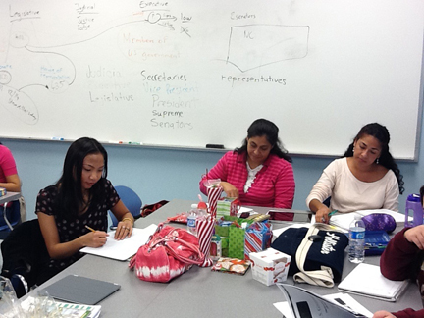
Slide 12: As the instructor, you pick a government function you would like to exercise and fill the blanks or gaps with factual information. Ask students to guess which function you are referencing. Encourage students to go back and forth on their iPad2s to consult all slides in the lesson. After they find the answer to you are, students follow your example to complete their own “Who am I?” statement. Each student then reads their “who am I?” text to the class, and classmates try to guess which function the classmate has picked by surfing the pages on their iPad2s.

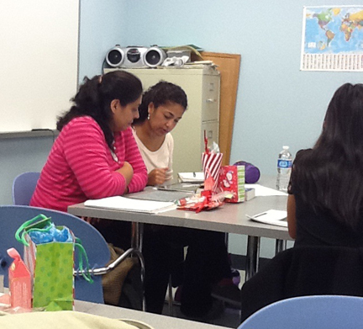
Slide 13: In the same manner, use the sentence starters on page 13 to model the function you most identify with (either a function you like or would like to assume). Read your text aloud to students. Your students should then pick the sentence starters they feel most comfortable with. They will need to work in pairs to complete this work and use the checklist to ensure they are fulfilling the requirements. Students complete this assignment with pencil and paper. They may use the iPad2s to access the information on the previous slides. Students share their written text with the rest of the class orally.

Slide 14: Listening students will use the table on page 14 to keep track of all student choices. Comment class choices after everyone has read hid/her work aloud, comment on the class choices and invite students to do so, too..
Slide 15: Use page 15 to briefly talk about other forms of government to enlarge the students’ horizons.

Evaluation and Recommendations

This lesson does not fit a three hour time frame! There are two main reasons for this:
- The content is too broad
- The technology is new to the students
The next time I teach this lesson, I will cut it in three segments of two hours. Each two hour segment will cover a single branch of the government.

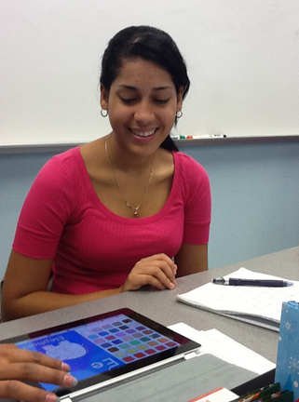

I would like to stress that at least five minutes should be given to the students at the beginning of the lesson to play around with the tablet. These tools will most likely be new to the students and they need to familiarize themselves with them. This will also cut down on the time they spend playing around with them during the lesson.

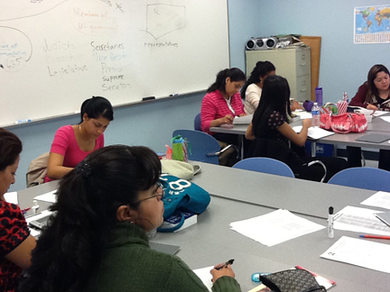
The most important part of this lesson came through the unscripted discussion we held in class. Students participated actively. We deviated more than once during the lesson to address questions such as “Who is our representative? Who is our governor?” The lessons were rich in questions and findings especially when students made connections with current events. This is a topic students enjoyed learning about (not only for themselves but also for their children).

