Past Influences on the Present

Your tribe’s final challenge is to explore ways that
survival in North Carolina today is influenced by United
States history, government, and geography.

Your tribe must focus on food.

Survival Plan: Sweet Tea,
Fried Chicken, and Mad Cow
By David Whitehead
Alamance Community College

Background

Level: My mixed class—consisting mostly of Intermediate students (high and low) and a few Advanced students—carried out this survival plan (aka project plan). My thoughts about adapting the plan for beginning students are at the end of this project plan under NOTES FOR THE FUTURE.

Objectives: Students will
- identify regional differences in U.S.A. food and drink that date back to early settlers,
- map the U.S.A. by food and drink,
- explore how traditional North Carolina favorites--such as fried chicken, sweet tea, country ham, and pork barbecue--contribute to North Carolina’s primary causes of death today,
- explore ways that fast food contributes to North Carolina’s major illnesses and causes of death,
- name the U.S. government agency responsible for the safety of our food supply, and read some materials this agency makes available to the consumer.

Time: Our class meets daily (M-F) for three hours, and we used one full class each week--three consecutive Fridays--for a total of nine hours, to complete this project.

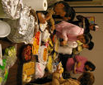
In our class, we regularly have “Food Fridays.” We all bring food and enjoy a meal and good conversation with our lessons. This tradition worked nicely into the food focus of this challenge.

Friday is also the day that we have free access to the computer room, so Friday was convenient for the Internet activities associated with this lesson.

You can easily adjust the activities in this project plan to fit comfortably into your own class timetable.

Education and Action

FIRST FRIDAY
Regional Foods
I introduced the topic of regional food by asking the students to tell about typical food from their home country and about variation in foods and ways of cooking in the different regions of their country. This easy discussion-starter brought forth student responses about Mexico, El Salvador, the Dominican Republic, and Brazil.

Next, I asked students to name “typical” American foods (in English). I wrote their responses on the board. The foods they named were largely limited to fast food such as hamburgers and hot dogs. (Another approach would be to have a student volunteer write the foods on the board and let the class help with spelling.)

To help students expand their thoughts about American food, I asked each person to list all of the states he/she had lived in or visited, and then to place a small sticker on our wall map to mark those states. (We used inexpensive, easily-removable “post-it” type stickers available at any office supply store.) With the addition of the last student’s stickers, our wall map gave us a clear representation of the parts of the United States our class had experienced.

Now the students’ task was to think of regional foods from these other states they had lived in—i.e., foods that were common, say, in Florida, but uncommon in other places they had lived. Students could work individually or with a partner who had spent time in the same state or region. Because I am from the South Carolina Low Country, I modeled this activity by explaining about Low Country cooking. I gave examples of Low Country dishes like hoppin’ John, which is traditionally eaten for good luck on New Year’s Day.

My sample map is shown on the following page.

By looking at the stickers on our wall map, we came up with the following “food areas” that our class members had experienced in the USA:
- Southern Cooking
- Florida/Caribbean
- Low Country
- Tex-Mex/Southwestern
- California
- Chesapeake Bay
- New England

The U.S.A. by Food and Drink

My personal food map shows all the states I have visited by name. For the areas I have lived in, I listed some typical traditional foods.

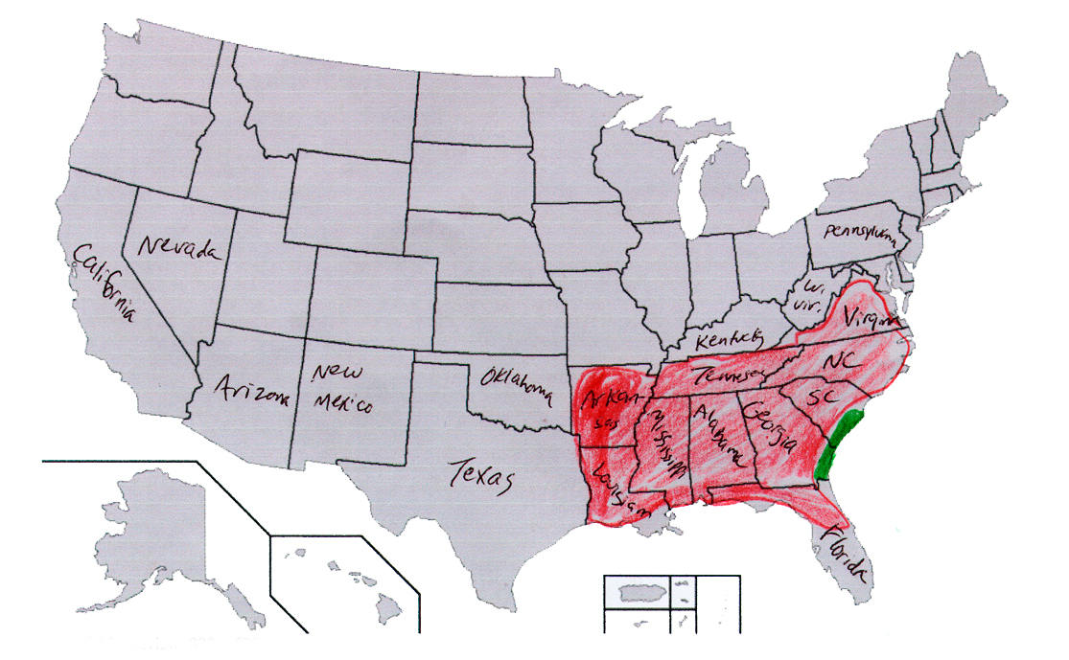

South | Low Country
Pork Barbecue | Rice
Corn | Seafood
Cornbread |   Shrimp
Fried Chicken |   Crab
Sweet Iced Tea |   Fish Stew
 | Hoppin’ John
 | Perlau

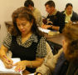
Mapping the U.S. by Food and Drink
I gave each student a map of the U.S. with the states outlined, but not labeled. Their task was to add the state names for:
- all the states they had lived in
- all the states they had visited
- any other states that they knew

Students who finished could then circulate around the room to consult with classmates to fill state “holes” in their maps.
(Any outline map of the United States works for this activity: At http://commons.wikimedia.org/wiki/Image:Blank_map_of_the_United_States.PNG, you can find one online.)

Next, we reviewed the food areas we had discussed previously and identified them on the maps. The goal was for each student to outline his/her areas of experience with a highlighter or colored pencil and then to list the regional foods that he/she had eaten in those places. If a student had experience in more than one region, he/she had the option of doing both regions or choosing just one.

I put the region names on the board and we discussed which states belonged in each region. For most of the categorization, we used the division of states found at http://www.lifeintheusa.com/food/index.html on the “America Eats” webpage. Cuba and the Dominican Republic got a nod for Caribbean because I had students from there! My students were totally unfamiliar with the terms “Low Country” and “New England,” so I told them what states were included there. The rest we decided upon by consensus. Our divisions were as follows:

- Southern Cooking Virginia, the Carolinas, Georgia, Alabama, Mississippi, Louisiana, Arkansas, Tennessee.

- Florida/Caribbean South Florida, Cuba, Dominican Republic

- Low Country a small coastal strip that stretches from Charleston, South Carolina down through Savannah, Georgia
- Tex-Mex/Southwestern Texas, New Mexico, Arizona

- California LA/Southern California

- Chesapeake Bay Delmarva peninsula (encompassing parts of the states of Delaware, Maryland and Virginia)

- New England Massachusetts, Connecticut, Rhode Island, Maine, New Hampshire, and Vermont

Students drew around the borders of “their” region with a hi-liter or colored pencil. Then I gave each student a handout corresponding to their region. I took the handout material from “Life in the USA -- America Eats” at http://www.lifeintheusa.com/food/index.html. These readings are at a fairly advanced level, so I edited them for clarity and length before taking them into the classroom.

We used the handouts as a reading exercise. Students worked independently to mark and look up unfamiliar words, and I circulated around the room to help with comprehension and pronunciation. Using the readings, students added additional foods to their map. Students who finished quickly were allowed to consult with their classmates who may have experienced different regions to expand their food map.

SECOND FRIDAY
Death by Diet
I introduced this segment by giving the students a “Healthy Lifestyle Survey.” I used a survey from
Downtown (Book 3) by Edward J. McBride. Thompson Heinle, 2006, pp. 122-127.
ISBN 0-8384-4380-X
This book has an entire unit on health, diet, and exercise, but teachers without access to it can find a substitute online. I like http://specials.newsweek.com/surveys/health-self-assessment-quiz/intro/. You can locate similar resources with your favorite search engine: Look for healthy lifestyle quiz, or how healthy are you, or health quizzes, and similar wordings.
We discussed ways that food choices affect a person’s health. I asked the students to tell me the names of health problems caused by unhealthy foods. They knew many of these conditions in their native languages, but not in English, so this became the day’s vocabulary lesson. Students freely used the Oxford Picture Dictionary. We came up with the following vocabulary list:
- Heart attack
- Stroke
- Diabetes
- Obesity
- High Blood Pressure
- Tooth Decay/Cavity
Next we went to http://apps.nccd.cdc.gov/giscvh/ and viewed maps of N. C. and the U. S. showing the number of deaths from heart attack and stroke. We looked at our food maps from the previous week and discussed how the traditional diets in each of these areas might contribute to these illnesses and deaths.

Choose your Poison
Students made a “meal plan” for one day (three meals) using traditional North Carolina foods such as pork, fried chicken, buttered corn, biscuits, and sweet tea, along with commercial food products with a N.C. connection. (North Carolina is the birthplace of Pepsi, Cheerwine, Krispy Kreme, Hardees, and Bojangles.) The task was to come up with three VERY unhealthy meals and explain why these meals were unhealthy. We used an online calorie counter at http://www.labpixies.com/ to count the calories in each meal and then noted which foods were high in sodium and fat.

Next, students created a menu for three healthy meals. The same ingredients could be used, within reason, but portions and/or cooking methods were changed.

The healthy and unhealthy meals that one of my students developed are shown on the following page. (Spelling is reproduced as written by the student.) I neither verified nor questioned my students’ math on the calories as long as the numbers looked reasonable, but I was available to help with their questions while they were putting together their meals.
Unhealthy Meals by Maria V.

Breakfast
Sausage links, scramble egs, hash browns, donut, coffee.
(Approx. 1100 calories, 55% from fat.)

Lunch
Fried Chicken, biscuits, Curli fries, large Cheerwine, ice cream. (Approx 1400 calories, 60% from fat)

Dinner
Large Barbecue plate, hushpuppys, slaw, large Pepsi, slice of pecan pie.
(Approx 1200 calories, 55% from fat)

Healthy Meals by Maria V.

Breakfast
Bowl of (healthy) cereal, banana, and juice.
(350 calories, 5% from fat)

Lunch
Salad mixed with grill chicken, baked potato (with only a little margarine and salt), Clementine or other fresh fruit, water.
(400 calories 10% from fat)

Dinner
Baked pork shops with orange sauce, green vegetables (beans or asparagus), wild rice, glass of white wine or grape juice, fruit salad.
(600 calories, 10% from fat).

THIRD FRIDAY
Fast Food
I put the names of several fast food restaurants on the board and asked how many people had eaten at each one, and how often they had eaten there in the last week. Students then wrote down what they and, if applicable, their kids normally eat at fast food restaurants.

Next, we went to the computer room and used the calculators at www.fatcalories.com to calculate the fat, calories, sodium, and cholesterol in the various dishes. Students used the calculator to create a healthy and tasty meal at the restaurant of their choice.

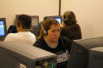
Food Safety
We discussed recent news stories about diners who found...shall we say...unsavory items in their fast food, as well as contaminated food purchased at grocery stores. We visited the website of the Food and Drug Administration to learn about food safety, and located several easy-to-read pamphlets. At http://www.fda.gov/opacom/lowlit/englow.html, we chose two that are available in English and Spanish:
- Keep Your Food Safe
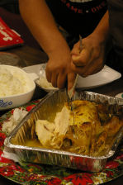
- Eating for a Healthy Heart

As an added exercise, my more advanced students chose one title in Spanish, printed it out, and then attempted to translate in into English. Dictionaries were permitted. Students then checked their translations against the English version.

We Met Our Challenge!

We finished this challenge with a reasonably healthy lunch of baked chicken, rice, and vegetables, prepared by the students and teacher!

Teacher Observations
Combining this project with “Food Friday” and doing it once a week made it a fun break from the daily class routine. For lower level students, the teacher may want to edit or rewrite some of the information in the web pages for brevity and ease of understanding. As with anything, I like to teach vocabulary first. Then everybody eats and there are a lot of opportunities for vocabulary development in each lesson.

Notes for the Future
- I think these lessons went well, so I would probably keep this project pretty much the same in future offerings.
- This plan could be done by beginning students; however, I would limit the amount of material covered. For example, instead of having them plan meals for a day, I would have them plan a single meal. Instead of opening the project to all regions of the USA, I would just focus on the region in which they now live.
- One student had the idea of making a class cookbook, where everyone contributes a healthy recipe in English. (The teacher would have to help with spelling, and check quantities like tsp. and tbsp. for accuracy.) It would be a fun and useful keepsake from the class to gather all recipes in a booklet with the contributors’ names and photos. These could be produced using desktop publishing and bound at a local copy/duplicating business. Since we did not do this, I don’t know what the cost would be.

