Prevention Strategies

You can do three things to help prevent the main causes of death in North Carolina. You can exercise, eat right, and avoid smoking. Your tribe must eat right to survive. As always, your survival tools are education and action.

Your challenge is to eat right (in relation to heart disease).

Survival Plan: Stop Digging Your Grave with a Fork
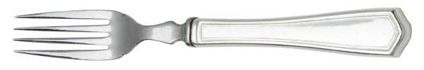

By Annette M. Harris
Central Carolina Community College
Siler City Campus

Background

Level: My class consists of intermediate/advanced students. This project can be adapted for beginning students.

Objectives: Students will
- make questions from handouts,
- adapt recipes to replace ingredients (fat, sugar, salt, calories, etc.) with more nutritious substitutes,
- identify ways to improve their diets in small steps.

Time: We meet every day for three hours. We used two days (five hours) to complete this challenge.

Education and Action

Day One (3 hours)
Introduction
I began this project by explaining that we would be looking at how to eat to help prevent heart disease. I passed out folders with handouts in English and Spanish. The handouts came from the websites shown below:

- Stocking a Heart Healthy Kitchen.
http://www.clevelandclinic.org/. Scroll down and click on Health Information Center in the menu on the left side of your screen. On the screen that comes up, choose your language on the left of the screen.
If you selected English, type in Stocking a Heart Healthy Kitchen and click on Search.
If you selected Spanish, scroll down and click on Salud de Corazόn. Then scroll down and click on Almacenando para un corazόn saludable.
For direct access, you can try http://www.clevelandclinic.org/health/health-info/docs/3600/3610.asp?index=11916 (English) or http://www.clevelandclinic.org/health/sHIC/html/s11916.asp (Spanish)

- Eating for A Healthy Heart. (English and Spanish) http://www.fda.gov/opacom/lowlit/hlyheart.html

- Get Pumped for Heart Month. (This article is in English only.) http://www.clevelandclinic.org/health/healthy-info/docs/4400/4407.asp?index=14067
If this website address does not work for you, go to http://clevelandclinic.org/, type Get Pumped for Heart Month in the search box, and click on go.

Forming Questions from Handouts
Each person received a copy of all the handouts listed above. We read them aloud (to focus on reading skills) and discussed them. Then I put some sample questions on the board and divided the students into three small groups. Each group took one of the handouts. Their assignment was to write questions from the handouts. This activity was given to help reinforce the information and to give the students practice forming questions. We used their questions on Day 2.

Adapting Recipes
Next, I put ingredients from a recipe on the board and asked the students to decide which ingredients (if any) could be replaced with more nutritious ones. After this demonstration exercise, the students joined into the same small groups they were in for the previous activity on making questions. I gave them the option of using recipes that I had collected from different sources or using their own recipes. Their challenge was to choose a recipe and--using their handouts--replace any ingredients that they thought needed to be replaced with more nutritious substitutes. Their healthy substitutions are shown at the end of this challenge.

The purpose of this exercise was for the students to recognize “heart risky” ingredients and potential substitutes. I did not include the preparation instructions in the student work that follows this project plan because I was only interested in the substitutions. Also, we did not make the dishes with the substitutions, and, as with any recipe, you must experiment to find out what will work and what will not work. It would be interesting to find out how these dishes taste with the substitutions!

DAY 2 (2 hours)
Answering Questions
I put the questions that students formed on Day 1 on the board, and we worked together make any needed corrections in spelling and grammar. Then the students used their handouts to answer the questions. Finally, we read and discussed their answers. (To demonstrate their work for purposes of this challenge, I selected three questions from each group to make up an “eating checkup” which is shown at the end of this challenge under the title Eating for a Healthy Heart.)

Quiz
There is a useful true/false quiz called Test Your Heart Disease IQ at
http://nhlbisupport.com/chd1/TFQuiz/tfquiz.htm. It can be taken on line, but I chose to print it. My students took this quiz. Afterward, I passed out the answer sheet. We read and discussed each item. (Note: If you have trouble accessing the quiz with the address shown above, use your favorite search engine to find NHLBI Resource Library. Click on the heart that says Tests/Quizzes in the Resource Library menu that runs across the top of your screen. Then click on Test Your Heart Disease IQ.)

Improving Our Diets
Each student wrote down at least five things about their typical diet and five ways they could improve their diet. They shared them with the class. Selected samples are given at the end of this challenge, typed to reflect the spelling, punctuation, and grammar that the student used.

EATING FOR A
HEALTHY HEART

Stir frying is healthful and delicious. True or False

- Name three good ways to cook.
________________ _________________ _________________

- Are the canola, olive, and sesame oils healthy for cooking? _______________________________________________

Questions by Adriana Serrano, Luis Fernando Perez, Patricia Corona

4. If you want to eat a heart-healthy diet, can you start stocking up on
nutritious foods?______________________

5. Fresh fruits and vegetables are not healthy. True or False

6. Name two fats or cooking oils. _____________ _____________

Questions by Araceli Reyes, Maria Felix Moreno, Miledy Espinoza

7. Is it healthy to eat less saturated fat? Yes or No

8. What can you eat to get your heart healthy? __________________
_____________________________________________________

9. What kind of exercises can you do to get your heart healthy?
_____________________________________________________

Questions by Henry Garcia, Chon Sue Smith, Hernan Cortes, Robin Vasquez

Graphics from Microsoft Clip Art

ANSWERS

- True
- roast, grill, bake (answers may vary)
- Yes, they are.
- Yes, you can
- False
- assorted raw nuts and seeds, non hydrogenated shortening (answers may vary)
- Yes, it is
- You can eat less fat and sodium, eat more fiber, and eat a variety of food including plenty of bread, rice, cereal, fruit ant vegetables. (answers may vary)
- Some exercises you can do to get your heart healthy are: walking, swimming, and gardening. (answers may vary)
Nutritious Substitutes

Replace fat, sugar, salt, and empty calories
with sound nutrition.

Lemon Curd Coffee Cake

Original Ingredients Healthy Alternatives

1/3 cup sugar 1/3 cup brown sugar

1/2 cup sour cream 1/2 cup non fat sour cream

1/4 tsp. salt 1/4 tsp. salt substitute

2 eggs egg substitute (egg whites)

2 ½ to 2 ¾ cups white flour 2 ½ to 2 ¾ cups whole wheat pastry flour

1/3 cup soft butter 1/3 cup canola oil

Other ingredients in this recipe are: dry active yeast, lemon rind, ready made lemon curd, and chopped walnuts, optional.

Adriana Serrano, Luis Fernando Perez, Patricia Corona

Graphics from Microsoft Clip Art

Nutritious Substitutes

What can we do to make this recipe heart healthy?

Mexican Lasagne

Original Ingredients Healthy Alternatives

cheese blend non-fat or reduced fat cheese

eggs egg whites

flour tortillas baked, trans-fat free tortilla chips

ground beef “round” or “loin” beef

salsa low-fat or fat-free pasta sauce

low sodium salsa

cottage cheese non fat or 1% fat cottage cheese or ricotta cheese

Other ingredients in this recipe are: taco seasoning, tomato sauce, and oregano.

Araceli Reyes, Maria F. Moreno, Miledy Espinoza

Graphics from Microsoft Clip Art

Nutritious Substitutes
Ways to make this recipe heart healthy

Lemon Poppy Seed Bread

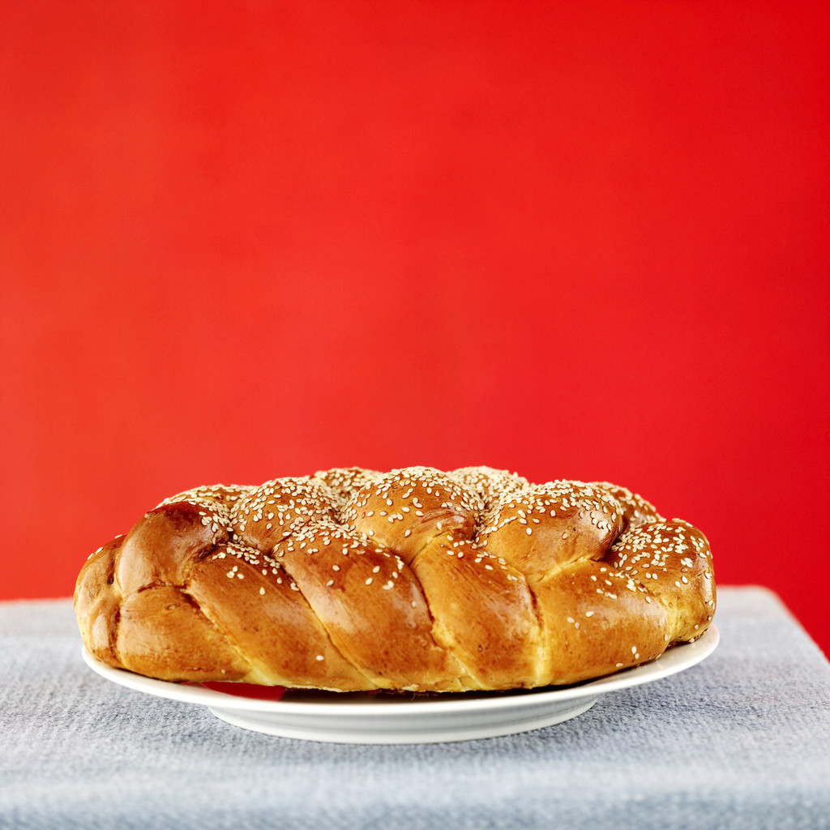
Original Ingredients Healthy Alternatives

milk soy milk

sifted flour whole wheat flour

sugar splenda, nutra sweet, brown sugar

egg egg whites

oil canola oil

Other ingredients included in this recipe are: poppy seeds, 3 tsp. baking powder, 1 tsp. salt, and 2 Tbsp. grated lemon peel.

Henry Garcia, Sue Smith, Hernan Cortes, Robin Vasquez

Graphics from Microsoft Clip Art
Students identify ways
to improve their diets.

Adriana Serrano is an advanced low student from Mexico.

My diet now Ways I can improve

1. lots of sugar 1. less sugar or substitute
2. tuna with oil 2. tuna with water
3. 5 tortillas a day 3. 2 tortillas
4. candies, chocolates, 4. dried fruits
1 piece a day
5. 1 piece of bread 5. ½ piece of bread

Henry Garcia is an intermediate high student from Mexico.

My diet now Ways I can improve

1. 3 gatorade 1. 5 glass of water a day
2. 1 fruit a day 2. 2 fruta a day
3. vegetables ones a week 3. 3 Vegetables a day
4. 3 yogurts a day 4. 4 yougurt a day
5. pizza 3 times a week 5. pizza 1 time every 2 weeks

Graphics from Microsoft Clip Art
Students identify ways
to improve their diets.

Luis Fernando Perez is an advanced high student from Mexico.

My diet now Ways I can improve

1. lots of sugar 1. brown sugar twin
2. 1 glass of softdrink a day 2. 4 glasses of water a day
3. no vegetables 3. 1 vegetables a day
4. no milk 4. 1 glass of skim or 1% milk a day
5. no fruits 5. 2 fruits a day

Hernan Cortes is an intermediate high student from Mexico.

My diet now Ways I can improve

1. no milk 1. 2 glasses of milk a day
2. lots soda 2. Drink more water.
3. no exercise 3. to walk 30 minutes
everyday
4. I am smoker. 4. No smoking more
5. no vegetables 5. Everyday eat more
vegetables

Graphics from Microsoft Clip Art

Students identify ways
to improve their diets.

Maria Felix Moreno is an intermediate high student from Mexico.

My diet now Ways I can improve

1. 2 percent milk 1. 1% milk
2. fried foods 2. baked, and such or not
fat cooking spray
3. eggs 3. only egg whites or

eggs substitutes
4. yogurt 4. fat yogurt o not fat or
1%
5. lots of sweetener 5. Splenda (sugar substitutes)
6. white rice 6. brown rice
7. breads whites 7. whole grain bread

Chon Sue Smith is an intermediate high student from Korea.

My diet now Ways I can improve

1. lots of fating chips for snack 1. Replace fruit.
2. to match caffee or Pepsie 2. Drink the water.
3. to match sugar 3. less sugar
4. lots meat 4. Eat more vegetables.
5. white bread 5. Whole wheet bread

Graphics from Microsoft Clip Art

