Heart Disease
THE NUMBER ONE KILLER IN NORTH CAROLINA

Your tribe must survive heart disease by using the tools of education and action.

Your challenge is to create crossword puzzles on heart
disease.

Survival Plan: It’s a Puzzle
By Andrés Hernández

Montgomery Community College

Background

Level: This survival plan (aka project plan) was carried out by my High Beginning/Low Intermediate students. It can be used and/or adjusted for higher levels.

Objectives: Students will
- learn to pronounce words related to heart disease,
- identify parts of the heart,
- define words associated with heart disease
- complete a crossword puzzle
- read about the heart and heart disease.

Time: Our class meets five days a week for three hours. We completed this challenge in a week by using an hour and a half to two hours of each class. Overall, we spent about nine hours on this challenge. You can easily adjust the project to a different timetable that will be more appropriate for your own class.

Materials and Resources

Easy crossword puzzle books in English

Using a Dictionary 1 (ISBN 1-56420-554-1) and
Using a Dictionary 2 (ISBN 1-56420-555-X) by New Readers Press

Internet access for both instructor and students

Sites for Teachers

http://school.discoveryeducation.com Click on Puzzlemaker in the menu on the left side of your screen. Click on Criss-Cross and follow the directions to make a crossword puzzle for your class.

http://office.microsoft.com/en-us/clipart/default.aspx Graphics from Microsoft Clip Art.

http://www.wikipedia.org/ Click on the language you want. Then scroll down to the heading Wikipedia’s Sister Projects and click on Wiktionary for the online dictionary. Wiktionary is useful when you are writing crossword puzzle clues for the vocabulary words.

Sites for Students

http://www.medtropolis.com/ Click on Virtual Body and then on a language (English or Spanish). Click on human heart or corazón humano.

http://www.kidshealth.com/ Click on the Parents button. Type heart disease in the search bar and hit your enter key. Click on the first entry, titled Heart Disease, and then click on the orange tab--on the right side of your screen—titled More Articles Like This. Click on All About the Heart. My students read this article in English and were given the option to read it in Spanish afterward.

http://www.medicinenet.com/script/main/hp.asp Look for the menu entitled Browse Centers on the right of your screen. Scroll down and click on heart. Use the menu in the center of your screen and scroll down until you can click on heart attack.

http://www.mayoclinic.com/ In the Find It Fast square on the left of your screen, click on H. Scroll down and click on heart attack.

Education and Action

SECTION ONE
Introduction
To prepare my beginning ESL students for this challenge, I distributed beginning (easy) crossword puzzle books in English. I needed to orient my students to the concept involved in a crossword puzzle. Many of my students had never done a crossword puzzle before, which presented a minor challenge for some of them until they grasped the idea of how one works. We spent 30-45 minutes working on these puzzles in the classroom.

Vocabulary
Next I gave my students a list of vocabulary words to be used in this exercise:
- chest
- heart
- pain
- faint
- nausea
- fatigue
- symptoms
- obesity
- cholesterol
- arteries

Their assignment was to use a dictionary to find the definition of each word. (Note: I had previously taught my students how to define words. I used Lessons 1-7 in Using a Dictionary 1 by New Readers Press, ISBN 1-56420-554-1.)

Pronunciation Practice and Definition Clarification
Upon successfully defining their list of vocabulary words, each student shared his/her answers with the rest of the class for comparison/correction of the various possible definitions. Students read their definitions aloud. I used the whiteboard to write any words that students had trouble pronouncing, and I spelled them phonetically to assist students with pronunciation.

SECTION TWO
Learning Online
We scheduled a class day at the computer lab so students could research information relating to heart disease. I gave the students the web addresses shown above in Materials and Resources under Sites for Students. One website that the class found very attractive is www.MEDtropolis.com. This site has an interactive virtual body and a presentation in Spanish and English. We listened and read along in Spanish first and then repeated the same presentation in English.

The students themselves found other online sources. I encouraged them to find bi-lingual sites if they were having trouble understanding a topic.

Heart Check
After the students completed their research, we did a review of the definitions of the vocabulary words. Then they completed the “HEART DISEASE VOCABUARY,” a handout that is included at the end of this project plan. (The answers are b, c, a, c, b, c, a, c, a, and c.)

SECTION THREE
Making Puzzles
Using CASAS placement scores and classroom observation as my guides, I divided the class into two groups to develop crossword puzzles.
- One group was assigned to develop a traditional crossword puzzle with short written clues.
- The other group was assigned to develop a crossword puzzle with pictures or drawings as clues for lower level students. I made up a sheet of clip art and graphics for students to use.

After the students decided which clues or pictures to use for the verbal puzzle, I put the puzzles together. I used Puzzlemaker at http://school.discoveryeducation.com. Then the students worked the completed puzzles in the class and approved the final product.

We Met Our Challenge!
Our two puzzles are shown on the following pages. More important, I was gratified that students acknowledged becoming more aware of heart disease prevention.

Project Follow Up
- We plan to share our puzzles and this project plan with other Montgomery Community College ESL instructors so they can work with their students on heart disease. Students from our class whose verbal skills are at a higher level will be encouraged to assist other instructors in presenting the material and in helping other students complete the crossword puzzles.

- I also plan to inform my students regularly of local forums in hospitals and clinics dealing with preventive measures that can be applied to daily life.

Teacher Notes
Recommendations to others who want to do this project:
- Attempt to find a competent health professional in the community to talk with the students in class and make them feel comfortable asking questions.

- Spend time stressing the importance of good eating habits and exercise. I found that these areas would be beneficial additions to this project.

- Allow some extra time in your schedule to accommodate the needs of lower level students trying to comprehend the vocabulary of heart disease.

- Try creating a word search with beginning students instead of a crossword puzzle. Crossword puzzles proved to be very difficult for my beginners.

- Try having students use magazines to cut out graphics/pictures to make up crossword puzzles in your classroom.
Heart Disease Vocabulary

Circle the correct answer.

- Juan places his hands over his chest and complains about a sharp pain. What is the best thing for you to say?

  - Hello
  - Are You O.K.?
  - How are things?

- Domingo goes to the doctor and discovers his _____________is too high. This may lead him to develop diabetes.

  - sky
  - grades
  - cholesterol

- ______________occurs when there is a temporary drop of blood to the brain.

  - Fainting
  - Heart attack
  - Cancer

- Being overweight/_______________ can cause someone to have a number of health problems, both physical and emotional.

  - good health
  - a nice smile
  - obesity

- A ______________is a sign indicating the nature of a possible medical condition.

  - artery
  - symptom
  - obesity

- ______________ is the sensation that there is a need to vomit (throw-up).

  - Heart attack
  - Fatigue
  - Nausea

- An unpleasant sensation that can range from mild, localized discomfort to agony can be defined as ______________.

  - pain
  - cholesterol
  - chest

- Beat, Drowsiness, Exhaustion, Feeling Tired, Lack of Energy, Lethargy, Sleepy, Tiredness, Weariness, and Wiped Out are all terms related to:

  - active
  - body parts
  - fatigue

- A vessel that carries blood oxygen content away from the heart to the farthest reaches of the body is known as an:

  - artery
  - tube
  - ship

- The average ______________ is about the size of a closed
fist and weighs about 10.5 ounces.

  - lung
  - brain
  - heart

Heart Disease Puzzle #1
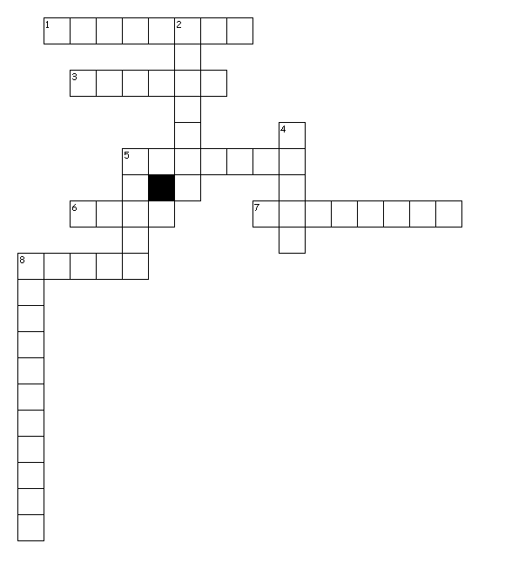
Across
1. signs of trouble
3. discomfort in the stomach with an urge to vomit
5. tired feeling, exhausted
6. an uncomfortable feeling
7. blood vessels that carry blood away from the heart
8. located on the upper part of the torso

Down
2. excessive body weight
4. organ that pumps blood
5. when someone suddenly becomes unconscious
8. there are two kinds, HDL and LDL

Created by Puzzlemaker at DiscoveryEducation.com
Heart Disease Puzzle #2
Created by Puzzlemaker at DiscoveryEducation.com

Across Down

SY__ __ T __ __ S
1. 2.

Across Down
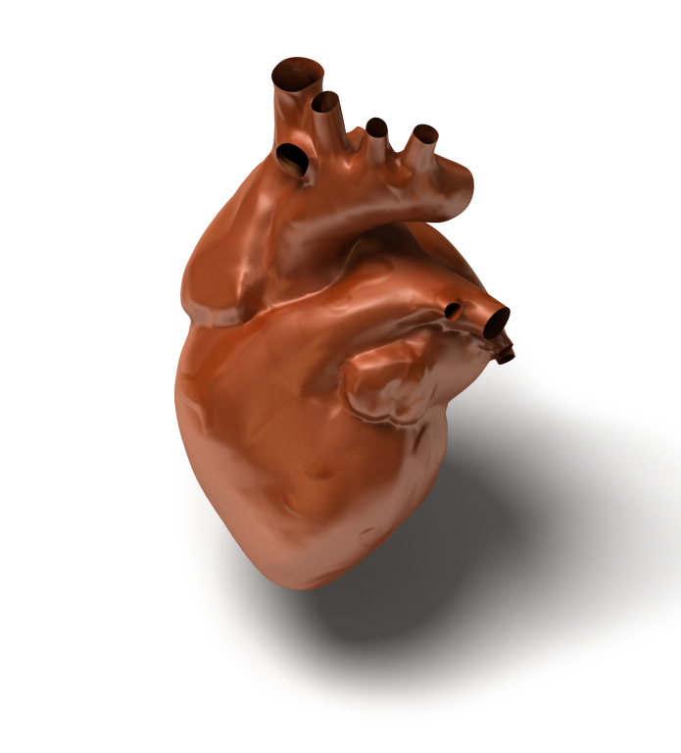

3. 4.



5.

__ AIN __

5.

6.

8.

LDL = Bad
HDL = Good

A __ T __ R I __ __
7.

8.

