Prevention Strategies

You can do three things to help prevent the main causes of death in North Carolina. You can exercise, eat right, and avoid smoking. Your tribe must avoid smoking to survive. As always, your survival tools are education and action.

Your challenge is to prepare five public service announcements on stopping smoking.

Survival Plan: Bringing You a
Public Service Announcement
By Eyda Bennett, Tammy Griffin, and John Anderson
Wilkes Community College

Background Information

Level: Our class is a mixture of beginning, intermediate and advanced students. This project can be adjusted to meet the needs of any level student.

Objectives: Students will
- learn about Chronic Lung Disease and how it affects the individual and the family
- learn about the effects of smoking, including passive smoking, on the body
- use this information and work with their classmates and instructors to write and produce five Public Service Announcements about stopping smoking and preventing COPD

Time: Our class meets daily for four hours. We completed this project in approximately three weeks spending at least one hour per day and totaling about 15-17 hours.

Education and Action

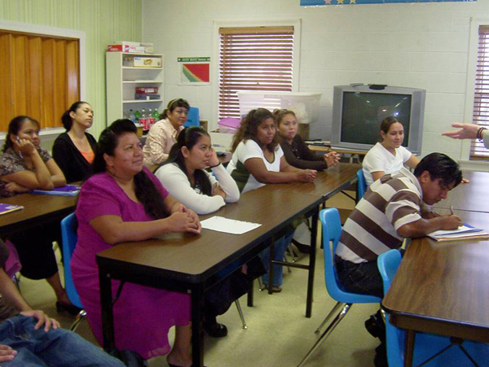

FIRST WEEK
Introduction
We began with a straw exercise. I gave all students a drinking straw. I asked them to pinch their noses closed and breathe through the straw for 30 seconds. After this time, students were breathing rather heavily and exclaiming that this exercise was moderately difficult. I went on to explain that this is how someone who smokes a pack of cigarettes per day breathes.

I then passed out stirring straws to each student, to many “Oh my goodness” remarks. I asked the students to pinch their noses and breathe through this small straw for only 20 seconds, as it would be much more difficult. At the 10-second mark, several students had stopped, and only about 5 students actually made it the entire 20 seconds. I then explained that breathing through this small straw is similar to the breathing of a person with COPD. There were many shocked faces and shaking heads.

Discussion
At this point I explained our challenge and asked the students, “ In your opinion, why do people smoke?” The class responses were comprehensive:
- curiosity
- teenagers thinks they’re invincible
- parental influence
- rebellion
- TV, movies, music
- peer pressure
- stress
- depression
- desire to lose weight

Survey
Next, we instructors gave the students a quick survey regarding their use of and exposure to tobacco. The Survey Results for our class are included at the end of this project plan.

Research
Students spent the rest of the week doing internet research. They worked in pairs and printed information they deemed important. At the end of the week, we came together and discussed their findings. At this point, we did a class KWL to identify What I Know, What I Want to Learn, and What I Have Learned. Our class KWL is included at the end of this project plan.

SECOND WEEK

Guest Speaker
We started this week with a guest speaker, Mr. Murphy Webber. Mr. Webber is a respiratory therapist from the Wilkes Regional Medical Center Respiratory Health Department. He gave a PowerPoint presentation about COPD. He discussed how the lungs work and the physical effects of smoking on lungs. At the end of the presentation, he answered students’ questions.

Discussion
We asked the students, “From your research, what are the causes of COPD?” Their responses were accurate and showed they understood the basics of the topic:
- smoking
- passive smoking
- air pollution
- occupational pollutants (coal mines, paint, etc.)

Planning Public Service Announcements
The rest of this week we devoted to choosing our target audiences for each PSA. The class decided that the most important groups of people to focus on were
- adult smokers,

teenagers, and

pregnant mothers.

Since only one of our students actually smokes, we decided to approach this project with prevention as our goal. Not only would we focus on prevention of teenage and adult smoking, but also prevention of passive smoking, which affects everyone.

We spent around 3 hours trying to decide on the ideas for each PSA. We asked the students to speak about their experiences with smoking: at work, at the park, at home, and with family. We then asked them what their concerns were regarding their children. During this class discussion, I wrote their answers and concerns on the board. From this list, we were able to come up with skit ideas. The class decided on the following:

Target Audience Message
adult smokers stop before it’s too late
adult smoker children want a better life for their parents
adult smokers effects on children – passive smoke
teenagers prevent from smoking
pregnant mothers quality of life for the family

After deciding on the target audiences for each, we began thinking about possible scenarios. We wrote Story Maps for each skit. Our Story Maps are given at the end of this project plan. For the story maps form, go to http://www.everythingesl.net/inservices/graphic_organizers.php and click on Story Map under the heading Activity Downloads. (Or you can go to http://www.everythingesl.net/, search for graphic organizers, and click on the entry titled Graphic Organizers for Content Instruction.)
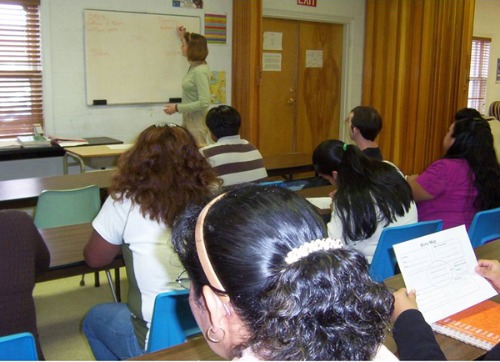
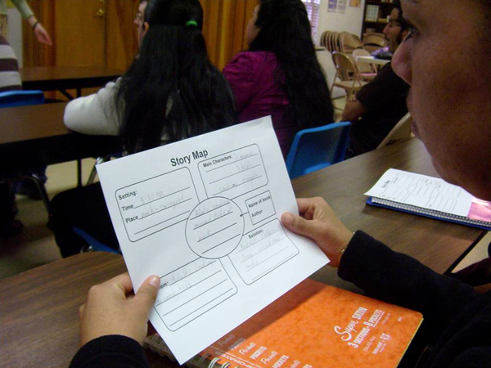
From the story maps determined by the students, we instructors scripted the basic PSAs. The scripts are included in the addenda to this project plan. Finally, the students enjoyed a bit of ad lib in the rehearsals that followed.

THIRD WEEK

Rehearsal
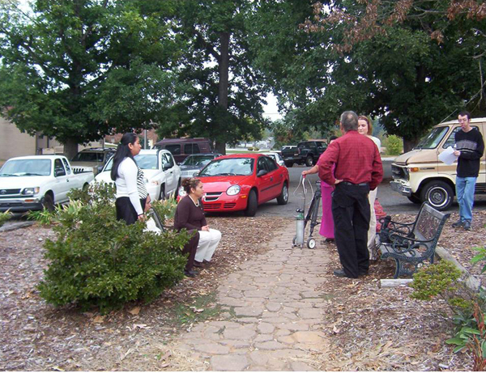
During this last week, we spent the majority of our time practicing the skits. I (Tammy) taught students about acting, emphasizing the importance of sincerity and seriousness. We also decided on props, clothing, and the ages of each character as well. I also purchased several fake cigarettes in order for the PSAs to seem more real.

A few days before we were scheduled to film the PSAs, our director Deborah Britton came and filmed our dress rehearsal. We then watched it and could see what we needed to do to improve for the final take.

Performance
Finally, we were fortunate enough to find a professional videographer, Mr. Mule Ferguson, who volunteered his time to come film the PSAs. This was a great opportunity and learning experience for all involved.

To support various computers and operating systems, our Public Service Announcements are available as both .MP4 files (which play in QUICKTIME) and .AVI files (which play in Windows Media Player). QuickTime is available online as a free download at www.quicktime.com

We Met Our Challenge!
We believe our students are much more informed about COPD and how if affects not only the individual, but the family as well. Also, we feel we met our challenge and that the PSAs are very effective and poignant.

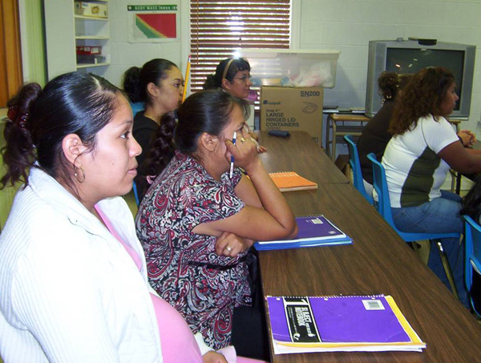
Smoking Survey Results

1. Do you smoke?
--11 out of 15 students don’t and have never smoked.
--3 out of 15 students have smoked in the past, but have stopped
--1 out of 15 students currently smokes

2. Why do you smoke?
--I have smoked for many years
-habit
-My husband smokes, so it’s hard to quit.

3. Do you live with a smoker?
--14 out of 15 students do not live with a smoker
--1 out of 15 students does live with a smoker

4. Is smoking allowed inside your home or must a smoker “take it outside”?
--12 out of 15 students say smoking is not allowed inside their homes
--3 out of 15 students say they do allow smoking inside the home

5. Smoking affects:
the lungs, the mouth/throat/ the heart/ the kidneys/ the bladder

6. Do people smoke at your job?
--10 out of 15 students say they are around smokers on the job
--5 out of 15 students either don’t work or are not around smokers on
the job

7. Are you worried about your children being influenced to smoke?
--15 out of 15 students say yes

8. What do you think are the major influences on your children?
--peers
--older family members
K-W-L
Wilkes Community College ESL Class
COPD—Chronic Lung Disease
Eyda Bennett, Tammy Griffin and John Anderson -- Instructors

K W L

What I Know What I Want to Learn What I Have Learned

-Smoking is bad for your -How does smoking cause COPD? -Prolonged smoking
health. damages the lungs

-COPD is a Lung Disease -What is COPD? -COPD is a disease
characterized by lung
damage and decreased
lung capacity.

-What are the symptoms -Symptoms—cough, bron-
of COPD? chitis, shortness of
breath, pain, need for
oxygen

-Can being around passive smoke -Passive smoke can
cause me to have COPD? cause COPD.

-Is there a cure? -No, there is no cure.
However, if the person
stops smoking, the
lungs can regain some
of their previous
strength.

Story Map

Setting:

Time_____12:30 P.M._________

Place____Bench in the parking lot

Main Characters:

3 women smoking and laughing__

1 woman with oxygen tank______

Problem:

_Co-workers smoking, not thinking
about consequences
___________________________

PSA Name
and
Author

CO-WORKERS ON BREAK
By WCC Moravian Falls ESL Day Class______________

Solution

______Stop before it is too late.__

___________________________

Story Map

Setting:

Time____6:00 P.M.___________

Place____At home____________

Main Characters:

__Mother and Teenage son____

___________________________

Problem:

Son wants Mom to quit smoking and

takes her cigarettes from her purse

PSA Name
and
Author

The Smoking Mother
By WCC Moravian Falls ESL Day Classs_____________

Solution

__Son wants to save Mom’s life._

___________________________

Story Map

Setting:

Time____5:30 P.M.___________

Place__Park – Swing Set______

Main Characters:

__3 Moms and 3 kids_________

__Smoking friend____________

Problem:

___Adult smoking around kids___
___________________________

Solution

___Protect children from _____

___secondhand smoke_______

PSA Name
and
Author

ADULT FRIEND SMOKING AROUND KIDS AT PARK
By WCC Moravian Falls ESL Day Class___________

Story Map

Setting:

Time_11:00 A.M.________

Place_Moravian Falls Elementary

School Playground_

Main Characters:

__4 Mothers, 5 Children, and _____

__1 Spokesperson______________

Problem:

_The father has COPD and cannot participate in the Soccer game with his son__________________________
Solution

__To prevent future generations__

__from smoking_______________

PSA Name
and
Author

PARENTS AND CHILDREN PLAYING SOCCER
By Moravian Falls ESL Day
Class_________________

Story Map

Setting:

Time____11:00 A.M._____ ___

Place____College Campus_______

Main Characters:
_Presenter, Graduates, Audience___

_(including pregnant Mom smoking__

________with child)____________

Problem:

_Pregnant mother smoking and

coughing__________________

PSA Name
and
Author

GRADUATION CEREMONY
By WCC Moravian Falls Day Class_________________

Solution

_Help Mom stop smoking in order to

be around for her kids______

SCRIPTS FOR PUBLIC SERVICE ANNOUNCEMENTS

CONVERSATION DURING OFFICE BREAK

Target audience: Smoking Adults

Participants: Avilania Reyes, Elsa Garcia, Blanca Mejia Velásquez, and Maria Niz.

A group of three women, are coughing, laughing, and talking.

Avilania Reyes says: Can you give me one?
All ad lib: Can you give her one more too?
Hey! It was a good party last night.
Hey! What are you doing tonight? Are you going to the party tonight too?
Elsa Garcia answers: Maybe yes.

Maria Niz walks by with her oxygen tank and coughing.

The three women stop talking as they look at Maria and look at their cigarettes.

CONVERSATION BETWEEN MOTHER AND SON

Target audience: Smoking Mothers

Participants: Jairo Isaak Rodriguez Niz (son)
Elsa Garcia (mother)

Jairo walks in while his mother is working on the computer. He takes her purse to take out the cigarettes. He thinks that if he throws them away, she will quit smoking.

His mother notices her purse is gone and gets up looking for it. When she sees him, she says:

Elsa: “What are you doing with my purse?”

Jairo: “Nothing”.

Elsa: “Are you taking my money?”

Jairo: “No.”

Elsa: “What is in your hand? Cigarettes?”

Jairo: “Mama, I just wanted you to quit smoking”.

The mother (Elsa) realizing the importance of this moment, embraces her son and says to him:

“OK, I will stop.”

CHILDREN ON SWINGS WITH THEIR MOTHERS

Target audience: Smoking Adults

Participants: Irma Amaya, Elsa Garcia and son Gael, Avilania Reyes and son David, Maria Martinez and daughter Paulina, and Maria Lopez.

While the mothers are pushing their children on the swings and Maria Lopez is sitting in one of the swings, Irma Amaya comes by smoking a cigarette and coughing.

Irma: Hey Maria! Hello. How are you doing?

She continues to walk towards them smoking and coughing.
Maria doesn’t answer. All the mothers leave with their children.

Spokesperson (John Anderson): “Smoking not only affects you, but also those around you.”

ADULTS PLAYING SOCCER WITH CHILDREN

Target Audience: Teenagers

Participants: One Teen (Noe Santiago Ponce) with his Mother (Maria Irma Amaya) and her oxygen tank

Children playing: Paulina and Eddie

Adults: Maria Martinez, Tammy Griffin, Avilania Reyes, Rosa Elvia Garcia, Mayra Guerrero, and Aracely Sandoval.

The mother is sitting down coughing and her son adjusts the tank to help her. They look wistfully at the children and adults playing soccer.

Spokesperson (John Anderson): “When you become a parent, which of these two parents do you want to be? IT IS YOUR CHOICE!”

A SMOKING PREGNANT WOMAN ATTENDING A GRADUATION CEREMONY

Target Audience: Pregnant Moms

Participants: Mayra Guerrero (smoking mother), Deborah Britton (presenter), Elsa Garcia, and Maria Martinez (graduates)

Presenter (Deborah Britton): Ladies and Gentleman, we are so happy that you could come to join us in this wonderful occasion. Now I would like to introduce to you and to award certificates to Elsa Garcia . . . . Maria Martinez…

The mother is smoking and coughing continuously at the graduation ceremony, holding her daughter, Arely.

Spokesperson (John Anderson): What kind of family life will this family have? Will the mother be able to be an active participating parent? Will she live long enough to see her children graduate from college?

