Chronic Lung Disease
THE NUMBER FOUR KILLER IN NORTH CAROLINA

Your tribe must survive chronic obstructive pulmonary disease by using the tools of education and action.

Your challenge is to design a series of “to your health” postcards on COPD.

Survival Plan: Send Me a Postcard
By Beth McAlister and Diane Wait
Wilkes Community College: Ashe Campus Family Central

Background

Level: Our mixed class (all levels) did this project, but the intermediate-to-advanced students participated in some reading activities that beginning level students could not/did not do. The level is noted for each activity described.

Approach: Our ESL class is part of a Family Literacy Program with a focus on parent education. Many of our students are parents of young children. We felt that the best approach to our challenge of designing “good health” postcards relating to COPD would be one that encourages people not to smoke. However, having worked with our group of students over time, we teachers were aware that none of our students smoke. To keep the class relevant to the lives of our students, we used this opportunity to focus on their children and look into the future: we had them create postcards with the goal of preventing young teens from starting to smoke.

Objectives: Students will
- learn the leading causes of death in the U.S.
- explore some ways that help prevent chronic diseases
- focus on Chronic Obstructive Pulmonary Disease (COPD)
- evaluate smoking statistics in the U.S. inasmuch as smoking is a major risk factor for COPD
- discuss factors that lead teenagers to start smoking and map out strategies for talking with teens about smoking
- develop five postcards with messages aimed at preventing teens from smoking

Time: Our class meets for six hours a day, four days a week. We interspersed this postcard project with other regular class activities over a period of four weeks. Any of the individual parts of this project can be carried out in 1-2 classes.

Activities

Introduction
Mixed levels
We began with a brief explanation of the Survivor N.C. challenges and then asked the class to name the leading causes of death in the United States. The students brainstormed about common diseases and causes of death. They named three of the top five leading causes of death--cancer, diabetes, and heart attack/heart disease--along with numerous other diseases and health problems.

We talked about lifestyle as a reason why such deaths are common in the United States. Students listed cholesterol, blood pressure, and obesity as lifestyle consequences. We also talked about some prevention strategies, i.e. eating more vegetables and fruit, and getting more exercise.

Before responding to our challenge, however, we needed to learn more.

Five Leading Causes of Death
Mixed levels
We divided the class into four small groups of 2-4 students and assigned each group one of four leading causes of death: diabetes, stroke, cancer (with lung cancer as the leading cause of cancer deaths), or heart disease. We saved COPD for later in our project.

We gave students a Leading Causes of Death Worksheet (Appendix A) to complete with the information they would gain about each of the four causes of death. We offered students the option of searching the internet for answers, but our class chose the safer route of using teacher-selected sites (Appendix B).

We asked each group to read and discuss their fact sheet and to fill out the part of the worksheet that asked about their assigned illness. Teachers floated among the groups to facilitate discussion and understanding of the fact sheets.

After becoming familiar with information on their group’s assigned illness, students from each group took turns asking the other groups questions about their topic and filling out the rest of their worksheet. As instructors, we encouraged and facilitated further discussion about the topics.

Families Eating Smart and Moving More
Mixed levels
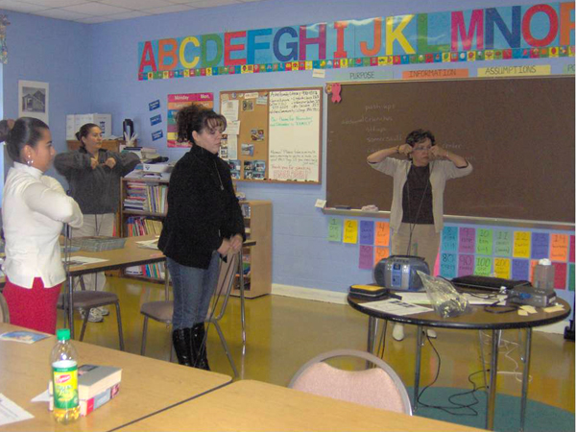
We invited a health educator from our local health department to talk about physical activity for health. She began the session with a presentation about unhealthy American habits. After some discussion on how to avoid these bad habits, she passed around resistance bands for every student. (Students were allowed to keep these.) We spent the rest of the morning learning exercises using a workout guide, accompanied by
music brought in by the students.
ESL students Flor, Luz Maria, Emelia and Isabel practice exercising with resistance bands.

For the workout guide that we used, go to http://exercise.about.com/. In the search engine within this site, type exercise workouts – resistance bands – upper body. Enter. Click on Resistance band workout – upper body. You will get a screen that on strength training with resistance bands: http://exercise.about.com/cs/exerciseworkouts/l/blbandworkout.htm

“A Pack a Day” Comprehension Activity
Intermediate/Advanced
We selected a reading and comprehension activity from the book Far From Home: Reading and Word Study , 2nd Edition, by William P. Pickett (Thomson/Heinle, ©1994, ISBN 0-8384-4852-6). This intermediate-to-advanced lesson is titled “A Pack a Day” and includes a reading accompanied by many comprehension and vocabulary activities related to smoking and health.

Instructors without access to the text above could (1) use LEA (language experience approach) to solicit a story from the class, or (2) have any smokers in the class talk about their experiences and make their words into a story, or (3) write a short story describing a person trying to quit smoking.

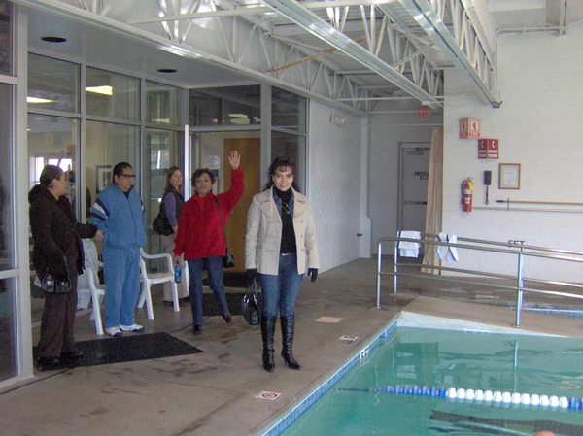
(Note: Had there been beginning level students in attendance on this day, we would have paired or grouped them with intermediate students and had them focus on learning some of the key vocabulary.)

Field Trip to Wellness Center
Mixed levels
As part of this project, we took a field trip to the local hospital wellness and fitness center called Mountain Hearts. A bilingual community outreach worker
from the hospital gave us a tour
of the facility, where we saw the
swimming pool, pulmonary
re-habilitation center, workout
room and exercise equipment. A staff member there talked with us about prices, classes offered and other opportunities at the center.
ESL students Luz Maria, Gerardo, Isabel and Emelia check out the swimming pool at Mountain Hearts

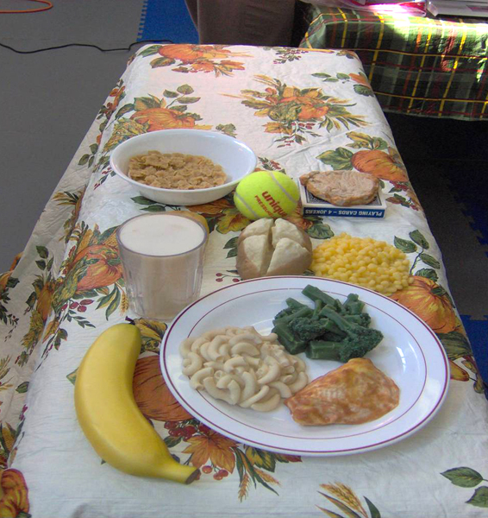
We also attended a class at Mountain Hearts that was about nutrition and reading food labels. Students learned about fiber, carbohydrates, fats and sugars. They asked questions, and everyone sampled the foods that were compared in the class.
Healthy food at Nutrition class.

Focus on COPD
Mixed levels
I began this lesson by drawing a table on the board showing the demographic breakdown of who smokes in the U.S. I found the information on http://www.quit-smoking.net/smoking-statistics.html. Students took turns explaining the chart, and then we read other smoking facts from the same resource.

On this day, we had a small class of intermediate students, so we took turns reading COPD facts from the National Health Institute’s website at http://www.nhlbi.nih.gov/health/dci/Diseases/Copd/Copd_WhatIs.html. In addition, we clicked on Signs and Symptoms in the menu on the left side of the screen and read those additional paragraphs. (Note: Had there been beginning level students in attendance, we would have paired or grouped them with intermediate students and had them focus on learning some of the key vocabulary.)

We discussed the differences between lung cancer and COPD, as well as asthma and other respiratory problems. We discovered that one student in our class had been a smoker for 17 years and had quit “cold turkey” one year ago! We talked about how smoking is an important issue to study, even by non-smokers, for the benefit of their children.

We continued our reading and discussion with two selections from http://quitsmoking.about.com/od/teensmoking/a/teensmokefacts.htm entitled “Secondhand Smoke Facts” and “Other Facts about Smoking”. If you have trouble accessing these selections directly, go to http://quitsmoking.about.com and click on the tab at the top called Health Risks. Type smoking facts for parents and teens in the search box in the upper right of your screen and click on search. Each listing that is given will show the URL at the end of the entry. Choose the one that matches http://quitsmoking.about.com/od/teensmoking/a/teensmokefacts.htm.

We concluded this section with a reading and discussion activity called “Please Let Me Smoke!” from Impact Topics by Richard Day and Junko Yamanaka (Pearson ESL, © 2001, ISBN 9789620050558). This reading is about an angry man who likes to smoke and is extremely frustrated about smoking bans in public places. Teachers without access to this particular resource might use an article from the web or a newspaper as the basis for a discussion (1) about smoking bans or (2) about how much control the government should have over personal choices.

Talking with Teens about Smoking
Intermediate/Advanced
We began this activity by reading and discussing the following:

“5 Truths about Teen Smoking” at http://parentingteens.about.com/od/tobaccouse/a/teen_smoking23.htm

“How to Talk to Your Teen about Smoking” at http://parentingteens.about.com/od/tobaccouse/ht/teen_smoking.htm

Next, each student selected a teacher-prepared card from a basket. Each card described a scenario:

- Scenario: You see friends of your daughter smoking. What will you do?

- Scenario: You and your teenagers are watching a movie. An attractive teenage girl in the movie smokes. What will you do?

- Scenario: You smell smoke on your child’s clothes. What do you do?

- Scenario: Your son tells you his best friend offered him a cigarette. What do you do?

The students thought about how they would talk to their child in this situation. Then they wrote a conversation based on the scenario on their card. Students shared their written conversations with the class and gave each other feedback. Samples of their work are given in (Appendix C).

Recommendations for the future: I would have the students act out the scenarios and conversations. This way, students could improvise what the teenagers might say to their parents, giving the students who are parents a more realistic opportunity to prepare for talking with their teens.

Students working on postcards: Isabel, Gerardo, Luz Maria, Concepcion, Juana, and Acela

Designing Postcards

Mixed levels

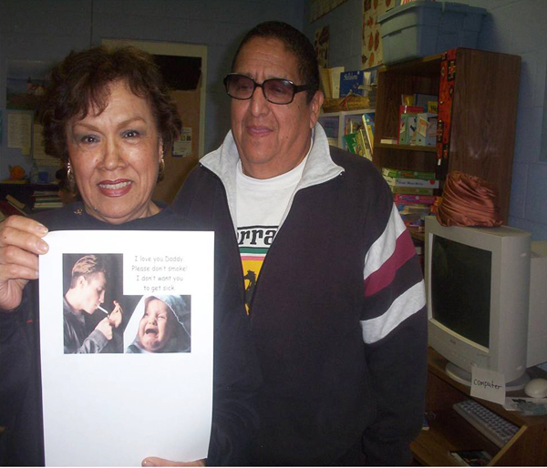
When we reached the time to design educational postcards targeting our young people with messages about not smoking, students immediately began sketching ideas with soccer balls, broken hearts, and a child reaching for her goals.

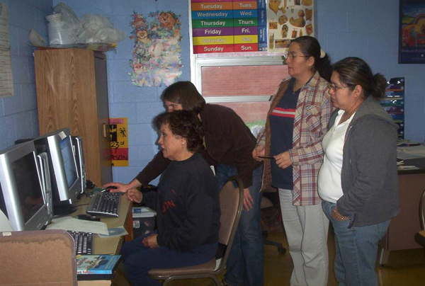
We worked with a variety of hands-on materials and clip art from Microsoft Office (http://office.microsoft.com/en-us/clipart/default.aspx). Each student came up with at least one very creative design. Some students worked on the computer while others drew pictures, or designed them out of felt and yarn.

Then we worked together to refine the accompanying messages.

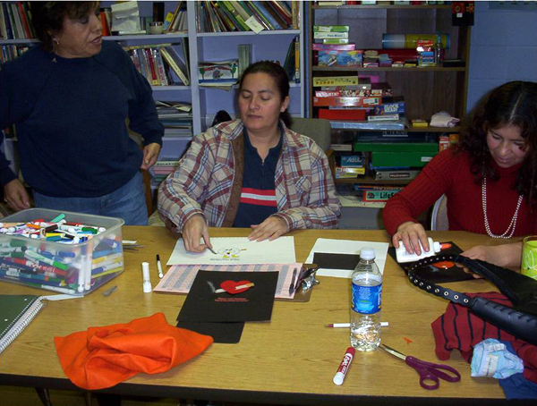
As usual, we were extremely impressed with our students’ creativity and enthusiasm for this project. Postcards designed in this project are shown in Appendix D. They include

- Soccer ball player with Cigarette-student drawing
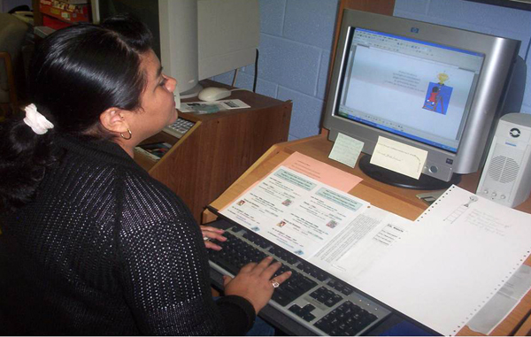
- Soccer ball player with Cigarette from Microsoft Clipart
- Broken Heart with Cigarette
- Orange or Cigarette, Life or Death?
- Reaching for your Goals-Spanish and English
- Baby Talking to Dad

Health History Form and Assessment

Mixed levels

We decided to wrap-up this project with a health history form. We used a generic health history form from the ESL Curriculum Guide: Domain Five: Health, provided by the NC Community Colleges. [Go to http://www.nc-net.info/ and click on Teaching Resources in the menu on the left side of the screen. Click on ESL in the resulting drop-down menu. Click on North Carolina Curriculum Guide (left side of screen) and scroll down to Domain Five and click on Health History Forms under the course entitled Illness.]

We began with a discussion about filling out forms at the doctor’s office and other places and about why those forms are important to understand. Students took turns reading aloud questions from the form, and we discussed the meaning of each question. Then students worked in small groups asking each other the questions and filling out their forms.

Finally, we used a short quiz (Appendix E) with some questions about the form, along with some questions about the five leading causes of death.

Results

We Met Out Challenge!

We met our challenge and went above and beyond the minimum requirements to gain a fuller understanding of the major health problems affecting North Carolina communities. Samples of student conversation scenarios (typed to reflect the spelling, grammar, and punctuation of the authors) and student-designed postcards are included in Appendices C and D.

Teacher Observations

Our students embraced this project and were able to gain knowledge of many health issues relevant to them and their families. Using a focus on the future well-being of their children engaged them in (1) developing materials to use with their children and (2) thinking of ways to talk with their children about smoking and other sensitive issues, like sex and drugs.

Appendix A

Leading Causes of Death Worksheet

Name_____________________________

What is lung cancer? _______________________________________________________

Who is at risk for lung cancer? _______________________________________________________

_______________________________________________________

How can you prevent lung cancer? _______________________________________________________

_______________________________________________________

What are the symptoms of lung cancer? _______________________________________________________

_______________________________________________________

What is the treatment for lung cancer? _______________________________________________________

_______________________________________________________

Page 2 of Leading Causes of Death Worksheet

Name_____________________________

What is a stroke? _______________________________________________________

_______________________________________________________

Who is at risk for a stroke? _______________________________________________________

How can you prevent a stroke?
_______________________________________________________

What are the symptoms of a stroke? ______________________________________________________

_______________________________________________________

What is the treatment for a stroke? _______________________________________________________

_______________________________________________________
Page 3 of Leading Causes of Death Worksheet

Name_____________________________

What is heart disease? _______________________________________________________

_______________________________________________________

Who is at risk for heart disease?
_______________________________________________________

_______________________________________________________

How can you prevent heart disease? _______________________________________________________

_______________________________________________________

What are the symptoms of heart disease? _______________________________________________________

_______________________________________________________

What is the treatment for heart disease?
_______________________________________________________

_______________________________________________________
Page 4 of Leading Causes of Death Worksheet

Name_____________________________

What is diabetes? _______________________________________________________

_______________________________________________________

Who is at risk for diabetes? _______________________________________________________

_______________________________________________________

How can you prevent diabetes? _______________________________________________________

_______________________________________________________

What are the symptoms of diabetes? _______________________________________________________

_______________________________________________________

What is the treatment for diabetes?
_______________________________________________________

_______________________________________________________
Appendix B

ONLINE RESOURCES WE USED WITH OUR STUDENTS

Heart Disease: Go to http://www.yourdiseaserisk.wustl.edu. In the center screen, click on What’s your heart disease risk? Now click on fact sheet (right of screen).

Lung cancer: Go to http://www.yourdiseaserisk.wustl.edu. In the center screen, click on What’s your cancer risk? Now click on Lung. Click on fact sheet (right of screen). We used the following sections:
- What is lung cancer?
- How common is lung cancer?
- Who is at risk of getting lung cancer?
- How do you prevent lung cancer?
- What are the symptoms of lung cancer?

Stroke: Go to http://www.yourdiseaserisk.wustl.edu. In the center screen, click on What’s your stroke risk? Now click on fact sheet (right of screen). We used all sections of this sheet except Who should be screened? We then added the F.A.S.T. test to detect stroke symptoms, found at http://www.stroke.org. Click on What is a Stroke? in the menu across the top of the page. Now click on Symptoms on the right side of your screen or use your favorite search engine to look for F.A.S.T. test.

Stroke: Go to http://www.stroke.org and click on What is Stroke in the menu bar across the top of the screen.

Diabetes: Go to http://www.yourdiseaserisk.wustl.edu. In the center screen, click on What’s your diabetes risk? Now click on fact sheet (right of screen).

Smoking: Secondhand Smoke Facts and Other Facts about Smoking at http://quitsmoking.about.com/od/teensmoking/a/teensmokefacts.htm are two selections you can access directly. (If you have trouble, go to http://quitsmoking.about.com and click on the Health Risks tab across the top of the screen. Type smoking facts for parents and teens in the search box at the upper right-hand corner of your screen and click on search. Choose the listing that shows the following URL at the end: http://quitsmoking.about.com/od/teensmoking/a/teensmokefacts.htm.)
Appendix C

Scenario: You see friends of your daughter smoking. What will you do?

Me: Remember the conversation about the smoking?

Daughter: I’m sorry mommy, my friends give me a cigarette and they talk me you can smoke.

Me: I’m not feeling happy for that. I give a opportunity for that you to decide if good or not.

Daughter: Some times I see many thing that my friends use in the cigarettes, but I talk to them this is not good for your health and for your future. I remember your advice. I don’t want to give problems Mommy, you can trust me.

Me: Okay daughter I be happy if you make healthy decisions. I love.

-Acela

Scenario: You and your teenagers are watching a movie. An attractive teenage girl in the movie smokes. What will you do?


Me: Chris and Alex what did you think about girl in the movie smokes, it is good or bad?

Chris and Alex: Well, we think it’s bad, but maybe once a day its fine.

Me: Kids I think once a day not is a problem, but you can start with a cigarette but another day your want more than one. So is when many teen have a problem they don’t know but are addicted.

Chris and Alex: Mom, smoke is it a habit or illness?

Me: Yes, Can be a habit or illness that can cause a person to die. You never smoke because I will love you forever.

-Emelia

Scenario: You smell smoke on your child’s clothes. What do you do?


Me: I smell smoke on your clothes. You smoke?

My son: No mami, I don’t smoke, my girlfriend smokes.

I told my son the smoke is no good for you body, cause lung disease, lung cancer.

-Isabel


Scenario: Your son tells you his best friend offered him a cigarette. What do you do?

Me: I tells my son this friend is no good, you smoky early being accepted as a reason for starting to smoke.

My son tells (me) Every young people smoke in the High School why not me? I make my decision when stop mayby before High School graduation.

I tells him: Stop now you continue smoke never will you convert addicted.

-Gerardo
Appendix D Student designed postcards
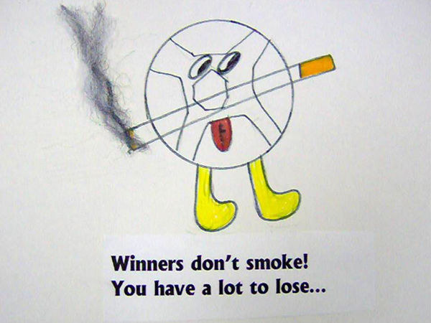



Winners don’t smoke!
You have a lot to lose…

Graphics from Microsoft Clipart
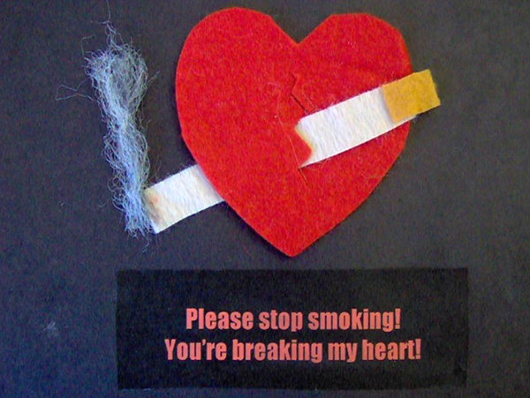

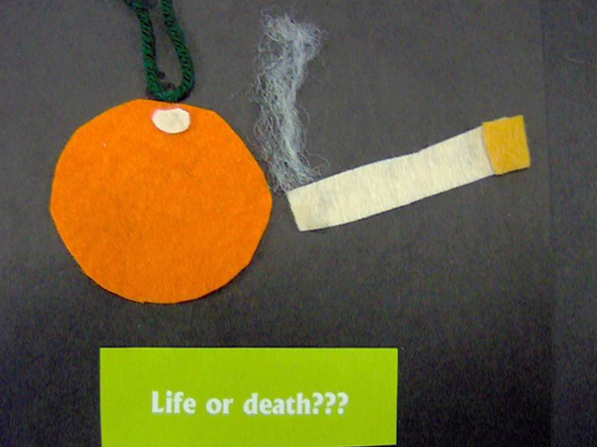



Reach for your goals and
don’t ruin your health smoking
because you have a future
full of great opportunities.
And know that you will win
the trophy of life!

Alcanza tus metas y
no malogres tu salud fumando,
porque tienes un futuro
lleno de oportunidades buenas.
¡Y sabrás que alcanzaras
el trofeo de la vida!

Graphics from Microsoft Clipart


I love you Daddy.
Please don’t smoke!
I don’t want you
to get sick.


Photographs from Microsoft Clipart

Appendix E
Use the Medical History form
to answer the following questions:

1. Which question refers to heart disease?
- 1
- 5
- 11
- 19

2. Which question does NOT refer to lung problems?
- 2
- 3
- 4
- 17

3. Which question would you check YES for it you have hypertension?
- 2
- 11
- 13
- 18

4. Emphysema, bronchitis, asthma, and smoking affect which organ in the
body?
- Kidney
- Lung
- Brain
- Liver

5. List three possible causes of heart disease:
_______________________________________________________
_______________________________________________________
_______________________________________________________

6. Circle the 5 major causes of death in the United States:

Diabetes COPD/lung disease Cancer
Pneumonia Asthma Flu
HIV/AIDS Heart Disease Stroke

