Past Influences on the Present

Your tribe’s final challenge is to explore ways that
survival in North Carolina today is influenced by United
States history, government, and geography.

Your tribe will focus on tobacco. Your survival tools are education, discussion, and writing.

Survival Plan: From Peace Pipe
to Smoke Free: a Timeline of Tobacco
By Tammy Griffin, Eyda Bennett, and John Anderson
Wilkes Community College
Moravian Falls ESL Class

Background

Level: Our class consists of beginning, intermediate and advanced students. The majority of the research in this project was done by the intermediate and advanced students. Beginners participated in and contributed to class discussions, sorted events chronologically, and shared personal experiences.

Objectives: Students will
- research the history, geography, and economy of tobacco in the United States
- develop a timeline showing important tobacco events

Time: Our class meets Monday–Friday for four hours. We spent approximately three hours per week on this project for two-three weeks. (This is a Family Literacy Center, so 90 minutes of Parenting Education and PACT time are included in the daily schedule.)
Education and Action
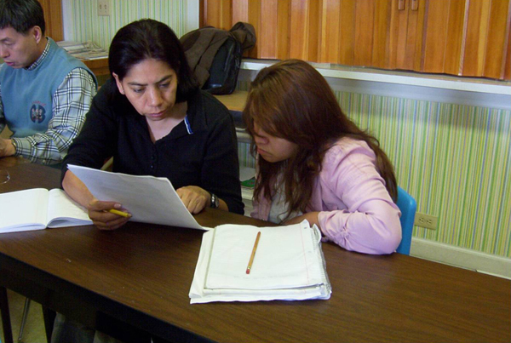

Introduction
Our class had previously completed a project on preventing COPD for which we produced a series of anti-smoking public service announcements. The research and activities we did while completing that project served as the basis for continuing our study of tobacco in the United States.

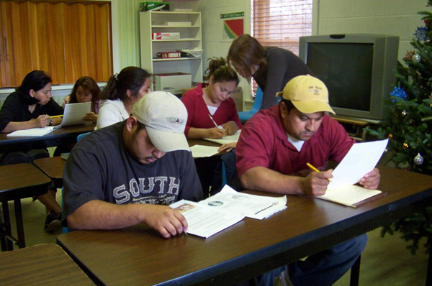

Research
We split the class into three groups. Each group was assigned to focus on one aspect of our tobacco topic:
- history
- economy
- geography

Our students then spent the majority of their time doing internet research on their topics. The class was in the computer lab for thirty minutes to one hour per day in order to get as much information as possible. We, the instructors, assigned a group of websites students needed to view.

The following websites were the main sources of information:
- http://www.tobacco.org/resources/history/Tobacco_History.html - “Tobacco Timeline”
- http://sftfc.globalink.org/economy.html - “Tobacco’s Impact on the Economy”
- http://etc.usf.edu/maps/pages/2000/2080/2080.htm - Map: “Tobacco Production in 1910”
- http://www.unctv.org/ncdependence/history.html - UNC-TV’s Timeline, “North Carolina’s Dependence on Tobacco”
- http://academic.udayton.edu/health/syllabi/tobacco/history.htm “History of Tobacco”
Other internet sources included
- Wikipedia (http://www.wikipedia.org) Use the search terms “tobacco,” “tobacco industry,” and “history of commercial tobacco in the United States”
- Historic Jamestowne http://www.nps.gov/jame/historyculture/tobacco-the-early-history-of-a-new-world-crop.htm - “Tobacco: The Early History of a New World Crop”
- Section on “Supply” (pgs 3-4) in article “Commodity Profile: Tobacco” at http://aic.ucdavis.edu/profiles/Tobacco-2007.pdf
- Centers for Disease Control
1) “History of the Surgeon General’s Report on Smoking and Health” at http://www.cdc.gov/tobacco/data_statistics/sgr/history.htm.
Also, starting at http://www.cdc.gov/, click on Healthy Living and then click on Smoking and Tobacco Use to explore a variety of smoking topics and publications.
2) For background information on secondhand smoke, go to http://www.cdc.gov/tobacco/secondhand_smoke/index.htm.
- U.S. Environmental Protection Agency (http://www.epa.gov/). Use the search term “secondhand smoke”.

Impromptu Discussions
As we looked at the online information, impromptu discussion topics came up, such as, "Have any of you smoked?” “Did tobacco advertising influence you, or did family and friends influence you?" We also talked about how science had discovered a link between tobacco and cancer and other health related illnesses in the late 1800s and early 1900s. Many of the students were surprised at how early this link was found and how tobacco users had ignored these findings.

We used the students’ research as a basis for instruction in vocabulary and language skills, and also as a platform for talking about U.S. history and culture. We strongly recommend that other instructors pursuing this same activity allow extra time and be prepared to deliver impromptu “pop-up” lessons throughout the research, as we feel that the teaching based on student questions at the moment of discussing the content were very effective learning experiences.

Planned Discussions
Throughout this project we also had “planned” class discussions on the questions shown below. Our intent was to help relate the information that students were finding to their own lives, and to stimulate them to think critically about the issues.

Discussion Question 1
How does tobacco affect you and your family?
Responses
The students’ answers centered around three things:
--having to deal with smoking at the workplace
--worries about peer pressure on our children
--effects of passive smoking

Discussion Question 2
In your opinion, should tobacco companies be held liable for tobacco-related deaths?
Responses
Class opinions were split:
--The majority of the students answered yes to this question, stating that the companies knew the addictive and dangerous nature of nicotine and other additives.
--However, there were a few students who said no. These students felt that we all should be held accountable for our choices.

Focus Questions
To bring attention to their current surroundings, we asked students to look for answers to the following questions:

- What part of the USA raises and processes tobacco?
Answer primarily North Carolina, Virginia, and parts of Kentucky
- What state has been and remains the largest producer of harvested tobacco acreage?
Answer North Carolina ranks number one in the production of tobacco
- What part of North Carolina’s economy is/has been dependent on tobacco?
Answer tobacco employs about 255,000 people in North Carolina
- Who benefits when you smoke?
Answer tobacco companies (students’ opinions)

Timeline
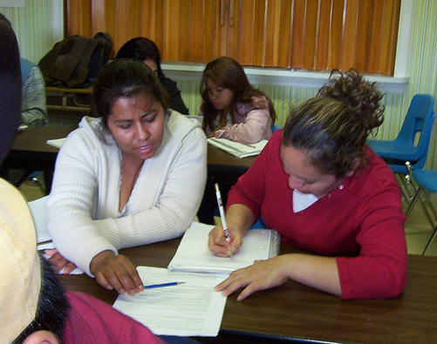
After students found pertinent information, we decided as a class on the most important tobacco-related events to include. Then we began to combine and organize these events into a timeline format. This part of the project was quite time-consuming. We asked students to put the events into chronological order. They worked in small groups to accomplish this task.
When students were satisfied with the final content, instructors typed the timeline for class display, using a free template that is available for download at http://office.microsoft.com/en-us/templates/TC010162651033.aspx?CategoryID=CT101172751033.
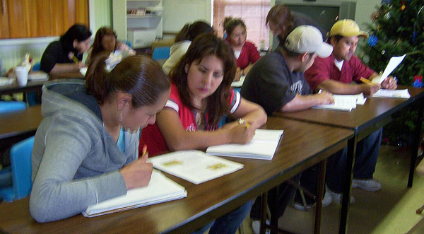

Results

We Met Our Challenge!
Our tobacco timeline is shown in the accompanying document.

Teacher Observations
All of us (instructors included) learned a great deal from researching this project. Only about 5 percent of our students smoke, but those few voiced to us that they were going to stop smoking because of what they have learned from this and the anti-smoking Public Service Announcement project. The others expressed a strengthened resolve to never smoke and to influence their children to never smoke.
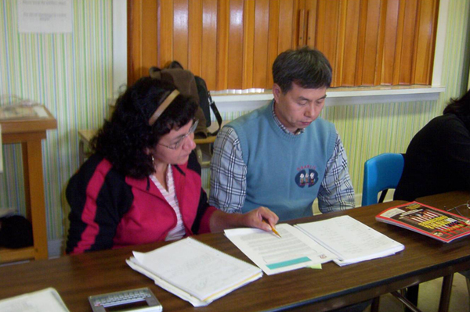
In addition to learning factual information, the students gained valuable experience in internet research, individual and group learning, and project-based learning, all useful to adult students. All of us agree that the projects were unique educational experiences which were very rewarding and worth-while.

