Prevention Strategies

You can do three things to help prevent the main causes of death in North Carolina. You can exercise, eat right, and avoid smoking. Your tribe must exercise to survive. As always, your survival tools are education and action.

Your challenge is to introduce walking as an effective physical activity. Research shows that 90% of adults can prevent weight gain by increasing daily physical activity by just 2,000 steps and eating 100 fewer calories¹. Losing as little as 5% to 10% of total weight can significantly improve health².

___________________
¹Hill JO, Wyatt H, et al. Science, vol 299: February 7, 2003.
²Diabetes Prevention Research Group. JAMA, vol 346, no 6: February 7,

Survival Plan: Make a
Motion Commotion
By David Whitehead
Alamance Community College

Before Beginning

Level: My Intermediate/Advanced ESL class carried out this survival plan (aka project plan), but it can be adjusted for other levels.

Objectives: Students will
- learn how to use walking as an effective activity to prevent weight gain and improve physical health,
- interview classmates about their exercise habits,
- make a walking plan based on the goal of 10,000 steps a day, and
- keep a walking log.

Time: Our class meets daily (M-F) for three hours. We completed this project in about an hour a day of class time during the first week. In the following week, we used only brief segments of time to allow students to update their walking logs. All students did their walking outside of class time. This project is easily adaptable to a different schedule.

Resources:
- We used the Downtown texbook (Book 3), which has a good unit on health.
- Downtown: Book 3 by Edward J. McBride. Thompson Heinle, 2006. ISBN 0-8384-4380-X. pp.122-127.
- The Oxford Picture Dictionary is another good resource that we used for vocabulary.
- Oxford Picture Dictionary by Norma Shaprio and Jayme Nelson-Goldstein.
Oxford University Press, 1998. ISBN 0-19-435188-2. pp. 74-87.
- We also used Far From Home, a reading text for intermediate level adult students, which has a story about Mario, whose doctor advised him to make changes in his diet and lifestyle.
- Far From Home by William Pickett. Thompson Heinle 2007. ISBN 978-1-4130-1721-2. p.158.

Education and Action

Approach
I incorporated this Survivor challenge into a unit on health and healthcare for my intermediate/advanced ESL class.

Setting Up this Survivor Project
We began by reading “Cholesterol,” a 2-page story in Far From Home about Mario. Mario’s doctor tells him that he must make some changes in his diet and lifestyle in order to lower his cholesterol.

To introduce walking as a fitness activity, we discussed some of the changes that the doctor advised Mario to make. I wrote and added the following sentences to the story, giving them to the students on a handout:

Mario’s doctor advised him to get more exercise and said that walking was a good way to lose weight and improve his cardiovascular health. He gave Mario some information about the health benefits of walking.

According to many health experts, a person should walk about 10,000 steps every day. The average sedentary person walks only 1,000-3,000 steps a day. Mario would like to walk some more, but he works and goes to school so he doesn’t have a lot of time.

Mario goes to English class every morning at Alamance Community College. He got the idea to walk around the building (inside) a few times before class, during the break, and maybe once after class. Perhaps he will walk to Food Lion, buy some fruit for a snack, and then walk back to his classroom. Every week he wants to add 500 more steps.

10,000 Steps
I then handed out copies of 10,000 Steps a Day, a page from The Walking Site at http://www.thewalkingsite.com/10000steps.html.

We used the 10,000 steps paper as a reading/vocabulary activity, and learned these new words and their definitions:
- New Word Definition
- guidelines suggestions
- average typical
- stride length of step
- step distance between your feet when you walk
- sedentary not very active
- goal something you want to do. It is usually difficult and requires a lot of work.
- increase get larger
- pedometer a tool to measure how far you walk
- track to monitor
- physician doctor
- prior to before

I gave students the following questions to answer:

- How many steps is it around this building (inside halls)?

- How many steps is it to the produce section at Food Lion and back? (Our class is located in a shopping center, an easy walk to/from the grocery store.)

- If Mario wants to add 500 steps a day, how many additional times will he need to walk around the building?

- What are some other ways Mario can increase the number of steps he walks every day?

- What are some ways you can increase the number of steps you take every day?

- What are the health benefits of walking?

- Do you think walking or running is better? Why?

Students counted the steps around the building and to Food Lion, and calculated their answers to the questions. (One student’s answers vary from another student’s answers because of the length of their steps.)
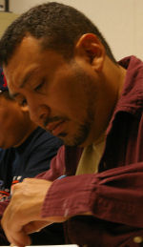
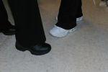

Maria and Delmy model their
walking shoes.

Ignacio calculates the number of trips around the building needed for 10,000 steps.

Exercise Interviews
Students “interviewed” each other to find out about their classmates’ exercise habits and then presented their findings orally to the rest of the class. Students had the option to create their own questions or use the list of suggested questions given below.

Suggested Questions:

- How often do you exercise?
- What kinds of exercise do you enjoy? Why?
- What kinds of exercise do you dislike? Why?
- Why do/don’t you exercise?
- Where and when do you exercise?
- How long have you done this type of exercise?
- Would you like to start exercising, if you don’t exercise now? Why or why not?

Each student interviewed one other student. All conversations, of course, had to be in English!

Moving and Improving
Students who were interested in beginning or improving an exercise regimen made a plan for how to increase their daily steps. One student’s plan is shown below.

My Walking Plan

Ways to increase my steps
- Walk to the mailbox at my apartment. Do not stop in my car before I get home.
- Park far from the door when I go to the store.
- Walk around the building at school during break.
- Walk around my apartment parking lot for about ten minutes in the morning and in the afternoon.

I will try to walk 500 extra steps every day for the next two weeks. This will be 7,000 steps more than I walk now.

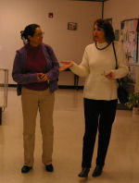
Each student kept a walking log and a record of how far he/she walked over the course of the final two weeks of the semester. Some excerpts from walking logs are given at the end of this project plan. Most students preferred to do their walking away from the class setting.

Milka and Anni make a lap around our building.

We Met Our Challenge!
Excerpts from student walking logs are shown on the final pages of this project plan.

Project Follow Up
Since we did this in the final two weeks of the fall term, I plan to check with the students to see whether they kept walking over the holidays. We will talk about New Year’s resolutions, and about how long it takes to make a lifestyle change!

Teacher Observation
Pedometers would be a fun addition, but they were an unbudgeted expense for our class.

Notes for the Future
Ideally, I would do this over a semester, working with the goal of adding 500 more steps each week to see if we can get to 10,000 steps a day.
Excerpts from Student Walking Logs



I walked yesterday in the Wal mart. I enjoy, but I liked more when I go to the park, because I can to walk and run with my kids without tell me “I want anything!”
–Arminda Isidro

I walked with my daughter and my son yesterday after we eat. We count our steps for 10 minutes, after we did not count more. We enjoyed walking because we were walking together.
–Herminia Cruz

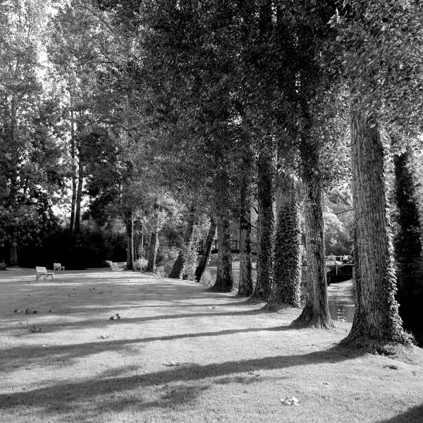

Yesterday, in the afternoon, I walked with my husband in the City Park, close to our home. The day was wonderful, warm, and the trees very pretty, some ones completely red. I love this time of the year because the nature paints the trees with many different colors. I am looking forward to the day my family and my kids can enjoy all this beauty we have in this beautiful country.
–Anni Fonseca-Jordan

