Past Influences on the Present

Your tribe’s final challenge is to explore ways that
survival in North Carolina today is influenced by United
States history, government, and geography.

Your tribe must focus on prayer.

Survival Plan: Heart and Soul
By Scott Crisco
Stanly Community College

Background

Level: My mixed class—consisting mostly of high and low Intermediate students and a few Advanced students—carried out this survival plan (aka project plan).

Objectives: Students will
- become aware of differences in religion in America and around the world,
- explore connections between prayer and healing,
- learn some North Carolina and U.S. geography
- learn that freedom of religion is protected by the U.S. Constitution

Time: Our class meets daily (M-F) for three hours. This challenge took about ten class hours to teach. I divided the activities up into five days so I could also teach other lessons.

Education and Action

Day 1
I began the challenge by asking a series of related questions:
- How many different religions do you know?
- What are the religions in your country?
- Do you practice a religion?
- If you do have a religion, tell the class about it.

I gave the students a handout with the above-listed questions and answer lines to use in making notes (copy attached). We spent about an hour of class discussion time talking about everyone’s religion. Then I had all the students write a paragraph about their religion. If they didn’t practice a religion I asked them to write a paragraph about a religion in their native country. Samples of their work follow this project plan.

Day 2
I listed on the board the different faith groups that we discussed in class the previous day:
- Buddist
- Roman Catholic
- Christian
(The students in my class are natives of Laos, Thailand, Mexico, Honduras, and China.)

I then introduced the word Prayer. I asked the students what this word meant. They were not in total agreement on the definition of prayer: I had “talking to God,” and I had “asking spirits for help.” Accepting their varied understandings of individual communication with the ethereal, we looked at and learned how to use all forms of the root word pray, and I had the students write a sentence with each of these forms:
1. Pray
2. Prayed
3. Praying
4. Prays
5. Will Pray
6. Prayer

Day 3
I started the class off by asking more questions:
- What do you think prayer is?
- Do you pray?
- Do you believe that prayer works?
- Have you ever prayed for yourself or someone else?
- To whom do you pray?
As in Day 1, I gave out a page with these questions and space for the students to take notes.

We used our discussion—especially our thoughts about the third question—to prepare for Day 4, when we would read and think about an article on a study at Duke University.

Day 4
Today I talked with the class about science and religion being linked together in medical research. We looked at a news article from the web site http://abcnews.go.com/print?id=117143. (The article reports a study in which Duke University cardiologists show that patients have better results from heart surgery if they are prayed for, even if the patients do not know they are being prayed for.)

I broke the class into two groups, mixing them so I would have some low and some intermediate level students in each group. Before they began their assignment, I went over a few vocabulary words that I thought the students might not understand. I used my own opinion of the simplest way to describe these words, and I made sure to give at least two examples for each definition. The vocabulary words I selected are:
- journal
- invasive
- cardiac
- stent
- therapies
- prayer
- stress relaxation
- clogged artery
- study
We then talked about where the study in this article was conducted. We located Duke University and the Research Triangle area of North Carolina on a classroom map.

Finally, my two groups began to write a paragraph of six to ten sentences about what this study showed and whether they believed it. Their group paragraphs are given in the pages that follow this project plan.

Day 5
We discussed the meaning and geographical location of the Bible Belt. We spent about an hour preparing to read the definition of “Bible belt” from Wikipedia at http://en.wikipedia.org/wiki/Bible_belt. (If you have difficulty with direct access, go to http://en.wikipedia.org/ and enter Bible belt in the search bar.)
I chose ten vocabulary words from this article for us to discuss.
Bible Belt
conservative
evangelical
dominant
denomination
gradually
mainstream
secular
geography
demographics

After we discussed these ten words I had all the students write a sentence with each word.

We discussed why there are so many churches in the south and how that relates to the Bible Belt. I reminded the class that freedom of religion is protected in the Constitution of the United States of America: The First Amendment says “Congress shall make no law respecting an establishment of religion, or prohibiting the free exercise thereof . . . .”

Surprises
I was surprised at how willing my students were to talk openly about their religious preferences. They seemed eager to talk about prayer and how they incorporate prayer into their culture.
Religions Around the World

- How many types of religions have you heard of? ___________________________________________________________________________________________________________________________________________________________.

- What are the main religions in your country? __________________________________________________________________________________________________________________________.

- Do you practice a religion? If you do what kind? ________________________.

- Can you describe a little about your religion? _______________________________________________________________________________________________________________________________________________________________________________________________________________________________________________________________________________________________________________________.

What is Prayer?

- What do you think prayer is? ____________________________________________________________________________________________________________________.

- Do you pray? _____________________________________________________________________________.

- Do you believe that prayer works? ________________________________________________________________________________________________.

- Have you ever prayed for yourself or for someone else? ___________________________________________________________________________________________________________________________________________________________.

- To whom do you pray? ___________________________________________________________________________________________________________________.
Continued on next page
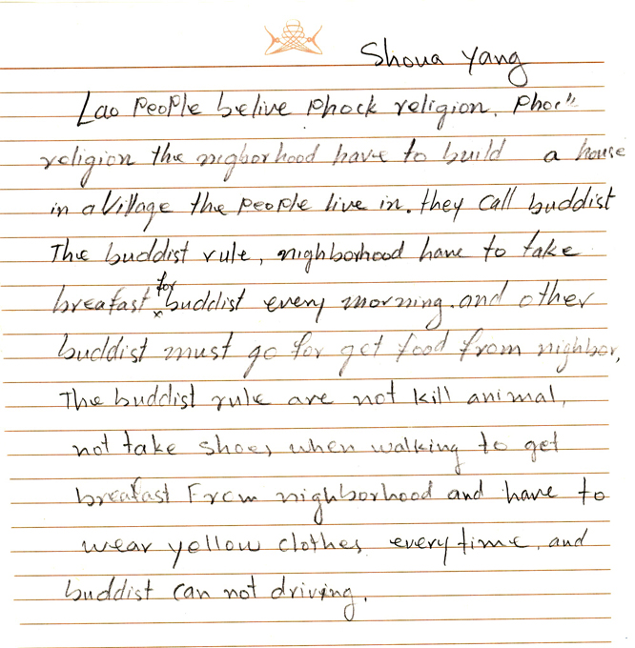

Kong Yayengva is from Laos.
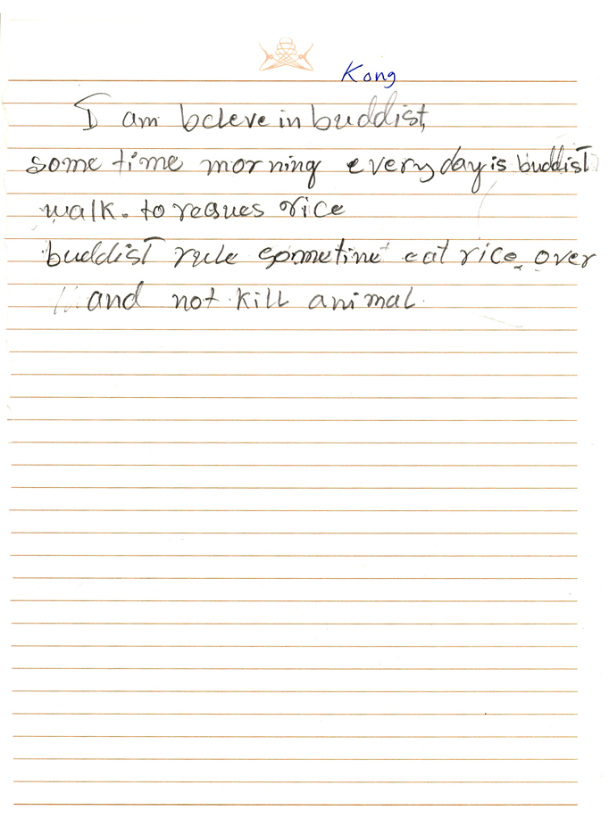

Graphics from Microsoft Office

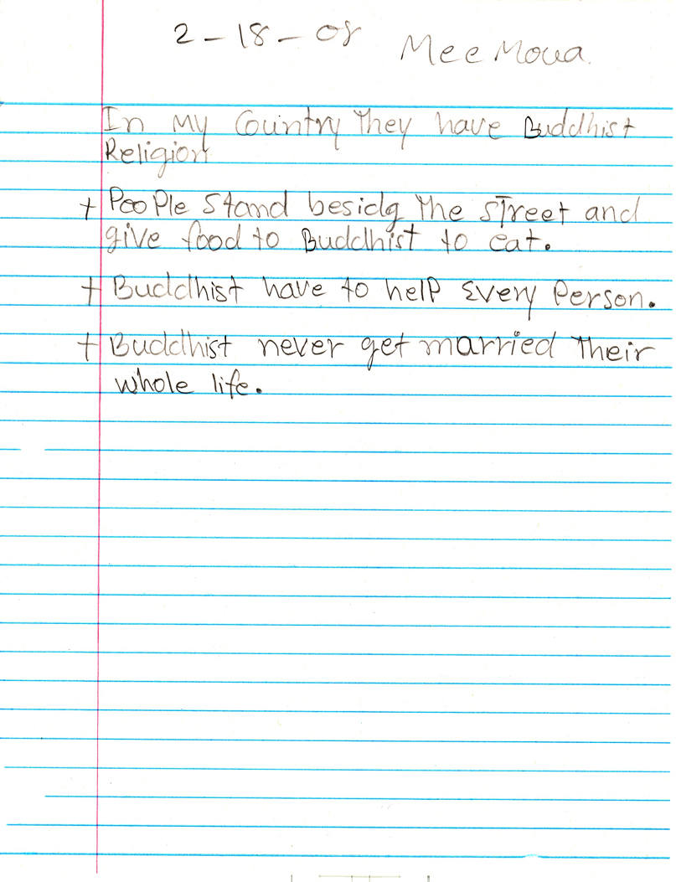
Mee Moua is from Thailand
Graphics from Microsoft Office

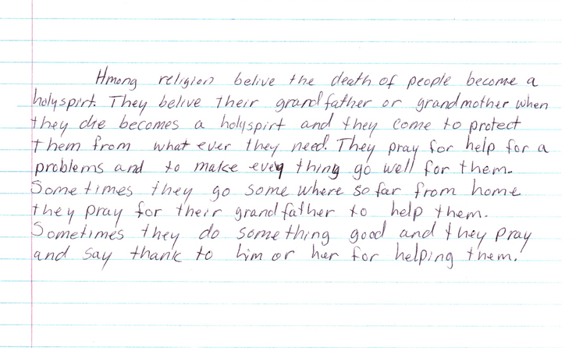
Mor Vang is from Laos.

Graphics from Microsoft Office

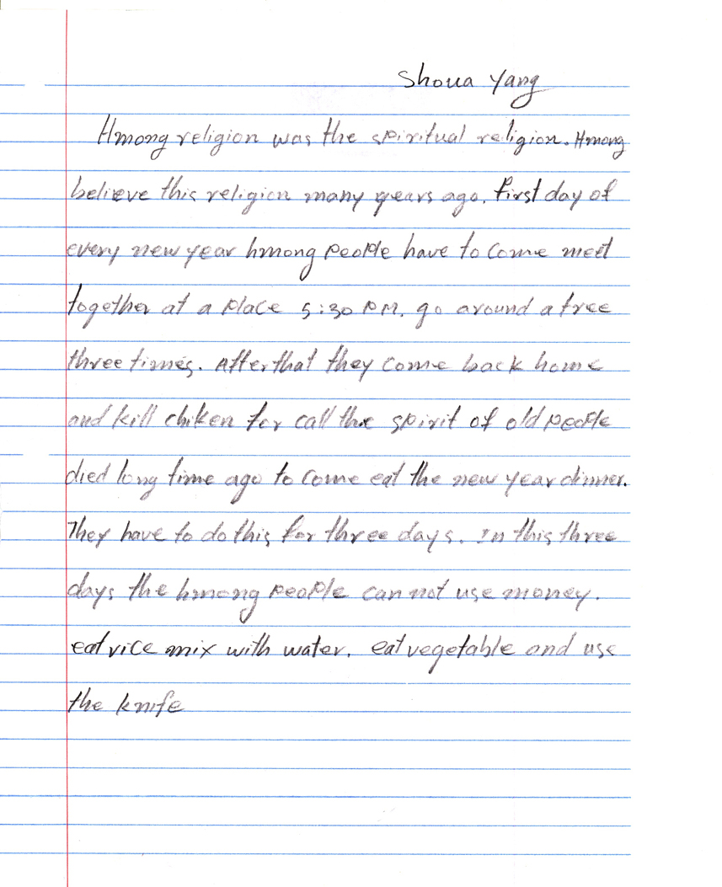

Shoua Yang is from Thailand

Graphics from Microsoft Office
Prayer Helps the Heart

We think prayer works if you do it with faith. If you really believe it, it will work. You have to put your heart and soul into it. It should become a regular practice for doctors who have patients with invasive treatments. Maria says her niece was sick and her brother took her to the doctor. He gave her medicine that wouldn’t work. Later a priest went over to pray, and the girl got better even when the medicine didn’t work. Mee goes to church. At her church they also pray for sick people. She is a Christian. Va doesn’t go to church, but she prays at home. I like going to church. But whenever I can’t go I pray at home. I plan
to teach my kids to pray as well.
Maria, Va, Mee, Dalia

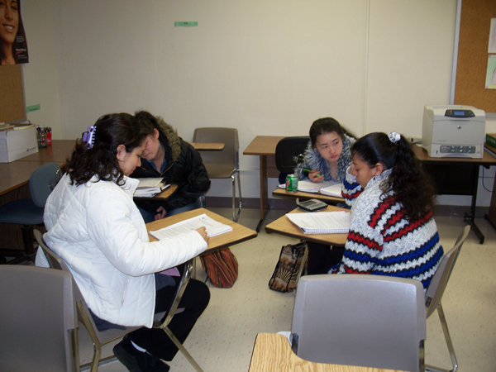
Prayer Helps the Heart
According to the American Heart journal, what we’ve read and understood about Dr. Duke research is that heart problems are very important. Some people can be helped by used a stent to place a clogged artery to hold it open, but mostly heart problems happened from the patient has several thing to think about, so they should be prayer and researched a lot. We were divided into two categories of patients. The patients that had heart problems got better when prayer for them or other. The patient that they have heart shock or other than that, we believe that we can pray and ask God for better health.
Thia, Noe, Kong, Evlin
