Past Influences on the Future

Your tribe’s final challenge is to explore ways that
survival in North Carolina today is influenced by United
States history, government, and geography.

Your tribe will focus on life span. Your survival tools
are education, discussion, and writing.

Survival Plan: Fast Forward
By Annette M. Harris
Central Carolina Community College
Siler City Campus

Background

Level: My Intermediate/Advanced students carried out this survival plan (aka project plan). It is not recommended for lower levels of English competence. Also, students need some prior internet experience before trying this project.

Objectives: Students will
- use the internet for information and interactive activities
- write about the life expectancy of a diabetic,
- assess their own potential life span and give examples of what they need to do now to keep themselves healthy as they grow older,

Time: Our class meets daily for three hours. We completed this project in two class periods or a total of six hours. You can adjust this project to fit your own class schedule.

Education and Action

Activities:
Students searched the Internet (in Spanish) for information about the life expectancy of a diabetic. They took notes and then translated their notes into English to share.

They played The Longevity Game on the following website:
http://www.nmfn.com/tn/learnctr—lifeevents--longevity. They had fun playing it.

They took a test at www.fastfa.com/life.jsp. They took turns reading aloud (translating when necessary) each question in order to focus on reading and comprehension skills. This test gave them the number of years they are expected to live, based on the answers given by the student.

The students wrote three things they felt they needed to be doing now to keep themselves healthy as they grow older. They read aloud to the class their life expectancies and what they needed to do.

Results

We Met Our Challenge!
Samples of student work are included at the end of this lesson plan. Each student’s work has been typed to reflect the spelling, punctuation, capitalization and grammar that they used.

Project Follow Up
Because of the transient nature of our student body, many students who participated in this Survivor challenge may no longer be in my class (or in our school) at the end of the academic year in May when we anticipate some type of a cumulative activity that will recognize and share the work of the whole year. Therefore, I put copies of students’ work for each individual challenge on a bulletin board, both to show the students themselves their accomplishments and to share with other students and visitors.

Teacher’s Notes:

This Survivor challenge was the most difficult challenge of all for me because it was the least structured. (Background note: In the challenge notebook given to instructors, the final challenge offered/imposed the freedom to design both your approach to the assigned topic and the format for your students’ final product.)

I tried to keep it as simple as possible. I kept the focus on diabetes since our tribe had previously worked on that topic. I had the students look at the life span of a diabetic, assess their own potential life span, and self-identify the changes they need to make to live a longer, healthier life.

Life Expectancy of Diabetics

Elder Juàrez Martha Olivares Yolanda Trejo

- The presence of diabetes reduces life expectancy by approximately 8 years compared to non-diabetic subjects at age 50.

- People with diabetes are expected to live shorter lives and the larger proportion of their lives with disability.

- The diabetics are likely to live a higher percentage of their lives with disability.

- For women aged 50, those with diabetes are expected to live on average 21 years.

- People with diabetes will live only 10.6 years.

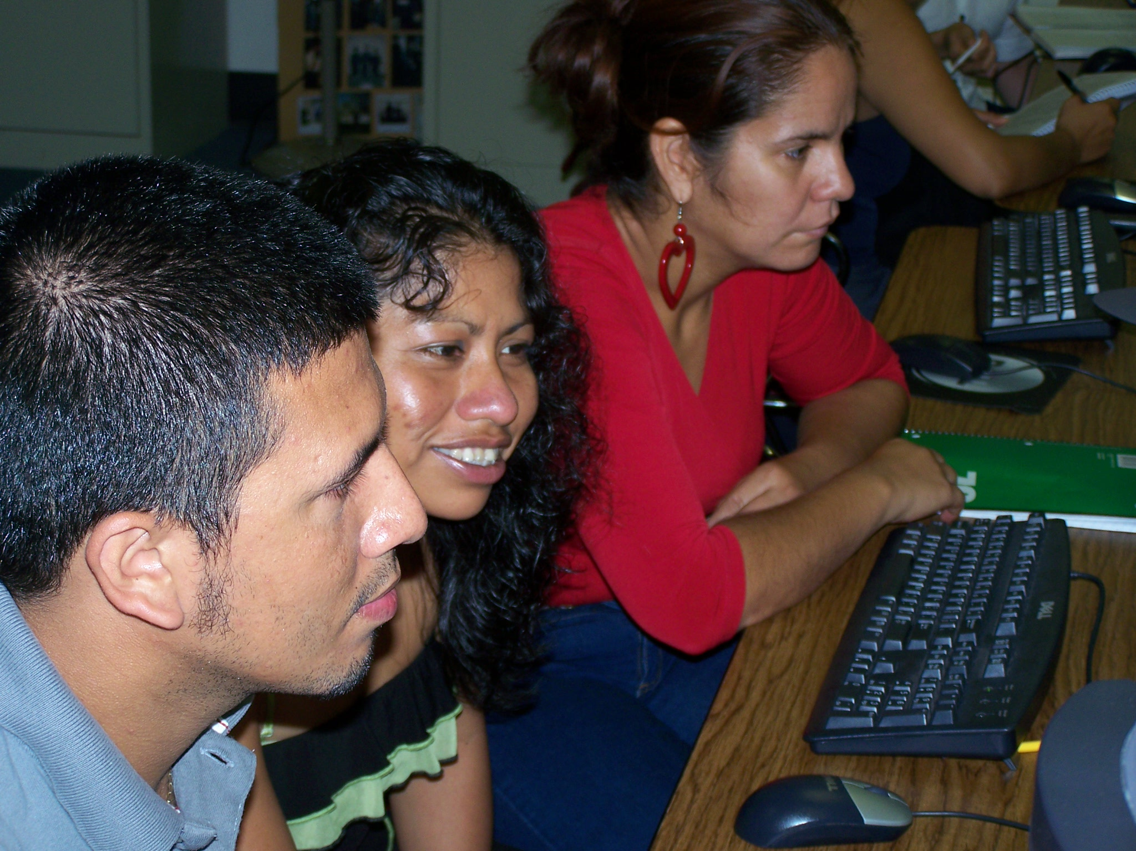

Life Expectancy of Diabetics

Maria Felix Moreno Macaria Nava Adriana Serrano

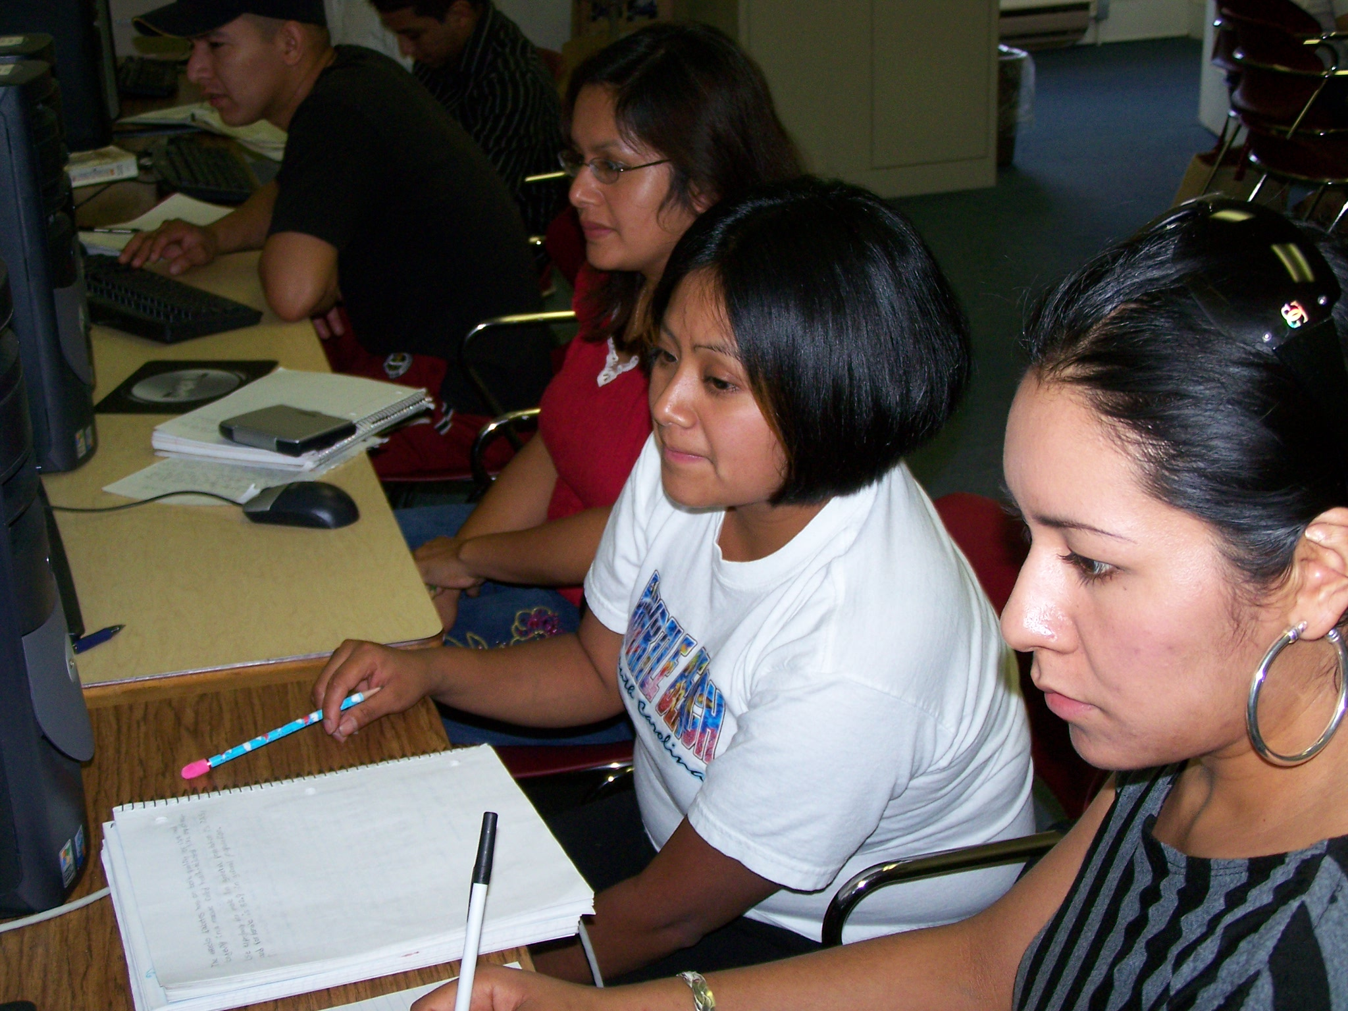

Diabetes reduces life expectancy by seven to eight years.

For men and women aged 50 and older, having diabetes reduced life expectancy by an average of 7.5 and 8.2 years less than nondiabetes.

The life expectancy of African Americans is 73.3 compared with 77.9 for whites.

Life expectancy for male in general population is 77.5 and for female 82.9.

Men and women at age 60 in Mexico City can expect to live about 20% of their remaining years of life with diabetes.

Life Expectancy of Diabetics

Henry Garcia

(center)

- By 2000, more than 171 million individuals had diabetes, a number that is expected to double in 25 years.

- Life expectancy free of cardiovascular disease was reduced by 7.8 years in men and 8.4 years in women with diabetes.

- Among those age 50 and older, diabetic men lived an average of 7.5 less than men without diabetes and diabetes reduced women’s life expectancy by an average of 8.2 years.

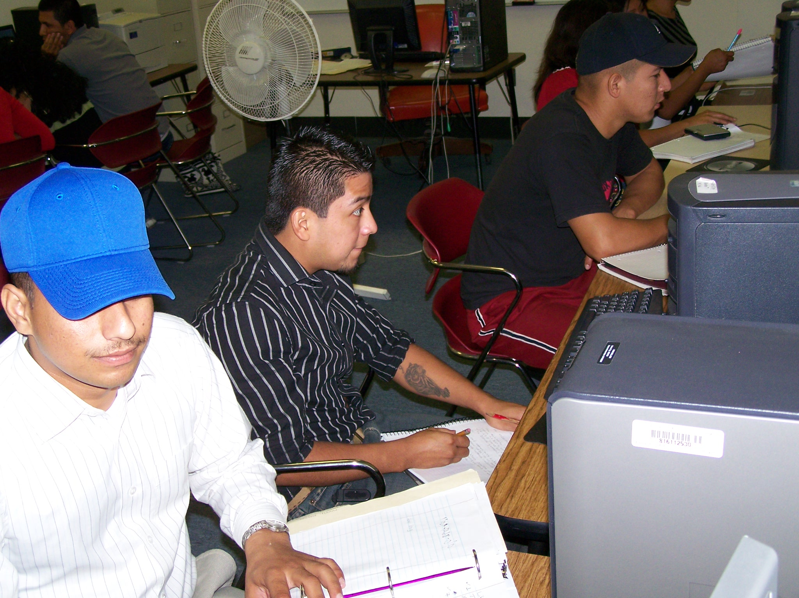

Life Expectancy of Diabetics

Araceli Reyes Olga Reyes Luz Saenz

- When one people have diabetes can live long life only if have one treatment correct.

- If one person have diabetes if change form his live can long the life.

- Today one person with diabetes can realize one life normal some other people.

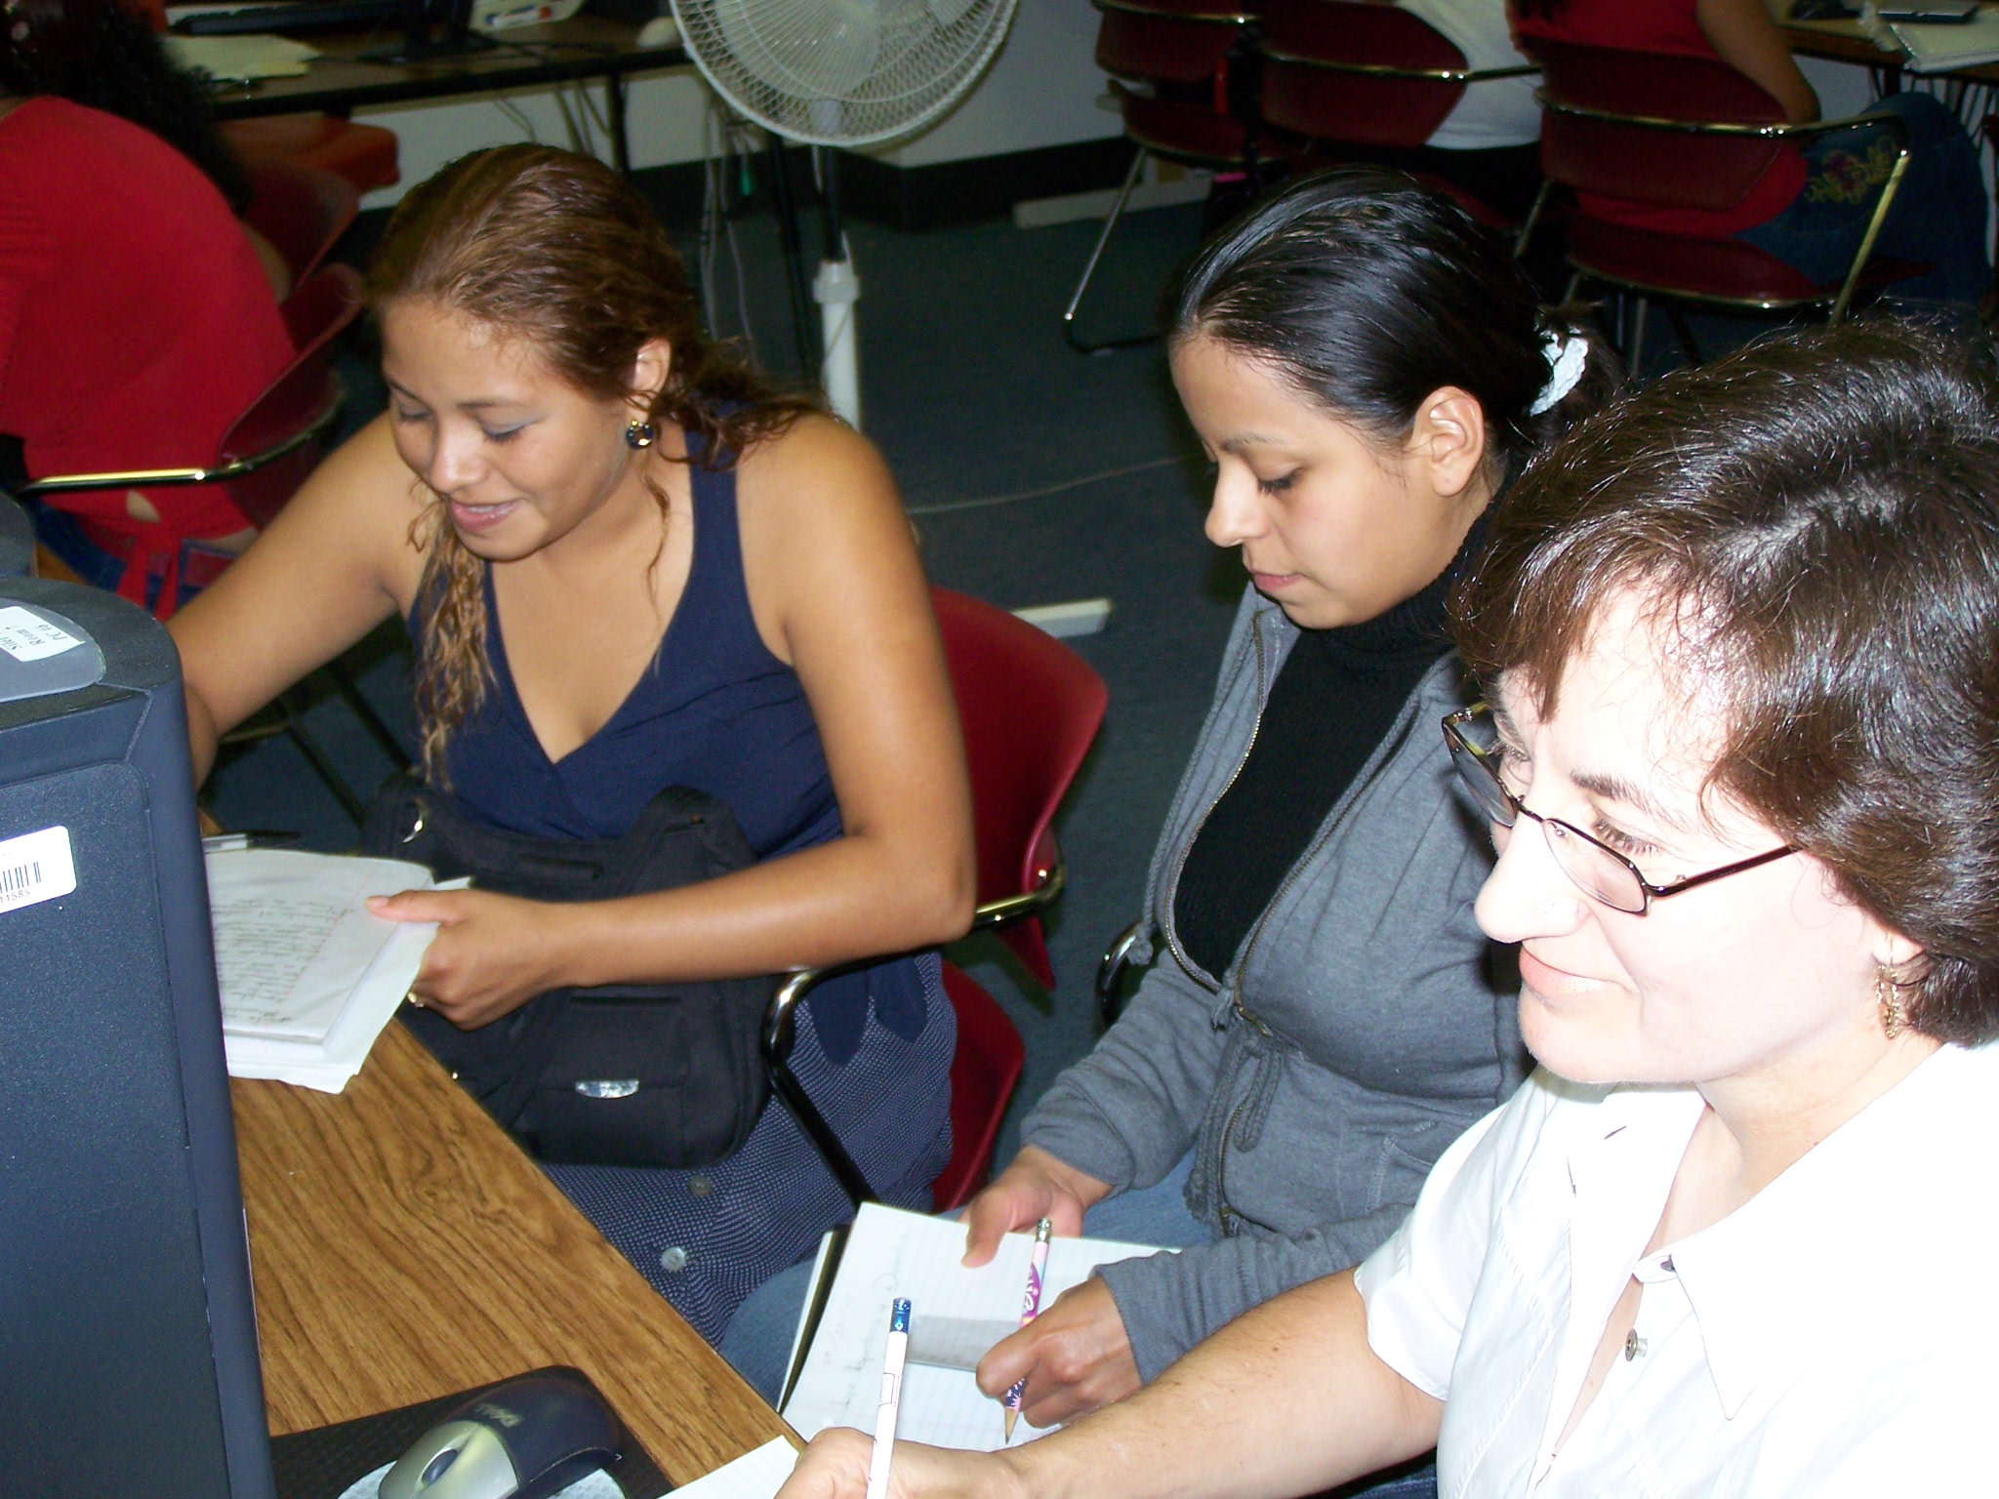

HOW LONG WILL I LIVE?

According to the test at www.fastfa.com/life.jsp, I will live _?_ years.

Here are three things I need to do to keep myself healthy.

Elder Juarez 81.2 years
I need to exercise three time a week, eat vegetables and fruits three time a day, and have a balanced diet.

Martha Olivares Juàrez 85.4 years
I need to do exercises three times for week, drink 8 glasses of water and eat more fruits.

Yolanda Trejo 89.5 years
I need to eat more vegetables everyday, drink more milk everyday, and get more sleep each night.

Araceli Reyes Hernandez 87.5 years
I need to do exercises, eat healthy food, and drink less sodas.

Luz Zulema Saenz 85 years
I need to get more sleep each night, eat more vegetables a week, and stop the sugar.

Henry Garcia 86.9 years
I need to eat more vegetables to get more healthy and do exercises about 3 times a week. I eat vegetables once a while and need to stop eat like McDonald’s and I need to walk about 15 minute everyday.

Maria F. Moreno 90.7 years
I need to eat much vegetable and eat less refined sugar. I cook with much oil. I need to eat more healthier.

Macaria Nava 89.4
I need to get 30 minutes exercise every day, change my daily food, and eat more vegetables and fruits every day and less fast foods.

Adriana Serrano 95.4 years
I need to drink more water, exercise more times, and eat more fruits.

Miguel Angel Cortez Tlapa 86.2 years
I need to eat less sweet bread, exercise everyday, and eat a balanced diet.

