Cancer
THE NUMBER TWO KILLER IN NORTH CAROLINA

Your tribe must survive cancer by using the tools of education and action.

Your challenge is to design informational highway billboards about lung cancer.

NOTE: Lung Cancer is the leading type of all cancer deaths in the United States. Tobacco (smoking and secondhand smoke) is the primary cause of lung cancer, so this instructor creatively adapted his tribe’s challenge to maximize two local opportunities:
- His campus is going smoke-free!
- His school allocated a bulletin board so ESL students could carry their project to completion, whereas billboard ads could be designed but not executed.

Survival Plan: The BIG Message
By Scott Crisco
Stanly Community College

Background

Level: My class is a mix of intermediate and low-intermediate students. An instructor can adjust this project satisfactorily for other levels of English competence.

Objectives: Students will
- explore some basic materials and concepts of advertising
- design and create a bulletin board about how to stop smoking

Time: My class meets Monday through Thursday, for four hours a day. We spent five days on this challenge, using the entire class period on the final day and about three hours a day during the other classes.

Education and Action

Day One
I introduced this challenge by talking about advertising. We identified a variety of advertising formats: magazines, TV, radio, billboards, and bulletin boards. I distributed the Handout Understanding Advertisements, which follows this project plan, along with some magazine ads for various products. I asked the students to answer the handout questions based on what they thought their ad was advertising. Then I had the students stand up in class and describe what they thought their ad was about.

Day Two
Today I focused on billboard advertising with the class. I showed examples of billboards and talked about how they work. (I just searched the Internet and found billboard companies that had samples of their work.) The students’ assignment for this day was to create a billboard about anything they want to advertise. When they finished, they stood in front of the class, and the class had to figure out what they were trying to say in their billboard ad.

Day Three
I introduced the concept of a “storyboard” and talked about how it can be used to design billboards or bulletin boards to express an idea or opinion. The students’ assignment for the day was to create a storyboard about how they got from their country to N.C. An example done by Phetsamai Vang is shown below. After they finished, each student showed the class his/her storyboard and explained it.

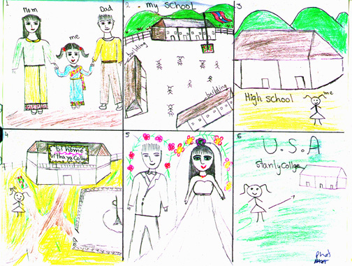

Day Four
This is the day that I combined what students learned from days One-Three and used it to focus students on how to get people to stop smoking. (Our campus is going totally smoke free, so I changed our challenge a little. We could design our own billboard but we couldn’t put our design to practical use, so I received permission from our college to design a bulletin board about how and why you should quit smoking.)

The first thing we did was to go and see the bulletin board that we would be designing. The class took measurements and notes about the size and shape of it. We then toured the rest of the buildings and saw many other bulletin boards on campus to give students ideas on what we had to do. We spent the rest of the class discussing how and what we would do.

Day Five
We spent the whole four hours in class working on the bulletin board. Some students worked on drawing while others cut and measured.
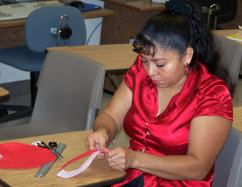
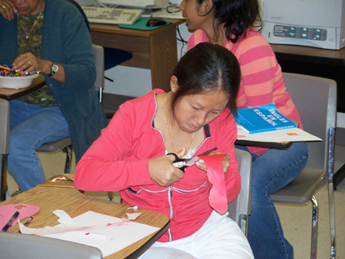
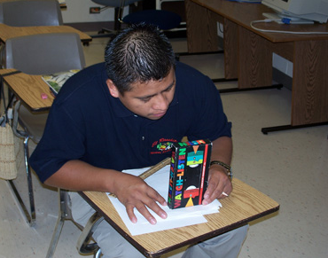
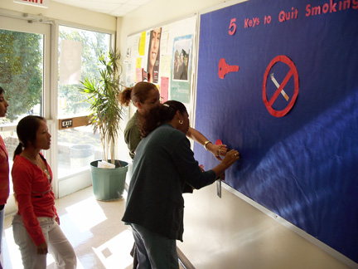

Results

We Met Our Challenge
I was very impressed with the students’ final results, which are pictured on the following page.
Our Project
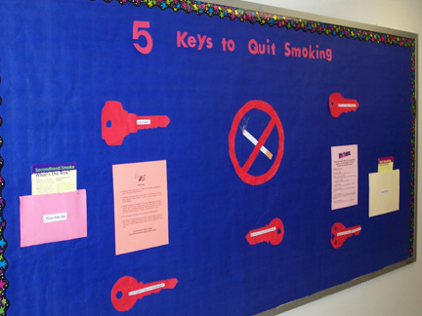
Teacher Observations
The students learned many things while working on this project: teamwork, math, grammar, and designing.
Understanding Advertisements

- What is this ad trying to sell? ____________________________________________________________________________________________________.

- What is the name brand of this product? __________________________________________________.

- What is the target audience they are advertising to? __________________________________________________.

- What do you like best about this ad? _______________________________________________________________________________________________________________________________________________________________________________________________________________________________.

- What don’t you like about this ad? ________________________________________________________________________________________________________________________________________________________________________.

- Do you or have you ever used this product? _____.
If so, did you like it? _________.
Would you buy it again? _____.
Why or why not? ________________________________________________________________________________________________________________________________________________________________________.

- What are some vocabulary words you learned from this ad? ________________________________________________________________________________________________________________________________________________________________________.

