Dream Trips
Carolyn Ashford-Works
Central Carolina Community College
Chatham County Campus

Lesson: Using a photo for inspiration
Topic: Vacations
Level: Good for a mixed-level or combination class

Students were freely able to work alone or use a partner in this writing project.

DAY ONE

- Students were asked to select a photo or picture from a teacher-assembled notebook containing divider tabs for (1) travel, (2) national landmarks, and (3) land and seascapes.

- Students were allowed to look up elements in their chosen picture that appealed to them using a Spanish-English/English-Spanish dictionary.

- Students were given time to write five or six short sentences/phrases on their desire to vacation there.

DAY TWO

- Corrections were done with one-on-one conferences. Correction sessions included praise for accomplishments.

- A class lesson was held on the excessive and inappropriate use of the word “the.”

- Students did a re-write, making their corrections.

- Students then showed their picture and read their work to their classmates.

A sample of students’ work is given on the following pages. The handwritten student submissions have been typed and graphics from Microsoft Clip Art and Media at www.office.microsoft.com were substituted for the original photos to comply with copyright law.

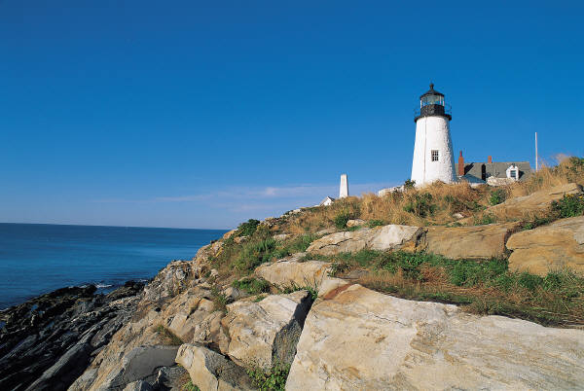

VACATION AT THE LIGHTHOUSE

By

Victoria Maldonado

I would like to vacation in that place.
I want to know about the lighthouse.
I would like to travel with my family.
I want to know about the rock.
I like to be at the beach.
I like to fish with my son.

_____________
Vicky Moldanado is a Beginning ESL student. She comes from Vera Cruz, Mexico. Married for eight year, she has lived in Siler City the whole time. She is a housewife who is looking for a job in the area. She and her husband have a seven-year-old child. Her husband has a small band that specializes in Latino dance music. He is also a professional truck driver.

Graphics from Microsoft Clip Art and Media at www.office.microsoft.com
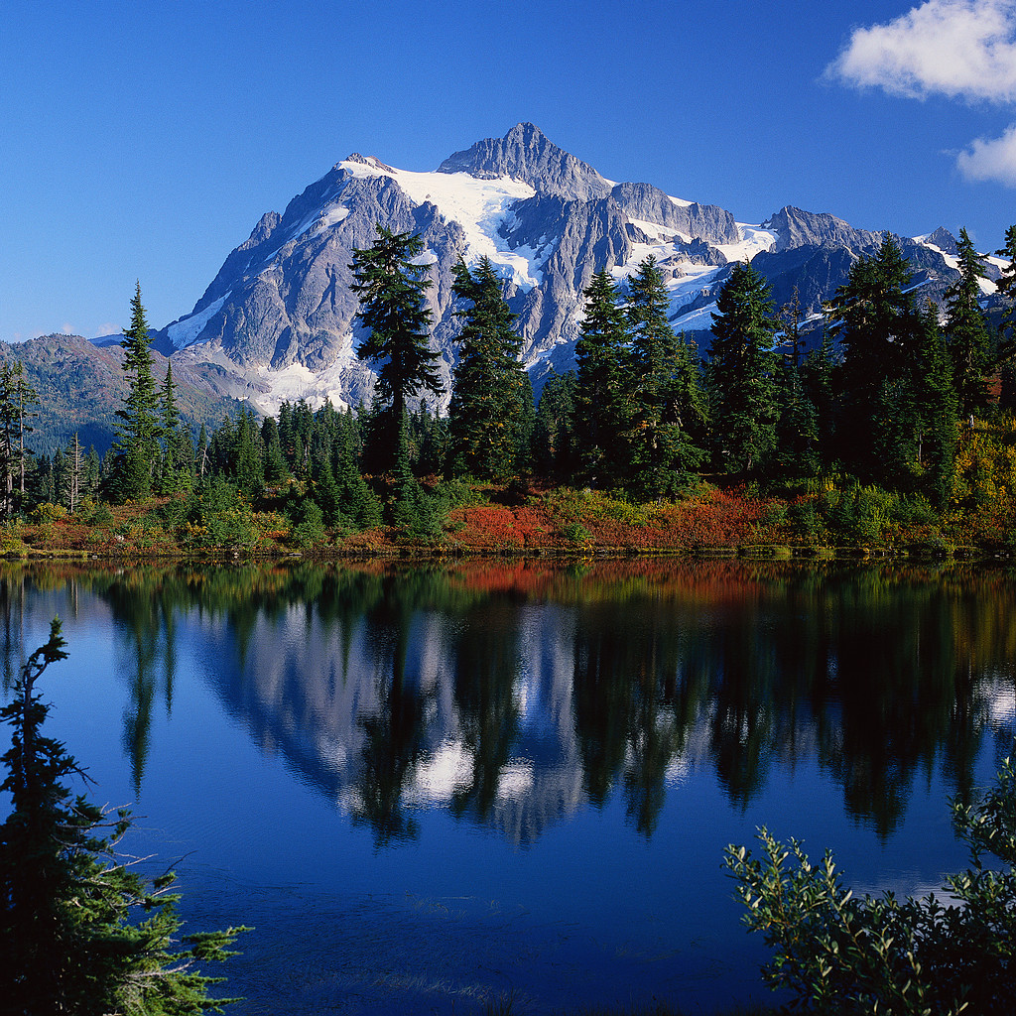

MOUNTAIN LANDSCAPE

By
Giovvana Utrera

I like to travel in the vacation to that place.
I like to know the mountains with snow. I like to walk in the snow from the mountains.
I like to see the landscape, the trees and other plants.
I like to hike for the mountains and to see the reflection from the trees in the lake.
I like to look at the big blue sky.
I like to explore every thing from that place.

______________
Giovvana Utrera, a Beginning ESL student, is sixteen years old and attended the class while she visited her aunt and cousins in Siler City. Her mother, father, sister, and brother recently moved to Winston Salem, where she will be attending school in the fall semester.
Graphics from Microsoft Clip Art and Media at www.office.microsoft.com


OUR VACATION IN PARIS

By
Alma Valerió Perez

I would like to travel to Paris. I would like to visit there because I hear that it is very romantic. My husband and I are very romantic. He would like to visit Paris because he likes landscaping. Once, he took my hand and said, “We are going to see the world.” We need to travel and enjoy life. When we stay in Paris, we are going to the movies; we are going out to eat, and we are going dancing at night. Also, we are going to visit the museums and ask which other places we should see. When we have used up almost all our money, we have
to return to Mexico!

_____________
Alma Valerió Perez has been in this country one year and four months. She is from Puebla, Mexico, where she earned a degree as an industrial engineer. Her husband studied law in Mexico for two years, but the two of them decided to move here to study English. They were married just before moving to Siler City. Alma is in High Intermediate ESL.

Graphics from Microsoft Clip Art and Media at www.office.microsoft.com

Mickey Mouse

MY VACATION IN WALT DISNEY WORLD

By
Alma Valerió Perez

I would like to travel to magic “Walt Disney World”. I would like to visit because I like cartoons and stories, for example Cinderella and Mickey Mouse, Daisy, etc. I would like to visit the castle. I want to enjoy the beautiful show of fireworks at night.

I don’t have an idea if Disney World is huge and I don’t know if one day is sufficient for a visit. Also I need to rest and eat. I would like to take pictures and maybe a video tape so that I will have a remembrance and I will show my family my great vacation.

_____________
Alma Valerió Perez has been in this country one year and four months. She is from Puebla, Mexico, where she earned a degree as an industrial engineer. Her husband studied law in Mexico for two years, but the two of them decided to move here to study English. They were married just before moving to Siler City. Alma is in High Intermediate ESL.

Graphics from Microsoft Clip Art and Media at www.office.microsoft.com
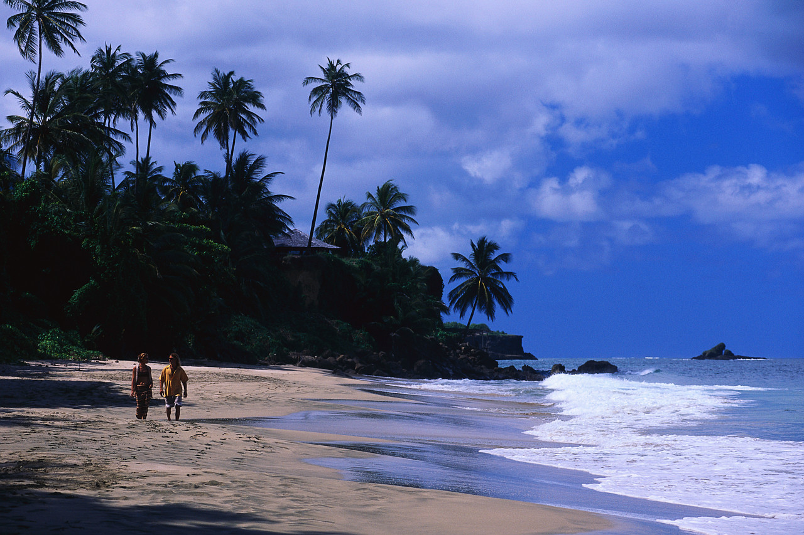

VACATION ON THE BEACH

By
Yolanda Trejo

I would like to go fishing at this place.
I would like to make a sand castle for my baby.
I would like to swim at the beach.
I would like to sunbathe on the beach.
I would like to travel with my family.
The beach is very romantic.
I want to gather shells on the beach.

_______________
Yolando Trejo, from Nayarit, Mexico, has been in Siler City for thirteen years. She met her husband only one month after moving here. They were inseparable—and married four years later. For ten years she worked in a sewing factory making pantyhose, but the factory has closed. Her husband is an auto mechanic, and both have earned U.S. citizenship. She is in the Low Intermediate level of ESL.

Graphics from Microsoft Clip Art and Media at www.office.microsoft.com

