Ten Years from Now
By Zsofi Teleki

Blue Ridge Community College

Topic: My future
Level: My mixed intermediate class has some students at a low level and some at a higher level.
Time: Our class meets for three hours three times a week. We originally spent about one hour on this topic, followed by about a half hour later to recopy.

Background: Original expression is an important part of my classes: I frequently give my students writing assignments that they must compose. Since we write opinions or paragraphs or reports with some regularity, it is usually easy for me to begin by leading students into a discussion on a topic that I have pre-selected.

Approach: In this case, I started out on an altogether different topic from the one shown here. I wanted the students to talk about the differences between their preconceived ideas of the U.S. and the reality that they found.

However, the concept proved too difficult for this mixed-intermediate level group, so I used the part about ideas and reality to springboard into a conversation about the future: We talked about our dreams, both possible and improbable.

I used a silly fantasy I always told my children about how I will be when I am an old lady: When I am old I will wear purple. I will have a long white braid and scarlet fingernails, and I will ride a motorcycle! The students were then able to share their own hopes and desires while we were in this discussion stage.

Writing and Corrections: When we finished our discussion, the students wrote their original versions in class while I walked among them to answer questions and make recommendations. They later made a clean copy of their written, corrected draft, and one student did artwork.

Selected samples of student work are included at the end of this lesson plan, typed to reflect the spelling, punctuation, and paragraphing that the students used. The pictures were taken randomly when I had a camera, but some individuals were shy of having their picture taken, and I respected that reticence.

Surprises and Problems: My big surprise was that students had trouble separating the dream from the reality. Perhaps that is because American movies are often seen abroad, so the dream is often not that different from reality.

Though not exactly a surprise, another problem is that some students can explain quite well verbally but freeze when they have to write.

Notes for the Future: Always keep a back-up lesson plan in mind.

10 years from now.

I will have good health and my family also. Then my hair will change color and my face no change or my body. I have big home and three cars and people to help me for example a cook and housekeeper and a babysitter.

When I have big house my family will live in Mexico. My parent can visit me for a year and more. I am very happy.

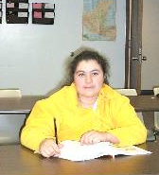

My name is Amada Manzanarez. I from Gro. Mexico. I am 34 years old. My birthday is Sectember 13. I live in Hendersonville for nine years.
10 years from now.

I will have my company about the business advice and the first is my mastery degree in lean manufacturing to keep my family united because is my principal motive. My goal is to marry a good lady and to had a good future. I will buy my big house. Car – my BMW – series M3 color silver blue coupe and my Jeep Wrangler for road dangerous. So for my pretty lady on Rav4 Toyota and after the long time I will have my gym.

Masters degree in lean manufacturing. These degree is about the increes production in all factories and continues improvement.

In the future probably I will have my wonderful house. This house will have 4 rooms and one bathroom with a garage and big yard.

Co. Business advice
The structure in this company is about the skills six sigma, 5’s, lean, SMED, BMEF, BPQP. This company can implement all skills about the continues improvement.

My name is Johnnattan Cantu. I come from Mexico, Monterrey city. My birthday is 5-30-85. I am 21 years old. I was here for 6 months. When I come from Mexico I did not understand anything English.
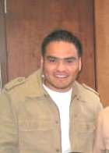

There with my serious and perseverant teacher I can understand English only in 6 months. That’s wonderful. So thanks to all teachers for give me and bring me good attention all time.

Sincerely,
Johnnattan Cantu
10 Years from Now

Before I thinked that the United State was a country without rock and tree.
I thinked that the men wined easy the money.

10 Years from now I will have three big houses and 20 grandchildren.

Too in 5 years I will learn a lot English and also to read English correctly.

Too in one year I will learn me to driven very well. and I will not have afraid for driven.

In 5 years I will go live to better that now. In 5 years I will have a kind of car Toyotta or other kind better.

In one year I will like understand and speak English and also work on the computer.

When I will come here my husband was says you too go with me. And I was dreams come to here. I was have a lot illusion to meet the United State and I came happy with my family. and I like to me here.

When I was girl studied one year to school noting more but I was happy for study since I liked a lot learn to write, to reade but not there teacher in my ranch and I decide learn for meself.

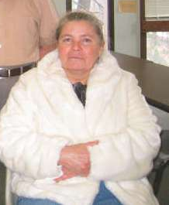

Maria Patino
Birthday – 8/14/54
Place – Guanajuato, Mexico
I have 7 children.
10 Years from now …

My husband and I will make a big party in Mexico for my daughter because my daughter will be 15 years old and will stay in Mexico with my parents. My family will live in Mexico.

My family will work to make big houses for old people and little children because in my country the people are poor.

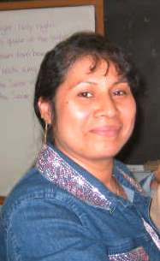

I’m married. My name is Maria Navorina Tuco Pineda. I was born in Guerrero, Mexico. My birthday is January 1, 1976. I have two children, one boy and one daughter. His name is Arnulfo Gutierrez Tuco and her name is Giselle Gutierrez Tuco. My husband name is Alfonso Gutierrez Soliz. I’m happy with my little family. And you?
10 Years from Now

10 Years from now I will be in Mexico and I would like to have a lot of money and have 2 or more cars and a good house to line in with my wife and with my children. I will speak perfect English to teach to my children to speak English to make their English class easy and some day they will be a business man.

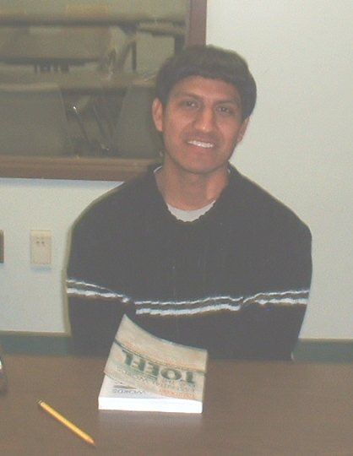

Omar Nolasco.
Born in Mexico 1987.
Work in a factory.
Single
10 Years from Now

I wonder what my life will be like ten years from now. My children will be in college and I will have a nice house and boat. I will be involved with my painting hobby.

My children are in Elementary School right now. They are doing very well in school. When they are old enough to go to college, I hope I will have enough money for their education. If they keep up their grades, they might be able to get a scholarship.

I have always pictured myself in a Victorian house by the lake up north. I will have a big yard that will be the size of a soccer field. My garden will be full of different kinds of vegetables and flowers.

During the summertime, my family and I will take a boat out on the lake. We will enjoy water skiing or fishing. Sometimes we will drive our boat from lake to lake and go camping.

My family and I will be pleased with all the things we will be doing together. My children will be in college, so my husband and I will have more time together. I will live healthy and happy for the rest if my life.

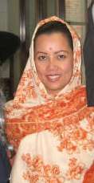

Siriwan DeVere was born in Thailand and is married to an American. They have two children. She obtained citizenship this year and will join her husband in Saudi Arabia.

