Using Writing Models with Beginning Students
By Sarah Drasgow

Alamance Community College

Level: Beginning ESL
Philosophy: Repetition with variety is the name of the game: To integrate new learning without becoming bored or disengaged, beginners need to practice the same concept (1) many times (2) in different ways (3) for short periods at a time.
Time: My class meets Tuesday, Wednesday, and Thursday evenings from 6:00-9:00 p.m., but I use only about 30 minutes of any class presenting writing models. We typically do a practice model daily for two or three days, followed by a final model on a subsequent day.
Objective(s): A specific learning objective needs to be incorporated into the model responses you design for your students. (See the sample prompts that follow this lesson plan.)
Instructor Preparation: Draft a short writing prompt. Then construct a model response of several sentences that uses the grammatical form, sentence structure, or punctuation indicated in your learning objective. Finally, construct several response variations that keep the same basic pattern but change the specific content. Your first model is your writing model; the variations are practice models.
Don’t be afraid to write silly models. Topics should be of interest to students. Both topics and models should be within students’ proximal zone of English development. Otherwise, they are worthless.

In the Classroom

Practice Models: With beginning students, I model a possible response to my intended writing prompt on the board daily for a few days. After each model, students are invited to read aloud from the board. We identify and define new vocabulary. We go through and circle the target form: for example, if I am modeling a prompt designed to elicit possessives, we go through and circle all the possessives, explain why we used the ones we did, and identify which rules apply-- and which exceptions there are, if any. I am fluent in Spanish, and so we next translate orally as a group from English into Spanish.

I do not ask students to write when we are doing practice models, but I invite them to join me at the board. I pull forth their ideas and scaffold them through telling their own story, with me scribing. In this way they get used to seeing their ideas in writing. They also see the way that language changes from its oral to written form.

Practice models are a good way to uncover and introduce any needed new vocabulary. For example, for the writing prompt “Tell me about the people in your family,” I had not taught the terms “housewife” or “stay at home mom” when I covered family terms. However, while modeling on the board, several students discovered that they needed those terms.

I also find it very helpful to model common errors and common writing pitfalls before giving the actual writing assignment.

The Writing Model: When the students are ready to write, I put the final model on the board. As with practice models, we spend about thirty minutes reading, translating from English into Spanish, and talking through the model. This modeling and the clarifying of expectations get the mystery, anxiety, and fear out of the way before students do the actual writing.

After we discuss the writing model, students write their responses to the prompt. Corrections are discussed with the students as they finish writing. Inasmuch as anticipated errors were covered with the practice models, students are very familiar with possible errors; when corrected, they usually respond with, “Oh. I told myself I would remember that!”

Sample Writing Prompts: Three samples of writing prompts that I used are given on the following pages, each with some illustrative student writing done in response to the prompt. The students’ work was submitted in handwritten form but has been typed for this lesson plan. Initial and corrected versions of each student’s work are shown.
Sample Prompt 1

Lesson Objectives: Increase student facility with
- possession
- third person present tense
- family vocabulary

The Writing Prompt: Tell me about the people in your family.

The Model Response: During the class period when the student writing is done, I put this final model on the board:

My mother’s name is Stephanie. She lives in Louisburg. My father’s name is Erik. He is a professor. He lives in Columbia, S.C. My sister’s name is Emma. She is a librarian. She lives in Raleigh with her boyfriend. My brother’s name is Joshua. He is a soldier. I have six cousins. One of my grandmothers is still alive, and one of my grandfathers too.

Student Writing: Samples are shown on the following pages.
Sofia Espinosa

Initial Version
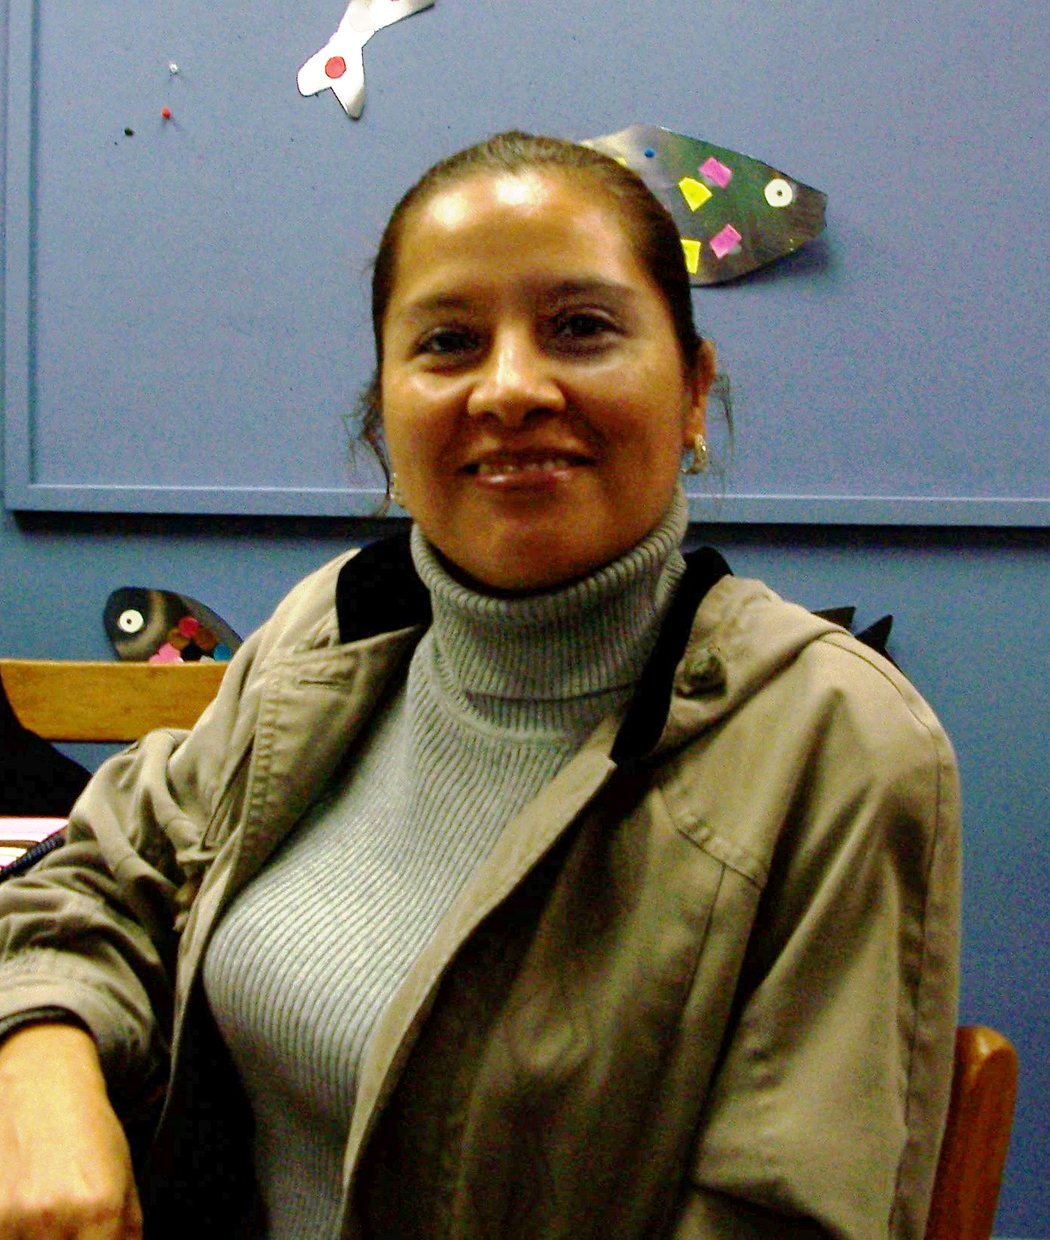
My mother’s name is Elva. She lives in Mexico City. She work in the hospital of a secretary. My father is name is Ramon. He is a painter. Her lives in Veracruz, Ver. My sister’s name is Genoveva. She lives in Burlington N.C. with her son. My brother is name is Ramon. He is lawyer. He have her office in Monterrey, N.L.

With Corrections
My mother’s name is Elva. She lives in Mexico City. She works in the hospital as a secretary. My father’s name is Ramon. He is a painter. He lives in Veracruz, Ver. My sister’s name is Genoveva. She lives in Burlington N.C. with her son. My brother’s name is Ramon. He is a lawyer. He has his office in Monterrey, N.L.

_____________
About the author: My name is Sofia. I am from Mexico. I have lived here for 6 years.
Rafael Ramirez

Initial Version
My mother’s name is Rosa. She lives in Salvador. She is housewife. My father’s name is Roberto. He live in Salvador too. He is electrician. My sister’s name is Dora. She live in Washington with her husband. They are working in restaurant.

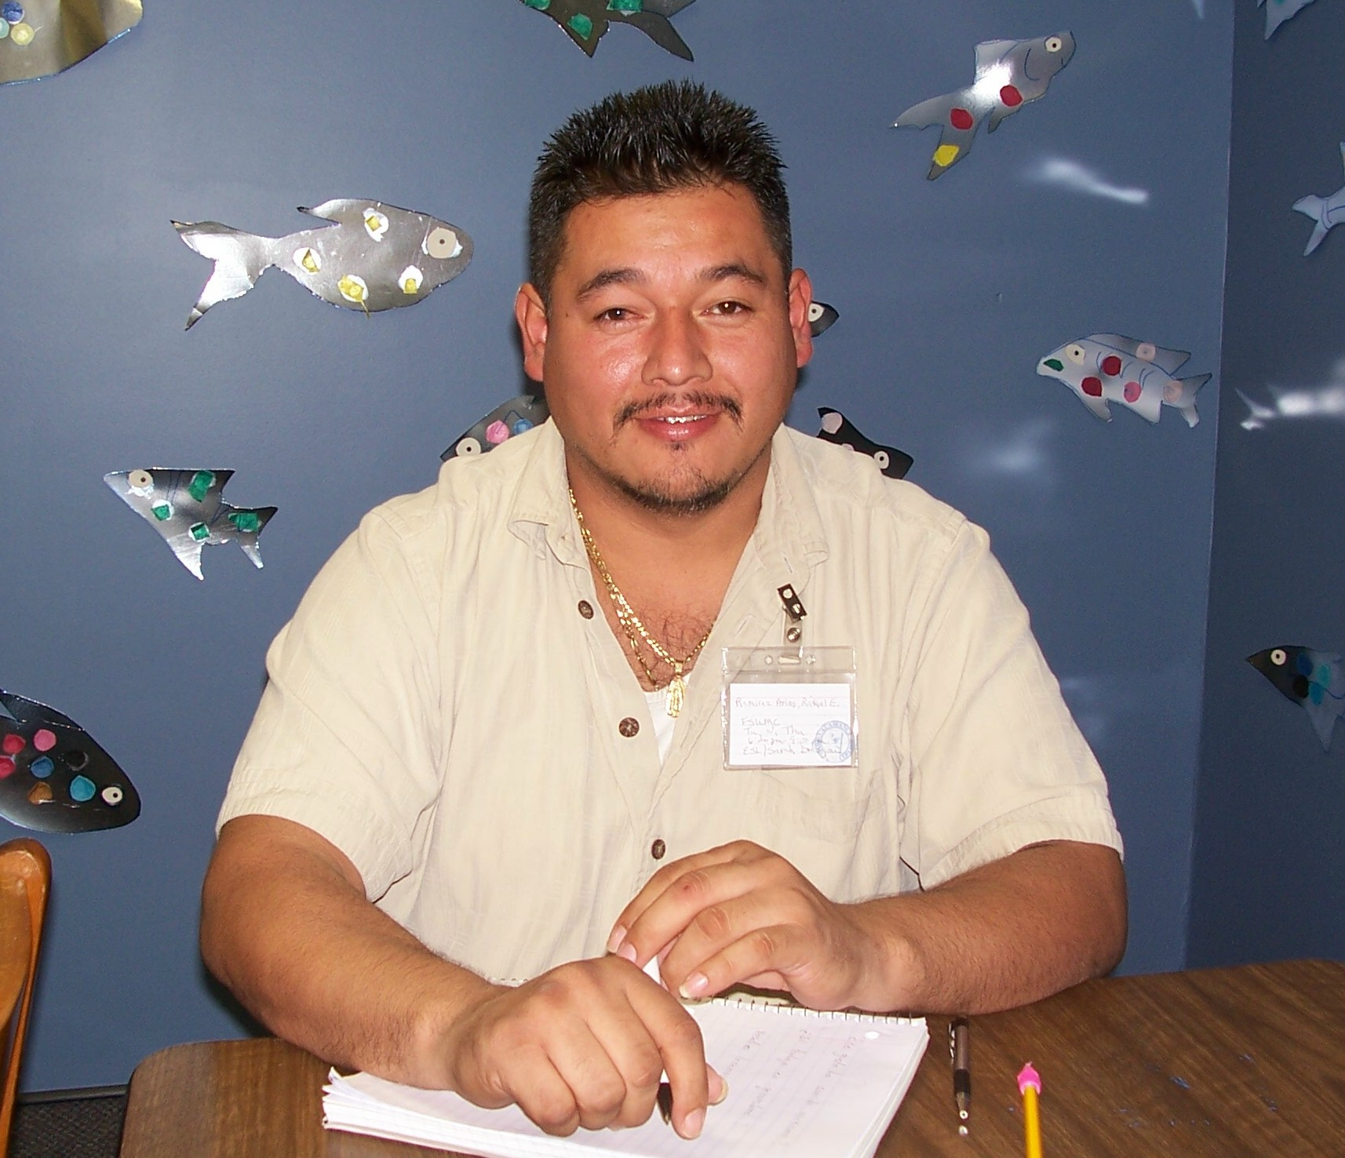

With Corrections
My mother’s name is Rosa. She lives in Salvador. She is a housewife. My father’s name is Roberto. He lives in Salvador too. He is an electrician. My sister’s name is Dora. She lives in Washington with her husband. They are working in a restaurant.
_____________
About the author: My name is Rafael. I am from Salvador. I have lived here for 8 years.
D. Catalina Pena Guzman

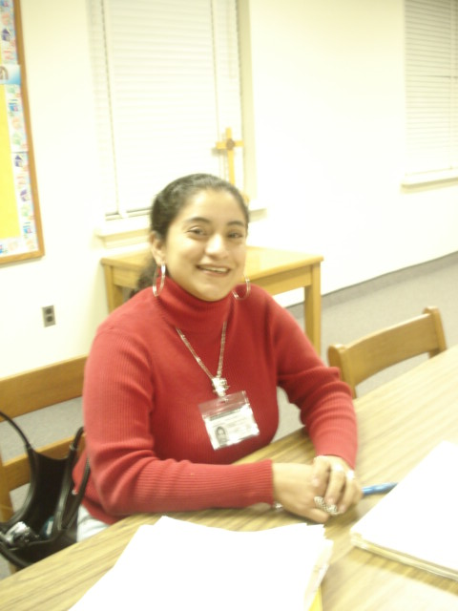
Initial Version
My mother’s name is Guadalupe. She lives in Mexico. My father name is Jesus. He was electronics repairman. He are died. My sister’s name is Elena. She live in Las Vegas, Nevada with her family. My brother’s name is Eusebio. He is Capitan. I have 5 nephew and one niece. My other brother is Elias. He live in Burlington. He is landscaper. His very fanny. I have other brother. He is very good student. He live in Las Vegas, Nevada. My children’s have 12 and 8 years. Their names is Jonathan and Hugo. I love them.

With Corrections
My mother’s name is Guadalupe. She lives in Mexico. My father’s name is Jesus. He was an electronics repairman. He died. My sister’s name is Elena. She lives in Las Vegas, Nevada, with her family. My brother’s name is Eusebio. He is a captain. I have 5 nephews and one niece. My other brother is Elias. He lives in Burlington. He is a landscaper. He is very funny. I have one other brother. He is a very good student. He lives in Las Vegas, Nevada. My children are 12 and 8 years old. Their names are Jonathan and Hugo. I love them.
Sample Prompt 2

Lesson Objectives: Increase student facility with
- pronoun + is/are + verb + ing
- descriptive vocabulary

The Writing Prompt: Imagine you are on a wonderful vacation. Tell me what you are doing.

The Model Response: During the class period when the student writing is done, I put this final model on the board:

I am on vacation in Asheville. It is cool and the mountains are beautiful. I am with my family.

My cousins are singing and playing the guitar. My sister is drinking beer with her boyfriend. I am looking at the mountains.

The restaurants are small and interesting. The people are friendly. The hotel is clean. We are having a good time.

Student Writing: Samples are shown on the following pages.
Santos Zepahua Xotlanihua

Initial Version

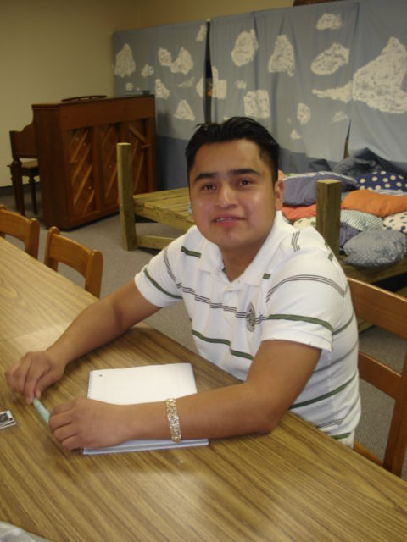
I am on vacation in Ajusco, Mexico. It is hot and the ground. My mother are fixing the kichen. I am right now I’m looking the ladies.

With Corrections

I am on vacation in Ajusco, Mexico. It is hot on the ground. My mother is fixing dinner in the kitchen. Right now, I’m looking at the ladies.

About the author: My name is Santos. I am from Mexico. I have lived in the United States for 6 years.
Enrique Gonalez

Initial Version

I am fishing in Birginia on the lake with my friend, and we catching many fish. But it’s very cold and we are very happy but in fact, very very good time. We thing we will return, next year.

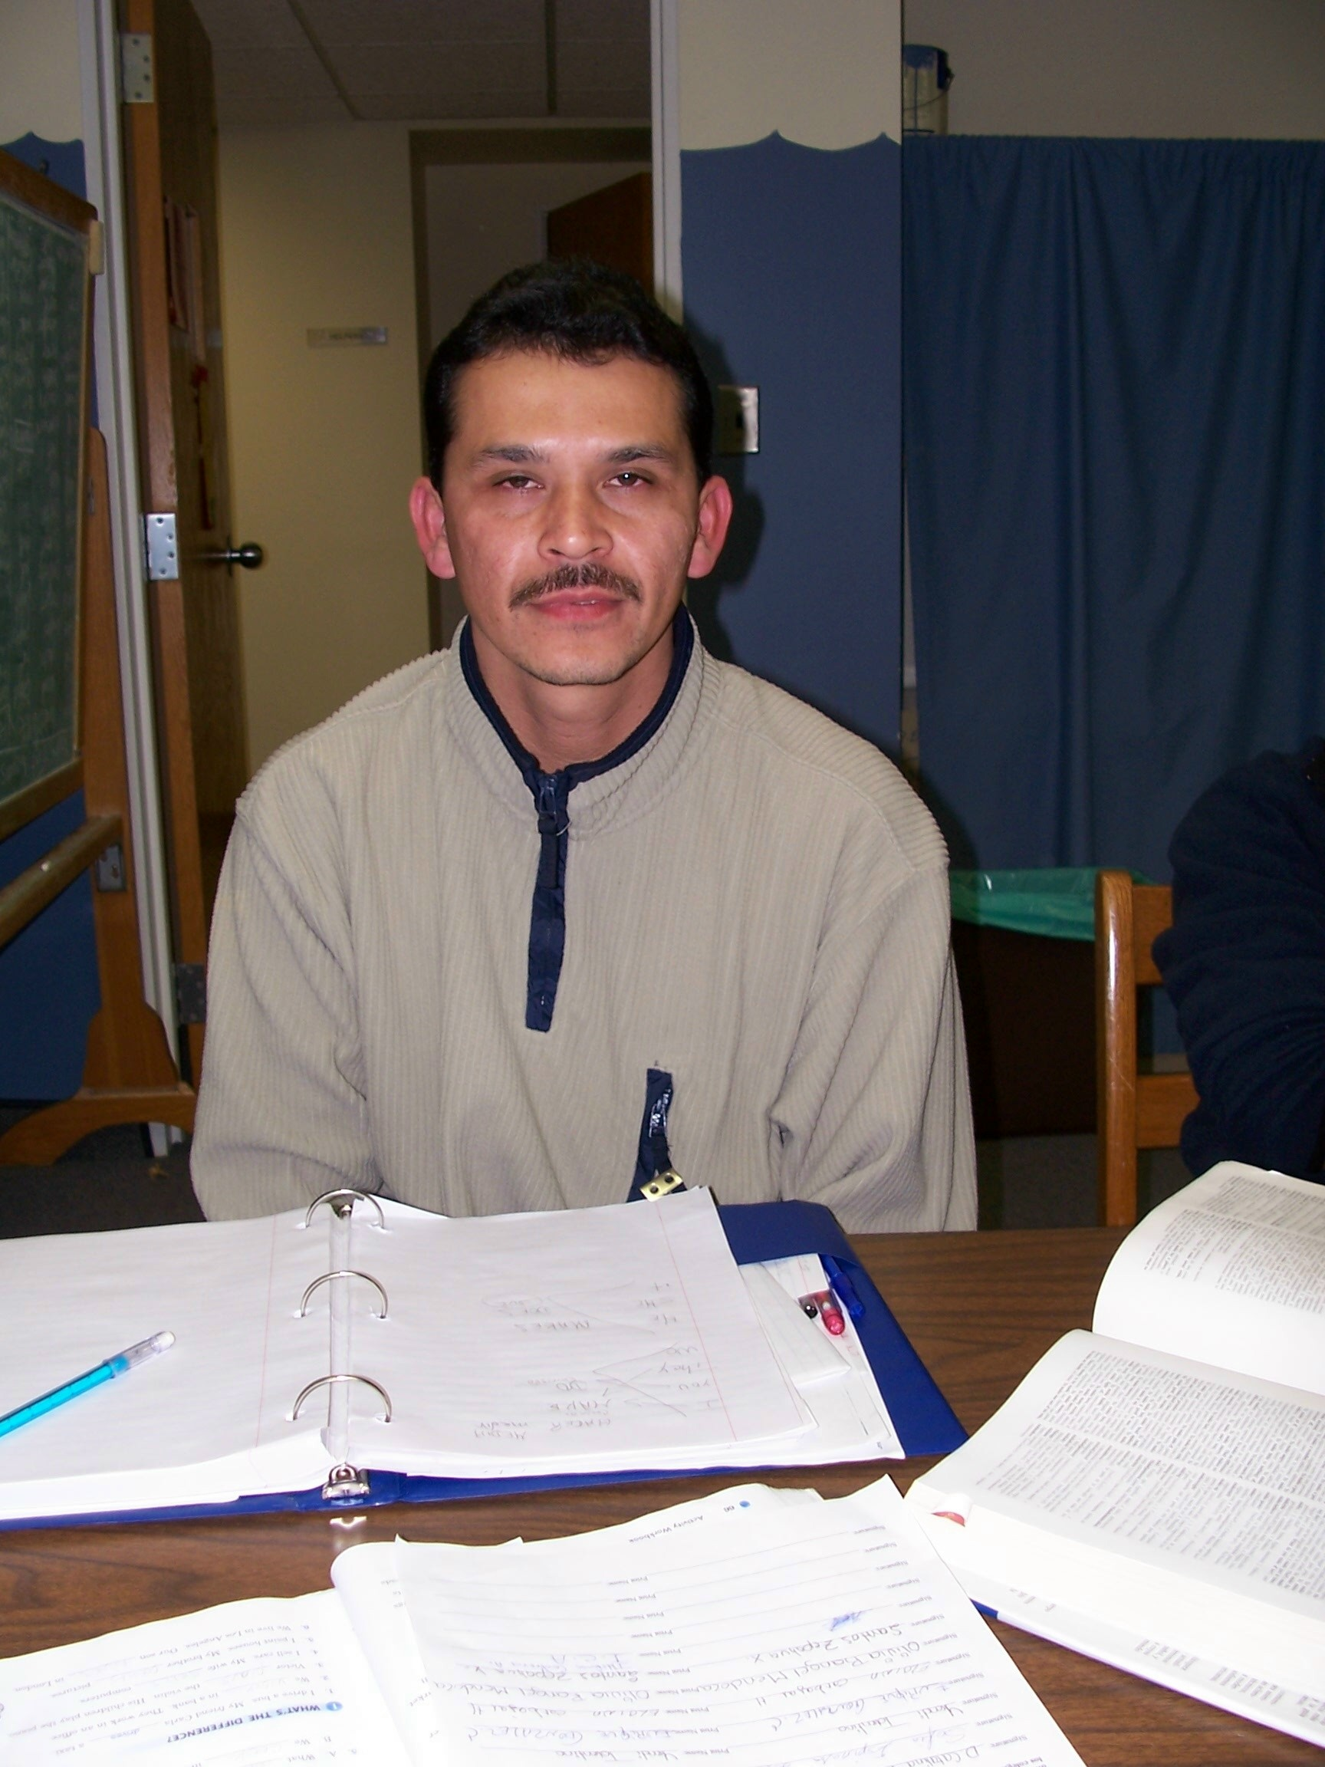
With Corrections

Enrique Gonalez
I am fishing in Virginia on the lake with my friend. We are catching many fish, but it’s very cold. We are very happy and in fact, We are having a very, very good time. We think we will return next year.

____________
About the author: My name is Enrique. I am from Mexico. I have lived in here for 6 years.
Javier Hernandez

Initial Version
I am vacation in Cancun. The hotes is very nice and espencive But I looking for my wirfrend. She was goin to tu the beach because she need to bay son beer and chost. I am gorry for her if she don’t cam back I have to call the emerllens number. But one hour later, she call me and she are good and happy. Naw I am fiel berry good I hope to have a nice time.

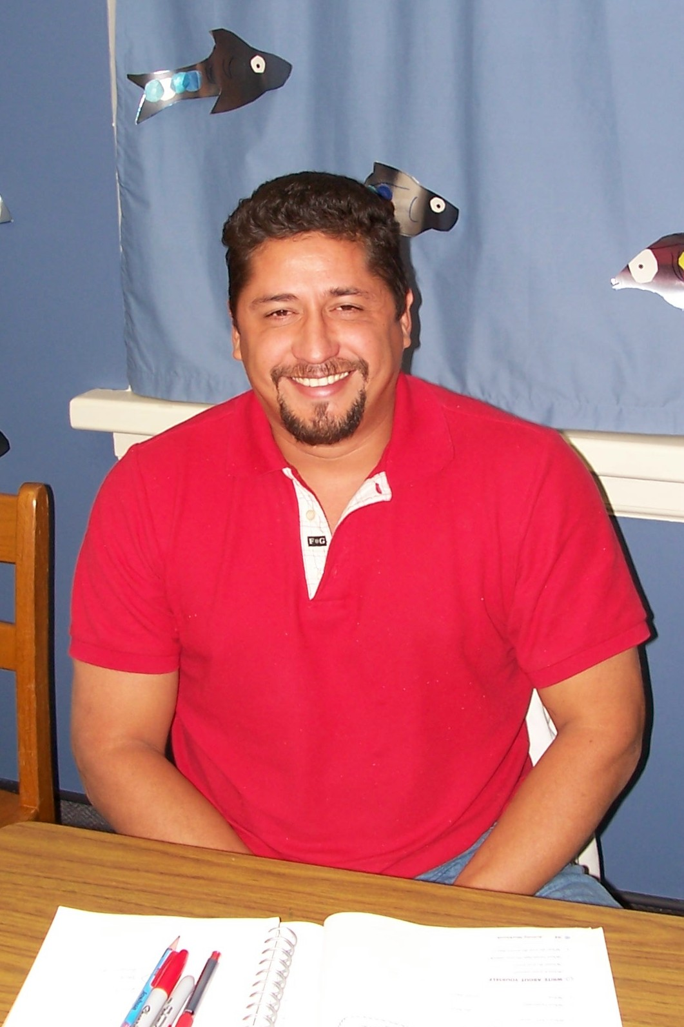
With Corrections
I am vacation in Cancun. The hotel is very nice and expensive, but I am looking for my girlfriend. She was going to the beach because she needed to buy some beer and clothes. I am worried about her. If she doesn’t come back then I will have to call the emergency number. But one hour later, she called me and she is good and happy. Now I am feeling very good. I hope to have a nice time.

____________
About the author: My name is Javier. I am from Honduras. I have lived in here for 1 year.

Sample Prompt 3

Lesson Objectives: Increase student facility with
- past tense
- descriptive vocabulary

The Writing Prompt: Tell me about growing up.

The Model Response: During the class period when the student writing is done, I put this final model on the board:

I was born in Buffalo, New York. I was my mother’s first child. I had black hair. When I was two years old, my sister was born. When I was three, my brother was born. When I was four years old, I went to kindergarten. I was very shy. I liked to read and ride my bicycle. We played in the snow too. When I was 12, I went to high school. My favorite class was religion. I liked to jog and dance.

Student Writing: Samples are shown on the following pages.
Olivia Rangel Mendoza

Initial Version
I was born in the hospital in Guanajuato, Mexico.
I was my mother’s second child. When I was a baby I a quiet baby. When I was three years, my brother was born. When I nine years, my thirthd brother was born. When I was 12 years my fourthd brother was born.

I went to kindergarten when I was 5, and I went to school when I six.
When I was a child, I was a quiet. My hair is black and was thin and tall. I liked to listened music and danced. I went to highschool when I was 12, and I have many friends. My friends and me playing basketball every today.
I liked read the book The Chapulin Colorado.

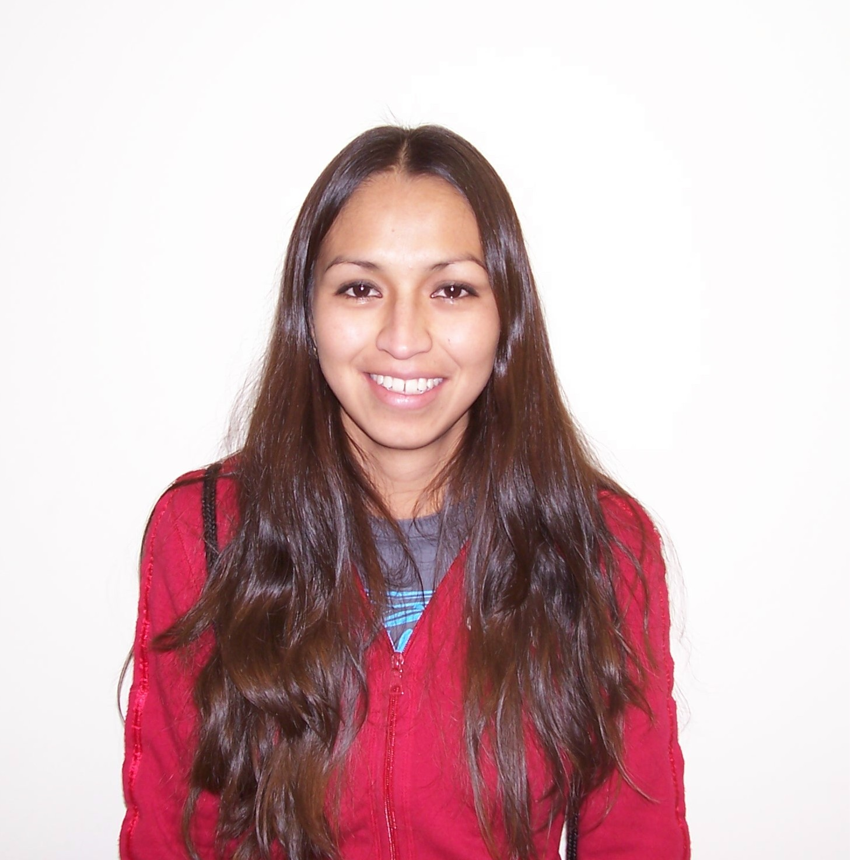
With Corrections
I was born in the hospital in Guanajuato, Mexico. I was my mother’s second child. When I was a baby, I was a quiet baby. When I was three years old, my brother was born. When I was nine years old, my third brother was born. When I was 12 years old, my fourth brother was born.

I went to kindergarten when I was 5, and I went to school when I was six. When I was a child, I was quiet. My hair was black and I was thin and tall. I liked to listen to music and dance. I went to high school when I was 12, and I had many friends. My friends and I played basketball everyday.
I liked to read the book The Chapulin Colorado.

____________
About the author: My name is Olivia Rangel. I am from Mexico. I have a two-year-old son.
“Angel” Ildefonso Contreras Arciniega

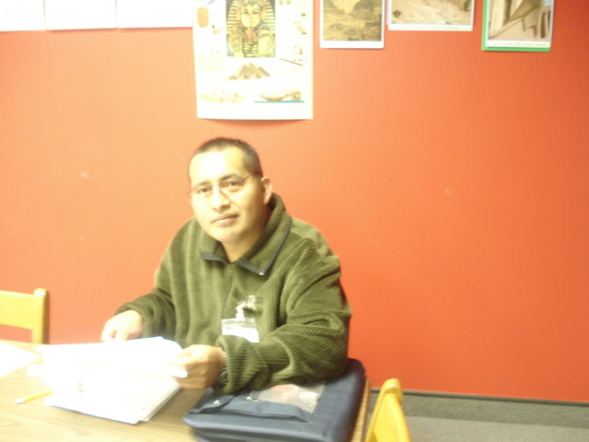

Initial Version

I was born in mexico. Name of the hospitas was Hospital General. I was my mother’s second child. My hair was black and still black. When I was a baby I was noisy. And I grew up in the capital. I went to school. When I was six my sister was three. I took care about her little be. We both played and ate. After that we took a different ways.

With Corrections

I was born in Mexico. The name of the hospital was Hospital General. I was my mother’s second child. My hair was black and is still black. When I was a baby, I was noisy. I grew up in the capital. I went to school. When I was six, my sister was three. I took care of her a little bit. We both played and ate. After that we parted ways.

_____________
About the author: I am from Mexico and I was born in 1973. I have lived here for 15 years.

