Bio Poems
Scott Crisco

Stanly Community College

Objectives: To get students comfortable talking about themselves
To help students understand themselves better
To give students time using a computer
Topic: Who Are You?
Level: Adaptable to all ESL levels
Time: My class spent about 20 minutes on warm-up and vocabulary, about 30 minute writing, about an hour on the computer, and about 30 minutes taking pictures on one another.

Warm-Up (10 minutes): Start off by asking the students, “Who are you?” This question will probably get you many blank stares. To prod some responses out of your students, lead by example. Tell who you are. For example: I’m a teacher.
I’m a mother/father.
I like to farm.
I love my children.
Ask students to tell things that define them as a person, things they are proud to be.

Vocabulary (10 minutes): Your vocabulary list can be any words that fit your students’ needs for describing themselves. Our class used
poem student teacher mother father
wife husband hobbies family I like
I love

Activity (30 minutes): Lead by example. Write your own Bio Poem first on the board. Ask students to make their own poem. The first word should be their first name and the last word should be their last name. The descriptive lines between their first and last names should be some impressions of themselves. Sometimes you will have to help students find a simple way to put their impression into a single word.

Using Computers (60 minutes): This can be a supplementary activity. If you have access to a computer lab, let students try typing their own Bio Poem on a computer. Since this is a short writing assignment, the typing will not be so intimidating. Typing also helps with spelling since misspelled words are underlined in red by the computer. When students asked about the red underlining, we helped them with spelling problems.

A sample of students’ poems is given on the following pages.
Va Yang
Laos

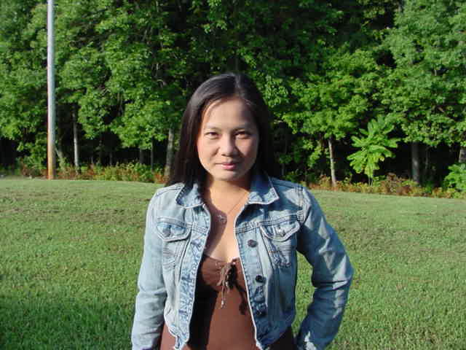

Va
Happy Wife
Likes mall shopping
English student
Yang

Manon Thao
Laos and France

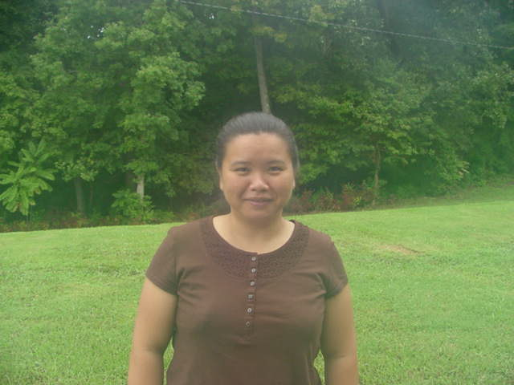

Manon
English student
Speaks three languages
Proud mother
Thao
Sergio Herrera
Mexico

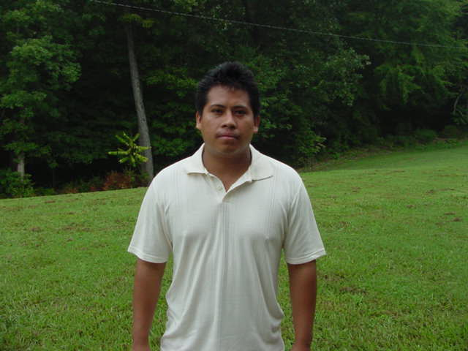

Sergio
Loves soccer
Works in restaurant
Learning English
Herrera

