Acrostic Poems
A Lesson Plan for Descriptive Writing
Scott Crisco

Stanly Community College

Level: This lesson is appropriate for any level. Less advanced students may use words and phrases: more advanced students may use phrases and sentences.
Objective: Descriptive Writing
Time: 1-1/2 to 2 hours.

Warm up:  5 minutes | Ask every student to write down one word that describes them.  The instructor may share several words/phrases to describe him/herself. Ask students to share the words they have written about themselves
Activities:  45 minutes | Get students to define aloud: personality  characteristics  Allow dictionary use.  Talk about some ways to describe a person. Define the following words aloud, using dictionaries as needed.  I am  mother/father  wife/husband  sister/brother  tall/short  pretty/handsome  To make sure students understand adjectives and other ways to describe themselves, ask them to write a sentence giving as many descriptions as possible.
The Poem:  40 minutes | Write MY LIFE vertically on the board. Ask students to write a self-descriptive word or phrase for each of the letters. Samples of student work are included on the following pages.  If you have access to computers, let the students type their poems in class.



Male

Young and energetic

Likes to go dancing

I’m crazy

Francisco is my name

English is hard for me

Written By: Francisco Barrios
ESL student at Stanly Community College

Graphics from Microsoft Clip Art and Media at www.office.microsoft.com



Many days I like to shop
Yang is my last name

Love my family and life
I’m an English student
Fond of learning English
ESL is my favorite class

Written By: Va Yang
ESL student at Stanly Community College

Graphics from Microsoft Clip Art and Media at www.office.microsoft.com

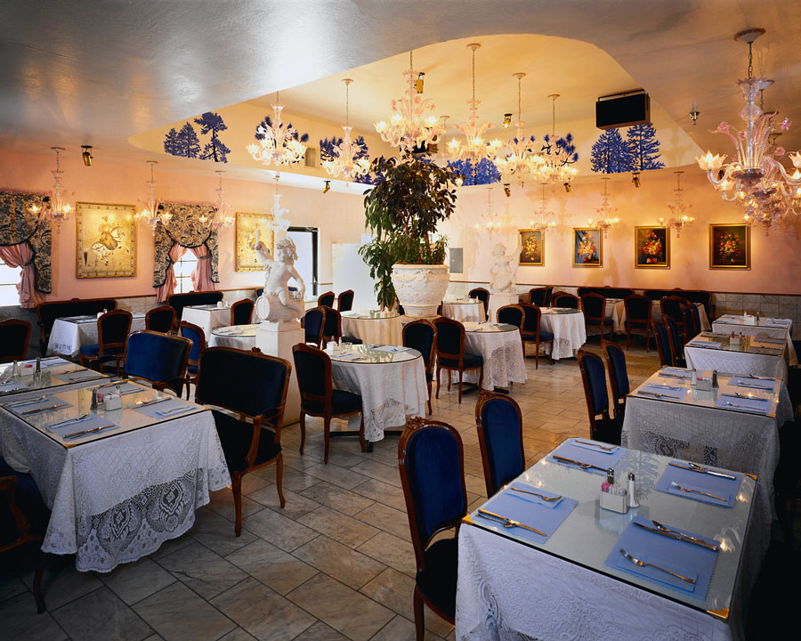

Manager at a restaurant

You and me are the same

Late coming to class often
I like my life
Future is my life
Every day I have high esteem for my work

Graphics from Microsoft Clip Art and Media at www.office.microsoft.com

Written By: Sergio Mata-Herrera
ESL student at Stanly Community College



Man that is single
Young and happy

Loves my son
I like soccer
Family is important to me
Employee at an industry

Graphics from Microsoft Clip Art and Media at www.office.microsoft.com

Written By: Alberto Santos
ESL Student at Stanly Community College



My name is Maria
Young and pretty

Loves my sister
I like to cook
Family is big
Enjoys playing soccer

Written By: Maria Zelaya
ESL student at Stanly Community College

Graphics from Microsoft Clip Art and Media at www.office.microsoft.com

