Christmas in My Country
Scott Crisco
Stanly Community College

Objective: To get ESL students interested in writing and learning about Christmas culture. Students should learn about Christmas customs and traditions in America. Students should share information on Christmas in their native countries.

Warm-up
Exercise: This lesson should be done right after Thanksgiving. Instructor should ask students about what they know about Christmas in America. Next ask them if or how they celebrate Christmas in their own country.

ChristmasVocabulary:

Christmas | Angel | Christmas tree
Christmas cards | Wreath | ornament
gifts | Christmas eve | Santa Claus
toys | parade | nativity
tradition | stocking | reindeer
snow | turkey | ham
holiday | Jesus

Exercise #1
Discuss the many Christmas traditions here in America. Try to explain all the vocabulary words and how they relate to our American customs and traditions. Have the students try to write some sentences using these words to see if they comprehend the meanings.

Exercise #2
Show the DVD (English subtitle) of the movie Miracle On 34th Street. When movie is over let the students talk about all the different vocabulary words they heard. Also let them talk about all the American Christmas traditions they saw in the movie.

[Check your local video rental store or use your favorite search engine and enter DVD Miracle on 34th Street English subtitles.]

Exercise #3
Have the students write a summary of how Christmas is celebrated in their country.

Conclusion:
Discuss the differences and similarities between Christmas in America and their countries.
Christmas in My Country

By: Va Yang
Thailand

In my country we celebrate Christmas. The first thing we do is we all go shopping for Christmas. In Thailand we always buy pigs, beef, chickens, and vegetables to cook for Christmas day. We like to buy a big pumpkin and cut faces in it. We always send Christmas cards to friends. We like to cook pumpkin pies and banana pies for Christmas day. We go shopping for many gifts for Christmas day. We decorate the Christmas tree and house for Christmas day. We put many gifts under the Christmas tree. On December 25, after we eat we open gifts and we use the video camera to remember the day. So you can see that our Christmas is about like Christmas in America.
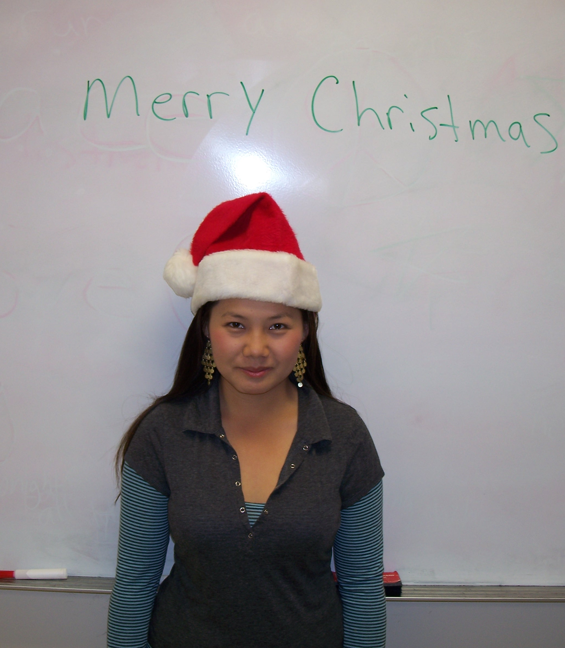

Christmas in My Country
By: Ana Amaya
El Salvador

In my country we celebrate Christmas. We have a big Christmas tree in El Salvador. My whole family gets together and has a big party. We like to dance and eat good food at the party. After the party we give out the presents. On Christmas Eve we go visit our family and friends. I go and visit my mom because this makes her feel very happy. My favorite thing to do is cook tamales and bread for my family. We also decorate our houses with Nativity scenes. Christmas in El Salvador is much like America.
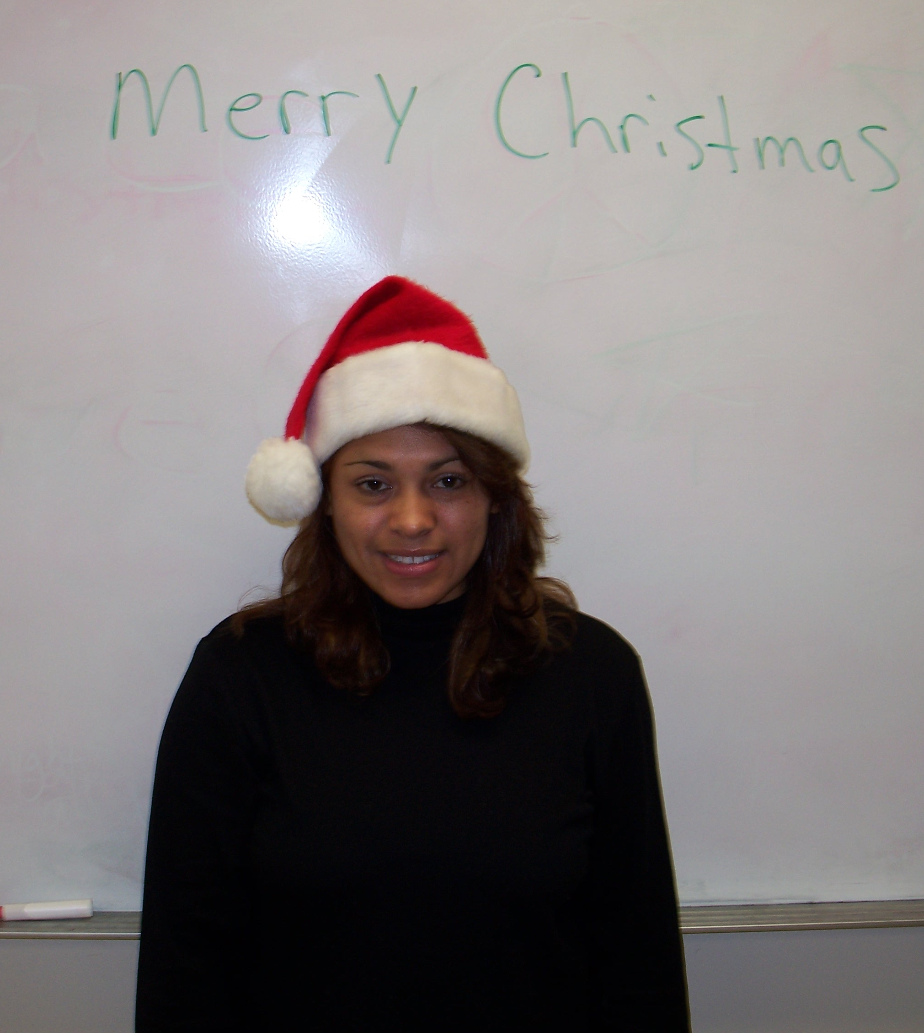

Christmas in My Country
By: Maria Zelaya
Honduras

In Honduras we decorate a Christmas tree just like here in America. We go shopping for gifts for family and friends. On Christmas Eve we have a big dinner with my family. We start the celebration 12 days before Christmas. The children shoot off fire works all night. On Christmas Eve we go to church to give thanks to God. Also the children write letters to Santa Claus. We also send Christmas cards to friends. On Christmas day all my family gathers together at my house to open their Christmas gifts.
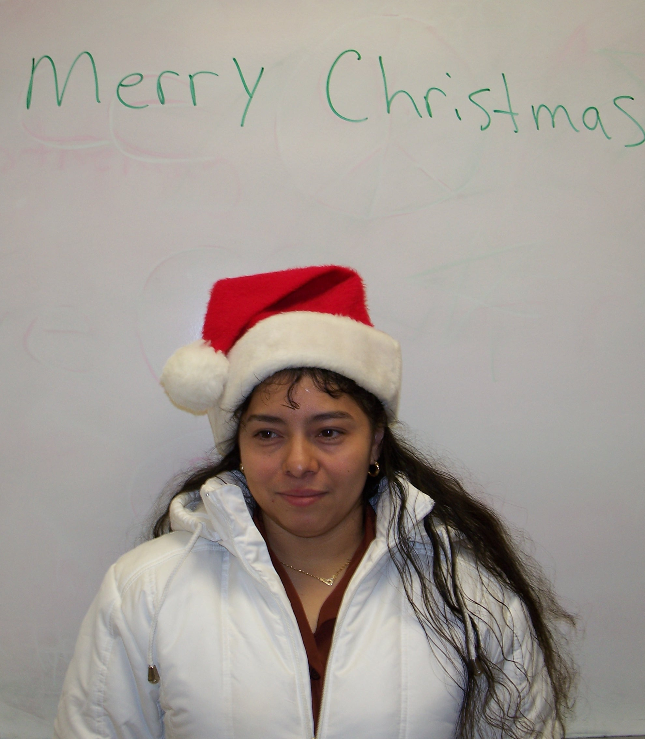

Christmas in My Country

By: Marco Villanueva
Honduras

In Honduras we decorate our houses for Christmas. I will buy a gift for my friends. Yesterday I bought my friend a pair of shoes for Christmas. Santa Claus comes to the homes of the children in Honduras. Santa Claus makes many children happy at Christmas. We also decorate the homes with wreaths and many trees. In my home the tree is on the table. There is a lot of work to do right before Christmas. We open gifts on Christmas Eve because we are so curious and anxious. People send Christmas letters and cards to their boy friends and girlfriends at Christmas. On Christmas day all the children are happy and grateful for all their gifts.
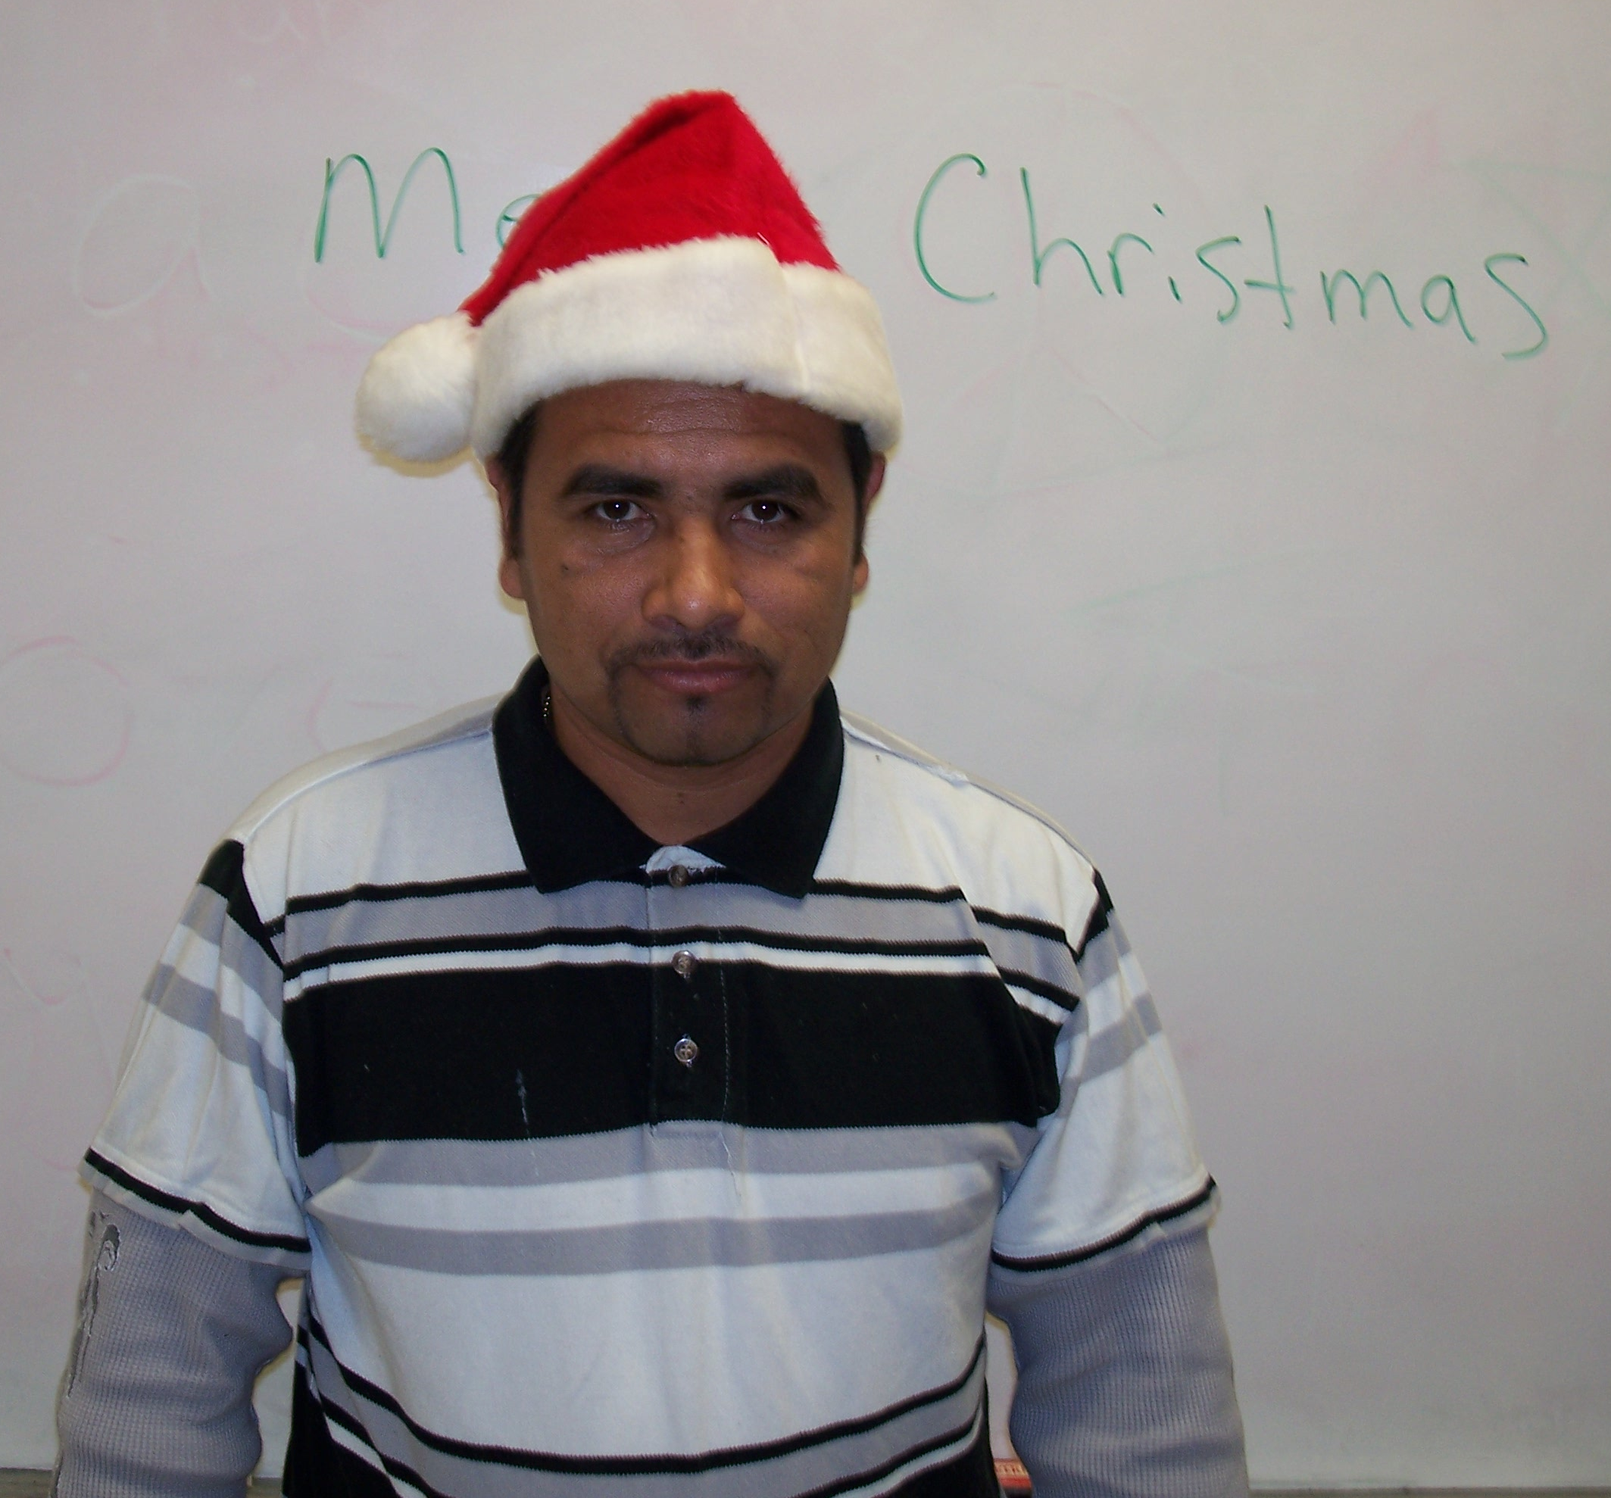

Christmas in My Country

By: Alberto Villanueva
Honduras

Christmas in Honduras is very pretty. In my country we all get together with family and friends for Christmas. I like spending time with my son because he is so excited about Christmas. Some of us go to the movies to fellowship and just spent time together. In Honduras the weather is much warmer than here so we can do many things outside. One thing that I like to do is get together with many of my friend and play soccer. We also decorate our homes with many Christmas decorations. Just like in America, Christmas in Honduras is a time to be with friends and family.

