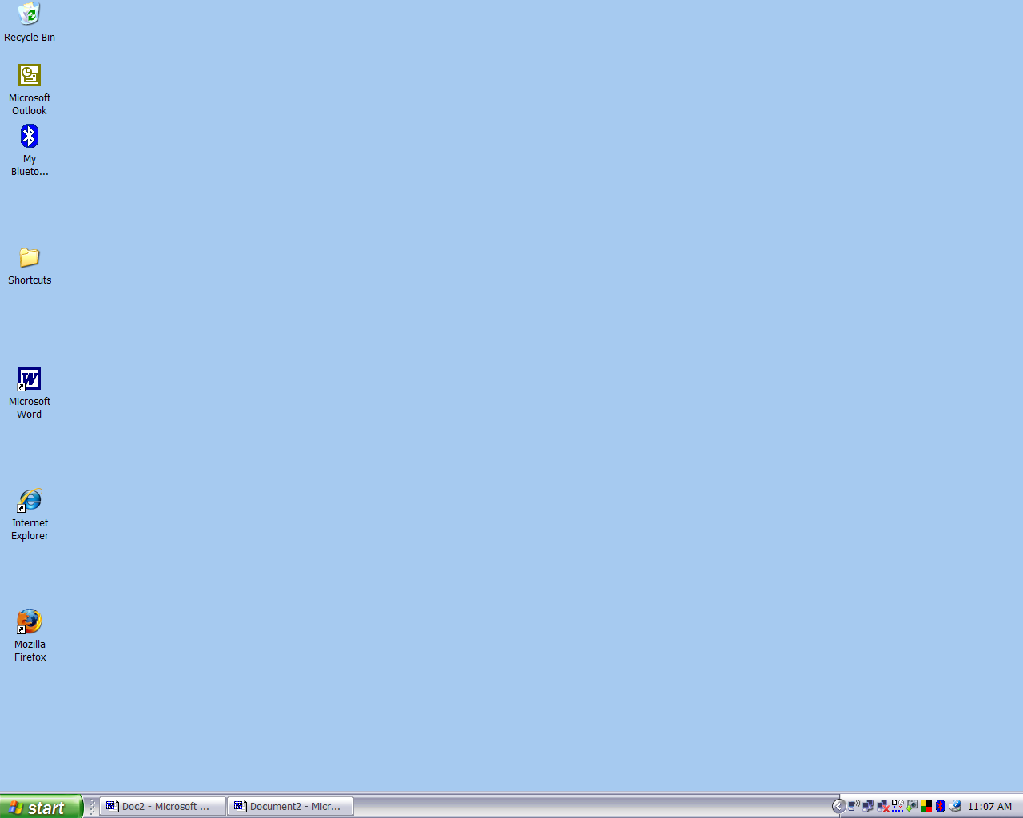
1. Using the mouse point to the Firefox icon.
2. Double (left) click to open the program.
- -
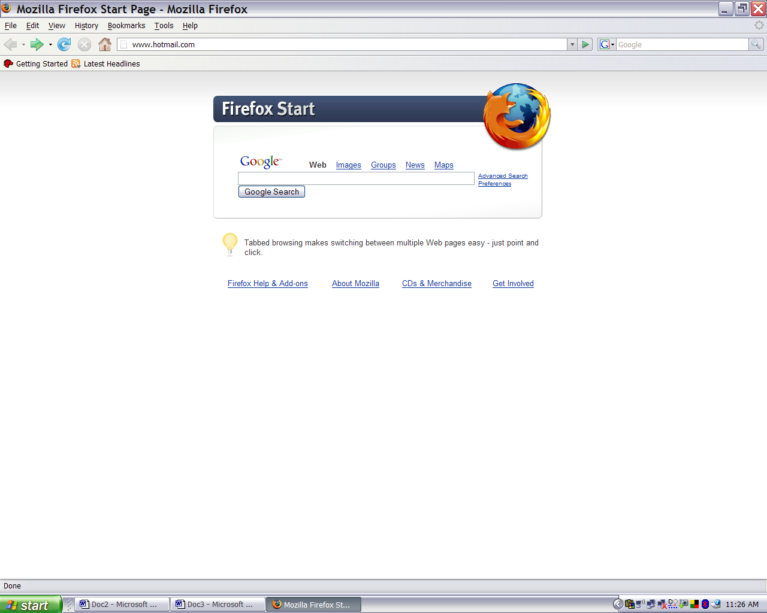
4. In search bar type: www.hotmail.com

3. Point to search bar and (left) click to select.

5. Press ‘Enter’ or point and (left) click on the search arrow.

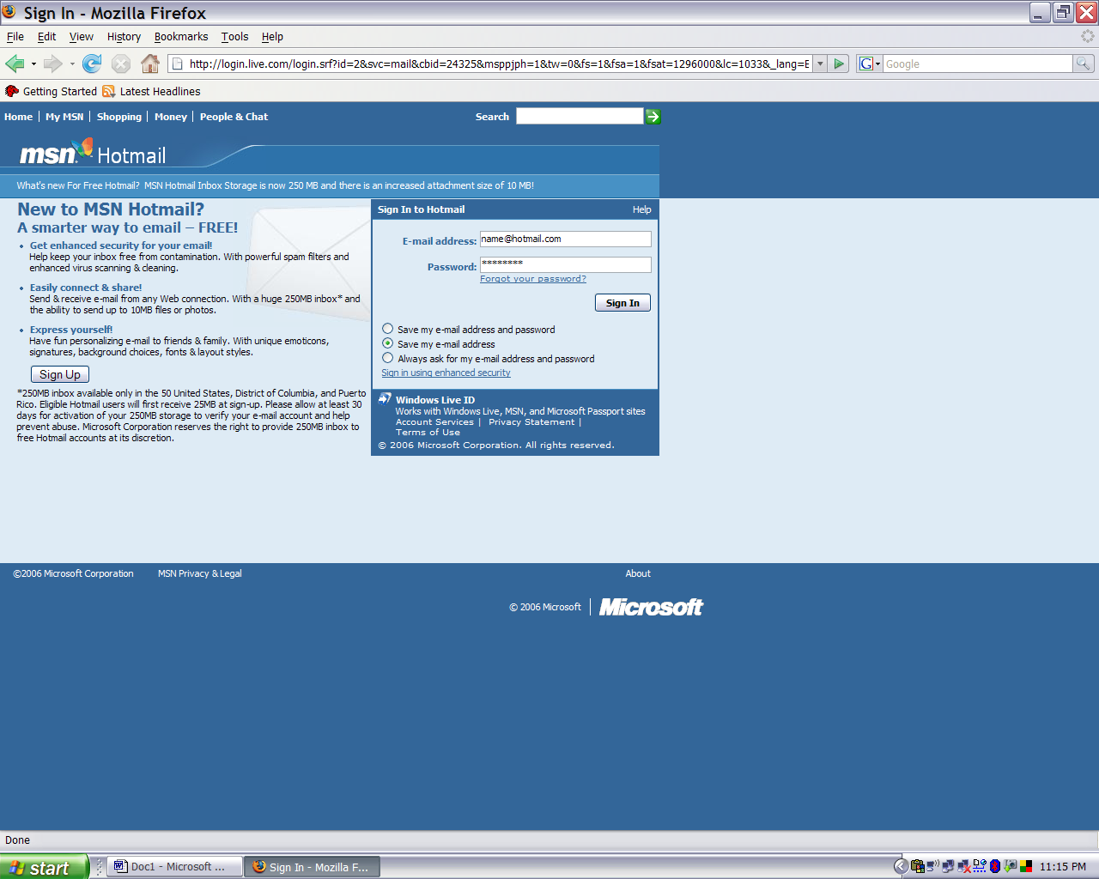
6. Type your address: name@hotmail.com
7. Type your personal password.
8. Press ‘Enter’ or Point and click to sign in.
- -
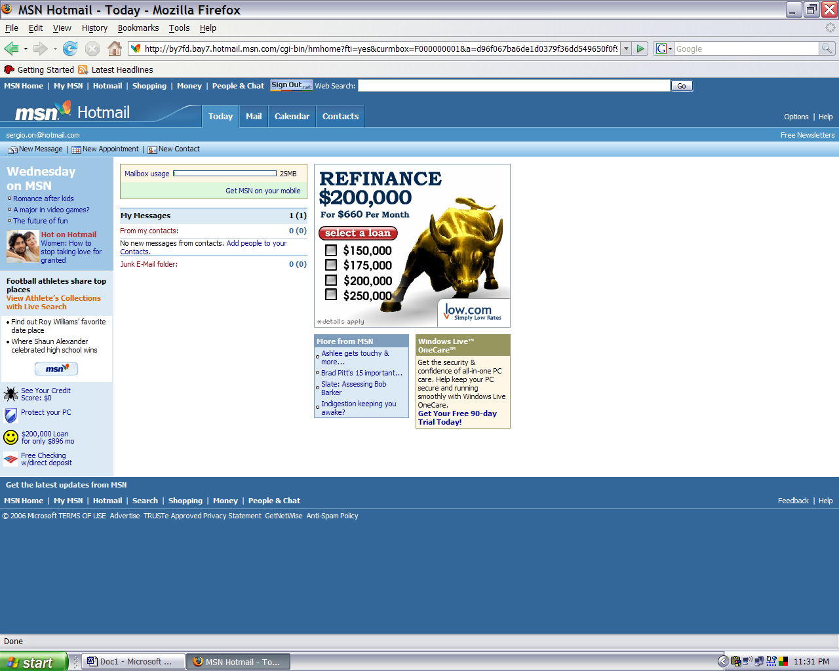
You are in!
9. Point and (left) click on ‘Mail’ tab.
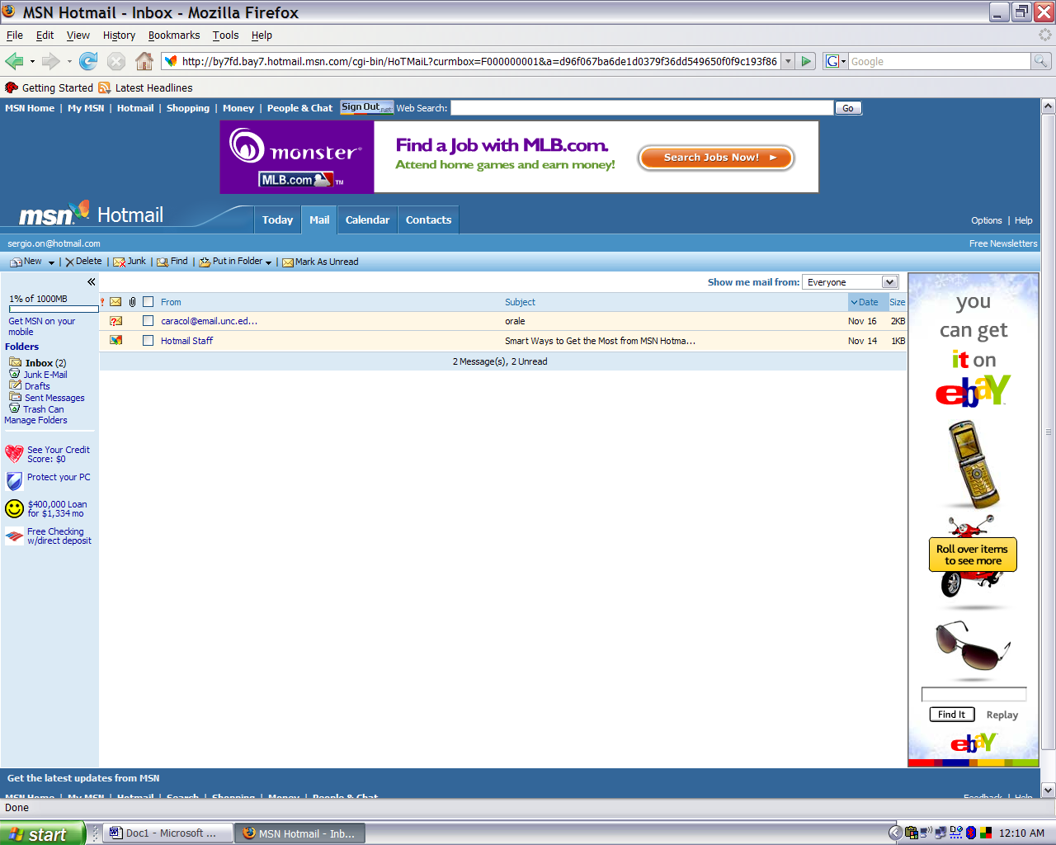
This is your mailbox window.
This is where your incoming mail appears.
10. Point and (left) click on one message to read it.
- -
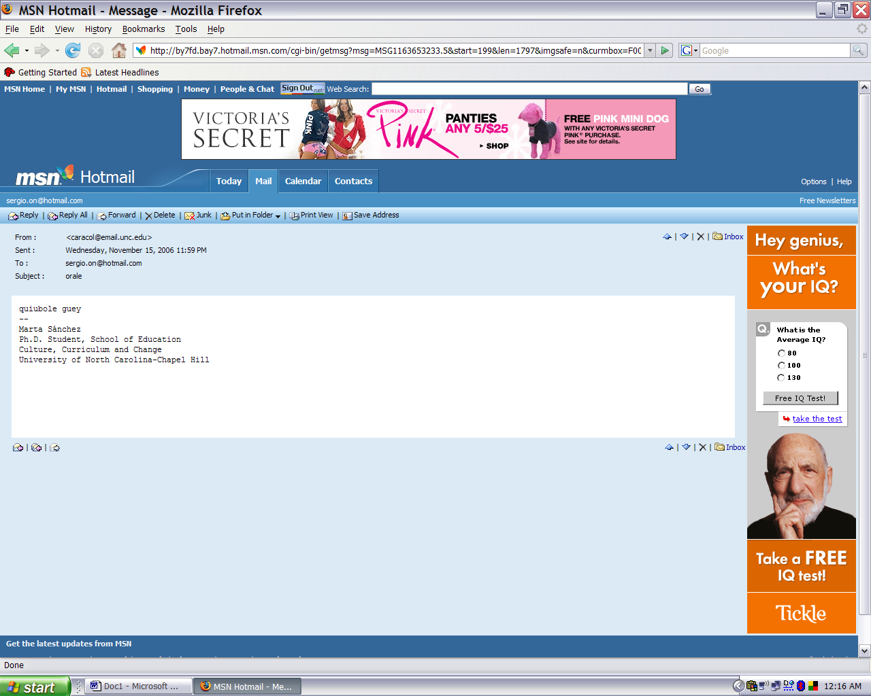
11. Once you have read the message point and (left) click on the ‘Reply’ tab.
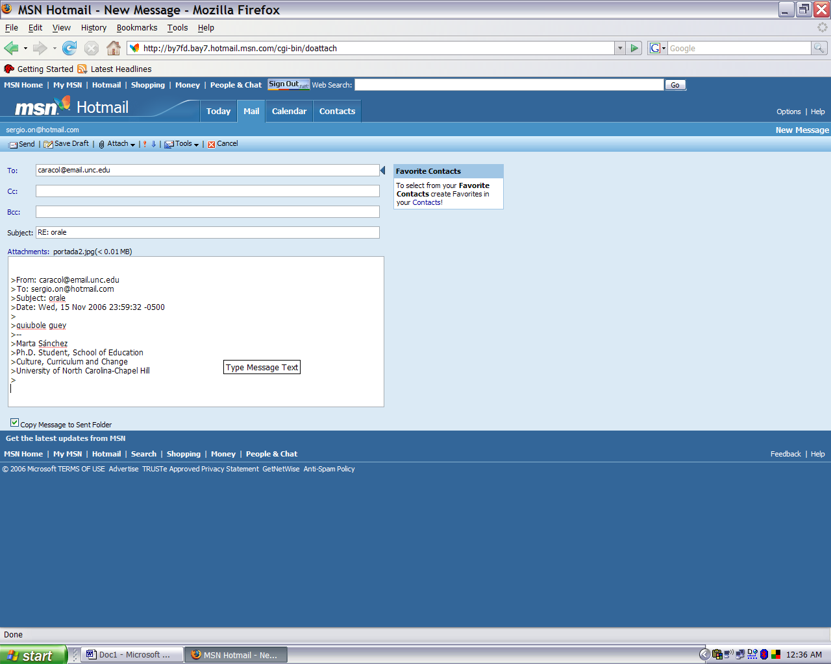
12. Here you can respond to the message below the original message.

13. When you are finished, point and (left) click on the ‘Send’ tab.
- -
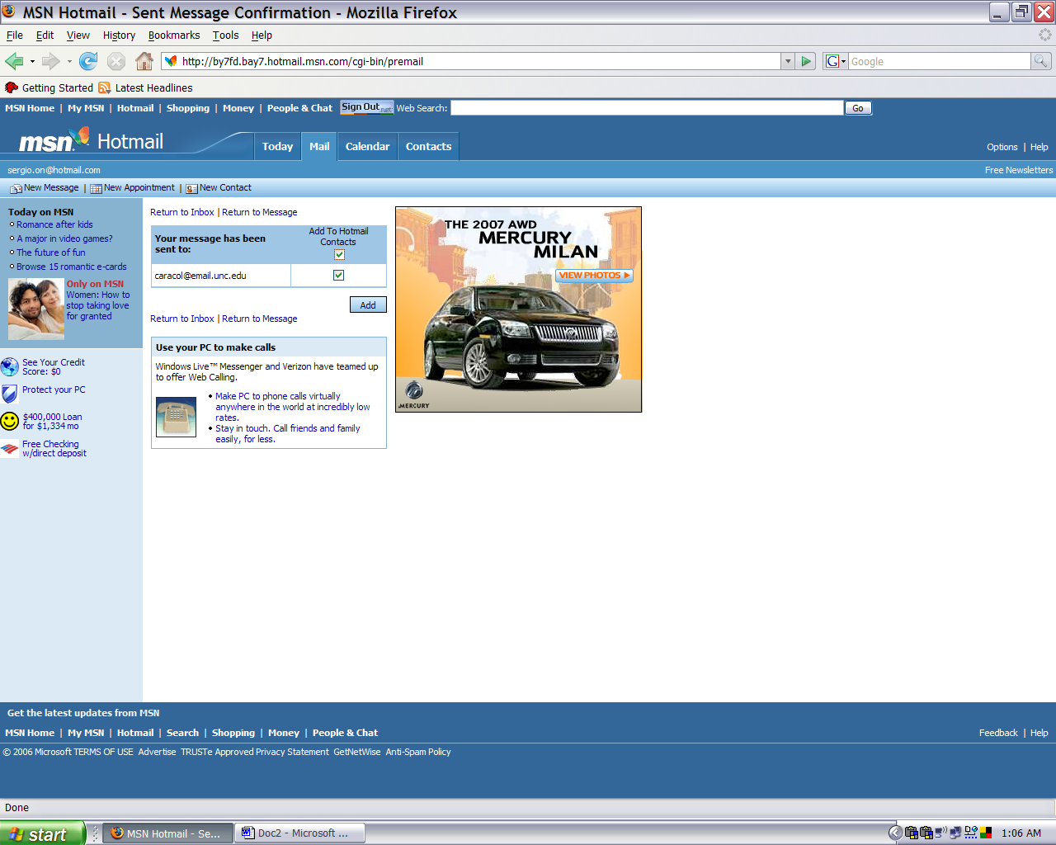
15. To close your mail account point and (left) click on the ‘Sign Out’ tab.
14. Check this box and (left) click on ‘Add’ box to save your contact address. information into your account

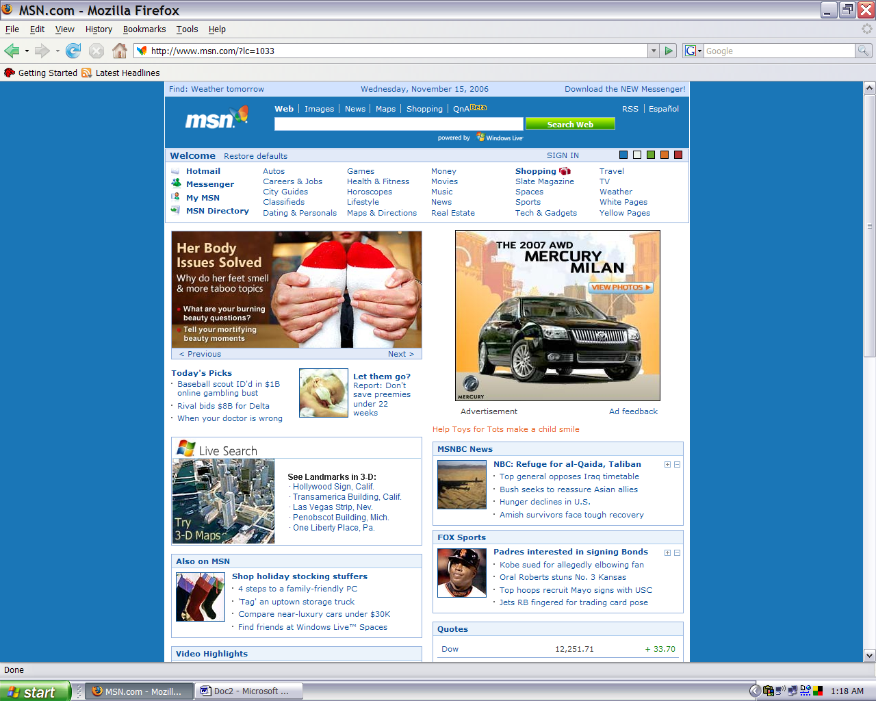
16. Point and (left) click in ‘X’ box to close the program.

Mouse Functions
Action | Result
Click | 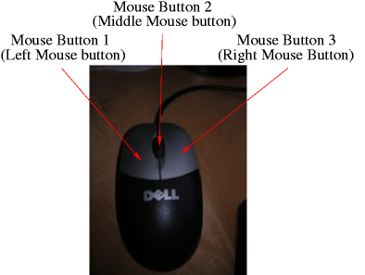  Left mouse button – moves the cursor, highlights an object, pulls down a menu, or chooses a menu command  Right mouse button – displays a shortcut pop-up menu
Double click | Left mouse button – highlights a word or edits an embedded object
Drag | Left mouse button – moves an object, resizes an object, highlights test, or highlights multiple objects
Highlight | By use of the left mouse button, you can drag the cursor over word, paragraphs, or pages.
Triple click | Left mouse button - Highlights a paragraph

