ESL Email Project
By Tanner Hock
Alamance Community College

Objectives: • Improve written communication skills
• Learn basic computer functions and manipulation
• Understand internet technology including email account activation

Level: Advanced ESL

Requirements: • Accessible computer(s) with internet capability (We were fortunate to have four in our classroom.)
• Step by step directions outlining the basic function of the selected email provider
• Brief overview of computer and various components
• Digital camera (optional)

Directions: Day 1
Vast differences in experience and ability from one student to another is, I think, typical for most ESL classes, so I started by giving a general overview about computer technology (the roles of major players and the internet infrastructure) in an effort to get everyone on the same page. (You can find a plethora of information on computer technology with your favorite search engine.)

Next, I asked students to write down their desired email address and a password. Doing this on the day before we registered eliminated extra time in contemplation during the actual registration process.

Finally, I gave out copies of very simplistic instructions outlining the basic functions of the selected email provider. These instructions started and finished with the Microsoft Windows desktop and gave students everything they needed to sign in to their account, access their mail inbox, compose a message, send a message, and sign out. (The document accompanying this lesson plan is a copy of my instructions.)

Directions: Day 2
The next step was to get everyone registered with a personal email account. I elected to use hotmail accounts because they seemed to present the least amount of friction in terms of set-up.

On registration day, it is crucial to have some sort of workshop or side activity so students will have something to do that does not require your full attention. Due to the individual attention required by students attempting to register, it is not possible to teach class as normal. I was extremely lucky to have a computer-savvy student willing to shadow everyone individually as they took to the computers for the first time. With only a few students, the registration process took an entire 2.5 hour class session. Remember to record all address and password information for your use and in case someone forgets/loses theirs!

I took a picture of the class on registration day so that I could email it to them that night. (I thought that might help get them more interested.)



In my email I simply asked the students to reply confirming that they received the picture. Most students did not get a chance to do so until the next class session, which was fine.

After all the confirmations were in, I was confident that everyone had a working account and could perform the basic email functions. It was time to introduce the writing portion of the lesson.

Directions: Day 3
I started out with a question in class about the rather mundane topic of growing technological trends, which sparked a surprising amount of controversy and discussion. After class, I sent out the first conversation question via email. After receiving their responses, I replied to each individual email with my thoughts and some writing advice as necessary. This was nice because I was able to guide and correct students without interrupting the flow of conversation. (See the student responses that follow this lesson plan. Clip art was added.)

Conclusion: Since the inception of the project, a multitude of written conversations have resulted from subsequent email questions, and these have proved to be a virtually endless source of improvable prose. It has been a pleasure to watch the students get enjoyment from the project as they continue to evolve their understanding of both the English language and modern technology.

Evaluation: If you have access to computers, this email project is a good way to generate class interaction and learning. I found that, after several class sessions, students were able to operate and manage their own email accounts with little trouble. Students did not need to be typists. Hunt-and-peck entry did not dampen their enthusiasm. Despite the somewhat laborious process of creating accounts and becoming familiar with asynchronous communication, the project turned out to be a fun and successful alternative to standard teaching methods.
Student Responses
*The following are examples of responses taken from my ESL class regarding the question of growing technology.
How do you feel about the growing influence of technology on your everyday life?

I feel surprised about the growing of technology, everyday it is being invented with new and advanced technology that if you dont be at it you will get to be lost.
The internet has allowed me to talk with my family and my friends in my country, also it has allowed me to see any kind of information that I need.
Carlos C.

Hi Carlos,
Thanks for the interesting response! You are definitely right about how fast technology is growing. If you do not keep up with it, it is easy to get lost!
Also, in long sentences, it is good to use as many periods as possible to separate ideas. Try putting a period between the words "country" and "also" in your last sentence.
Let me know if you have any questions!
Tanner
Graphics from Microsoft Clip Art and Media at www.office.microsoft.com

How do you feel about the growing influence of technology on your
everyday life?

I feel happy that the technology is growing more fast than the pass years, and every year something new came making our life more easy, in communications, home, entertainment, but I dislike the new games our children plays because it is full of violence.
Alicia

Hi Alicia,
Thank you for the interesting response! The subject of violence in video games is of much debate. Why do you think violent games are so popular these days?
Great usage of commas to separate different items in your first sentence. Try to remember to separate ideas with a period in long sentences. You could do this by putting a period between the words "entertainment" and "but". Then, change "but" to However" and capitalize the "H".
Let me know if you have any questions!
Tanner
Graphics from Microsoft Clip Art and Media at www.office.microsoft.com

How do you feel about the growing influence of technology on your
everyday life?

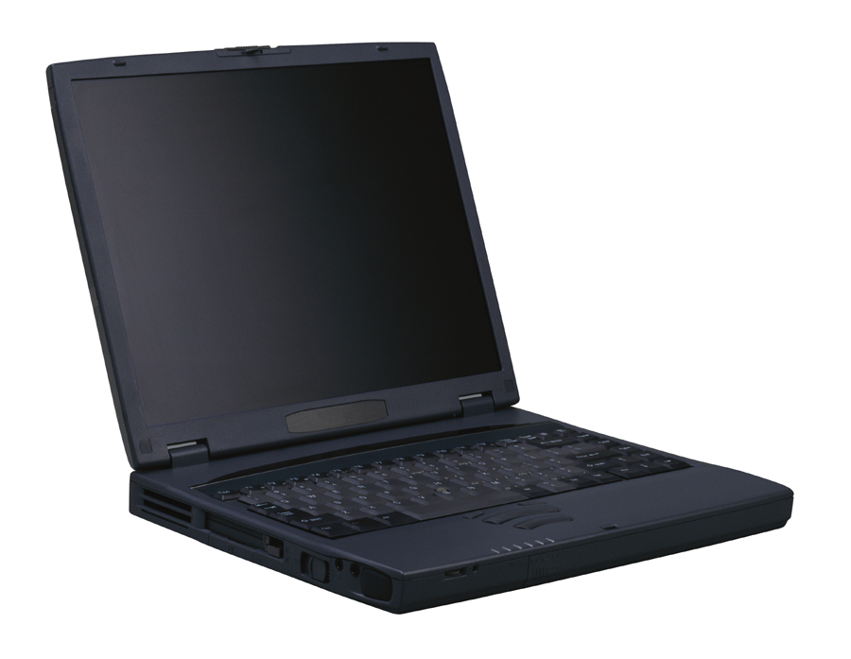
I feel excited about the growing influence of technology on my everyday life. new technology, such as the internet it can help me to contact with my family in mexico and i will be able to get information on my everyday life.
gregorio martinez.

Hi Gregorio,
Thank you for the interesting response! I am also excited about new technology. Things move so fast these days.
Great usage of a comma in the phrase “such as…”. Put another one after the word "internet" and they will be perfect! Also, try separating ideas in a long sentence with a period. You could put a period after the word “Mexico”, and then use the word “Also” to start the next sentence.
Let me know if you have any questions.
Tanner

Graphics from Microsoft Clip Art and Media
at www.office.microsoft.com


How do you feel about the growing influence of technology on your everyday life?

I feel happy about the growing influence of technology on my every life. The new technology has allowed me to talk with my family in Mexico and see them at the same time.
Norma Ramirez

Hi Norma,

Thank you for the interesting response! I also enjoy talking to my family. Do you use a cell phone? I just got one the other day and I like it so far. That may be because I haven’t gotten a bill yet!

These are good sentences Norma. The word everyday can be difficult to use. In this case, it is an adjective. It describes the noun, “life”.
Let me know if you have any questions.
Tanner

Graphics from Microsoft Clip Art and Media
at www.office.microsoft.com

How do you feel about the growing influence of technology on your
everyday life?

I feel happy about the growing influence of technology on my everyday life. however sometimes I think about because one of this machine will take my place in my work one day.
Jose Moises Ramos

Hi Jose,

Thank you for the interesting response! You have made a good point. People often wonder about the effects of technology in the workplace. Do you use much technology at your job?

Your sentences look good for the most part, good job! The first sentence is perfect. I like how you restated the question. In the second sentence, you may want to say something like, “However, sometimes I think a machine will take my job in the workplace.”

Let me know if you have any questions!

Tanner
Graphics from Microsoft Clip Art and Media
at www.office.microsoft.com

How do you feel about the growing influence of technology on your everyday life?


Hello Mr. Tanner. I expect that you would have a great day! Here is my answer. The technology influence has been changing or affecting a lot our daily living way, nowadays in almost everything we do we have new artifacts that makes easier or simplier our daily duties. Thanks to a motor, and artificial intelligence we expend less time, and effort to realize wherever we need or want,simple examples are:1. - WE don't walk to go to school or to aour job, a car ride us whereever we want. 2.- We send emails from a computer instead of using normal mail to be in touch with our beloveds. 3.- We use to prepare our food a lot of electric appliances to make it simplier. 4.- Also we want to have al kind of digital cameras, iPOD's, video games, to experience ousrselves the most cool of the hi-tec.
Maria

Hi Maria,

Thank you for the interesting response! Your list of examples is really insightful. There are so many ways we use technology!

I like how you broke the paragraph down into a list. That makes it easy to read. Another way to make your writing easy to read is by being straight forward and simple. Sometimes, using simple words and small sentences helps a lot!

Let me know if you have any questions!

Tanner
Graphics from Microsoft Clip Art and Media
at www.office.microsoft.com

