Writing Notes
By Lynn Limon
Alamance Community College

Objectives:  Students will write (in English) a suitable note for the situation described to them.
⬧ Students will use correct form for their note.
⬧ Students will acquire key vocabulary pertinent to note writing: for example, pen pal.
Level: My class is Mixed (intermediate and advanced)
Time: I cover the initial instruction on writing notes as a part of the work we do in class over the course of two weeks. Then we continue to practice throughout the semester using a variety of note-writing scenarios.

ACTIVITIES

Introductory “Lecture”: I begin by giving the class a simple orientation to note writing similar in content to the following paragraph:
Note writing is a common form of social communication. Although society today is leaning toward e-mail, it is still important to learn the skill of note writing. Notes can be used to express a concern, to communicate gratitude, to extend an invitation, or to ask a question. Notes can also be a way to show someone you are thinking about them.

Set the Scene: Next I describe to the class one specific scenario or situation in which it is appropriate to write a note. A list of several scenarios that I use is given below for your consideration.
  - Thank you for my birthday gift
  - Invitation to my house for dinner
  - Thank you to the church where our ESL class meets for allowing us to use the facilities
  - Note of encouragement to a Marine, to say thank you for serving this country. (We mail these.)
  - Pen pal note
  - Note to a mechanic explaining a problem with the brakes
  - Note to the teacher explaining why you can’t come to class tomorrow

Modeling: I involve the class in drafting a sample note that I write on the board. I include most of the following points, adjusting for the type of note we are doing:
- Structure of a note (date, heading, body, closing, signature)
- Kind of note (I explain the kind of note we are writing. The list in the section above gives the different types of notes that my class typically writes over the course of a semester.)
- Capitalization
- Punctuation (commas, periods, question marks)
- Vocabulary
- Synonyms (for example thankful, grateful)
- Ideas to include in your letter
- Forming questions - word order (I cover this and the next point when we do pen pal letters.)
- Answering questions

Writing and Correction: When it’s time to write, each student works independently on a draft, which he/she then shows to me. We discuss corrections together, marking the draft and making changes as necessary. Students usually do a re-write that day or the next. Depending on the type of note, we may take two to three days to complete the writing and revision, all of which is done in the classroom. I collect the final copies.

Presentation: When the notes are finished, I usually ask several students to read theirs aloud, or sometimes, I read them to the class. Occasionally we do something that needs to be collected and sent out quickly, so we don’t read them aloud.

Most of the notes we write are delivered to specific recipients. For example, we mail our notes to the Marines to my Marine son-in-law for distribution. The notes to the Church Staff are hand-delivered, and the Pen Pal notes are delivered in the classroom to our “resident” pen pal, my aide.

Samples of notes from my students are given on the following pages. Each student wrote a complete note, including date and heading, on a separate sheet of stationery. For brevity of presentation in this lesson plan, all notes on the same topic are given in a list format under a single date and heading.

Expansion: After the class has done the first note, I find it helpful to return to the topic of writing notes periodically. I repeat the modeling process and review prior learning as we work through drafting a note for a new scenario.

Dear Marine

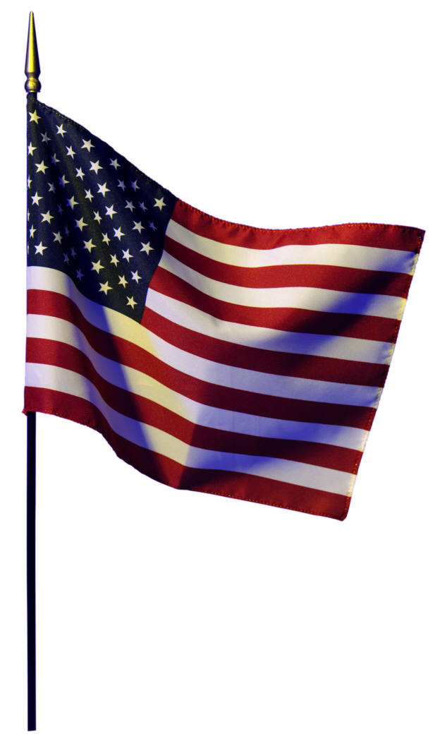
January 12, 2007

Dear Marine,
_______________________________________________________

Hi! My name is Jose Carchi. I’m from Ecuador. I’ve lived in United State for 10 years. I’m a student of ESL class.
Thank you for your efforts.
We appreciate your service to the U.S.A. I hope you return safety and I hope you come home soon. I am praying for all of you.
Sincerely,

Jose Carchi
_______________________________________________________

We are missing you. Thank you for serving your Country. I am an English student from El Salvador. I have lived here 12 years.
God bless you.
Sincerely,
Victoriano Romero
_______________________________________________________

My name is Sanjuana. You don’t know me and I don’t know you but I wrote this little letter to greet you, give you thanks, and encourage you. I from to Mexico, I live in Burlington, N.C., and I am studying English. I recognize you efforts and for this reason I am praying for all of you everyday and I hope you return safely. God bless you. You can do it.
P.D. Sorry my English not is perfect yet.
Sincerely,

Sanjuana Limόn
_______________________________________________________

We are thinking about you. Thank you for serving your country.
I am an English student from Korea. I have live here 1 year and I have two children. one son anothe daughter. They are very smart. My son goes to the Turren-tine Middle School. He likes school and my daughter goes to the Smith-elementary School. She likes the school too so we like living here. The American People are very kind very good people and I go to the English clas. My teacher Lynne. She is very good teacher I like her. and my family too. We want to live here a probably we can do it. But sometime it’s very hard and different because it difficult culture and difficult work and language. Maybe we can do it.
God bless you.

Sincerely,
Min Se Kim

Dear Church Staff

January 17, 2007

Dear Church Staff,
_______________________________________________________

Thank you for allowing us to use your facilities. I’m so happy in this class. The room is big and the parking lot is big too.
Thank you so much,

Minerva Mendoza
_______________________________________________________

We like the church because I am a Christian and my class student too.
We are using the church every day. We are using the classroom, kitchen, etc. Everything is really nice.
Thank so much. The church staff is very kind. We meet the church staff every morning and they “say Hi. How are you? And smill face. I like them and everything. Thank so much.
(appreciated)
Min Se Kim
_______________________________________________________

I’m Mariana.
I glad to come in this place. You are very Friendly PeoPle.
I say Thank You For allowing Us to use the Facilities: our room, Kitchen, etc.
Thank you for allowing us to use it. Godbless
Sincerely,
Mariana Marquina

_______________________________________________________

Thank you for allowing us to use your facilities. This church has nice people and friendly and rooms are clean.
Sincerely,
JoseCarchi
_______________________________________________________

Thank you for allowing us to use your facilities (rooms, Kitchen, etc.) Everyone is very kind and friendly.
God bless you.
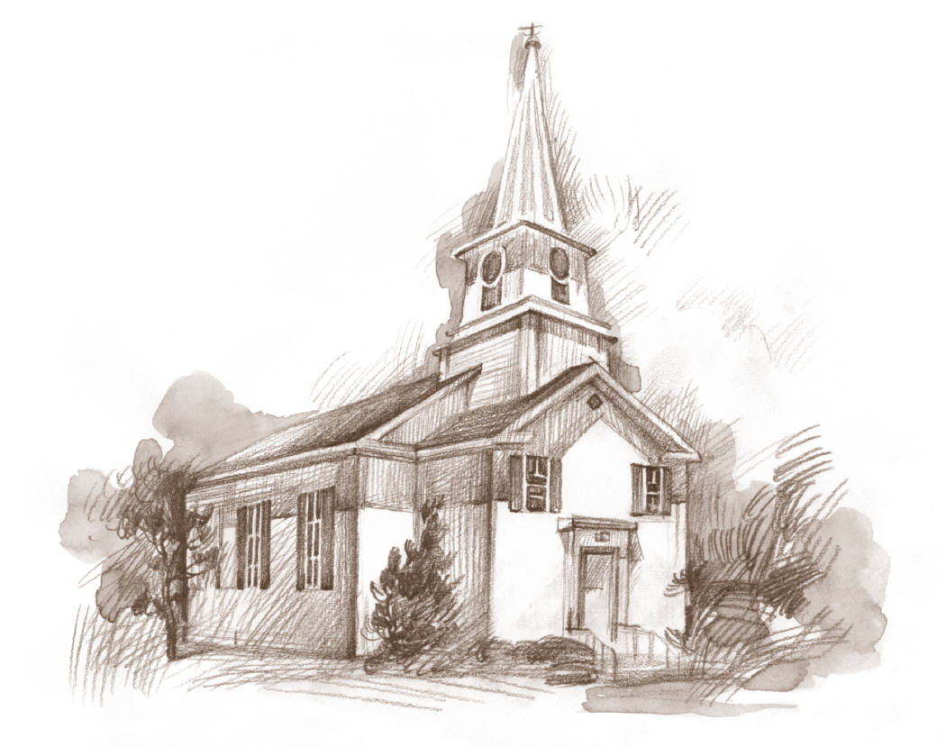
Sincerely,
Victoriano Romero
_______________________________________________________

I want to say thanks for all the facilities that you offer us. All the students are very comfortable.
God bless you.
Sincerely,

Sanjuana Limón

Dear Pen Pal

My aide, Elaine, was our pen pal for this exercise. She wrote one general note to the class, asking questions in her note. Each student wrote his/her own personal response. Many are continuing to write back and forth. Elaine replies, and we deliver the letters during class time. Elaine’s initial letter is given below, followed by the students’ answers.

February 1, 2007

Dear Student,

How do you like living in North Carolina? Is living here what you expected? Have you visited the mountains or the beach?

I hope you will write to me so I can get to know you better.

Sincerely,
Elaine Jones

- - - - - - - - - - - -

Student replies are shown on the following pages.

February 2, 2007

Dear Elaine,
_______________________________________________________

I have been living in North Carolina since 1993, and I expect to live here with my family. I have visited the beach one time and it was beautiful. My children and my husband enjoyed it very much.
And how about you? Tell me where do you like to go on your vacation? If you go somewhere like the beach or mountain I hope you enjoy it.
Sincerely,
Ana Romero
_______________________________________________________

I’m Mariana.
I’ve been living in North Carolina since 2000. I like here because it’s quiet the other places. I’ve never gone to the mountains, but I will be. I hope to go to there one day. And about if I’ve been to the beach? Yes I like that.
I expect to live here for a long time.
Sincerely,

Mariana Marquina
_______________________________________________________

How are you? My name is Sanjuana and I want to say that I like to live in North Carolina because it’s beautiful, very quiet, and I love the vegetation. The first time that I visited to North Carolina I loved this place. I’ve visited the mountains, they’re beautiful. I’ve never visited the beach.
I love to live here. I invite you to visit North Carolina. Please come soon!
Sincerely,

Sanjuana Limón

_______________________________________________________

When did you Come to United States?

Do you like it in North Carolina? What do you like in North Carolina? Do you like the mountains or the lakes? Do you have friends, or family in this Country? I hope to see you soon.

Sincerely,

Victoriano Romero

Notes of Concern
The following are notes the students wrote to Elaine when her mom went to the hospital.
_______________________________________________________

February 8, 2007

Dear Elaine,
_______________________________________________________

Hi teacher. I listened today to hear that your mom had a broken leg. I am sad for you. My aunt broke her leg too ten months ago. For a long time she was at home. I hope your mom recuperates. Soon and I hope you come back to English class soon.
Sincerely,

Min Kim

_______________________________________________________

I am sorry for your mom. I hope she will be well soon. Don’t worry—everythind will be okay. Please don’t do hard things and stay in her home and rest. It was very hard for me to hear about your family.
Sincerely,

Jose Carchi

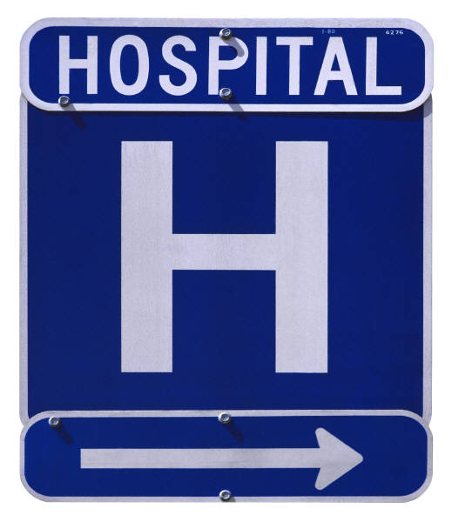

_______________________________________________________

Hi! I hope you are very well. It is very lamentable that your mom’s fall occurred. Please don’t worry because God is with us. I hope for a recuperation soon. I’ll pray for that.
God bless you.
Sincerely,

Sanjuana Limón
_______________________________________________________

I’m sorry for your mom, and I hope. She will be better, and We are said sorry Don’t be worried about the surgery. Itll be Fine. Stay, with her, Miss Elaine. I appreciate you and God bless you.
Sincerely,

Mariana Marquina

_______________________________________________________

I’m sorry teacher. Don’t be worried. God bless you. I’m praying for your mom. I hope she’ll be better soon.
With love,
Marlene Lazo

