A Beach Scene
Deborah Patrick
Surry Community College

Lesson: Descriptive Writing
Topic: The Beach
Level: I did this activity with a mixed-level class
Time: This descriptive writing project was a two-day activity requiring approximately 1-1½ hours per class.

Introduction
I began with an overall, general class conversation about favorite vacation spots. I used some leading questions to elicit student responses: What is your favorite vacation spot? Why do you like it? When did you last visit? Why it is a good idea to take a vacation?

Activity:
I gave each student a drawing of a beach scene showing numerous people engaged in a variety of activities. Beneath the picture I added approximately a half-page of lines for students to use for their writing. The lines help students with neatness and indicate an approximate length for their work.

After students looked at the picture, we discussed the beach, along with what students like to do at the beach and why. Each student then wrote about what he/she saw in the picture, i.e., what the individuals in the picture were doing. During this writing, some of the students discussed their ideas together and helped one another if they could not think of the right word that they wanted to use. Dictionaries were allowed. Writing this first draft took about 1½ hours.

Next, I sat with each student and went over what they had written, making some necessary corrections, but not enough to spoil the original writing. The students then revised their writing. Their rewrite took about an hour since they did not want to make any mistakes.

Upon completion of their revisions, I encouraged all students to read their work aloud to their classmates, but only if they wanted to.

The students turned in their completed work in handwritten form. Selected student compositions have been typed as written to share via In My Own Words.

I explained to the authors of the examples chosen for In My Own Words that background information is important so whoever reads their story will know something about them as a person. They were excited and proud, gladly adding the biographical information that is included with their writing samples on the following pages.
A BEACH SCENE
By Carmen Niemierc
Advanced ESL
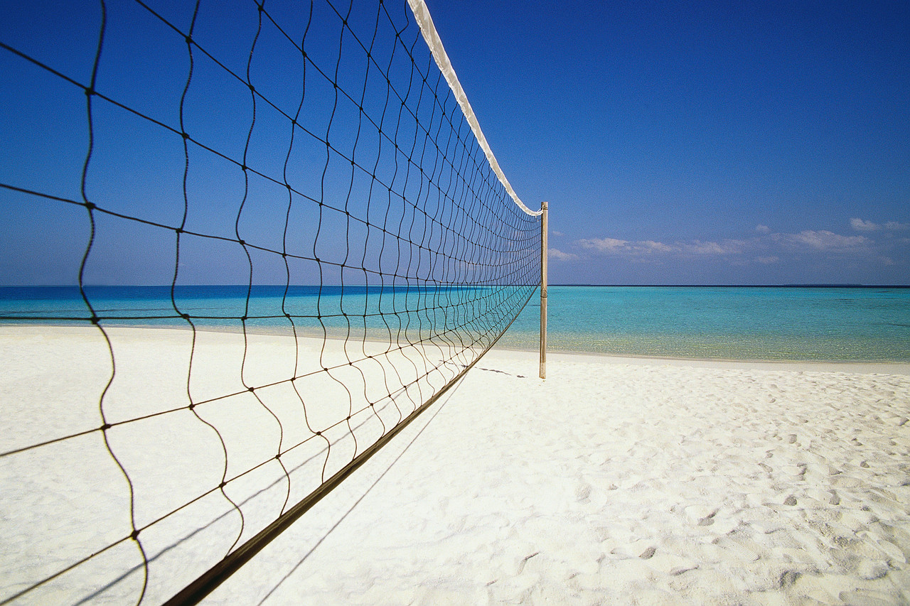
During the hot summer days most of the people try to find relief from the hot weather. So one of the plans is to escape
to the Beach. Parents plan to take their children for vacations, sometimes for a weekend or sometimes for the whole week, that’s depends on the situation. We can spend wonderful time at the Beach. Great time playing in the sand; for an example: the children love to buit sandcastles. The teens like to play volley ball, others prefer to surf the waves. Also, the Beach is a great place to fix a picnic party or a “Luau” party; the mothers can fix refreshings meals, good drinks and everybody can enjoy it as a family. And when the sun is getting down it is a good time to go fishing, so the daddys can teach their children how to use a fishingline and how to catch a fish. I think the beach is a great place to take the family out, is a wonderful place to share, to play and specially to spend time with the people who you love most:
the family.
_____________________
My name is Carmen Niemierc, I am 27 years old and was born in Monterrey, Mexico. This city is a wonderful city, is a really huge city and is located north of Mexico. But for the last five years I have been living in State Road, North Carolina, this is a small town, but it is very quite, it has no comparison to my old city of Monterrey. I spend all my time at home because I am a homemaker and I go to school two nights a week. At school I am taking English class. I am trying to improve my English skills with the purpose of entering college next fall of 2007. I will like to take the RN program. I am getting prepared to take the CPT in the next three months. I have a 4 year old little boy, I spend all my time playing with him, and teaching him different activities, and what is loves the most is playing games on the computer.

A BEACH SCENE
By Fredy Orozco
Intermediate ESL

The people are on the beach. Some people are swimming and two people are plays with a ball. One man is singing and is using a guitar. A man and a woman is taking the sun.
A boy is building a castle of sand. A woman is shouting for help. Two people cover with a umbrella from the sun.

Two birds are flying over the ocean. Two people are covering a man or woman with sand.

Everybody is observing the lifeguard. In short everybody enjoys a day of fun.

_______________
My name is Fredy Orozco and am from Guatemala. I like to listen to music, play soccer, watch TV and read books. I like my class, because I need to learn English so I can get to know more English speaking friends

A BEACH SCENE
By Maria Duran
Intermediate ESL

The family is going to the beach.
Some people are playing ball, and other people playing with fiishus. Two people swimming in the water. The woman is resting on the towel because the boy is playing the guitar. The woman is having a picnic with her husbend. The are two women talking to the man by the lifeguard waches the people. There are two people covering a other person, with the sand. The children not to get out of the boat. The boy has a surfboard in the water he is not scared. The boy and girl lay on the towel to catch sun. The are two bird in the sky. The crab’s walking on the sand.

___________________
My name is Maria Duran. I am from Mexico. I like to go to school. I like the class because I can learn English so I can help my girls. I would like to a new career once I have learned more English.

A BEACH SCENE
By Maria Grande
Intermediate ESL

On day my family and I went to vacation. At the beach everybody went to buy Swimsuits. I am planning a picnic on the beach, The women are cooking, On the beach my friends and I play ball. The childrens swim a lot, And lifeguard watches everybody, After we play and build sand castles, My brother plays the guitar. He sings Pretty. My dad relaxes and studys a book, There are to many pretty girls on the beach! The beach is big. And a lot of fun By the time we went home everyone was exhausted.

______________
My name is Maria Grande. I am from Mexico. I like to study English. What I like most about class is to learn English. I enjoy my class.

A BEACH SCENE
By Maria Vidal

The Beach is a favorite place for the people, when they think on vacations, because they can do differents activities. A lot of people enjoy to take a bath of sun, while they are reading a book or playing the guitar, other people bring a tape-recorder to listen to music while eat lunch. In all the Beach there are lifeboat for the security of all people. So the mothers playing safe with your children in the water. The children are building castles, of sand they enjoy to ride bicycle around the Beach. So the people come back, to home happy and relaxing after a Beach day.
