Special Customs and Holidays
Jan Fisher
Pitt Community College

Level: Low Intermediate – High Intermediate
Objectives: Students speak and write about a holiday or custom specific to their native country.
Time: Allow 2-3 weeks for this project, depending on the number of students in your class. This was not the only activity we did each day. You need a couple of weeks to fit in the presentations and work on written corrections. My class likes to eat, so we spaced the presentations out to ensure good food each day.

Preparatory Activities: We used the text Celebrate with Us by J. H. Kennedy to read about the 4th of July. I did specific vocabulary for the celebration and followed up with a local newspaper article about events planned in the area.

Introductory Activities: Following the July 4th break, I broke the class into small discussion groups to talk about each student’s observations and activities. In these small groups each student described Independence Day celebrations in his/her country. Then as a large group, we discussed similarities and differences.

Core Activities: I formed small discussion groups for three or four students, making sure to mix native countries/languages in order to maximize the use of English. Then each student described a special holiday or custom unique to his/her country. Finally, I had the students write, based on their small group discussion, a brief description.

Each student was assigned a day to do a class presentation on his/her topic. I encouraged students to bring in visuals to help explain the custom/holiday. Some low intermediate students matched up with high intermediate students to do joint presentations. Students wrote out their presentations and I helped them with corrections. Vocabulary was unique and required a lot of dictionary use. We used the text The Oxford Picture Dictionary (page 168) as an additional resource.

At the intermediate level, I have a broad spread of writing abilities. Some students were only able to write 5 or 6 sentences about their holiday/custom and some wrote a page or more.

Samples of student writing follow this lesson plan. (The students submitted their work in handwritten form: I typed the student writing exactly as it was written for inclusion in the project In My Own Words.)

Mexico’s Day of the Dead
Blanca Tinoco

November first is a special day for the dead children. On this day, people go to the cemetery. They take beautiful different colored flowers, special dead food (for example: dead bread) and typical Mexican food, CD music, Mexican bands (mariachi, trios, banda) it depends on the people. If the people have money, they can bring to the cemetery a big Mexican band. The people clean the tomb. Some people are in the cemetery all day and all night and they eat in this place. November second is a special day for the dead adults. The custom is similar but on this day it is typical for the adults to drink beer, they make a big party in honor of the dead person. In Mexico on this day there is a big party in the cemetery.

I’m Blanca Tinoco. I’m from San Luis Sonora, Mexico. I’m single. I’m an accountant. I’m studying English at Pitt Community College.

Korean Lunar New Year
Eunyoung Jeon

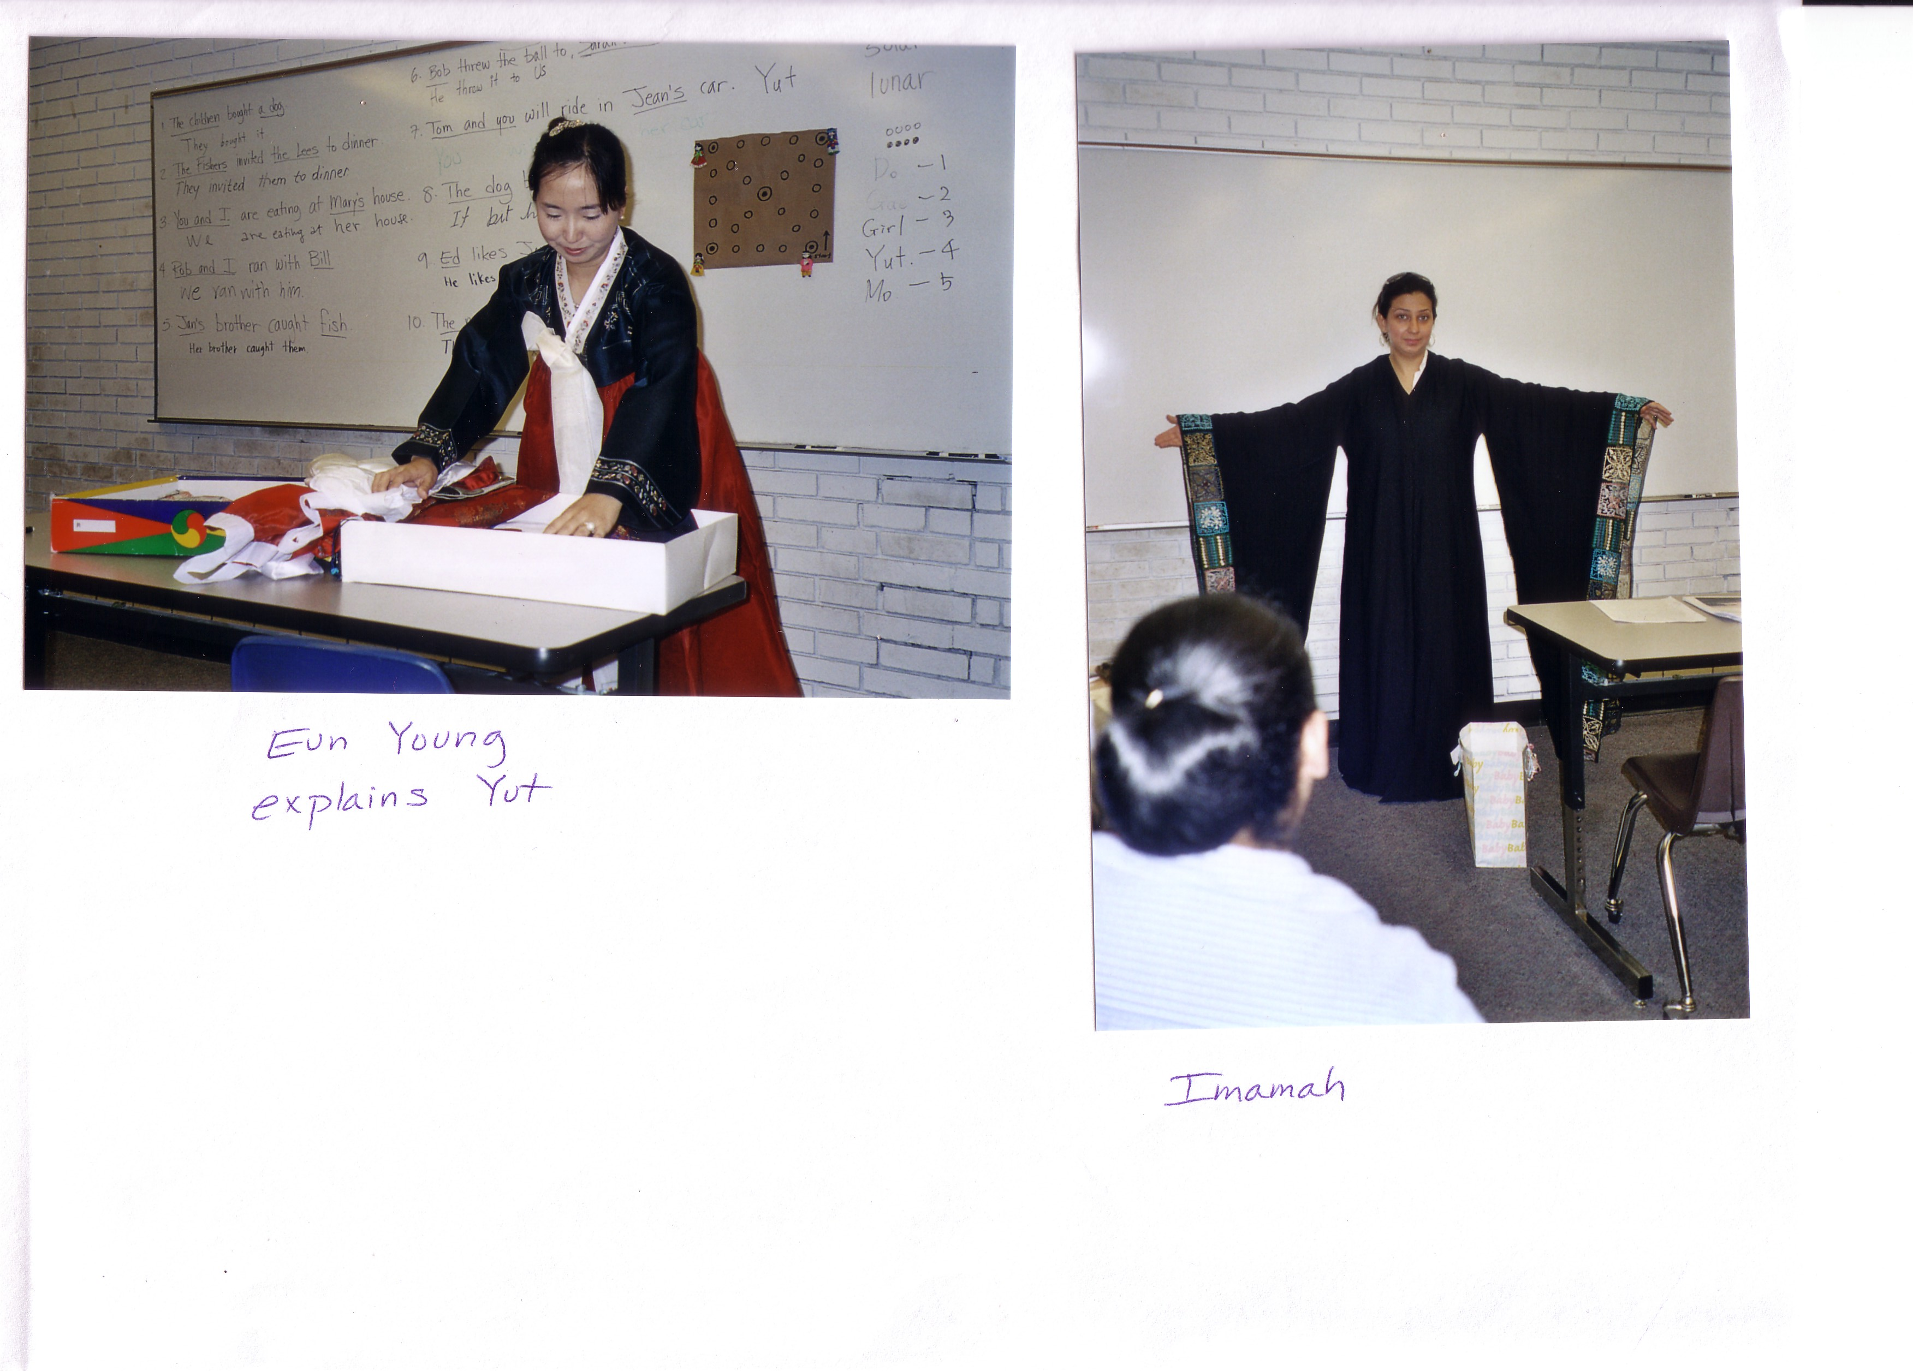

I’m going to introduce my country’s special holiday to you. First, Korea has two calendars. On is a solar calendar like America. The other one is a lunar calendar. Korea has had the lunar calendar from ancient times. However, generally Korea has used a solar calendar. But when they have a special holiday Korea uses a lunar calendar.

Korea has two special lunar holidays. One is the New Year’s holiday on January first. The other one is giving thanks to our ancestors on August fifteenth. The second is the same as Thanksgiving Day. But it (Thanksgiving Day) is due to a lunar calendar. My country’s holidays are almost solar. However these special holidays are lunar.

I want to introduce all of them. But is is impossible because I need too much time. So, I have to choose one. I’m going to explain the New Year’s holidays: lunar & solar.

Korea has one day for the holiday when the New Year starts. It is the same as in the U.S. But I have just one day on January first of the solar calendar. Then I have three days for the Lunar New Year. It will be in February this year. On the first day, people usually go to their hometown. There is too much traffic on the express ways but they want to go back to their hometown. They want to meet their parents, relatives, and old friends. In ordinary times, from Seoul (Korea’s Capital) to Busan (a big city that most people live in) takes five hours by a car. But on this day it takes thirteen or fourteen hours.

When they arrive at their home, Korean women prepare the fruit, fish, meat, vegetables, and food, etc. And they make the food for an ancestor-worship ceremony. The ceremony requires things from the sea, the land and the mountain. It means that Koreans repay their ancestors for the favor that year.

The women make a bar of rice cake. It is specific food for the New Year. It is rice cake soup. I slice the rice cake, beef, and fried eggs, etc. Korean women have to do so much housework on this holiday. So some women hate these holidays because there is so much work. I couldn’t understand this before I got married. But now I understand fully.

On January second of the lunar calendar, people hold a memorial service for their ancestors in the morning. And then the family eats a bowl of rice cake soup all together. It means they grow older (just one year). In the U.S. I grow older on my birthday. But my country’s custom is different. A Korean becomes older on New Years day.

After that, I wear the traditional Korean clothes (Hanbok), and I bow on ceremonial occasions to my superiors (for example, my parents). Then my parents say well wishing remarks.
“Be healthy.” “Make much money.” “You will be O.K.”
The children receive money for bowing to their parents, relatives. And then, people visit their ancestral graves and relatives. It is like Memorial day.

After all of this, the family plays a game of ‘Yut’. ‘Yut’ is the four stick game. I need four wooden sticks about twenty centimeters, eight markers (I use buttons) and a game board. The number of players doesn’t matter.

First I divide people into two teams. According to the order, one person throws the four sticks to the floor. One stick is turned inside out and is called “Do’. The marker moves forward one point. Two sticks are ‘Gae’. Three sticks are ‘Girl’. Four sticks are ‘Yut’. Four sticks aren’t turned inside out and is ‘Mo’. The marker moves forward five points. The markers return to the beginning, a game of ‘Yut’ is finished. It is the winner of that team who returns first. My family always plays “Yut’. We make a bet with a little money on the game. The winner receives the money, and he buys chicken or pizza. Therefore we eat them joyfully.

In conclusion, on this holiday people meet parents, relatives, and friends. And they praise their ancestors out of respect. I think that is a good and pleasant holiday.

My name is Eunyoung Jeon. I am from Korea. I am an ESL student. I am studying English. I hope to speak English very well.

I am married. I have been married for four years. I have a daughter. I was a primary school teacher in Korea. I taught for five years.

La Quinceañero
Yohana Clark

My name is Yohana Clark and I am from Honduras, Central America. This is one of the customs we celebrate very often, a girl’s 15th birthday. We celebrate the first fifteen years, only for the girls. We call it “La Quinceañero” like sweet fifteen. Usually she has to dress in a beautiful pink dress for her ceremony in the church. Her parents, relatives and invited guests pray for her life and her future. On this night, she has a court of 14 girls. All of the girls dress in the same color too. Usually the ceremony is at night time. First the ceremony is in the church and then afterwards they have a big party in a hall. Here she has to dance with her father at the ball. Later, everybody dances to modern music and eats.
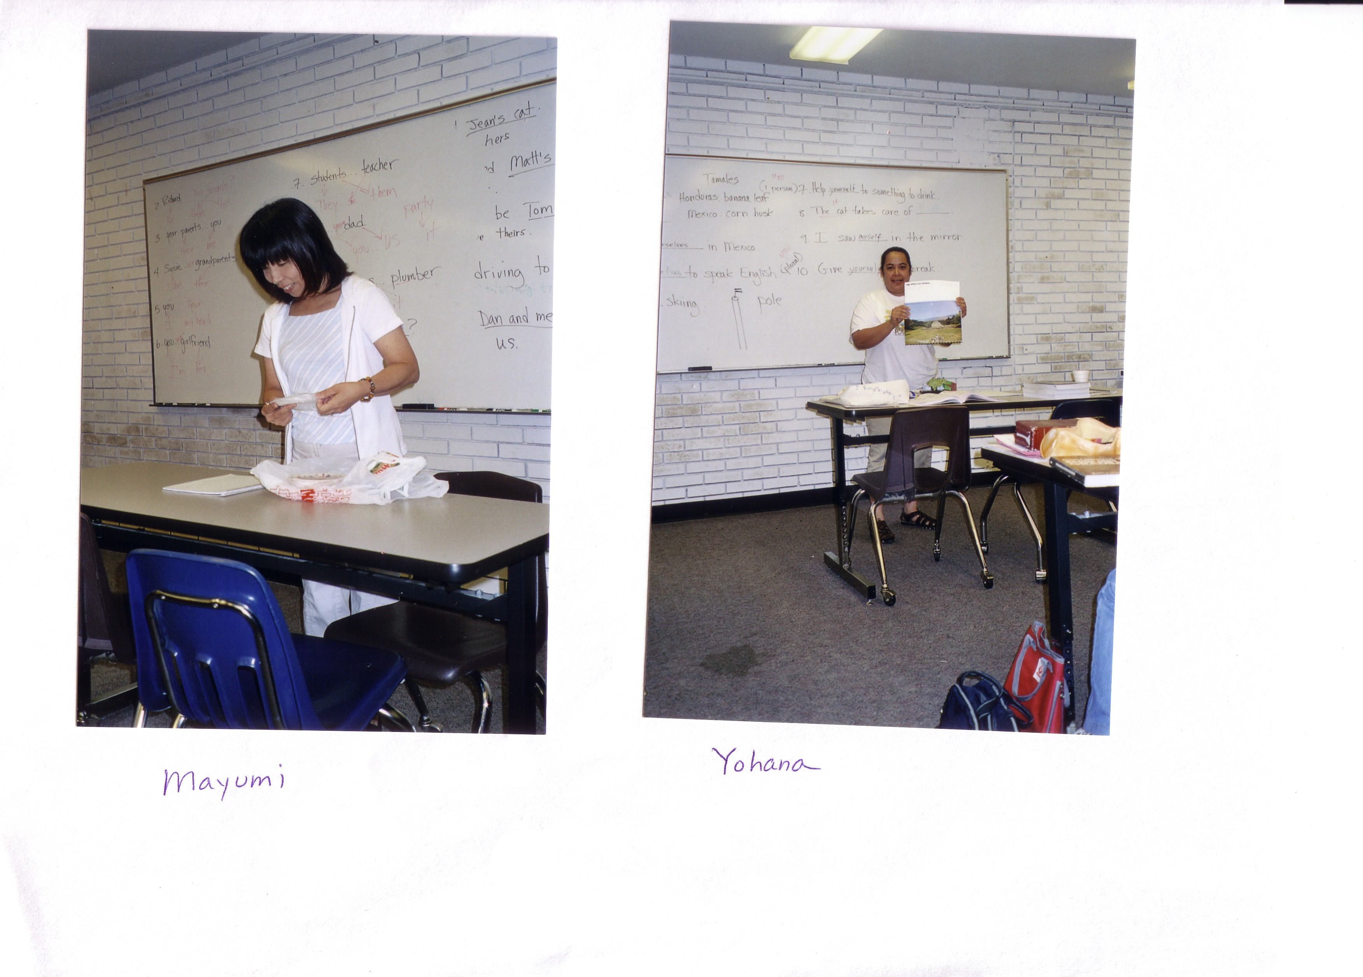

My name is Yohana Clark and I am from Honduras, Central America. I am married and I have lived in Greenville 6 years.

Eid Alfetr Almubarc
Imamah Samman

First of all, I would like to introduce my country’s special holiday which is called in Arabic Eid Alfetr Almubarc. All the Muslims around the world celebrate this holiday. However, my country celebrates this holiday in its own way.

To begin with, this holiday comes after the holy month which is the month where people fast. During this month, people concentrate on praying and preparing themselves. For example, some people change the decorations in their homes or the furniture or buy new things. However, the most common custom is to buy new cloths, luxurious chocolate, and some desert. Furthermore, every one must give the poor people money, clothes, and food. By the way, this holiday continues for seven days. Nevertheless, the general celebration occurs in the first three days.

On the first day all of the people have to take a shower, put on their new clothes, and spray perfume (like a bride or a groom). Then they go to the mosque to pray and congratulate each other. After that, every family meets together in the family’s big house to have breakfast which is called in Arabic debyaza which contains raisins, dry apricot, almonds, and hazelnut.

In the evening, the whole family starts to visit each other. The guests are served juice, Arabic coffee, luxurious chocolate, tea, and some desert. Also, the young people must visit the older people. So, the older people have to say at home for the guests. However, they can start visiting the next day even the same person who already visited them. Beside, most of the families make a schedule for dinner each day in different restaurants and houses, or they can rent a farm or villa with a swimming pool and field to do some competitions and play different games.

There is something very important without it the holiday will be tasteless, which are the gifts. The oldest people must give money to the children and the single girls. Also, the young people can give money or gifts to the older people, for example, the mother and the grandmother. However, sisters, brothers, and cousins exchange only gifts.

In addition, almost all the restaurants are open all night. Also, there are some festivals that take place during the holiday including fireworks, singing parties and all kinds of competitions.

In summary, during this holiday you will not find anyone angry or having problems with anyone else (if he is a normal person).

My name is Imamah Samman. I am from Saudi Arabia. I am studying English at PCC so I can go to the university. My husband is a student at ECU. I have one son.

Shichi-Go-San

Mayumi Sugiyama

I am from Japan. A special custom is “Sichi-Go-San.” Shichi-Go-San means seven, five, three years old. We wish growth and health for our children.

The boys wear Hakamas and the girls wear Kimonos. They go to a shrine with their parents and their grandparents.
For my Shichi-Go-San I went to a shrine together with my preschool classmates. The teachers brought preschool kids. It was popular when I was a child. Now, each family celebrates Shichi-Go-San.

My name is Mayumi. I am from Japan. There are four people in my family but my son lives in Japan by himself. I want to speak English well.

