Shaped by Tradition:
Home Remedies, Holiday Celebrations, and Family Heirlooms
By Lynn Franklin and Pat Wepprecht
Brunswick Community College

Topic: Family traditions help shape us into the person we are. This assignment lets students share personal information by looking at home remedies, holiday celebrations, and family heirlooms.
Level: Mixed
Objective: Students will learn new vocabulary for talking about home remedies, holiday celebrations, and family heirlooms.
Time: The time requirement for this topic varies from two to three classes. Each class lasts for two hours. Some students take all three meetings and others use one night in class and take much of it home. When they return they have completed their writing and are ready to cut out pictures or illustrate their writing. It works well to have two instructors so one can finish up with the writing while the other continues lessons or discussions with students who have completed the assignment.

Brainstorm: Have students brainstorm about what traditions are. Let them talk in small groups first and then have someone write on a board or white board. Shy students will begin to join in as they see others participate. Move from identifying the meaning of the word “traditions” to naming some individual family traditions in the areas of home remedies, holidays, and heirlooms.

Vocabulary: The class identifies the needed vocabulary as we talk about the topics. Ours is a mixed class and the more advanced students drive the conversation. Students then use the generated vocabulary to write their stories. The vocabulary list developed by this class is given below.

Vocabulary for Home Remedies | Vocabulary for Family Traditions
Gil’s dad set his collarbone | New Year’s Easter
Lemon/alcohol on cuts | Tamales camp on beach
Tobacco on a cut-Vietnam | wear new clothes no cooking
Salt on a cut | shoot rifles Christmas
Lemon juice for clear skin | Mother’s Day mole
Tooth paste on a burn | dance, gifts posada
Urine for cuts | all go to mom’s house
Rock and Rye soaked candy for colds | Day of the Dead
Onion on a cut | light candles
Spider web and coffee grounds for cuts | make cookies

Vocabulary for Family Artifacts
Family pictures
Grampa’s boots
Baptismal Dress from a wedding train
Dad’s jacket to remember him by

Draft: After students finish brainstorming and listing vocabulary, have them begin to write. Allow students to compose in whatever language is most comfortable for them. Many will compose better in their own language and the writing will flow better. For beginning students or those not literate in their own language, it works very well to let the student dictate their story in their own language or in English while the instructor writes it.

Collaborate and Revise: After they have written their stories in their own language, allow time for students to search for vocabulary in dictionaries. They may ask for help getting the syntax correct for English. Some of their peers may be able to help, and this kind of help should be encouraged.

Illustrate: Students may cut out magazine pictures or draw pictures to illustrate their written work.

Heirloom Presentations: I would encourage instructors to allow students to bring pictures or actual artifacts to class for a “show and tell” type of sharing. This was a solidifying moment for our classes. Each of the students shared without worrying what others would say, and it helped the whole class to become more unified.
When I was a kid
By Gil Aquino

One day I broke my collarbone playing football with my friends. My father fixed it with his hands, and 3 days later he checked me again and he put more medicine on it.

At Christmas our traditions are making cookies and mole and breaking piñatas. Yes I like the old traditions.
Then on New Year everyone shoot rifles and we live a good year together.

Graphics from Microsoft Clip Art and Media at www.office.microsoft.com
When I Was a Kid
By Lauro Aquino

When I was a kid my dad bought me one watch to remember him. When I cut my hand my Mama put lemon/alcohol for remedies.
On New Year we break piñatas. On New Year’s Eve we shoot rifles and drink soda.
On Nov. 1 Day of the Dead we light candles and special food, tamales, mole and drink sodas.

Graphics from Microsoft Clip Art and Media at www.office.microsoft.com
When I Was a Kid
By Erika Martinez

When I was a kid I played with my cousin. If I fell my mom cured my knees with hydrogen peroxide. If I got sick with a cough she gave me lemon and honey.
We celebrated Christmas and New Year’s with a feast. The Three Kings Day my presents were clothes and a doll which cried. I liked this.

We celebrated Mother’s Day with presents for her, food and cake, everybody was happy. We celebrated special days all together with my family and dear friends.

Graphics from Microsoft Clip Art and Media at www.office.microsoft.com
Working Draft
On the birthday we are accustomed to prepare mole also we are accustomed to selabrat the day the Dead. This is one of the more most well remembered customs mom utilize the homade remedy. For anything for cots pot aspiderweb and coffee on the cot. To for tha cough we utilize honey y lemon.

Customs from Childhood

On our birthday it is our custom to prepare mole, also we are accustomed to celebrate the Day of the Dead. This one of the most well remembered customs.
Mom utilized home remedies. For things such as cuts we put spider webs and coffee on the cuts. For a cough we utilize honey and lemon.

By Yolanda Delgado

Graphics from Microsoft Clip Art and Media at www.office.microsoft.com
When I Was Young

By Huong Liptok

When I was a young person at home in Viet Nam, my finger got cut. Blood came out a lot, so my mom put some tobacco on so the blood would stop but it hurt so much. I remember she said to me that next time you must be careful.

On May 5 all over people would go to the beach to get wet. They trust in the Holy. On May 5, it will give them a lot of luck and all their sicknesses they got will go away, and they do not eat hot food.

On Easter day we quit work, only relax. Everybody came to Mom’s home to lunch and drink and talk together and take some pictures together.

On New Year some like to wear special new clothes for three days if we are able to do it.

Graphics from Microsoft Clip Art and Media at www.office.microsoft.com
Traditions
By Elfego Cardoso

On December 24 our tradition is to have posadas in our houses. We have parties, eat foods like candy and cake and give gifts.

On May 10 th to the 16th we celebrate our mothers. We play basketball and dance. On the 16th th the son takes his mother to the kitchen and serves his mother her dinner.

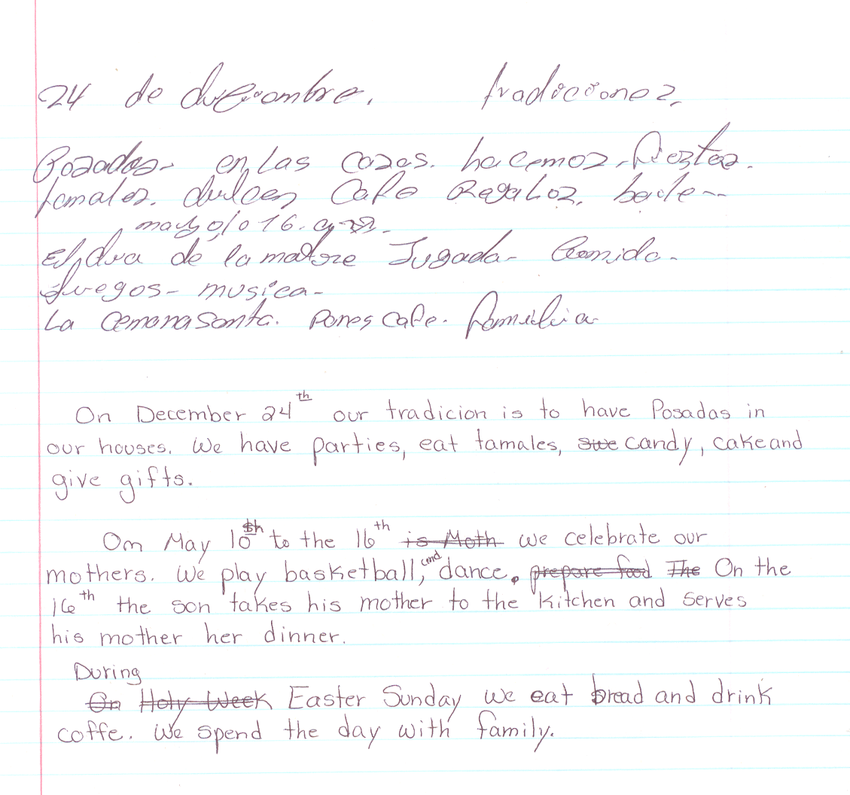
During Easter Sunday we eat bread and drink coffee. We spend the day with family.
Graphics from Microsoft Clip Art and Media at www.office.microsoft.com

OUR CHRISTMAS EVE

I remember, when I was a child, how my family would have fun at the Christmas season. They chose a house, like my grandma’s house, and each person chose one thing to do. Somebody cooked rice and beans and pork. Some others made cake, traditional desserts, bought beer, rum, etc.

Christmas eve was the first family reunion we began at 7:00 PM with music, everybody was dancing and lit fireworks. At 9:00 PM everybody went to the dining room and everyone served their own food and gave thanks to God and started to eat.

At 12:00 AM everybody went to their own home because Santa Claus was coming for everybody.

MERRY CHRISTMAS!

By
Juan Diaz
Graphics from
Microsoft Clip Art and Media at www.office.microsoft.com

When I Was a Kid
By Anastacio-De La Cruz

I remember when I was a kid what happened was I cut my knee with a rock., and my Mom put a bandage and we went to the hospital.

On the New Year we celebrate with music together. My family eats mole and drinks beer and tequila and soda.
Graphics from
Microsoft Clip Art and Media at www.office.microsoft.com

