A Quilt Story

Fond Memories of Childhood
in our Countries

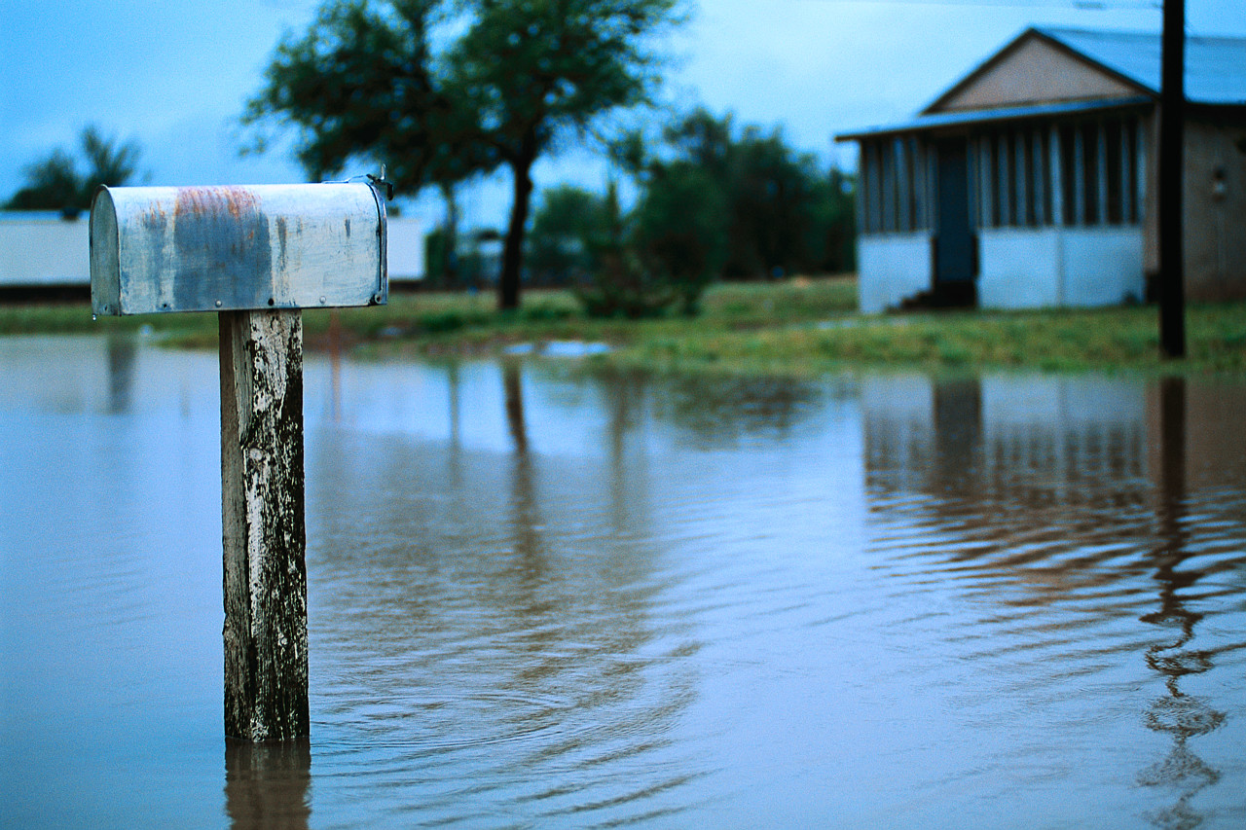
Graphics from Microsoft Clip Art and Media at www.office.microsoft.com

A Quilt Story
Instructors: Kathryn Mayton, Joyce Yonke and Leigh Goroski
Volunteer: Rhoda Brown
Wayne Community College

A quilt is a lifetime keepsake, and a “quilt” of student writing makes a special keepsake for a class.

Lesson: Descriptive Writing
Topic: One Fond Memory of My Childhood in
My Native Country
Level: Can be used with a multi-level class
Format: Our class meets four days per week, four hours per day, in a lab type class.

Introduction of topic: Our class is a lab where students work individually and come to class at different hours on different days. The students’ schedules dictated the time spent on this writing assignment. Each student was given the topic, written in English, within a one-week time period. A verbal explanation was given about the topic, which was selected for the lesson as a way to generate conversation and interest. At least 45 minutes were devoted to group discussion on writing development, meaningful writing, revision, and writing for enjoyment (joke, poems, music). Instructors gave assistance in how to start the writing process (start with what we know about the subject), brainstorming words, using brainstorming words in sentences, and using pictures to help with sentence structure. Our students had the option of not doing this assignment if they were working on other assignments of interest to them at the moment.

Previous class work: Students in our class are used to instructors conversing with them and asking them--on the spur of the moment--to do assignments that are not on their Individual Education Plan. For this assignment, there was no specific preparatory class work.

Approach: When our students do an assignment of this type, they are generally worried about correct grammar and composition and want instructors to help them right away. Instructors wanted student submissions to be in their original form, as there is a great charm and simplicity in the storytelling that comes from language and grammar as the writers currently use it. Some students may have done a draft or two on their own, but instructors did not assist.

Student Submissions: Students’ original submissions were hand-written; one even included artwork to illustrate the story. The stories were typed later legibility. A sample of the students’ stories that make up the Childhood Memory Quilt for our class is included on the following pages.

Subsequent class work: When students submitted a story, instructors gave them back a copy and then provided individual assistance in making corrections in form, content, and grammar. This process generated additional conversation between students and teachers about family and cultural norms.

Surprises: The only surprise was the art that illustrated one student’s work.

Evaluation: We think students really enjoyed this assignment! In repeating this project with another group of students, we might ask everyone to do artwork on their story. We could provide magazine pictures, markers, and similar resources for their use in illustrating their work. Working together in this way tends to generate relationships, bonding, and much-needed conversation between students and teachers.
My Tenth Birthday

My fond memory of my childhood in my country was my birthday, when I reached the age of ten. It was an unforgettable day. I felt so happy because it was the first time my parents did a big party for me where there was food, birthday cake and many things. My whole family was happy with me. I received presents from my family and neighbors. It was a special day in my life.

Jovel Escalante
Guatemala
Advanced ESL Student

Graphics from Microsoft Clip Art and Media at www.office.microsoft.com
Learning to Swim

When I was a little girl, I said to my father “I would like to learn to swim.” Then he told me, “ok go ahead” and he pushed me into the river. Then he started to tell me how to move my arms and legs. Next I learned to float in the water. I felt safe, trusting and happy. My father was happy when he saw me float. After that he entered the water and showed me how to swim.

By Jeshua S. Cortes
Mexico
Advanced ESL Student

“I like to sew cloth.”

Graphics from Microsoft Clip Art and Media at www.office.microsoft.com
Flooding

When I was growing up in the Philippines, we stayed in my grandparent’s house. We lived at a nearby barrio with my mother, my sister and my brother. During wet season, we experienced the flooding. Being a kid, it was fun playing on dirty water with my childhood friends. We were swimming, riding on a boat and playing water games. This was without the knowledge of my mother. But eventually she found out that I went out with my friends and she warned me not to play on the water because it’s dirty and there would be a chance that I might get sick.

Flooding is considered normal. It happens once or twice a year. The older folks were panic because of its danger, however for the young generation it was fun and attractive to play in regardless of the danger brought by the flood.

By Virginia B. Terhaar
The Philippines
Advanced ESL student

“When I moved here to the United States and got married I like more to stay home and manage household chores. Aside from that, I’m taking a chance to go to swimming pool twice a week. I like swimming very much as my favorite sport.”

Graphics from Microsoft Clip Art and Media at www.office.microsoft.com
School

I remember when I was young in Mexico and I was in the 4th grade the teacher passed me from 4th grade to 6th grade. They gave me a voucher, a voucher is a thing that the teachers give you when you are smart and they pay for everything. They took me from the place where I was living to another place five hours away from my home. I was there for one full year and they were paying for everything. But when I got out of middle school in Mexico and came to the USA it was just me and one of my brothers. So I could not go to school because I had to work so I can pay for everything I need so I could live. I was not able to go to school until now. I’m in school and I am so, so proud.

By Pablo Flores Venegas
Mexico
Beginning ESL Student

“I love to go to the beach with someone special and have a cookout at night.”

Graphics from Microsoft Clip Art and Media at www.office.microsoft.com
The Rooster

Hi! My name is Soveyda Aguirre Campos. I come from Mexico. I am 33 years old. Let me tell you about my fondest memory. I miss my friend, her name is Reina. We had fun getting into a lot of mischief when we were younger.

I remember especially one time we was seven years old. We were trying to kill a famous fighting rooster. It all started when the rooster came to my friend’s home. The famous fighting rooster was trying to kill her rooster and she got mad. My friend asked me, “Soveyda, what should I do?” I told her to kill it now! Then we went into the kitchen and I tried to kill the rooster, but I was unsuccessful. I was failing. My friend tried and she failed too. We tried together and we still failed. Finally, at last my friend used a big machete and tried to take off its head. We were all afraid (we didn’t kill the rooster), but it was still alive. So we all agreed to throw the rooster on the highway and forget what happened.

By Soveyda Aguirre Campos
Mexico
Intermediate ESL Student

“I like conversation and talking to different people.”

Graphics from Microsoft Clip Art and Media at www.office.microsoft.com

