Home Remedies
By Mitch Million
Siler City Center, Central Carolina Community College

Topic: A remedy from your homeland
Level: Beginning Literacy
Time: These submissions were done during one 3-hour class session. Our class meets 6 hours per week.

Discussion: While talking with the students several weeks ago the topic of home remedies came up. The students were eager to share their treatments for various common ailments. I decided that because the students were so vocal with their input, the remedies should be recorded.

Writing: Each student was asked to write about the topic A REMEDY FROM YOUR HOMELAND. The responses that follow are in their raw form. At a later date, the responses will be corrected during a session on grammar. The purpose of this assignment was to get the students to write down what they had just spoken.

Surprises: The greatest surprise was the students’ response rate. Even students that are normally quiet in class spoke freely of their remedy.

Follow-up: I plan to try several of these homeopathic ideas and will report the results to the class!

Home Remedies

When I was a child, got sick at asthma my mother put on my chest and back Vick Vaporud and boil onion, honey with water to drink every morning and night. Too, to drink fish oil and milk with a drop of petroleum.

My name is Elias Zarate Amador
I am from Oaxara, Mexico

_______________
Elias has been in Siler City for several years. He decided that he needed to take ESL classes so he could help his children with their homework assignments.

Graphics from Microsoft Clip Art and Media at www.office.microsoft.com
Home Remedies

For diarrhea people make a tea From a head oF garlic with a liter oF water. Boil the garlic For 10-15 minutes, then drink it all and wait.

Nov 20, 2006
My name is Espranza Ocampo Rico Edo oxaca

________________
Esperanza is shy, but determined. She comes to class when she can and always gives 100%.

Graphics from Microsoft Clip Art and Media
at www.office.microsoft.com
Home Remedies

When I as sick as a child, I got stomachache, my mother made medicine with the ingredients:

1 Egg
1 Soup Spoon Coffe

5 Leaves Lemon
Rubbing alcohol
and ashes.

She mixed egg, coffe, Lemon Leaves, after she put it, on hot ashes, when it was tepid she puit it on a cloth and wet it with alcohol. and after put it on my stomach.

My name is: Maria Suyapa Ortiz
I am From: Honduras, C. A.

____________________
Maria is a single mother who enjoys learning. She is proud of her Honduran heritage, but is becoming more "Americanized" by the week.

Graphics from Microsoft Clip Art and Media at www.office.microsoft.com
Home Remedies
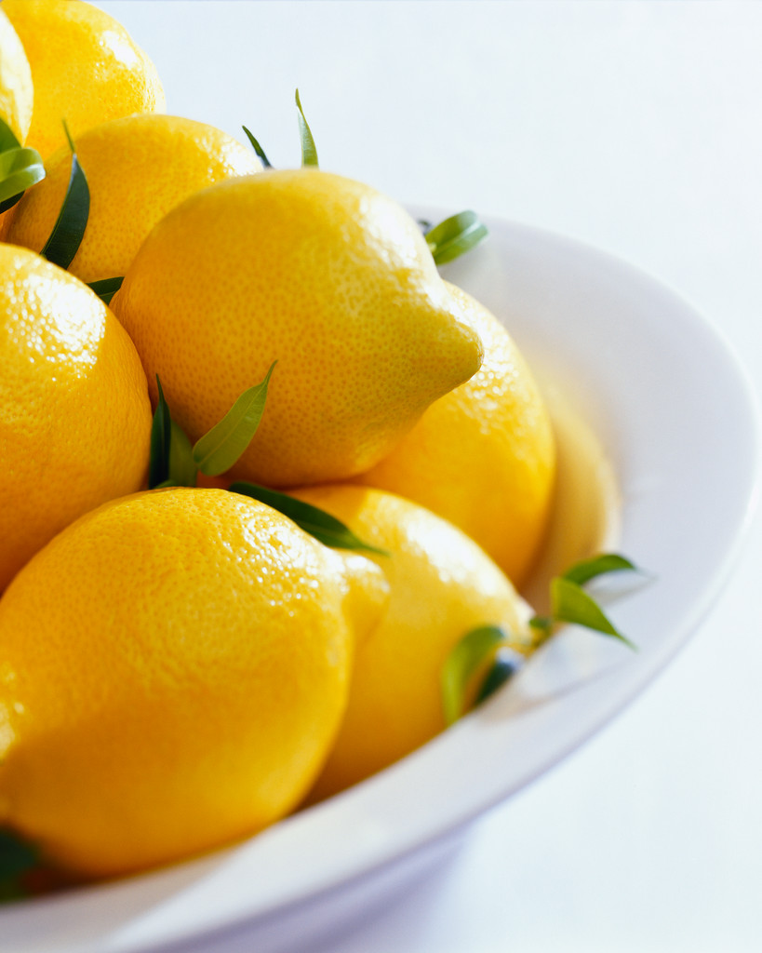

When I was sick I was Ten years old I got sick with Fever and cough. We did not have doctor in My Village. My mother cured me with Tea From Cinnamon, honey and Lemon mixed it gave me a drank and in small cloths damp in front and chest and cure me.

November Twenny Two Thousand Six
My name is: Patrica Manrique Castro
I’m From: Mexico City State Hidalgo

____________________
Patricia has been in the Siler City area for about one year. She has made great strides in her pursuit of the English language. She comes to class every night that she can.

Graphics from Microsoft Clip Art and Media
at www.office.microsoft.com
Home Remedies


When I got sick a chid of stomachache my family gave me a ruda tea and when I got sick of a sprain foot my frend put one bandage end other time I got sick of Sore throat my family gave me water whit salt for I did gargle with that and when I am was burns my fingers my mother Said tomatoes put on

My name is: Juan Benitez
I am from: Mexico, Tuanaguato.

________________
Juan has been in Siler City for several years, but he had not studied English until this past year. His oral comprehension is quite high for a beginner, and with a little work, his written work will improve greatly.

Graphics from Microsoft Clip Art and Media at www.office.microsoft.com
Home Remedies

Hello.
My name is: Ofelia Reyes
I am from: Guerrero Mexico

When I was a little girl and I got sick or something hurted, my mom cured me with remedy’s home
For example:
For throat pain, put above a pice of cloth. 2 fried tomatos with Vick Vaporub as hot as they can get.

For a burn, she cured me with onion above the affected part.

I am grateful and I thank our teacher Mitch Milion for giving us the opertunity to remember or expresse how our ancestors cured us when we were Kids with remedies home or naturals, there for we can Shair some of these with you and keep our traditions alive.

NOV. 20, 2006

_______________
Ofelia has been in Siler City for many years. She started taking ESL classes so she could help her children with their homework.

Graphics from Microsoft Clip Art and Media at www.office.microsoft.com
Home Remedies

When I got ick with burns a clean put on olea vera, toothpast, and rib Fat.

Nov. 20-2006
my Name is.- Sergio Galindo
I am From.- Guatemala

________________
Sergio has been in Siler City for about 5 years. He works in the shipping/receiving department at Townsends, and he says that ESL classes have helped him at work to communicate with others.

Graphics from Microsoft Clip Art and Media
at www.office.microsoft.com

