Echoes from the Past

By Zsofi Teleki
Blue Ridge Community College

Lesson: Writing Practice. In this class, we do written expression often, varying the topics.
Level: TOEFL class
Time: Our class meets for 2 hours every week. Class time for this writing was about 45 minutes. Some recopying or finishing was done at home and returned the following week.

Preparation: I introduced this writing project by talking about the importance of memories and how strong a force they are in our lives. The first thing I asked the students to do was to close their eyes and let themselves feel the memory that rose to the surface. Then they made notes on paper of the feelings, sounds, colors, smells, joy or sweetness. I gave them samples by writing my own memory pictures on the board. These are the sort of examples I wrote when I asked them to close their eyes and let the visions of childhood float to the surface:

I see a soft sun-washed landscape, houses painted a soft yet vibrant yellow, their shutters open to let the sun flood the rooms within, white sails bobbing on silken waters.

I paddle madly around the boat with a rope around my waist, the other end of which is firmly in my Father’s hand.

I see rain beating on the window, drenching the winter gray city, but I am warm and safe nestled between my grandmother and aunt under a voluminous blanket listening to stories of the past.

Then I asked them to start weaving their own words into their own story--NOT using the same structure as mine of course. Some students connected the influence of their echoes on their present.

Drafts: I allowed only two drafts and made minimal corrections. Each student, of course, wrote his own paper.

Corrections: I walked around among the students and talked with them while they were writing, making suggestions and asking questions to make sure they were on the right track.

Final format: The students hand-wrote their papers, except for the one who typed because of a hand injury. Pictures were taken at a later date.

Presentation: Copies were placed on a bulletin board to share with other students and visitors. Selected samples of student work are included at the end of this lesson plan, typed to reflect the spelling, punctuation, and paragraphing that the students used.

Surprises: The surprises for me were that some individuals had difficulty with the vision part of the exercise and that they had trouble differentiating between a biography type of writing and a life shaping or influencing event.

Notes for Future Use: In the future, I will try to be more specific in evoking a memory as opposed to a general feeling of the past/childhood.
Echos from the Past

There’s a beautiful city right in the middle of Centralamerica called Mangua where I grew up. Summertime is always very hot as well as winter. There are a lot of mountains and volcanos surrounding the city.

During my wonderful years of childhood I can remember with great joy the time when I used to play on the street with many others kids who lived on the neighborhood. We were always playing something. It could be baseball, football, or playing with marbles or just running around. Sometimes we got together and started telling storys each other and we always had a good time. There were some occasions when we also fought or had some arguments but we forgot about it very quickly.

It was a time when my heart it was not still full of all the evil things that we star learning when we grow up in this world.

I wish I could be as a child now, and I don’t mean being playing all the time, but be as a child in the evil things. When I was a child I didn’t have so many bad thought as I do now. I used to care about others, I used to think that we can live in a better world. Today I realize that only God can make my dreams come true in a place where there’s no evil anymore, no pain, no tears and I’m going to be happy forever.

______________________

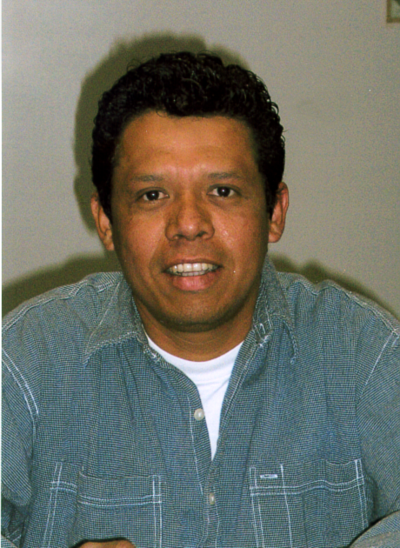
My name is Mariano Borge and I am from Nicaragua. I was born in Managua on April 30, 1971. I went to a elementary school in a small school in my neighborhood and I attended High School at Ramires Gugena Institute. After my graduation from High School I attended College for three years at National Engineering University. During those years of education I also went to the National Conservatory of Music and I learned how to play the clarinet and saxophone. In 2003 I traveled to U.S.A. and started working in construction and now I attend to the Fruitland Bible Institute and Blue Ridge Community College.

Echos from the Past

The echo that deeply remains in my thoughts, and I will always remember is about my parents raising me, my brothers and sisters.

They never gave up, even though we have passed through very sad difficult times.

There were times were we experienced hunger and desperation. My mother was always there to give us love, hope, care and to embrace us when we were crying.

I did not have the opportunity to grow up with my father all the time, due to his job circumstances. But, I always appreciated and loved him very much as he was as well.

I am very proud of them. They have always understood that education was very important and a priority matter as they were raising us.

Thanks to my parents now I have a good life, foundation and I have learned to be a good and responsible person. They have said to me, to always look forward and to conquer my dreams, to respect and appreciate others.

_____________________

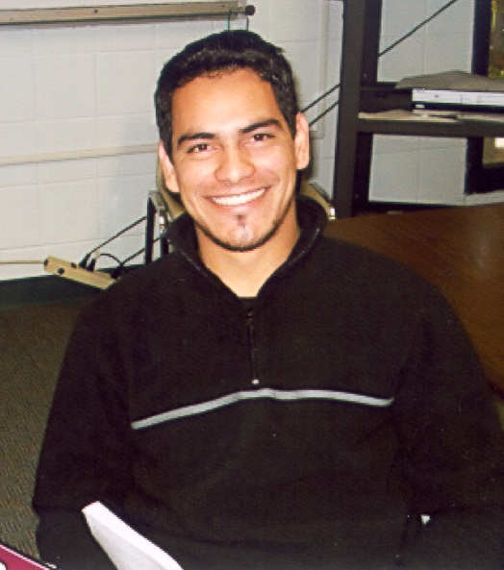

Name: Antonio Cabrera-Martinez
Country: Paraguay, South America
Age: 24, married
Profession: Autotechnician
Echos from the Past

Here in the United States, I still live in a big house with my aunt. When I get home I do not hear people in the kitchen or in the living room anymore as I used to hear in my house in Ecuador.

I do not feel every day like summer in United States because there are four seasons up here. I can notice when summer, spring, fall and winter are coming.

I feel safer when driving on streets or even when walking on sidewalks in downtown by myself. I missed those days when I looked at people everywhere on streets playing wherever. Here I barely see teenagers or even adults talking or playing on streets.

In Ecuador I used to call my friends to stop by my house and enjoying each others. Here I do not have many friends. I can not call them to come to visit me because they are either working or leave miles away from me.

_____________________

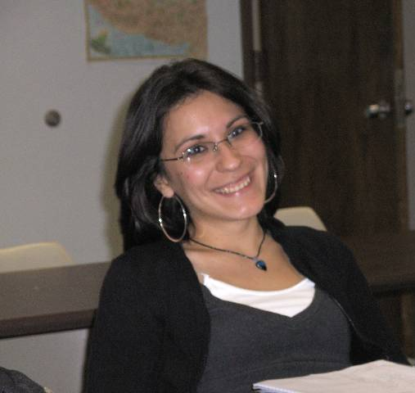

My name is Fernanda Paladines. I was born Guayaquil-Ecuador. I am 20 years old. I study at Blue Ridge Community College. I have two sisters and one brother. I live in Arden. I am studying Business Administration.
Echos from the Past

I used to live in a beautiful neighborhood where you could feel the youth, because of the sound of the music everywhere, and the children playing their different kinds of games. The place where I live now, it’s so quiet, and I don’t see the children playing outside their houses. I don’t even hear any music at the neighborhood. Here in the United States it’s more difficult to make some friends. I think it’s maybe because of the customs, I don’t know. But I really like here because it’s a safe place to live. It is also a place where your rights are heard.
______________________

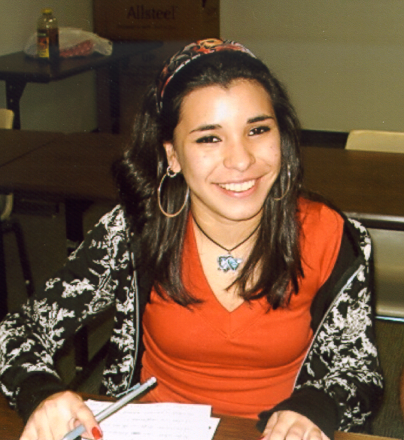

My name is Marcia C. Paladines. I’m 19 years old. I am from Guayaquil, Ecuador. I have one brother, and two sisters. I live in Arden, North Carolina. I study English at Blue Ridge Community College.
Echos from the Past

When I start thinking about my past, I can realy hear my ecos, all the good memories with my family and friends.

I have been living in this country for seven years and until last April I dreamt of going back almost every week, so I finally told my wife I was going to go back the end of the month (April). I was very happy, with a lot of different feeling. When I was there I realize that after seven years every thing wes different, all my friend and family were living a lot different than when I left 7 years ago. So only one week was more than enough to say I do not belong to this place any more, I still love them but I’m sure that my ecos from the past will not call my any more.

________________

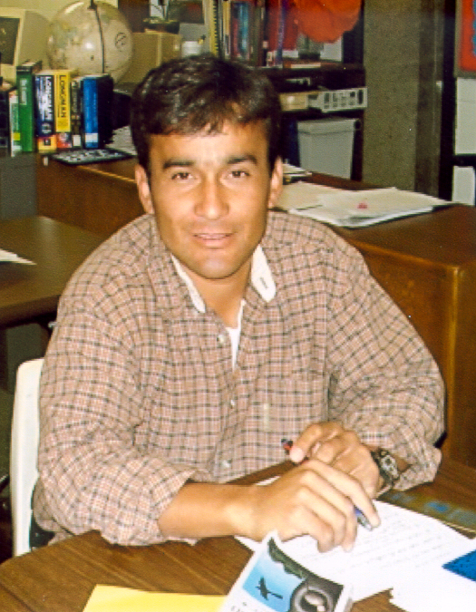

Name: Raul Souza
Country of origin: Chile
Family members: 2 brothers, 3 sisters; married and 2 sons
7 years living in the USA

