Crossing the River
An Independent Study Project
by Debra Johnson (teacher) and Charlie Chang (author)
Alamance Community College

Topic: A Personal Narrative: Crossing the River
Level: Advanced

Charlie Chang, an ESL student whose life experiences so fascinate his fellow classmates and teachers that “he could write a book,” is, indeed, interested in capturing his experiences in English. An active ESL participant at Alamance Community College, Charlie takes more than one class at the time. Among his current pursuits are Intermediate-Advanced ESL, Advanced Writing for ESL, and Intermediate-Advanced Pronunciation.

Crossing the River is an independent writing project Charlie undertook in addition to his class work. The writing continued over a period of several weeks for the author. In his narrative, he shares his memory of a time when he was a young boy in China. Japan was invading his country.

Charlie drafted his story with a dictionary as his companion. The instructional component of this independent study project--in addition to ongoing encouragement--consisted of assistance with capitalization, punctuation, and spelling. Charlie’s final handwritten version was later typed for this Consortium project.

The “lesson plan” for this independent study consisted of ongoing discussion and interaction between two people working toward a common goal. Such collaboration can be a highly rewarding teaching and learning strategy for bringing out the best in adult learners, as the resulting narrative illustrates.
The Author
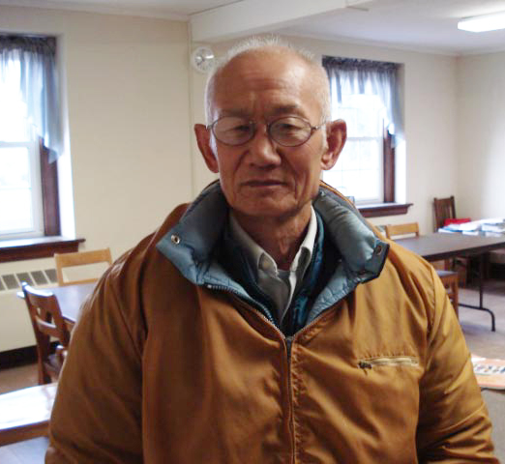

Born into the China of Chiang Kai-shek, Charlie Chang was profoundly influenced by the fortune and fate of this famous Chinese leader. As a youngster, Charlie was being educated at his Bejing home by private tutor. Chiang Kai-shek and the Kuomintang army engaged in civil war with Communist warlords in the northern provinces of China until 1931, when Japanese forces invaded Manchuria. Armed “incidents” between the two countries ensued, leading to full-scale war in 1937--the War of Resistance against Japan. In Crossing the River, Charlie describes his childhood escape with his parents as the Japanese army approached Bejing.

The War of Resistance merged into World War II. After WW II ended in 1945, civil war with the Communists in China continued. Chiang was eventually driven from mainland China to Taiwan (1949), where the Koumintang set up a government-in-exile. Chiang then served as the President of the Republic of China and Director-General of the Koumitang until his death in 1975.

As a young adult and an ardent anti-communist, Charlie joined the army of the Republic of China. He followed Chiang to Taiwan in 1949. But his dream was a better education. He emigrated from Taiwan to the United States. Originally settling in Westchester County, New York, Charlie eventually made his way to North Carolina. He did a variety of jobs, but his joy was a big greenhouse. He often took his produce to the farmers’ market in Carrboro, and he has been featured on the front page of the Durham Herald.

Today (2007) he is enthusiastically pursuing his dream of a better education at Alamance Community College, where he is a joy to classmates and faculty.

Keep a green bough in your heart and a singing bird will come.
Chinese Proverb

Crossing the River

One day we were at home and we heard a loud noise outside in the street. My parents told me to go see what had happened. When I went outside, people were rushing away and they asked if my parents were at home! If “yes,” tell them to leave here! The Japanese army is coming!

Quickly I ran back to my parents. Then I told them, “The Japanese army is coming!” My father told me to follow him at night. Then we went out of the village to the farm fields. It was early summer. There were many different plants in the field. It was good for hiding from the army but it was hard to walk. There were many sorghums with pole beans. My poor mother had fallen many times. She had bound feet. By that time I felt very sad for her. Finally we found a cemetery to hide in overnight. At night the air was full of mosquitoes. They hummed as they raided us. We were bitten badly. The day was dawning. We had to leave. Where should we go? My mother said, “We are going to your mother’s home (my grandmother).”
Graphics from Microsoft Clip Art and Media
at www.office.microsoft.com

My mother’s home was on the other side of the river. The bridge was heavily guarded. How could we cross the bridge? Also, none of us could swim. We had to go anyway. We were going to find a way to cross the river. “Let’s go,” my father said impatiently. “Let’s go,” my mother said to me, depressed.

We were walking along the river. My father was in front of us. My mother was following my father, and I was walking with my mother. We were walking quietly. No one talked to anyone. My mother had difficulty walking with bound feet. We had been walking almost a whole day without drink, food, or rest.

I glanced at my mother, who was wiping her tears. I felt so bad for my mother. My tears were falling but I didn’t want them to be seen by my mother. I was behind her. My mother suddenly didn’t see me, so she turned back to look for me and she saw that I was crying.

We were in a difficult situation that changed everything. My father didn’t smoke tobacco as much as at home that day. He had smoked a lot on the road. I didn’t pay attention to his smoking, but every time I heard him use his ho-lian to strike the tobacco’s burner, my eyes followed the direction of the sound. I saw his tobacco pouch. He didn’t have much left. My mother usually smoked more than him, but that day she didn’t smoke any.

We were walking along the river bank. We saw a lot of dead men and women floating in the river. Those people were killed by the Japanese army, then dumped in the river. My parents were very religious. They believed in God and ghosts, especially my mother. When we passed some dead people she was always seeming to say something to them. I was scared. My father was walking in front of us. He was quiet. He didn’t say anything. My father walked slowly. It seemed he had a million stone around his neck. He may have been tired or had too many things on his mind, or he worried about my mother and me or our whole family.

A few small houses on the riverbank appeared gradually in front of us, but we did not see anyone outside the houses. My father told us to stay put and wait for him to return. He was going to a house to ask if someone could help us cross the river. Later a young man carried a big po-lo with my father. Then he put the
po-lo into the river to soak a while to make the po-lo swell and tighten. He poured the water out of the po-lo. Then he jumped into the po-lo and moved around and said, “It is safe to go across the river.” A po-lo is very common on farms in the north part of China, but no one knew it could be used as a miniature raft to carry a person across the river. A po-lo is made by hand with wooden shander (rushes) just like making a basket. It is very neat as a container. The shape is like a baby swimming pool.

When we were crossing the river I was very scared of the dead people floating by me. Finally, we were across the river!

