Stories from My Childhood
Jan Fisher
Pitt Community College

Level: Low Intermediate – High Intermediate

Objectives: To speak and write about their reading experiences as a child
To emphasize the value of reading to improve their English
To encourage reading to and with their children

Time: This writing assignment is spread out over 2-3 days depending on whether you do a field trip.

Preparatory Activities: We used the text The Oxford Picture Dictionary by Shapiro and Adelson-Goldstein and the beginning level workbook. We did page 98 in both books, which is a segment on the library. I broke the class into groups of 3 to 4 students with the discussion questions shown below about their experiences with libraries, access to books in their country, and their favorite books/stories when they were children. The emphasis was on conversation practice and vocabulary.

- Have you been to a library in this city?
- Which library is closest to you?
- Do you have a library card?
- What is your favorite section of the library?
- How do you find a book at the library?
- What do you do if you want to take a book home?
- How often do you go to the library?
- Did you have a library in your hometown?
- Compare libraries in the US to libraries in your country?
- Did you have books in your home when you were a child?
- Who told you stories or read to you when you were a child?
- Do you read to your children?
- Do you have books in your home? What kind?

Core Activities: We used the text Let’s Talk 1 by Leo Jones and worked in pairs on unit 8B (a good read) on pages 34 and 35. This is a listening and speaking activity that expands on the vocabulary from the previous day. If you don’t have this book, bring in pictures of people reading (different ages with books, magazines, newspapers, etc.) to generate paired conversation.

- What do you like to read?
- Where do you like to read?
- When do you like to read?
- What was your favorite story as a child?
- What is the best book you’ve ever read?

After this paired conversation, I asked the students to write about their favorite story as a child. At the intermediate level, I have a broad spread of writing abilities. Some students dictate part of their writing to me; which usually helps them get started. I correct repeated spelling mistakes or grammatical errors.

Follow-up Activities: We took a field trip to Barnes and Noble. I used the handout on the following page, which is an assignment to find categories of books and titles. The purposes of the trip were to familiarize the students; with the bookstore and, also, to encourage them to bring their children back with them and get comfortable in a “reading environment.” You could also visit a library and get library cards.
Barnes & Noble Trip
Jan Fisher
Pitt Community College

Where would you find it? List the book category and
give a title for each of the following situations:

- You are having your first baby and know nothing about parenting.
category:
title:

- You want to learn how to play the guitar.
category:
title:

- You want to plant a vegetable garden but you don’t have a green thumb.
category:
title:

- You went to a great Japanese restaurant and want to try to cook some Japanese food at home.
category:
title:

- You want to improve your English vocabulary.
category:
title:

- You’ve heard about the American author Mark Twain and want to read one of his books.
category:
title:

- Your preschooler loves cars.
category:
title:

What about you?

What are your three favorite sections of the bookstore?

What is the most interesting book you’ve seen today?

Bambi
Mariana Bolanos

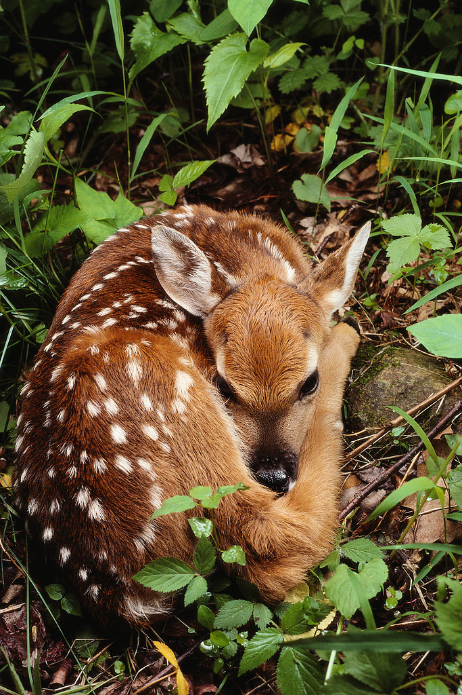

My favorite story when I was a child was “Bambi.” My cousin read this to me when I was like six years old. I really liked that story. It is so sweet and has a good message for kids and for all people. It was one of my favorite stories of my childhood.

My name is Mariana Bolanos. I am a student at Pitt Community College. I’m 19 years old and I am from Costa Rica. I live with my parents. I want to go to an American university to get a degree as a bilingual preschool teacher.

Graphics from Microsoft Clip Art and Media at www.office.microsoft.com
Akazukin-Cha
Mayumi Sugiyama

My favorite story when I was a child was “Akazukin-cha” (Little Red Riding Hood). A little girl wore a red hat. She wanted to meet her grandmother, but a wolf got there ahead of her. The wolf wanted to eat her. I was scared and my heart beat hard and fast during this story. I read this story in my house. I read it many times.


My name is Mayumi. I am from Japan. There are four people in my family but my son lives in Japan by himself. I want to speak English well.

Graphics from Microsoft Clip Art and Media at www.office.microsoft.com
Maugly
Damir Begishev

My favorite story when I was a child was “Maugly.” My mom read this book to me at night when I was five years old. I like this story because I like animals. The animals help the little boy in the forest. This boy is the only human in the forest. He is two years old. He is a little boy without his family. When he is 16 years old, he is stronger than the animals.
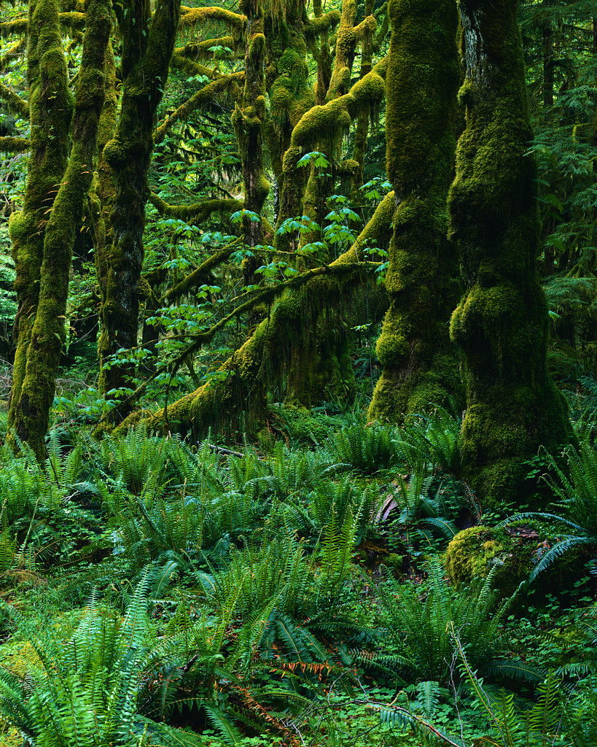

My name is Damir. I am from Turkmenistan. I’m a student at Pitt Community College. I live with my wife and daughter. I want to go to an American university for a degree in medicine. I’m 34 years old.

Note: The fictional Mowgli first appeared in Rudyard Kipling’s short story “In the Rukh” and later appeared in The Jungle Book.

Graphics from Microsoft Clip Art and Media at www.office.microsoft.com

The Kite
Yohana Clark

My favorite story when I was a child was “The Kite.” This story told about a child that usually went to a place with his kite to fly it. Sometimes the wind was strong. One day he lost his kite. It was gone with the wind. I remember this story because it was sad. He was a poor child. He cared about his kite more than anything. His name was Nacho.

My name if Yohana Clark. I am from Honduras, Central America. I am married and I have lived in Greenville for 6 years..

Graphics from Microsoft Clip Art and Media at www.office.microsoft.com
Grandmother’s Stories
Rostam Amiri

My favorite story when I was a child was any story my grandmother told me. The stories were like history books or mystery books from some very famous Persian king. In the stories my grandmother taught me how to love God or people. She taught me how to make a family or friend, and how to help people or your friend. Her stories were about me in the future and how to be a lucky person. I was four to twelve years old.

My name is Rostam. I am from Iran. I am studying English at PCC so I want to speak English well. I work at a restaurant.

Graphics from Microsoft Clip Art and Media at www.office.microsoft.com

