Integrated Civics Worksheet 1

To the Teacher

Give your students a blackline map of the United States, a copy of the worksheet on the following pages, and these directions: Fill in the blanks with the missing vowels and color the part(s) of the map accordingly.

To find a map, use your favorite search engine to look for USA blackline map. Some sites for your consideration are listed below. Be sure to abide by copyright law and honor subscription policies in any use you make of the following materials.

Start at http://www.clickandlearn.com/documents2/BlankMaps.htm and click on blackline map (beside USA). A one-step URL is http://www.clickandlearn.com/GIFFiles/WhiteUSA.gif.

At http://www.eduplace.com/ss/maps/ click on United States. Then scroll down and click on United States (no labels).

At http://www.theodora.com/maps/, scroll down and click on USA coloring map. For the terms of using this map, return to http://www.theodora.com/maps/ and click on the rectangle with the copyright symbol and the words “Your Web Site” at the top of the menu on the left side of your screen.

At http://www.enchantedlearning.com/label/geography.shtml, scroll down and click on USA Map Find Your State. This is a subscription site.
Integrated Civics Worksheet 1

Missing Vowels

Directions: Fill-in the blanks with missing vowels
and color the part(s) of the map accordingly.

1. One of the two longest rivers in the United States:

M __ s s __ s s__ p p __ R __v __ r

2. Ocean on the East Coast of the United States:

__ t l __ n t __ c __ c __ __ n

3. Ocean on the West Coast of the United States:

P __ c __ f __ c __ c __ __ n

4. One of the states that borders Canada:

M __ n n __ s __ t __

5. One of the states that borders Mexico:

C __ l __ f __ r n __ __

6. Capital of the United States:

W __ s h __ n g t __ n, D. C.

7. Capital of North Carolina:

R __ l __ __ g h

8. Where is the Statue of Liberty:

N __ w Y __ r k

9. State that borders North Carolina in the west:

T __ n n __ s s __ __

10. Largest state of the United States:

__ l __s k __

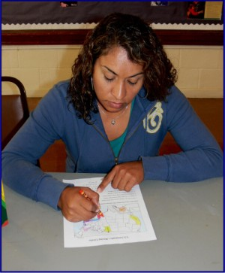
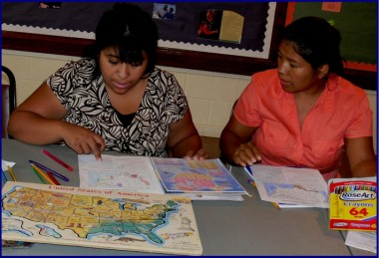

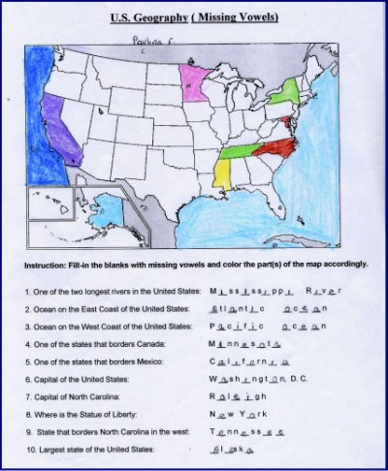

Integrated Civics Worksheet 2

Label the Map

graphic from http://office.microsoft.com/en-us/clipart/default.aspx

Review
Before working on the following activity, my students reviewed the names of all states using a wooden U.S. Map Puzzle Board that belonged to one of my students.

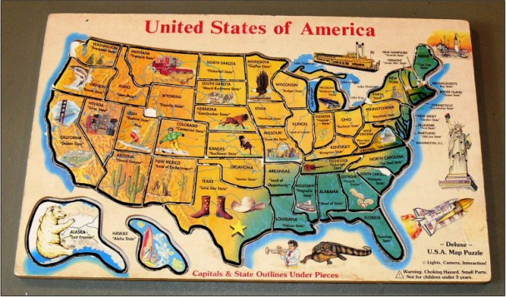

Maps
To find a blank black line map of the United States, go to http://www.clickandlearn. Under Helpful Links, click on Free Blackline Maps. Under USA, click on blackline map.

Another free printable maps is at http://www.coloringcastle.com/. Under Maps and Flags in this site’s menu, click on USA Maps. Click on USA with State Outlines. Keep URL www.ColoringCastle.com on the map.

To find other similar resources, use your favorite search engine to look for USA coloring map.

Directions to Give to Students
Ask students to label and color all fifty states on the map.

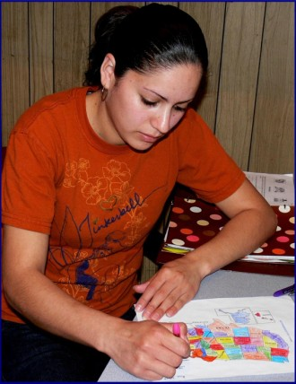

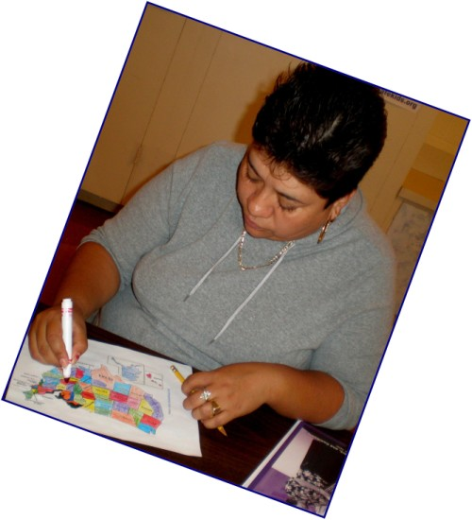

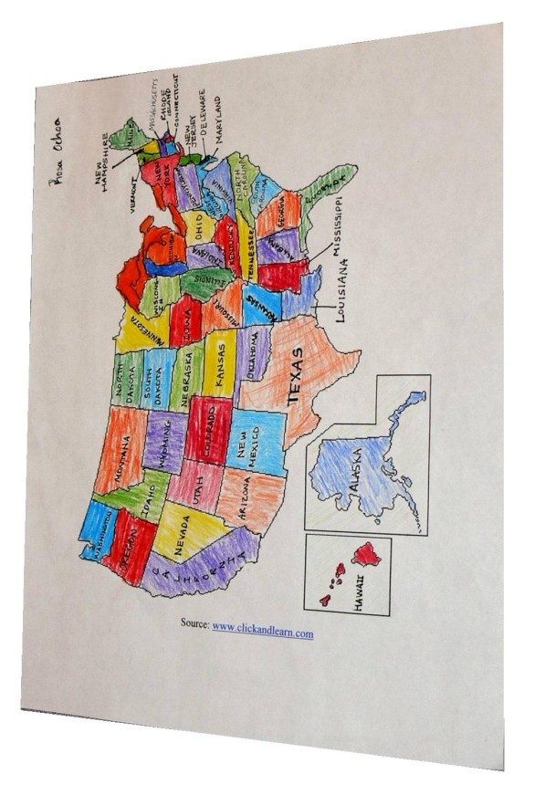
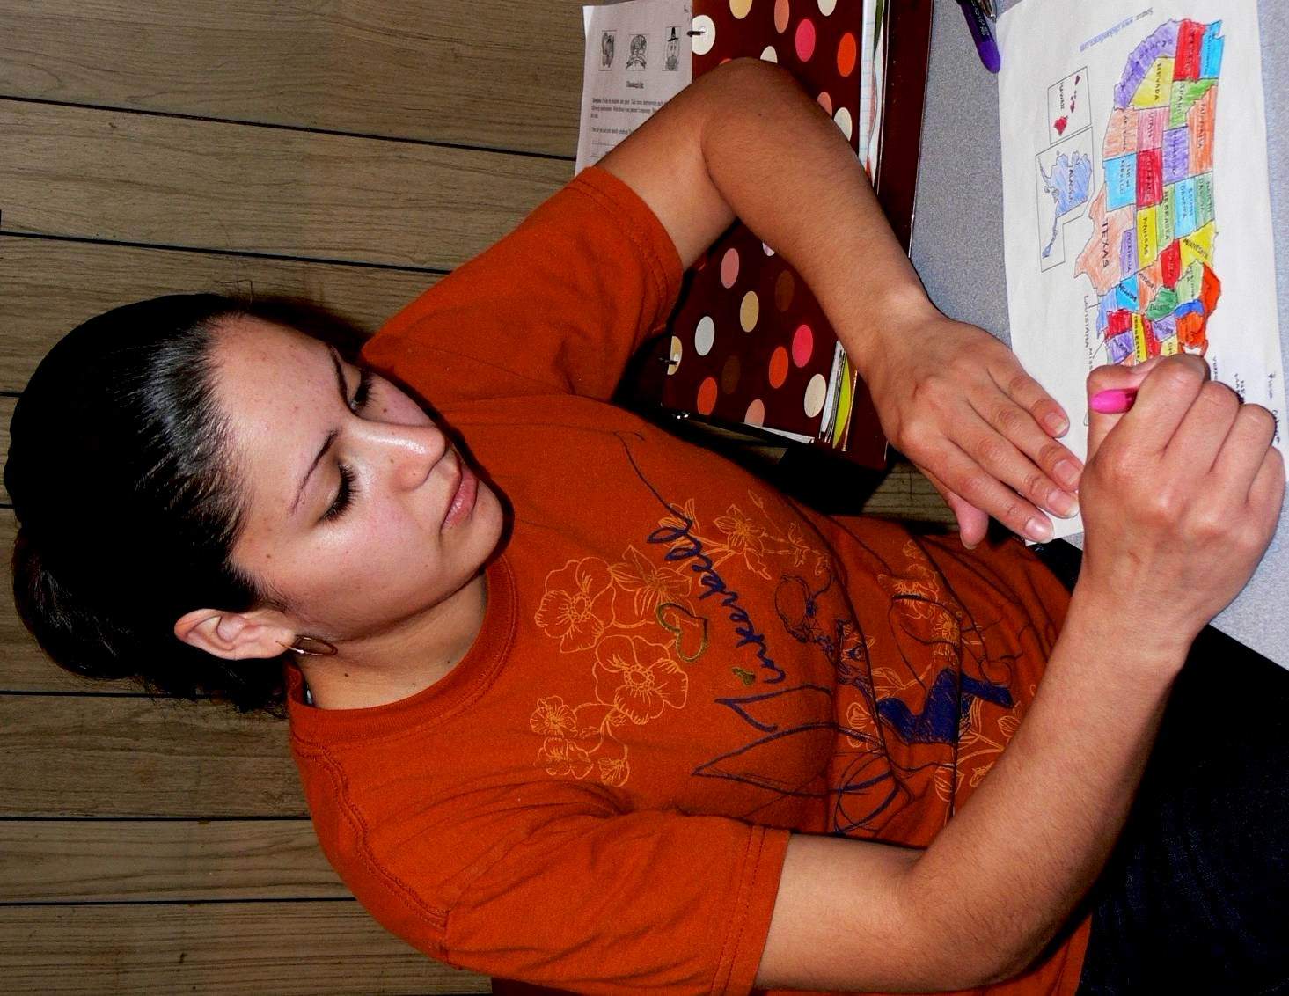
Integrated Civics Worksheet 3

Reading Comprehension

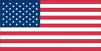
United States Flag

Directions: Read Integrated Civics Handout 2 and
answer the following questions.

1. What are the colors of the flag? ______________________

2. How many stars are there in the flag? __________________

3. What does the red color stand for? ____________________

4. What does the blue color stand for? ___________________

5. What does the white color stand for? __________________

6. What do the stripes stand for? _______________________

7. What do the stars stand for? ________________________

8. What was the last state to be added in the United States? ____________________

9. What was the 49th state to be added in the United States? ____________________

10. When was Hawaii added in the United States? _____________________
Integrated Civics Worksheet 4

U.S. Flag – Now and Then

For this Integrated Civics topic, I gave my class a page with the current and original American flags to color. As a member of the inexpensive subscription site Enchanted Learning (located at http://www.enchantedlearning.com/Home.html), I used materials from http://www.enchantedlearning.com/crafts/books/julyfourth/Flag.shtml in my class.

Some other sites with the current American Flag and the Betsy Ross flag are listed below. Be sure to abide by copyright law and honor subscription policies in any use you make of the following materials.

Current flag
http://www.shininghours.com/creating/usa_flag_bw.htm
http://www.crwflags.com/fotw/flags/cbk-na.html and scroll to USA
http://proteacher.com/090019.shtml and scroll to United States Flag
http://familycrafts.about.com/cs/independenceflag/l/blcoloramflag1.htm
http://ourworld.compuserve.com/homepages/SGroll/flagpage.htm
http://printables.familyeducation.com/flags/united-states/57709.html

Betsy Ross flag
http://www.apples4theteacher.com/coloring-pages/flag-day-united-states-symbols/
http://parenting.leehansen.com/downloads/coloring/Patriotic/USA/besty-ross-1776.htm

Directions to Students
Color both the original and the current American flag. Label “Now” for current and “Then” for original flag with thirteen colonies.

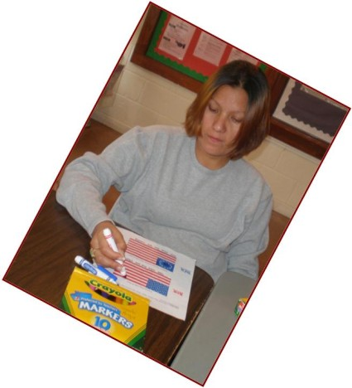
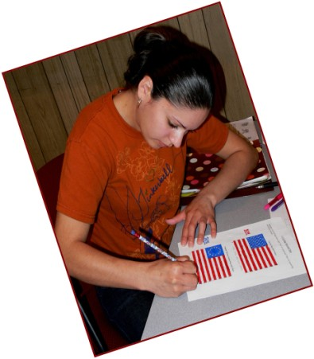

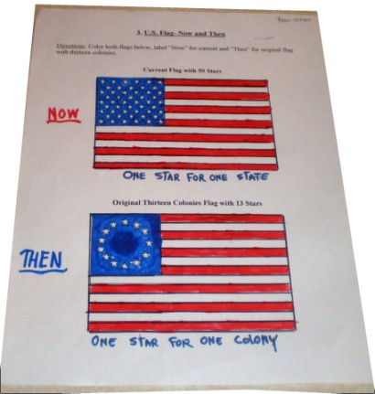


Integrated Civics Worksheet 5

Thanksgiving Reading, Writing, and Oral Work

Directions: Divide the students into pairs. Take turns
interviewing each other using the following questionnaire. Write
down your partner’s responses. Share the responses with the class.

1. How do you and your family celebrate Thanksgiving?

________________________________________________________________________

________________________________________________________________________

2. Why do we celebrate Thanksgiving?

________________________________________________________________________

________________________________________________________________________

________________________________________________________________________

3. What part of Thanksgiving holiday do you enjoy most?

________________________________________________________________________

________________________________________________________________________

4. What part of Thanksgiving holiday do you enjoy least?

________________________________________________________________________

________________________________________________________________________

5. What are some of the things in your life you are most thankful for having?

________________________________________________________________________

________________________________________________________________________

________________________________________________________________________ graphics from http://office.microsoft.com/en-us/clipart/default.aspx



Integrated Civics Worksheet 6

Christmas Cloz Activity

Word Bank

lights carols toys greetings
decorate Eve parties presents
schools holiday federal goodies
church Merry celebration gatherings

Directions: Fill in the blanks with words from the word bank above.

Christmas is a ___________ __________ we celebrate on December 25 every year. All______________, banks, and post offices are closed on Christmas Day. Christmas is a two-day _________________ that starts on December 24. It is called Christmas ________. People go to the ___________ and sing _________. We give _____________ to friends and family, send _____________, and wish __________Christmas. We ______________Christmas trees and put up _________ around the house. Children get lots of ____________ and ____________. It’s a time of family _______________ and holiday ______________.


graphics from http://office.microsoft.com/en-us/clipart/default.aspx
Integrated Civics Worksheet 7

Unscramble Words

Directions: Read the following passage about Memorial Day and unscramble the underlined words using the words from the box.

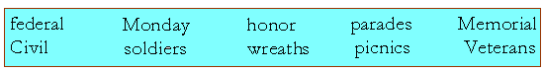

Memorial Day is a special American holiday to remember and rnooh soldiers who died serving their country. It is celebrated on the last dyaonM in May. People first started celebrating it after the American ilCvi War.

lamoMeri Day is a redfeal holiday. Schools, banks, post offices, and most of the government offices are closed this day.

Many towns have Memorial Day dserpaa. ranteVse and dlsosrei march while people wave American flags.

Friends and relatives decorate soldiers’ graves with flowers, hawsret, and flags. Many families go for cincisp in the park, while others have cookouts at home.

graphics from http://office.microsoft.com/en-us/clipart/default.aspx
Integrated Civics Worksheet 8
Veterans Day Word Search

U | B | J | M | B | Z | F | X | P | D | V | J | M | N | T
Y | F | O | W | E | U | A | R | L | I | N | G | T | O | N
R | R | R | M | L | M | L | U | E | M | G | Z | E | V | Z
E | M | E | J | Y | D | O | X | V | Q | A | N | J | E | D
I | P | V | V | P | H | W | R | C | S | L | J | D | M | K
D | F | T | B | A | I | L | A | I | N | Q | R | I | B | C
L | T | H | U | U | R | M | R | A | A | E | K | V | E | Z
O | C | H | W | J | M | B | T | E | J | L | E | A | R | Y
S | K | A | N | Y | I | R | F | O | W | T | M | F | J | E
N | R | W | H | P | O | J | N | U | E | D | Z | M | S | A
A | L | Z | U | N | I | K | O | R | R | V | J | N | Y | F
V | E | N | O | Q | E | J | A | H | U | P | H | F | B | V
Y | Q | H | F | E | D | N | X | C | E | G | U | A | R | D
U | Z | V | O | F | S | O | P | R | S | R | L | V | M | A
Y | Q | N | Y | R | T | N | A | F | N | I | O | U | C | V
Find the words below in the Word Search form above. The words may run forward, backward, up, down, or diagonally.
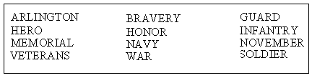

Created by Puzzlemaker at DiscoveryEducation.com
Integrated Civics Worksheet 9

Labor Day Crossword Puzzle

Created by Puzzlemaker at DiscoveryEducation.com

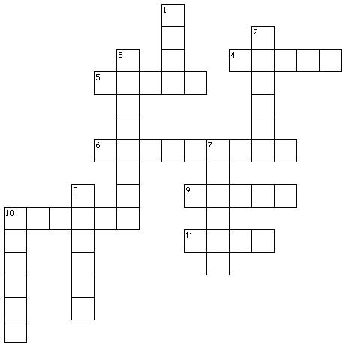

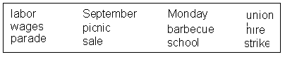
WORD BANK

Across
4. to work hard
5. income or earnings
6. ninth month of the year
9. organization that represents workers
10. organized work stoppage
11. stores advertise low prices

Down
1. to give someone a job
2. procession of marchers and bands playing music
3. meat cooked on a grill
7. first day of the weekdays
8. meal eaten outside
10.a place to receive an education
Answers to Civics Worksheet 9

Labor Day Crossword Puzzle

Across
4. labor
5. wages
6. September
9. union
10. strike
11. sale

Down
1. hire
2. parade
3. barbecue
7. Monday
8. picnic
10.school

