American History Worksheet 1
Question Sentences

Resource: http://www.hsp.org/default.aspx?id=644

Directions: Write questions for the following sentences using the question words who, where, how many, when, what, and why. The underlined words are the answers.

1. ___________________________________
Colonists came to America for religious freedom.

2. __________________________________________
Native Americans lived in America before the Europeans arrived.

3. _________________________________________
The Declaration of Independence was adopted on July 4, 1776.

4.___________________________________________
There were thirteen original states called colonies.

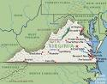
5. _______________________________________
Virginia was the first colony.

6. _________________________________________
The colonists first landed on Plymouth Rock, Massachusetts.

7. _______________________________________
The Constitution was written in 1787.

8. __________________________________________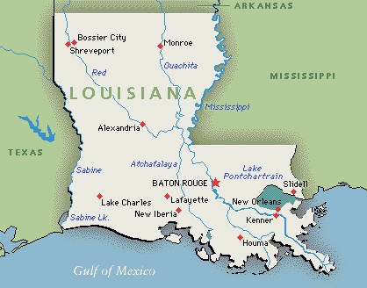
The United States bought Louisiana territory from France in 1803.

9. __________________________________________
George Washington is called the “Father of Our Country”.

10.________________________________________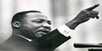
Martin Luther King, Jr. fought for civil rights movement.

King photo from http://www.nps.gov/malu/photosmultimedia/index.htm
graphics from http://office.microsoft.com/en-us/clipart/default.aspx
American History Worksheet 2
Multiple Choice Questions
Directions: Circle the correct answer to each question.
1. When was the Declaration of Independence adopted?
a. July 4, 1787 b. July 4, 1776
c. October 13, 1812 d. February 18, 1775

2. Who was the main writer of the Declaration of Independence?
a. James Madison b. George Washington
c. Abraham Lincoln d. Thomas Jefferson

3. When was the Constitution written?
a. 1776 b. 1787
c. 1803 d. 1812

4. Who is the “Father of Our Country”?
a. George Washington b. Abraham Lincoln
c. Thomas Jefferson d. Benjamin Franklin

5. What did the Emancipation Proclamation do?
a. Ended the Civil War b. Freed the slaves
c. Freed the Indians d. Ended World War II

6. What was the 49th state added to the United States?
a. Puerto Rico b. Alaska
c. Hawaii d. Guam

7. What is the name of the ship that brought the Pilgrims to America?
a. The Santa Maria b. The Titanic
c. The Mayflower d. The Nina

8. What country did we fight during the Revolutionary War?
a. France b. Germany
c. Great Britain d. Japan

9. Who did the United States fight in World War ll?
a. Japan, Germany, and France b. England, China, and Japan
c. Germany, Korea, and Japan d. Japan, Germany, and Italy

10. Who was Martin Luther King, Jr.?
a. Writer of the Declaration of Independence
b. A civil rights leader
c. Presidential candidate in 1984
d. President during the Civil War

11. Why did the colonists come to America?
a. To escape the Revolutionary War b. In search of gold
c. To meet the Indians d. To gain religious freedom

12. Who was President during World War l?
a. Abraham Lincoln b. Woodrow Wilson
c. Benjamin Franklin d. Thomas Jefferson

13. What territory did the United States buy from France?
a. Louisiana b. Alaska
c. Hawaii d. Puerto Rico

14. What U.S. war was fought between the North and the South?
a. Revolutionary War b. World War l
c. Civil War d. War of 1812

15. Who fought for women’s rights?
a. Susan B. Anthony b. Martin Luther King, Jr.
c. George Washington d. Francis Scott Key

Sources:
http://www.socrato.com/mytestpage.php (subscription site)
http://www.uscis.gov

Multiple Choice Questions

Answer Sheet

1. | b
2. | d
3. | b
4. | a
5. | b
6. | b
7. | c
8. | c
9. | d
10. | b
11. | d
12. | b
13. | a
14. | c
15. | a

American History Worksheet 3
Phonics
Directions: Look at the pictures, pronounce them, and
circle the letter with beginning sound of words.

graphics from http://office.microsoft.com/en-us/clipart/default.aspx

C G R | D S F
N C M | T R A
B N C | N E K
N P O | M T S
T M R | I F D
American History Worksheet 4
Sentence Structure

A. Use some of the information you have learned to write 5 sentences about the Original 13 Colonies of the United States.

1______________________________________________________

2______________________________________________________

3______________________________________________________

4______________________________________________________

5______________________________________________________

B. Read the following questions and answer them by writing complete sentences.

1. From whom did we gain our independence?

______________________________________________________.

2. Who was the President during the Civil War?

______________________________________________________.

3. Who wrote the Declaration of Independence?

______________________________________________________.

4. What happened on September 11, 2001 in the United States?

______________________________________________________.

5. What movement tried to end racial discrimination?

__________________________________________________.
American History Worksheet 5
Singular/Plural Verbs

graphics from http://office.microsoft.com/en-us/clipart/default.aspx

Directions: Look at the pictures below and write sentences with singular or plural verbs as “This is…” or “They are….”.

1. ________________________________ | 2. _______________________________
3. ________________________________ | 4. _______________________________
5. ___________________________________ |   6. __________________________________
  7. ________________________________ | 8. ________________________________
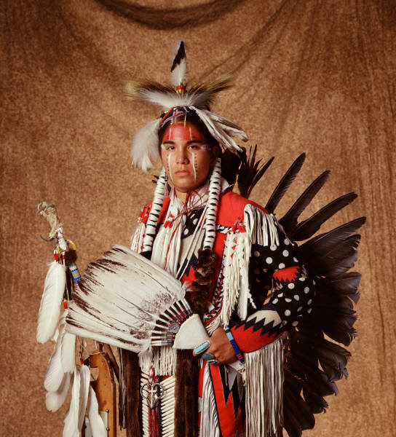  9. _______________________________ | 10. __________________________________

American History Worksheet 6
Matching

Directions: Match the correct answer in the column B to the words/phrases listed in the column A.

Column A Column B

1. Mexican-American War a. 1900s

2. President during World War I b. Susan B. Anthony

3. President during World War II c. Benjamin Franklin

4. War between North and South d. 1800s

5. Cold War e. George Washington

6. Cherokee f. Franklin Roosevelt

7. Vietnam War g. Civil War

8. First Postmaster General h. Communism

9. Women’s Rights Movement i. Indian tribe

10. First President of United States j. Woodrow Wilson

Matching

Answer Sheet

Column A | Column B
1. | d
2. | j
3. | f
4. | g
5. | h
6. | i
7. | a
8. | c
9. | b
10. | e

American History Map Work

Map of Original 13 Colonies of America

Finding a Map for Your Students to Use
Use Google to search for 13 colonies. Click on Image Results for 13 colonies. Explore the results to find a map of the 13 colonies that you can print for your students to color and label.

Some maps come from inexpensive subscription sites, and some are under copyright. Please comply with legal and ethical parameters in your use of material. One alternative is to draw your own map using online resources as your references.

As an Enchanted Learning subscriber, I can use a map from http://www.enchantedlearning.com/usa/label/13/13.shtml. or http://www.enchantedlearning.com/usa/label/13/label13.GIF.

Directions for Your Students
Label and color all thirteen colonies. Divide the colonies into three regions: New England, Middle, and Southern.

Notes for the Teacher
According to the website Social Studies for Kids, the New England colonies are New Hampshire, Rhode Island, Massachusetts, and Connecticut. The Middle Colonies are New York, Pennsylvania, New Jersey, and Delaware. The Southern Colonies are Georgia, South Carolina, North Carolina, Virginia, and Maryland.

You can locate this listing of the colonies , by starting at http://www.socialstudiesforkids.com/. Click on U.S. History in the blue menu column on the left of your screen. Click on Periods in U.S. History in the middle of your screen and then, in the resulting drop-down menu, click on Colonial Times. Now click on 13 American Colonies in the center of your screen. In the block titled More of this Feature, click on Part 2: Characteristics of the Colonies.

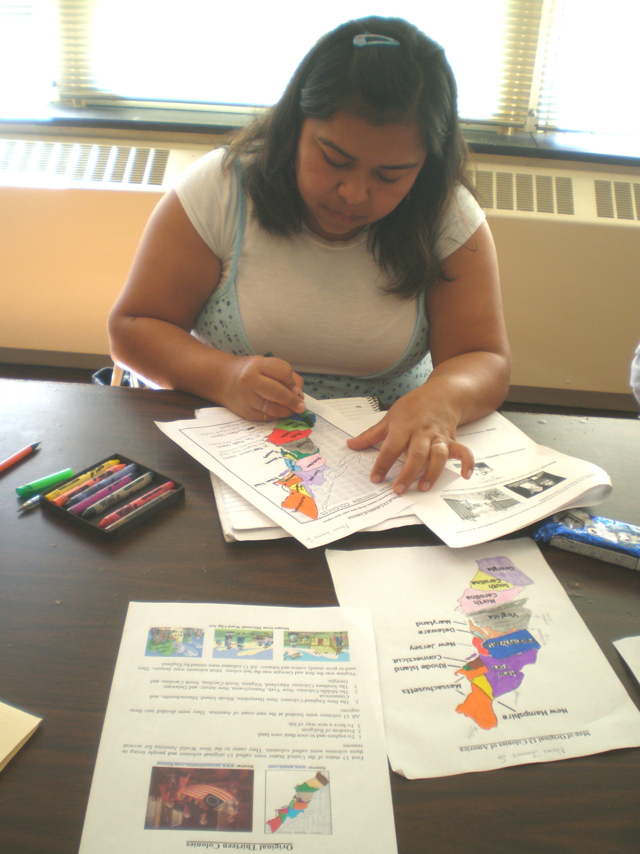

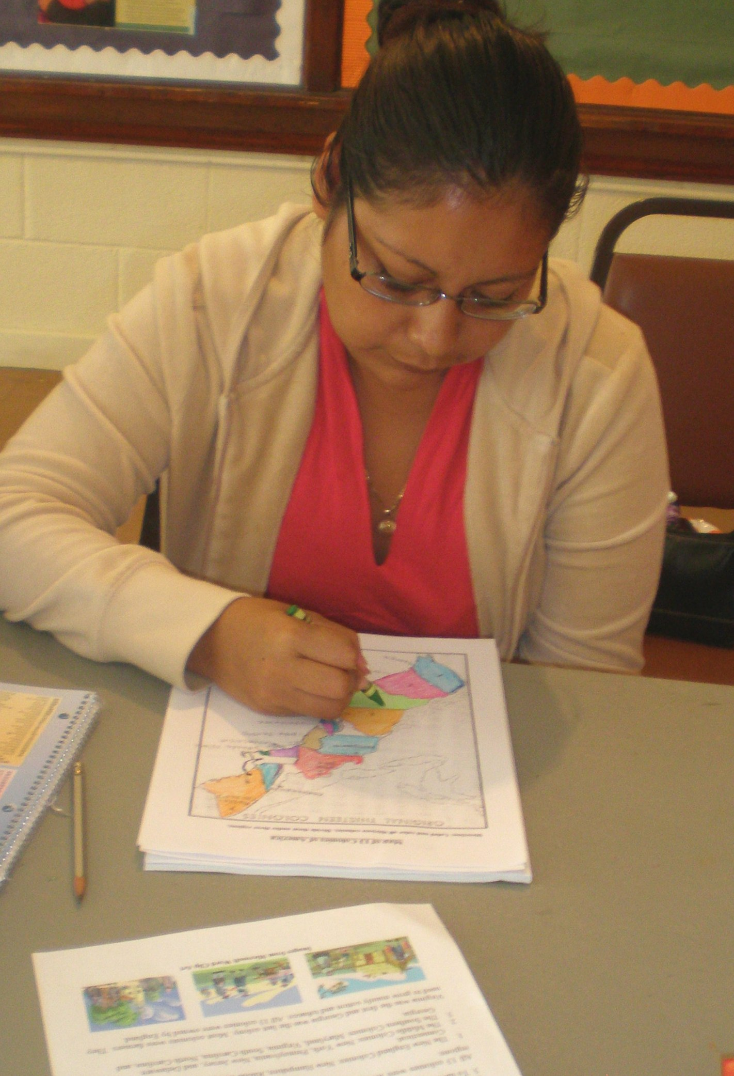
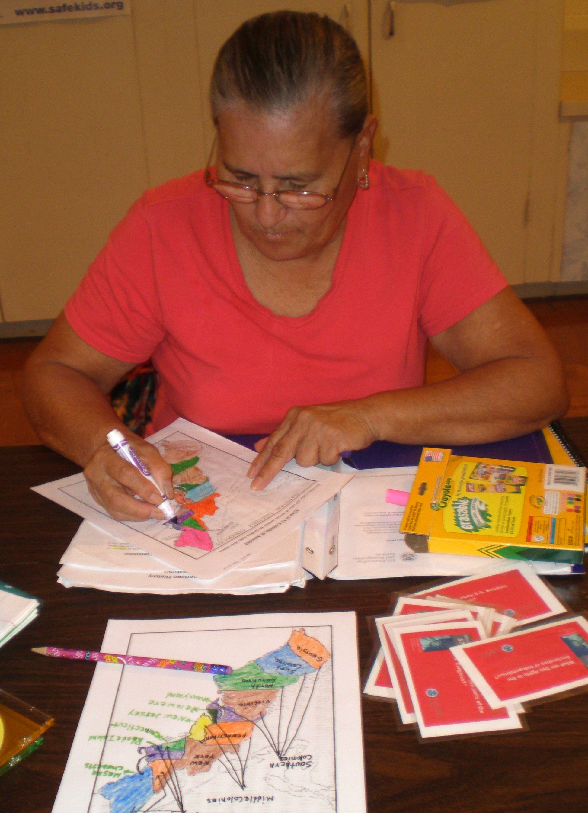

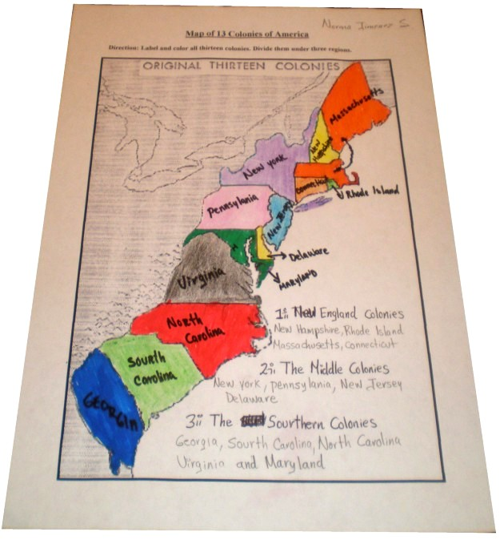
American History Quiz
13 Colonies

Directions: Use your map to answer the following questions.

1. Which colony was farthest north? _________________________________

2. Which colony was farthest south? _________________________________

3. What ocean bordered the colonies on the east? _______________________

4. Which colony was just south of Virginia? __________________________

5. What colony bordered Virginia to the northeast? _____________________

6. What colony was between the two parts of Massachusetts? _____________

7. What colony was located east of Connecticut? _______________________

8. What two colonies bordered New York on the south?
________________________________ and ______________________________

