American Government Worksheet 1
Principles of American Democracy

True/False
Read the sentences carefully.
Circle ‘T’ for true and ‘F’ for false statements.

1. The Constitution is the supreme law of the land T F
2. Every U.S. citizen must practice the same religion. T F
3. The United States got independence from Japan. T F
4. The Constitution has 27 amendments. T F
5. The first ten amendments
to the Constitution are called Preambles T F
6. ‘We the People”
are the first three words of the Constitution. T F
7. The Constitution interprets and reviews the laws. T F
8. An amendment
is a change or an addition to the Constitution. T F
9. The third amendment
gives people the right to bear arms. T F
10. The “rule of law” states that no one is above the law. T F
11. The U.S. is often described as a "capitalist" economy. T F
12. The Declaration of Independence
announced a war against Italy. T F
American Government Worksheet 2
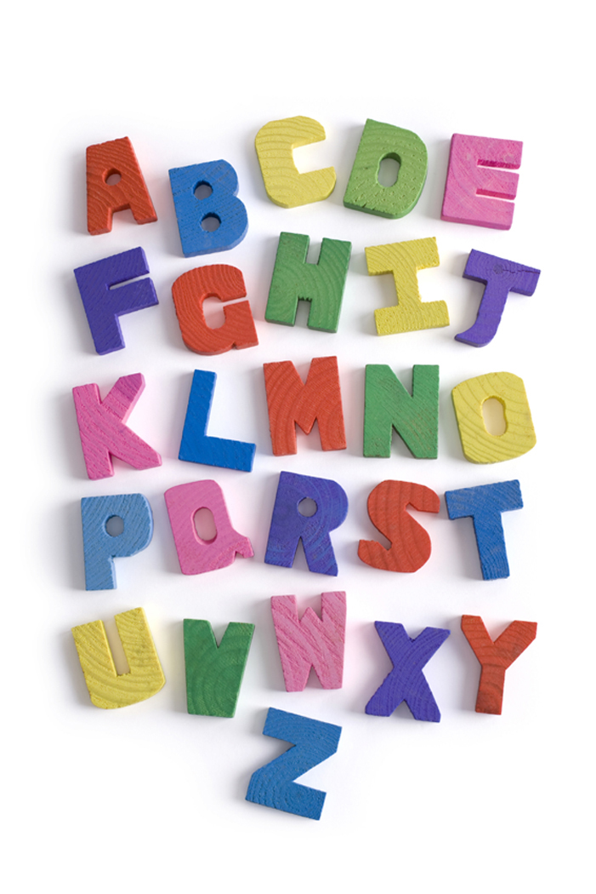
Vocabulary - Alphabetical Order

Directions: Refer to your Handout called Pictorial Vocabulary. Arrange the following vocabulary words in alphabetical order.

1. Democracy _______________________

2. Constitution _______________________

3. Bill of Rights _______________________

4. Amendment _______________________

5. Petition _______________________

6. Declaration of Independence _______________________

7. Cabinet _______________________

8. Naturalization _______________________

9. Executive _______________________

10. Legislative _______________________

11. Judicial _______________________

Graphics from http://office.microsoft.com/en-us/clipart/default.aspx
American Government Worksheet 3

Articles ‘A’ or ‘An’

Direction: Fill-in the blanks with either A, An, or X (No article).

- ________ advisor

- ________ President

- ________ United States

- ________ amendment

- ________ senator

- ________ congressmen

- ________ election

- ________ congressman

- ________ American

- ________ congress

- ________ Capitol Hill

- ________ freedom

- ________ office

- ________ judge

- ________ citizen

American Government Worksheet 4

System of American Government

White House Supreme Court Capitol Hill

Matching
Match each question with the correct answer.
1. Who elects Congress? | a. Congress
2. How many justices are on the Supreme Court? | b. Star Spangled Banner
3. Who vetoes bills? | c. Three
4. What do we call a group of advisors to the President? | d. Six years
5. Where does Congress meet? | e. Nine
6. What does the judicial branch do? | f. Washington, D.C.
7. Who elects the President of the United States? | g. Governor
8. How many branches are in the U. S. government? | h. Cabinet
9. What is the promise of loyalty to the United States  called? | i. Capitol Hill
10. What is the name of the U.S. National Anthem? | j. President
11. What is the name of the President’s official home? | k. Pledge of Allegiance
12. Who makes federal laws? | l. Electoral College
13. What is the capital of the United States? | m. White House
14. Who is in charge of the executive branch at the state  level? | n. Citizens of the United  States
15. For how long do we elect a U.S. Senator? | o. Explains and reviews laws
Graphics from http://office.microsoft.com/en-us/clipart/default.aspx

American Government Worksheet 5

Cryptogram

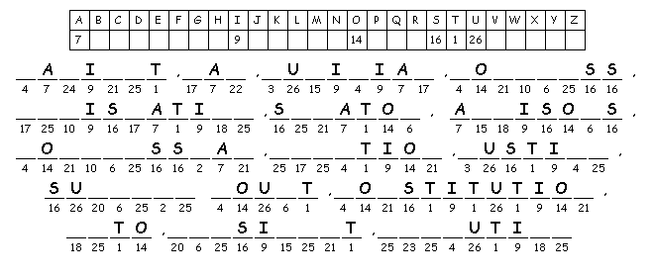
Cryptogram Word List

Cabinet, Law, Judicial, Congress, Legislative,
Senator, Advisors, Congressman, Election, Justice,
Supreme Court, Constitution, Veto, President, Executive

created at http://puzzlemaker.discoveryeducation.com/
graphic from http://office.microsoft.com/en-us/clipart/default.aspx

