Word Searches
By Lea Blanton
Alamance Community College

Overview
Word Searches are a fun format to focus students on a circumscribed amount of information about a single topic. Three searches are given on the following pages, one on the Star Spangled Banner, one on the thirteen original states, and one on Facts about America.

Word Search  Hidden Title
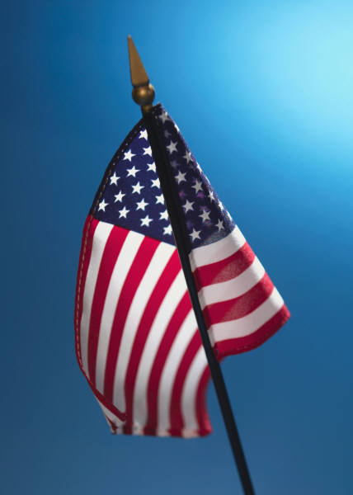
R V W Q H F X X O S J T J Q D M B A U J H Z C H K
M E S O K Z P P T E N I L V Q K Y I A P J I Q O Q
O H N P M E Z R C R R W R Q B C W X W H S K M G R
Z Q N N X N E O H I P T A S Z C Y W C J M K D F I
C W V F A A Q Y X F W N H D N Q E J X Y Z C U L M
S R T Y M B J S S W J R O E E O R J X H I B T C I
S T T I J S D M H O Y J H C R H S Y N X E Y H B X
R K N E K X R E X B O T X Q P A T E E Y D L G T Z
S G G X Z W S S L Q H S X M O O M Y R W I E I P J
E X A A N D B R I G H T S T A R S P B E H V L X Y
P O L E W E P B U L N H D Z F T J U A P W Q Y Q J
I W L L Z B A O S R S A Y S H Y J T E R C K L O Z
R H A Y I F R Y Q D Q A P G J K V R Y U T A R L P
T A N A C H I W I G V K I S M W I A B C F S A K U
S T T S T L Y E E X Z L X R R L D E L I A H E W F
D S L H W A M T Q W I V V S O A C A N Y O U S E E
A O Y O G Y A T E W A F N U Q V T N S U M Q M K Y
O P H R V Z O Y T W P T S R V S X S T C V X W J I
R R X S T L R E A F J F C G N I M A E L G T S A L
B O M L Q A H U X P I R O H R B D U I H N U Z K I
E U K J S T F N Y G P F X X E P R I M L T O Q V B
S D E X T D A T H A H E T O H D Q C O N T T Y R P
O L N A A K P T F H Y J X H A A M B D J Q P A P R
H Y N G F D F G H D A N N J V C F A R G B H Z G D
W T T Z N I W X U L G F Y B M M N N J X C J I Y U

Directions: Circle the words listed below. They run in all directions: forward, backward, up, down, and diagonally.

OH SAY
CAN YOU SEE
BY THE DAWNS
EARLY LIGHT
WHAT SO PROUDLY
WE HAILED
AT THE TWILIGHT’S
LAST GLEAMING
WHOSE BROAD STRIPES
Created with Puzzlemaker at DiscoveryEducation.com
Graphic from http://office.microsoft.com/en-au/clipart/default.aspx

AND BRIGHT STARS
THROUGH THE
PERILOUS FIGHT
O’ER THE RAMPARTS
WE WATCHED
WERE SO
GALLANTLY
STREAMING
FIND THE HIDDEN SONG TITLE

THE POWER OF THIRTEEN

M E D K B N X M L H T L Z S A
W A K Y B O A D I U I X O V I
N U S N W R A S C D X U S K N
E E O S Y T C I V E T A R S A
H A W L A H T Y G H P O S V V
S D A J W C Y U C R Y Z Q U L
Z N V J E A H A Z W O M U D Y
D F S N Z R R U E I J E B E S
R C N X F O S N S F S L G L N
O O K R L L C E G E X X S A N
C T H I I I Y V Y L T F T W E
N C N A I N I G R I V T A A P
Z A U S J A Q W L L R I S R Q
E R I H S P M A H W E N E E U
R H O D E I S L A N D G G N V

Directions: Find and circle the thirteen original states listed below. They run in all directions: forward, backward, up, down, and diagonally.

- CONNECTICUT
- DELAWARE
- GEORGIA
- MARYLAND
- MASSACHUSETTS
- NEW HAMPSHIRE
- NEW JERSEY
Created with Puzzlemaker at DiscoveryEducation.com

- NEW YORK
- NORTH CAROLINA
- PENNSYLVANIA
- RHODE ISLAND
- SOUTH CAROLINA
- VIRGINIA

A Word SearchCreated by Puzzlemaker at DiscoveryEducation.com
Q | A | M | E | N | D | M | E | N | T
A | L | M | E | A | D | A | N | A | C
F | L | A | G | T | I | K | Q | H | I
F | E | D | E | R | A | L | I | S | T
K | G | B | I | D | E | N | A | Y | N
V | I | E | T | N | A | M | E | W | A
P | A | S | S | P | O | R | T | S | L
T | N | E | D | I | S | E | R | P | T
Y | C | H | E | R | O | K | E | E | A
V | E | C | I | V | R | E | S | O | H
Directions: Find and circle the word that completes each sentence below.
A change in the Constitution is called an __________.
The two parts of Congress are the House and the _________.
The Commander in Chief of the military is the ____________.
Saying the Pledge of __________ shows loyalty to the United States.
The ________ Papers supported passing the U.S. Constitution.
At age eighteen all men must register for the Selective ________.
The current Vice-President of the U. S. is ________ (last name).
Everyone must obey the ______.
To carry a U.S. _______ is a right only for U.S. citizens.
The ________ are a famous North Carolina American Indian tribe.
An unpopular war fought by the U. S. since 1900 is the ________ War.
Minnesota shares a border with another country called __________.
The _______ Ocean is on the East Coast of the United States
The “stars and stripes” or the stars and bars” refers to the American ____.

A change in the Constitution is called an amendment.
The two parts of Congress are the House and the Senate.
The Commander in Chief of the military is the President.
Saying the Pledge of Allegiance shows loyalty to the United States.
The Federalist Papers supported passing the U.S. Constitution.
At age eighteen all men must register for the Selective Service.
The current Vice-President of the U. S. is Biden (last name).
Everyone must obey the law.
To carry a U.S. Passport is a right only for U.S. citizens.
The Cherokee are a famous North Carolina American Indian tribe.
An unpopular war fought by the U. S. since 1900 is the Vietnam War.
Minnesota shares a border with another country called Canada.
The Atlantic Ocean is on the East Coast of the United States
The “stars and stripes” or the stars and bars” refers to the American flag.

