
A Review for the
Redesigned Naturalization Test

By Dr. Nutan Varma
Central Carolina – Harnett Campus

This multi-part Review consists of an introductory exercise on the Great Seal of the United States followed by activities addressing each of three competencies as shown below.

Introduction. The Great Seal – An Introductory Exercise
Competency One. American Government, which covers:
A. Principles of American Democracy
B. System of Government
C. Rights and Responsibilities
Competency Two. American History, which covers:
A. Colonial Period and Independence
B. 1800s
C. Recent American History
Competency Three. Integrated Civics, which covers:
A. Geography
B. Symbols
C. Holidays
Each competency includes some/all of the following:

- Games
- Puzzle(s)
- Handouts
- Grammar
- Reading and Writing
- Picture stories
- Vocabulary

The following pages list Study Resources common to all competencies, followed by a list of Handouts and Worksheets for each individual competency. For optimum loading time, the Handouts and Worksheets are set up as independent documents and referenced in the competencies.
Graphics from http://office.microsoft.com/en-us/clipart/default.aspx

Study Resources for All Competencies

I gave students the following four handouts from the web:

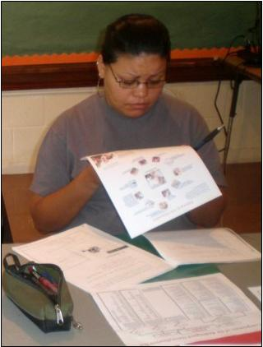
- Pathway to U.S. Citizenship
http://www.uscis.gov/files/nativedocuments/M-685.pdf.
This is a spiral graphic showing the general requirements for naturalization of an adult immigrant.
If the direct web address above does not work for you, use your favorite search engine to look for Pathway to U.S. Citizenship and check the web address at the end of the entries.

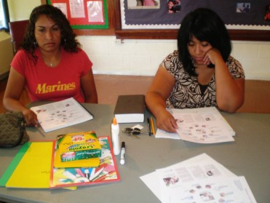

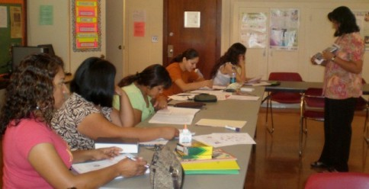
- Components of the Redesigned Naturalization Test
http://www.uscis.gov/files/nativedocuments/M-685.pdf.
This is a one-page graphic of the new test. It includes (1) study questions for history, government, and integrated civics as well as (2) vocabulary words for the reading and writing parts of the test. This document and Pathway to Citizenship (listed on the previous page) are consecutive pages of the same publication.
- Naturalization Test Questions
(Beginners were given both English and Spanish versions.)
http://www.uscis.gov/files/nativedocuments/M-685.pdf (English)
http://www.uscis.gov/files/nativedocuments/M-685.pdf (Spanish)
If the direct web addresses above do not work for you, go to
http://www.uscis.gov/portal/site/uscis. Click on Education and Resources in the menu bar that runs across the top of the page. Click on Civics and Citizenship Study Materials on the left side of your screen. Scroll down until you can click on Redesigned (New) Naturalization Test. In addition to English and Spanish, you can print this document in Chinese, Tagalog, and Vietnamese.
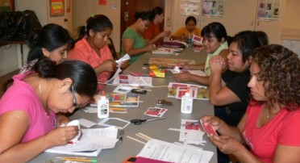
- Flash Cards
We also downloaded all the flashcards from the same website http://www.uscis.gov/files/nativedocuments/M-623_red.pdf and put them on index cards in order to review the naturalization questions in groups in the classroom.
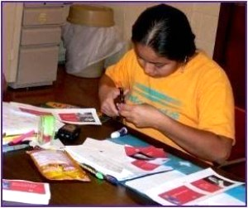
Additional Study Resources for Competency One:
American Government

Handouts
For Competency One, I supplemented USCIS (United States Citizenship and Immigration Services) materials with the following Handouts:
- Branches of American Government
- Bill of Rights
- State of North Carolina Government
- National Anthem
- Pledge of Allegiance
- Oath of Allegiance
- Pictorial Vocabulary

American Government Game
WHO WANTS TO BE AN U.S. CITIZEN?
This game is based on the popular TV show “Who wants to be a Millionaire?” Variations in the game’s rules have been made to accommodate the limitations of a classroom and of ESL students as the contestants.

American Government Worksheets
After the game, we used the worksheets below as a set of summary activities.
- Principles of American Democracy – True/False
- Vocabulary– Alphabetical Order
- American Government – Articles A or An
- System of Government – Matching
- Criptogram

References
http://www.webjunction.org/178/articles/content/447715 This site has a game called “Who Wants to be a Naturalized Citizen?” which was posted to Web Junction by McKinley Sielaff, Colorado College, on 03/17/08.

http://eslmadness.wordpress.com/2007/07/26/who-wants-to-be-a-millionaire/ This ESL Madness location has instructions for playing “Who Wants to be a Millionaire?” in the ESL class.
http://millionaire.itv.com/home.php This itv.com site has a link to an interactive game running alongside the broadcast of Who Wants To Be A Millionaire? on ITV1.
http://www.onestopenglish.com/ Use the site search to look for millionaire. Click on Teen games: who wants to be a millionaire? Richard Gresswell gives instructions on revising classroom multiple choice questions to use in a format based on the show Who Wants to be a Millionaire?
http://www.uscis.gov/civicsflashcards Civics flashcards for the new Naturalization Test.

http://www.quia.com/rr/51466.html Rags to Riches, a Citizenship-Political Science literacy starter lesson.

http://www.dar.org/natsociety/citizenship.cfm Buel, John L. DAR Manual for Citizenship. National Society Daughters of the American Revolution, Washington, DC, 1998.
2002-2003 ESL Special Project, Basic Skills Department, Caldwell Community College and Technical Institute, North Carolina.

http://www.nc-net.info/ESL/WayneCC.php. ESL: A Guide to U.S. Citizenship, Wayne Community College, North Carolina.

Quinby, Marge. Simple Steps to U.S. Citizenship. Oceanside Press, Oceanside, California, 1989.

Additional Study Resources for Competency Two:
American History

Handouts
For Competency Two, I supplemented USCIS (United States Citizenship and Immigration Services) materials with the following Handouts:
- Original Thirteen Colonies
- Vocabulary
- Some Important Wars
- Map: Original Thirteen Colonies

American History Puzzles
In this competency, students solved three different types of puzzles.
- Jigsaw Puzzle
- Double Puzzle
- Word Search

American History Worksheets
As part of our study of American History, we used the following worksheets:
- Question Sentences
- Multiple Choice Questions
- Phonics
- Sentence Structure
- Singular-Plural Verbs
- Matching
- Map Work
- Quiz

Additional Study Resources for Competency Three: Integrated Civics

Handouts
For Competency Three, I supplemented USCIS (United States Citizenship and Immigration Services) materials with these Handouts:
- Map of the United States
- The United States Flag
- Flags of Different Countries: Comparison

Integrated Civics Games and Projects
- U.S. Geography Board Game
- Make a U.S. Flag
- American National Holidays

Integrated Civics Worksheets
These are the worksheets we used for Integrated Civics:
- Missing Vowels (Geography)
- Label the Map (Geography)
- Reading Comprehension [Flag (Use with Handout 2, The United States Flag.)]
- US. Flag Now and Then (Flag)
- Reading, Writing, and Oral (Thanksgiving)
- Cloze Activity (Christmas)
- Unscramble Words (Memorial Day)
- Word Search (Veterans’ Day)
- Crossword Puzzle (Labor Day)

References
http://www.elcivics.com/labor-day-vocabulary.pdf Labor Day printable matching exercise

http://www.theholidayzone.com/labor/labor-vocabulary-match.htm A drag and drop matching exercise on Labor Day

http://www.educationallearninggames.com/geography-games.asp. The Scrambled States of America

http://www.growingtreetoys.com/product/great-states-geography-board-game Great States Geography Board Game

http://boardgames.lovetoknow.com/Edutainment_in_School_With_Board_Games Games for Geography

http://bensguide.gpo.gov/3-5/symbols/index.html Symbols of U.S. Government

