Paraphrase the Oath of Allegiance

By Lea Blanton

Alamance Community College

Teaching Objectives

“Renounce and abjure” . . . . . “bear true faith” . . . . . ”take this obligation”. . . . . Some words and phrases in The Oath of Allegiance are not common in spoken English today. The objectives of this exercise are for students to

Gain an understanding of the promises they will make, and

Explore some of the expectations that have united Americans through the years

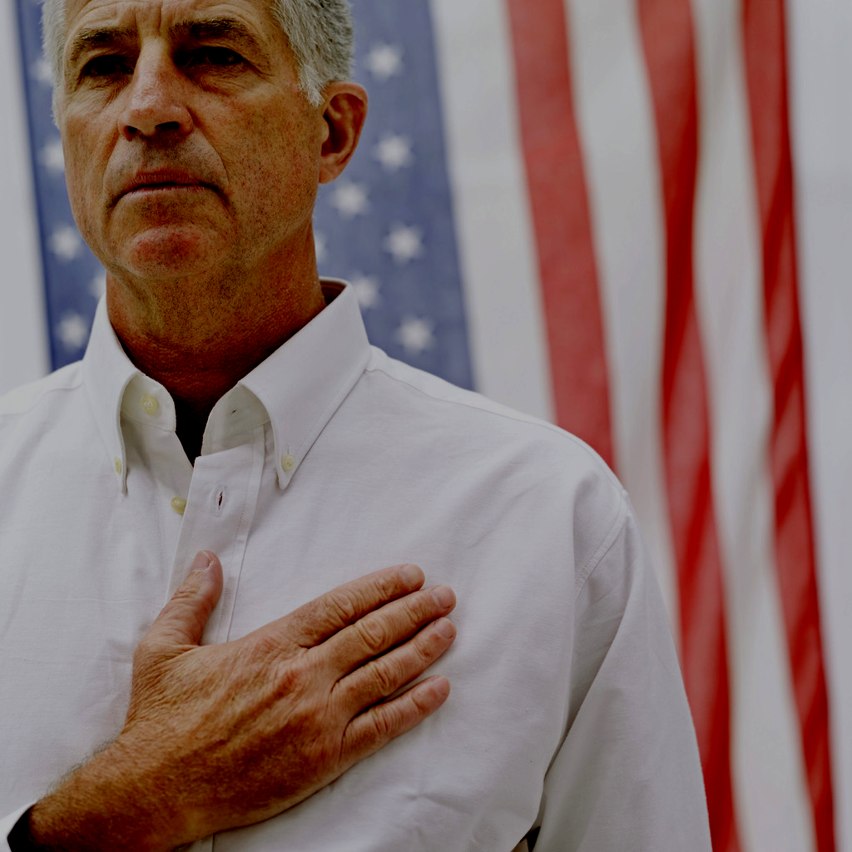

Directions

Give each student a copy of the page in this exercise that has the heading What Am I Promising? Tell them the class will write the Oath of Allegiance to the United States of America in their own words to make sure that they understand what they are promising and can explain what each part of the Oath will mean for their future.

Allow students to work alone for a time and then lead the class to work together to construct a single paraphrase of the Oath.

Graphic from http://office.microsoft.com/en-au/clipart/default.aspx

Discuss your finished work. Ask students if there is anything in the Oath that surprises them. Ask them to give examples of ways that the promises they will be making may affect them as an American citizen.

Teaching Resources

A sample paraphrase is included at the end of this exercise for your reference.

- An article that discusses using the Oath of Allegiance in the context of Citizenship curricula can be found at http://www.nelrc.org/cpcc/, the Civic Participation and Citizenship Collection. Click on Citizenship Preparation in the left column of the screen; then click on Citizenship Teacher Writings in the center of your screen. Scroll down and look under Resources for Teachers until you find "Questioning Citizenship Curricula," by Erik Hugo Jacobson. Click on http://www.nelrc.org/cpcc/questioning.htm, the link to this article.
Jacobson is a proponent of introducing the Oath early in a student’s study and using it as a touchstone throughout the process of learning about American civics and government.

What Am I Promising?

When a person becomes a naturalized citizen of the United States, he or she makes promises by taking the Oath of Allegiance. That oath is printed below. Re-write it section by section to tell in your own words what this oath means.

Oath of Allegiance to the United States of America

"I hereby declare, on oath,

- that I absolutely and entirely renounce and abjure all allegiance and fidelity to any foreign prince, potentate, state, or sovereignty of whom or which I have heretofore been a subject or citizen;

- that I will support and defend the Constitution and laws of the United States of America against all enemies, foreign and domestic;

- that I will bear true faith and allegiance to the same;

- that I will bear arms on behalf of the United States when required by the law;

- that I will perform noncombatant service in the Armed Forces of the United States when required by the law;

- that I will perform work of national importance under civilian direction when required by the law; and

- that I take this obligation freely without any mental reservation or purpose of evasion; so help me God."
In other words . . .
(A SAMPLE PARAPHRASE)

"I hereby declare, on oath,

BY MAKING THIS PUBLIC STATEMENT, I PROMISE

- that I absolutely and entirely renounce and abjure all allegiance and fidelity to any foreign prince, potentate, state, or sovereignty of whom or which I have heretofore been a subject or citizen;

THAT I GIVE UP MY LOYALTY TO ANY LEADER OR GOVERNMENT EXCEPT THE UNITED STATES,

- that I will support and defend the Constitution and laws of the United States of America against all enemies, foreign and domestic;

THAT I WILL STAND UP FOR THE U.S. CONSTITUTION AND THE LAWS OF THE UNITED STATES,
THAT I WILL PROTECT THE U.S. CONSTITUTION AND LAWS FROM ENEMIES AT HOME OR ABROAD,

- that I will bear true faith and allegiance to the same;

THAT I BELIEVE IN AND WILL BE 100 PERCENT LOYAL TO THE CONSTITUTION AND THE LAWS OF THE UNITED STATES,

- that I will bear arms on behalf of the United States when required by the law;

THAT I WILL GO TO WAR FOR THE UNITED STATES WHEN THE LAW REQUIRES ME TO DO SO,

- that I will perform noncombatant service in the Armed Forces of the United States when required by the law;

THAT I WILL DO NON-FIGHTING WORK IN THE U.S. ARMED FORCES WHEN THE LAW REQUIRES ME TO DO SO,

- that I will perform work of national importance under civilian direction when required by the law; and

THAT I WILL DO NON-MILITARY WORK THAT IS VALUABLE TO THE U.S.A. WHEN THE LAW REQUIRES ME TO DO SO.

- that I take this obligation freely without any mental reservation or purpose of evasion; so help me God."

NO THOUGHTS KEEP ME FROM WANTING TO BE AN AMERICAN CITIZEN. I AM NOT BECOMING AN AMERICAN CITIZEN FOR ANY DISHONEST REASON. AS GOD IS MY WITNESS, I MAKE THESE PROMISES AND ACCEPT THESE RESPONSIBILITIES WILLINGLY.



Graphic from http://office.microsoft.com/en-au/clipart/default.aspx

