Integrated Civics Games and Projects
By Dr. Nutan Varma
Central Carolina – Harnett Campus
PART 1: U.S. GEOGRAPHY BOARD GAME

Objectives
Students will
- enrich their knowledge of U.S. geography facts while they compete against other players
- learn important facts about the USA such as landmarks, oceans, and capitals
- be more eager to learn and more likely to retain what they have learned
- practice social skills such as taking turns, graceful winning (and losing!) and being patient with other players

Level
My class consists of high beginners, high intermediate, and advanced level ESL students. Our class meets three days a week for four hours a day.

Graphic from http://office.microsoft.com/en-us/clipart/default.aspx.
Student Preparation
Students reviewed U.S. geography questions from the handouts for Competency Three and the Redesigned Naturalization Questions. They also practiced small group question-answer sessions for one hour every day for three days using the flashcards downloaded from www.uscis.gov. For these preparation materials, see the document called A Review for the Redesigned Naturalization Test. Handouts and worksheets are included in the documents accompanying this competency.

Making the Game

Materials
Sturdy Poster Board: Cut into 8.5 x 11” size or bigger.
Blank template of game board
Set of U.S. geography questions
Dice
pegs (or other markers) equal to the number of students

Design
I typed one geography question in each box. To make the game board brighter, I filled the boxes with bright colors and added funny emoticons.

Emoticons

Graphics from http://office.microsoft.com/en-us/clipart/default.aspx

The map/picture, game title graphics, and emoticons are all from http://office.microsoft.com/en-us/clipart/default.aspx.

U.S. Geography



Map/Picture Title

I mounted a game board printout on the poster sheet. It helps to laminate it to preserve the game board for a longer period of time.

My puzzle is on the next page, followed by a blank format for you to use for making a puzzle of your own design.

Graphics from http://office.microsoft.com/en-us/clipart/default.aspx

Go ahead 2 spaces.

Where is the Statue of Liberty?

What is the smallest state of U.S.A.?
END

Miss one turn.

Go ahead 2 spaces.

Name the state that borders Mexico.

Name one of the longest rivers.

START
Take the Shortcut Pass.

Go back 2 spaces.

Name of ocean on the east coast of U.S.A.
Miss one turn.

Name one U.S. territory.
Take an extra turn.

What is the largest state of U.S.A.?

Name of ocean on the west coast of U.S.A.

Name one of the states that borders Canada.

Take an extra turn.

Go back 2 spaces.

Name the state with largest population.

Name the state that is an island.

Name the state that borders N.C. on the north.

Go ahead 2 spaces.

What is the capital of U.S.A.?
Take the Shortcut Pass.

What is the capital of North Carolina?
U.S. Geography

U.S. Geography

END

START

UU
Delete and add an image here.

Delete and add an image here/ Type the Game Title.
HOW TO PLAY
Players roll one die. The player with highest number on the die starts the game. That player moves the peg the same number of boxes on the game board as the number of dots he/she rolled on the die, but the player can stay in that box only if he/she correctly answers the question in that box. If not, the player has to go back to the original box where he/she started in this particular round. Each player takes a turn in clockwise direction. The first player to reach the end of the game wins. Continue playing to find out the player in the last place.
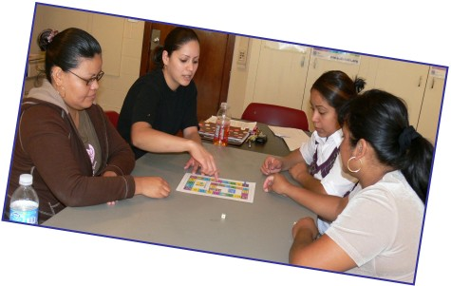

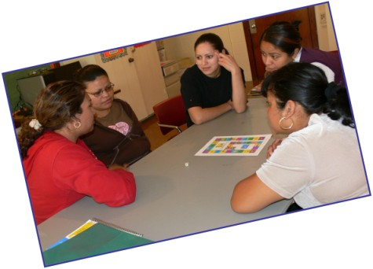
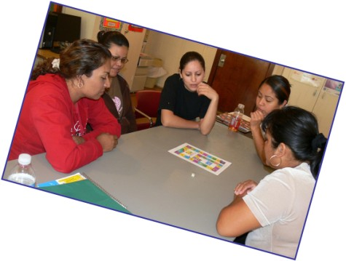
PART 2: MAKE A U.S. FLAG

Objectives
Students will:
- demonstrate their knowledge of flag symbolism by explaining the meaning of all symbols in the U.S. flag
- demonstrate creativity by designing and creating a U.S. flag
- discuss the significance of a national flag
- display their understanding of numbers and basic measurement techniques
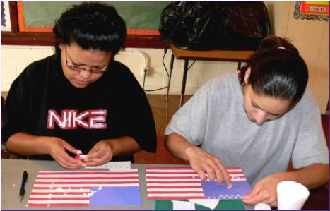

Materials
Blue Construction Paper – 1
Red Construction Paper – 1
White Construction Paper (for stars) – 1
Star puncher (optional)
Thin stick (about 1.5 ft long) – 1
Scissors
Markers
Ruler
Glue

Student Preparation
Students reviewed the U.S. flag using (1) the document called A Review for the Redesigned Naturalization Test and (2) the Handouts and worksheets for Integrated Civics, which are independent documents accompanying this competency.

Procedure
Cut seven red stripes of equal sizes. Glue them on white construction paper horizontally. Cut a blue square of the same size as the width of seven stripes together from the top. Glue the square on the top left corner of the flag. Cut out 50 white stars using star puncher (convenient) or cut 50 little stars with scissors. Glue all the stars on the blue square. Finally, roll and glue the left side of the flag around the stick.

U.S. Flags Created by Our Class
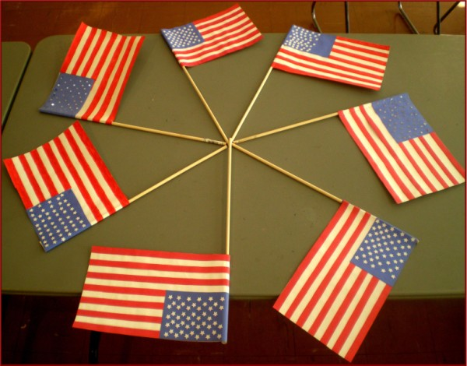
PART 3: AMERICAN NATIONAL HOLIDAYS



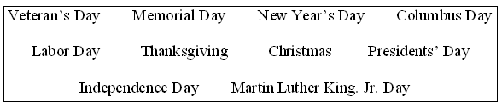
Directions: Fill-in the blanks with the appropriate holidays
from the box above.

1. ________________________ This holiday comes on January 1st.

2. ________________________ This holiday is on July 4th

3. ________________________ This holiday is on the last Monday in May.

4. .________________________ This holiday is the 3rd Monday in January.

5. ________________________ What holiday is on October 12th?

6. ________________________ This holiday is on November 11th .

7. ________________________ This holiday is the 4th Thursday in November.

8. ________________________ This holiday is on December 25th.

9. ________________________ This holiday is 3rd Monday in February.

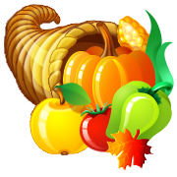
10. ________________________ This holiday is the 1st Monday in September.
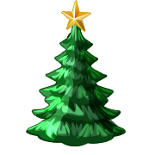

Graphics from http://office.microsoft.com/en-us/clipart/default.aspx
For online clickable holiday questions, see http://a4esl.org/q/h/vm/us-holidays.html

