IDENTIFY THE FEDERAL HOLIDAYS
By Lea Blanton
Alamance Community College

Teaching Objective
Students will identify the Federal holidays.

Overview
The following handout consists of graphics to help students internalize mental pictures as an aid to remembering/naming the Federal holidays. Any calendar that documents the holidays will make a useful reference for those who need it.

Answer Key
New Year’s Day
Martin Luther King, Jr. Day
¹Presidents’ Day
Memorial Day
Independence Day
Labor Day
Columbus Day
Veterans Day
Thanksgiving
Christmas

_______________________

¹Commonly called Presidents’ Day, the Federal Statute designates this day as Washington’s Birthday. See any of the following web sites:
http://stockholm.usembassy.gov/Holidays/celebrate/presiden.html
http://familyinternet.about.com/od/holidayfun/a/presidentsday.htm
http://en.wikipedia.org/wiki/Presidents_Day_(United_States)
http://score.rims.k12.ca.us/score_lessons/special_events/presidents_day/
The USCIS Civics and American Government Items for the Redesigned Naturalization Test uses Presidents’ Day
Identify the Federal Holidays
Write the name of each holiday.

________________________________
January

_______________________________
January

_______________________________
February

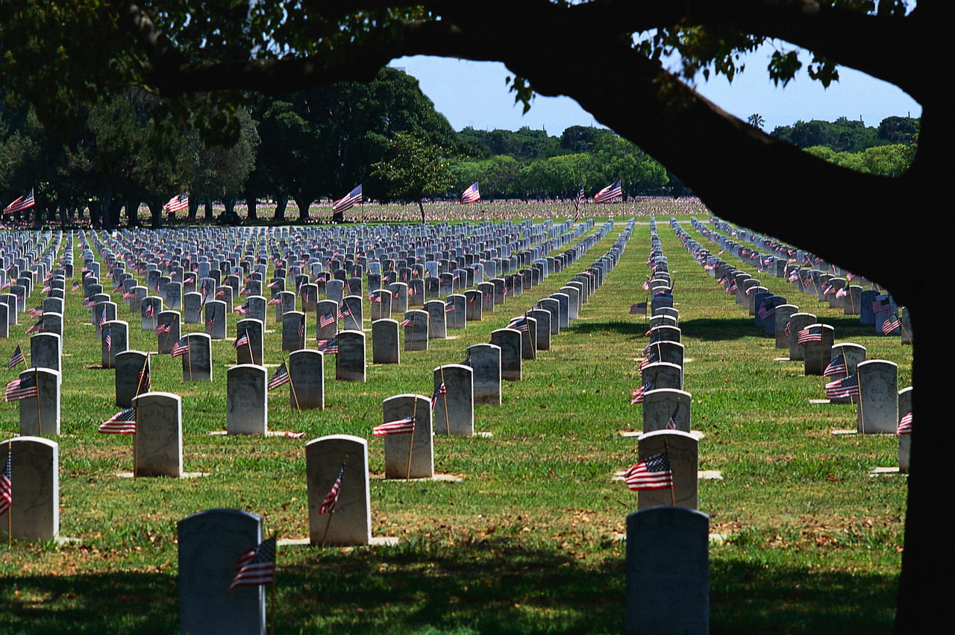

________________________________
May

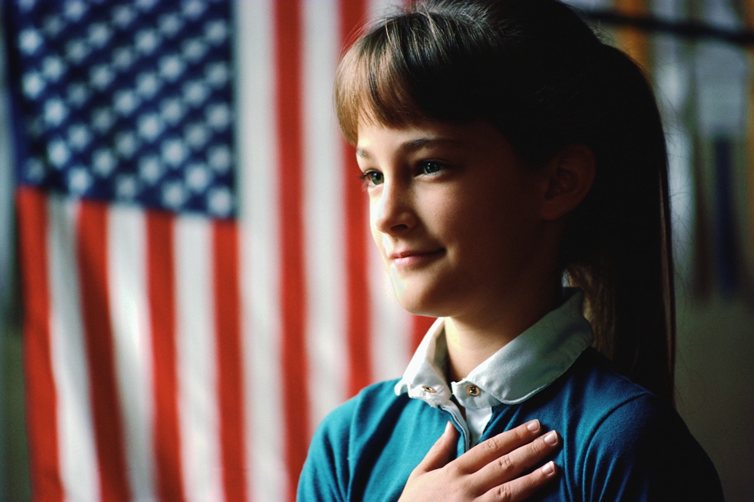

__________________________________
July

Page 1 Graphics from http://office.microsoft.com/en-au/clipart/default.aspx


_______________________________________
September

____________________________
October



_______________________________
November



_________________________________
November


_________________________________
December

Page 2 Graphics from http://office.microsoft.com/en-au/clipart/default.aspx

