American History Puzzles
By Dr. Nutan Varma
Central Carolina – Harnett Campus

Objectives
Students will:
- identify and locate the 13 original colonies of America
- learn about the three regions of Colonial America
- utilize various sources to gather information about geographic locations
- connect dates, events, and places in history to learn how the U.S. was formed
- analyze, sequence, and develop logical thoughts and problem solving skills

Level
My class consists of high beginners, high intermediate, and advanced level ESL students.

Time
Our class meets three days a week and four hours a day. We spent about two class hours for two days on learning the names, locations, and other details on the original thirteen American colonies.
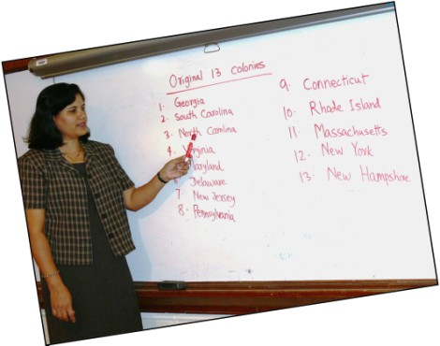
Student Preparation

Students used handouts for Competency Two and a map of thirteen colonies which were provided in the class.

(See the document called A Review for the Redesigned Naturalization Test. The handouts and worksheets themselves are included in documents accompanying this competency. The source of the map is http://www.founderblogs.com/images/map_over.jpg.)

Students also made and used flash cards. They further prepared through group discussion. Finally, they used a hyperlinked map at http://www.mrnussbaum.com/13.htm to learn important details about each state,
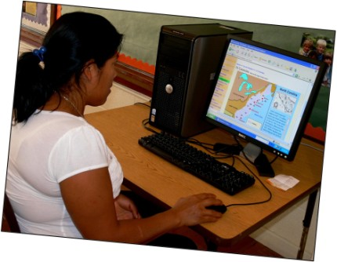

The Puzzles
Three American History puzzles with instructions are on the following pages:

1. Jigsaw Puzzle: Original 13 Colonies
2. Double Puzzle
3. Word Search
1. Jigsaw Puzzle: Original 13 Colonies

Graphic from http://office.microsoft.com/en-us/clipart/default.aspx
Materials
2 sturdy white sheets (8.5” x 11” each) to print the map on. (You may elect to make your puzzles a different size.)
Map of the 13 original colonies
1 white sheet for puzzle template
Scissors
Pencil
Stopwatch

Preparation
I planned for two teams of players, so I made two puzzles, one for each team. Reproducible puzzle pieces are near the end of this competency.

First I printed two colored maps of the 13 original colonies.

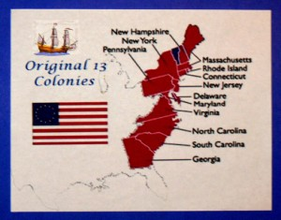

Next I drew a template with six columns of blocks lengthwise and five rows of blocks in height for a total of 30 pieces.
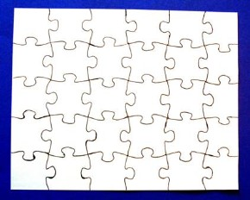

Then I traced the blocks on the two maps by putting the template over each map as follows:
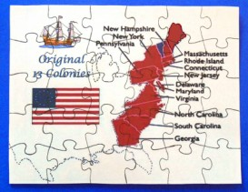

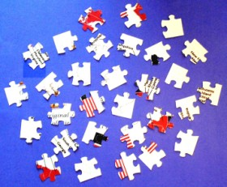
Finally, I cut out all 30 pieces in each puzzle, and a Jigsaw puzzle was ready for each of my two teams.
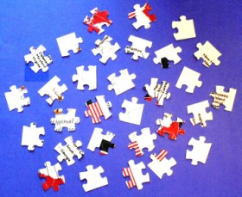

Putting Together the Puzzle
I divided the class into two teams of players and gave each team one set of 30 puzzle pieces. I used a stopwatch and let the teams start connecting the pieces at the same time. The stopwatch gave the exact time both team took to finish the game.

Team 1
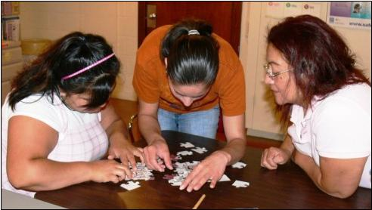

It was exciting! Both my teams did their best to finish the game as quickly as possible. The winning team, i.e. Team 2, finished the game in six minutes--two minutes earlier than Team 1.

Team 2
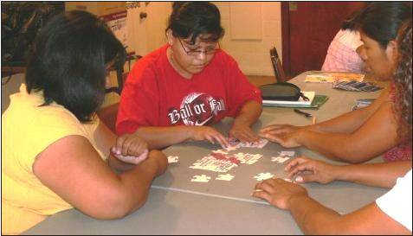

Winners’ Choice
But, the competition was not over yet! The funniest part was yet to come! The winning team decided on six action verbs and the losing team had to act them. The purpose was to cheer up the losing team and, at the same time, to review some action verbs/vocabulary.

The selected action verbs were
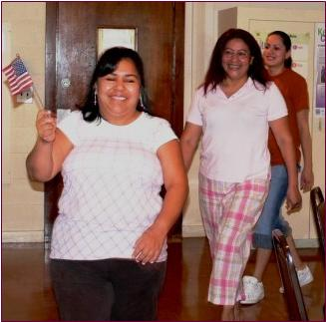
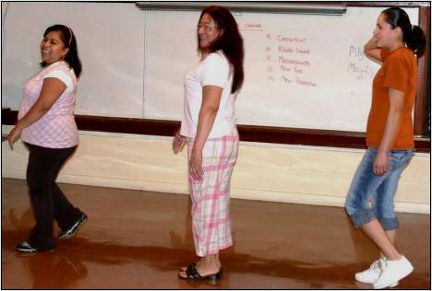

Walk March with the
U.S. Flag
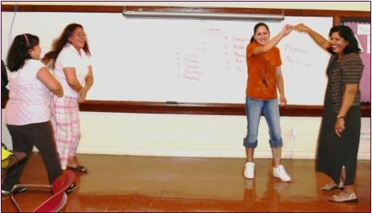
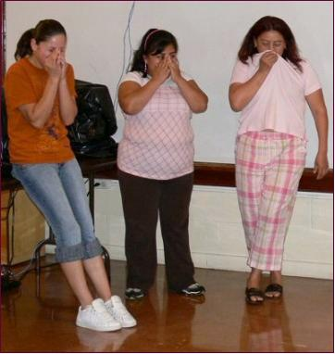

Dance Cry
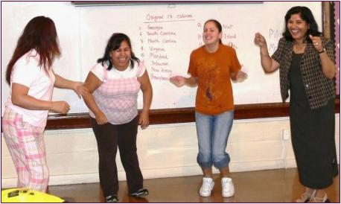

Jump Rope

And finally, the winners joined the losers to
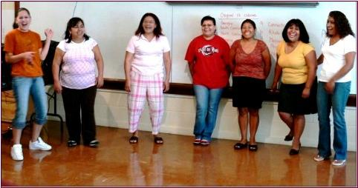

Laugh!

Our Jigsaw Puzzle
The following pages show our jigsaw puzzle.

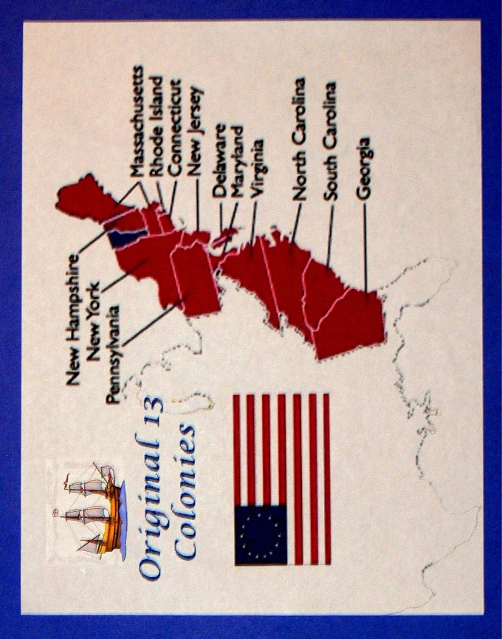

Original 13 Colonies
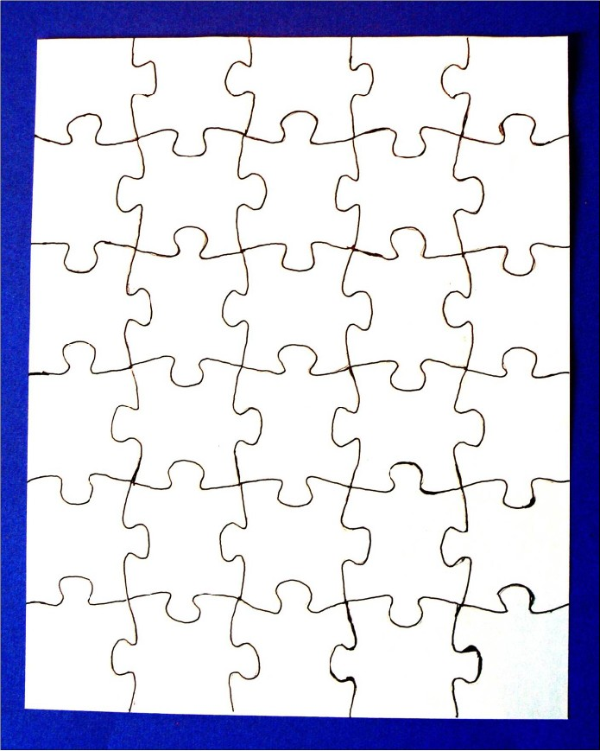

Blank Template
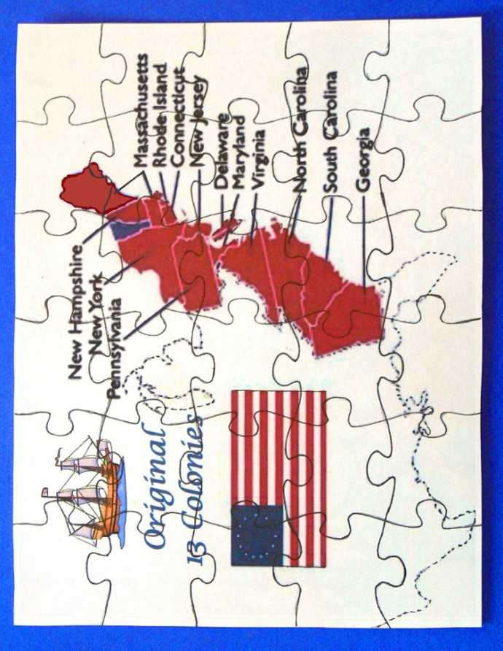

Map with 30 Blocks
Reproducible Puzzle Pieces
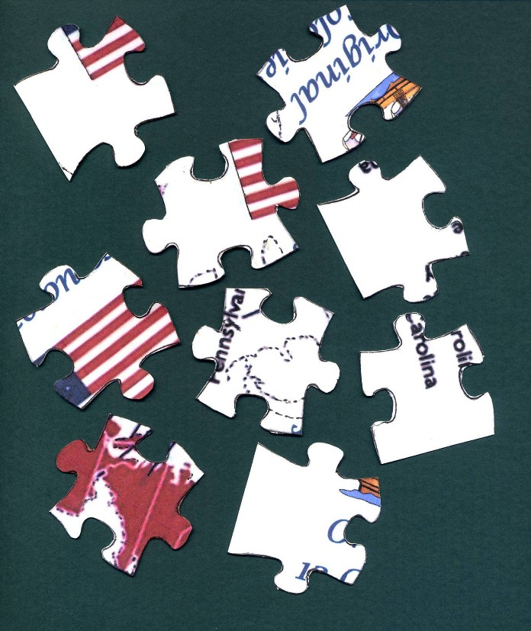

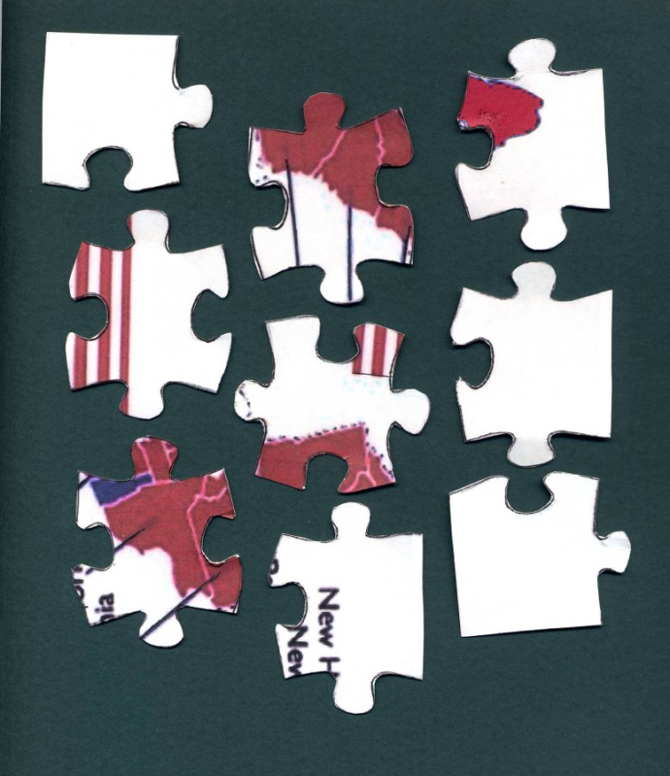

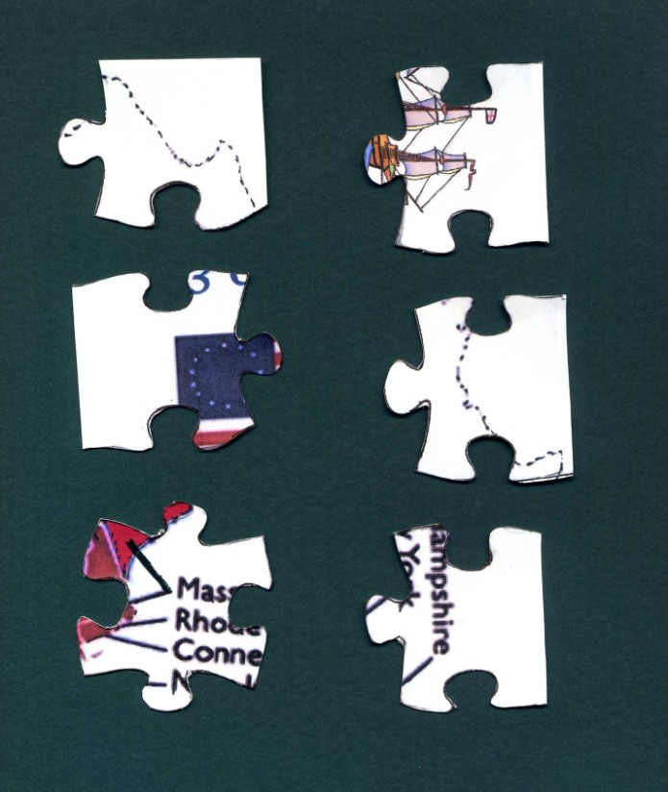

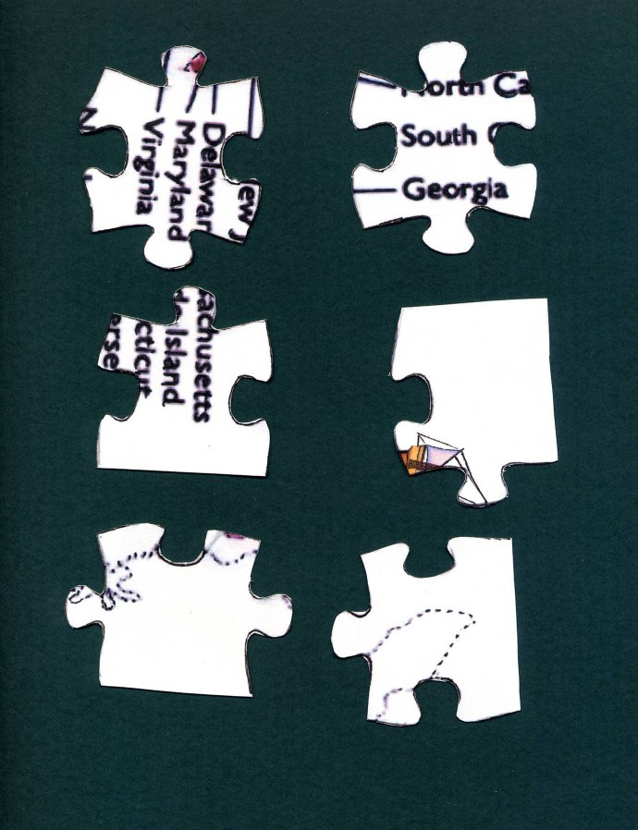

See http://www.lessontutor.com/ltpuzzlehome.html

2. Double Puzzle

Directions: Unscramble each of the clue words. Copy the letters in the numbered cells to other cells with the same number. Reveal the secret phrase hidden in the bottom two boxes.
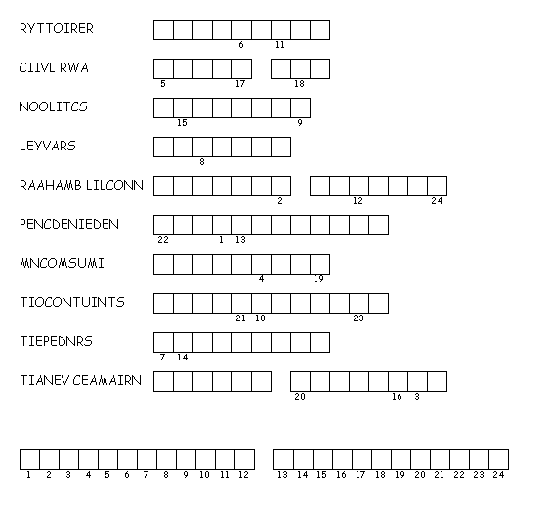
Created by Puzzlemaker at DiscoveryEducation.com
Graphics from http://office.microsoft.com/en-us/clipart/default.aspx

Instructor’s Double Puzzle Answer Sheet

T | E | R | R | I | T | O | R | Y

C | I | V | I | L
W | A | R

C | O | L | O | N | I | S | T
S | L | A | V | E | R | Y
A | B | R | A | H | A | M
L | I | N | C | O | L | N
I | N | D | E | P | E | N | D | E | N | C | E
C | O | M | M | U | N | I | S | M
C | O | N | S | T | I | T | U | T | I | O | N
P | R | E | S | I | D | E | N | T
N | A | T | I | V | E
A | M | E | R | I | C | A | N

Secret Phrase
E | M | A | N | C | I | P | A | T | I | O | N
P | R | O | C | L | A | M | A | T | I | O | N

3. Word Search
E | N | E | N | M | R | P | E | N | R | S | A | U | P | Z
N | C | N | Y | E | X | N | W | M | E | H | B | A | I | X
Q | F | N | M | N | G | E | S | M | W | Q | Z | S | L | S
T | L | R | E | L | O | I | H | G | O | N | B | P | G | C
Y | A | P | A | D | N | L | P | J | L | P | O | H | R | W
F | S | N | M | U | N | U | O | R | F | L | C | T | I | P
Q | D | W | M | Q | Q | E | P | C | Y | Y | R | N | M | S
X | R | M | V | P | P | C | P | Z | A | A | B | O | N | J
P | O | M | B | V | H | I | O | E | M | W | J | T | A | J
C | O | C | C | A | B | O | T | L | D | E | J | T | I | Q
I | M | M | I | G | R | A | N | T | O | N | C | O | Q | B
S | L | A | V | E | G | H | Q | A | S | N | I | C | F | G
K | D | N | X | U | B | O | O | X | T | U | I | O | H | U
F | P | G | P | Z | E | E | K | E | V | T | G | S | X | C
Z | S | N | N | W | Y | M | V | S | I | V | N | P | T | X

Top of Form
Bottom of Form
Directions: In the Word Search above, find the following words. They run in all directions: forward, backward, up, down, and diagonally.
COLONIST | COLONY | COMMUNISM
COTTON | ENGLAND | FARMER
IMMIGRANT | INDEPENDENCE | MAYFLOWER
PILGRIM | SLAVE | TOBACCO

Created by Puzzlemaker at DiscoveryEducation.com

