American History Handout 1

Original Thirteen Colonies

Graphic from
http://office.microsoft.com/en-us/clipart/default.asp

First 13 states of the United States were called 13 original colonies and people living in these colonies were called colonists. They came to the New World America for several reasons.

- To explore and to own their own land.
- Freedom of Religion.
- To have a new way of life.

Many immigrants moved from Europe to settle in the colonies. All 13 colonies were located at the east coast of America and owned by England. They were divided into three regions:
- The New England Colonies: New Hampshire, Rhode Island, Massachusetts, and Connecticut.
- The Middle Colonies: New York, Pennsylvania, New Jersey, and Delaware.
- The Southern Colonies: Maryland, Virginia, North Carolina, South Carolina, and Georgia.

Virginia was the first and Georgia was the last colony. Most colonists were farmers. They used to grow mainly cotton and tobacco. Native Americans helped them.
American History Handout 2
Vocabulary
Graphics from http://office.microsoft.com/en-us/clipart/default.asp
Territory: an area under the control of a foreign government and it has a lower status than most constituent parts of the state.
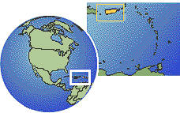
Puerto Rico (U.S. Territory)

Civil War: a war between the regions of the same country such as war between northern and southern regions of the United States.

Colony: a distant territory controlled by its parent country from far.

Colonists: people living in colonies.

Slave: person forced to work with no or little pay.

Independence: freedom from control of others.

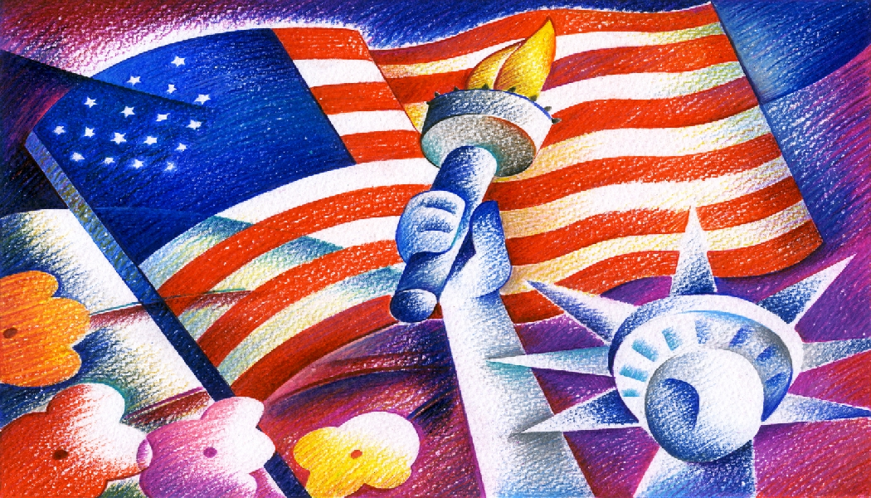

Native Americans: original inhabitants of the Americas before pilgrims’ arrival.

Inhabitant: one who lives permanently in a place; house, town, city, state, or county.


Pilgrim: one of the colonists from England who came to America on the Mayflower and founded the colony of Plymouth in New England.
.

Mayflower: the ship in which the pilgrims sailed from England to Massachusetts

Emancipation Proclamation: a document that declared freedom to the slaves.

Farmer: someone who grows crops and other food on the farm.
Cotton: a soft fiber that grows around the seeds of the cotton plant and is used to make fabric.

Tobacco: a plant mainly used for smoking or chewing.
Immigrant: someone who leaves one place to live in another, temporarily or permanently.

References for American History Handout 2
http://answers.com
http://www.merriam-webster.com/dictionary
http://www.thefreedictionary.com
http://www.apparelsearch.com/Definitions/Fiber/Cotton_definition.htm
http://www.hsp.org/default.aspx?id=644
American History Handout 3
Some Important Wars

- The Revolutionary War (1775-1783): Original thirteen colonies of America wanted to be independent from England. King George of England wanted to keep the colonies under his control. Revolutionary War was declared. With the help of France, Germany, Poland, and other countries, the United States won the war.

- The Mexican War (1846-1848): Americans set up a colony on Mexico’s land and named it Texas. In time they wanted to have their own government and not be under the rule of Mexico. This led to the war between Mexico and the United States. The U.S. won and Texas became a U.S. territory. Later, U.S. purchased land from Mexico which is now California, Arizona, New Mexico, Colorado, and Nevada.

- The Civil War (1861-1865): The Civil War between northern and southern states of America started because of slavery, economy, and states rights. Abraham Lincoln, 16th President of the United States issued the Emancipation Proclamation, a document that freed slaves. Southern states wanted to separate from the Union. But, the North won and the South came back into the Union.

- The Spanish American War (1898): America had a war with Spain over Cuba. The U.S. won and Puerto Rico, Guam, and the Philippines became U.S. territories.

- World War I (1914-1918): England and France were at war. After Germany sunk an American ship, Lusitania, the U.S. declared war against Germany and joined England and France and helped win the war.

- World War II (1939-1945): When Japan attacked Pearl Harbor on December 7, 1941, the U.S. declared war on Japan and its allies. They continued to fight until the U.S. dropped atom bombs on Hiroshima and Nagasaki. On August 15, 1945, the Japanese surrendered.

Source: Quinby, Marge. Simple Steps to U.S. Citizenship. Oceanside Press, Oceanside, California, 1989.
American History Handout 4

Map of the Original 13 Colonies of America

Give your students a map of the original 13 colonies, with the colony names. Use the following information for help finding such a resource.

At http://www.founderblogs.com/images/map_over.jpg there is an excellent map. Right click on the image.

To find similar resources, use Google to search for Microsoft clip art or go to http://office.microsoft.com/en-us/clipart/default.aspx. Scroll to the bottom of your screen and search for 13 original colonies. Click on Go. When “no results found” comes up, look at the bottom line and click on Live Search to find pages of resources

At http://www.socialstudiesforkids.com/. Click on History - U.S. in the menu on the left side of your screen. Click on Periods in U.S. History (center panel of your screen). In the drop-down menu, click on Colonial Times. Click on The 13 American Colonies (center panel of your screen). In the box toward the right on your screen, click on Clickable map of the 13 Colonies with descriptions of each colony.

