
American Government Handout 1
Branches of American Government

The Executive Branch enforces the laws.

The Judicial Branch explains and applies the law.

The Legislative Branch makes the law.

The Legislative Branch makes the laws. The Senate and the House of Representatives make up the legislative branch. There is no limit to the number of times Senators and Representatives can be re-elected.

The Executive Branch includes the President, the Vice-President, and the Cabinet members. No person may be elected President more than twice.

All graphics from http://office.microsoft.com/en-us/clipart/default.aspx

Two good resources on Branches of the American Government are
http://library.thinkquest.org/J0110221/ and
http://www.ohagan.net/courses/ap_gov/3branches.jpg

The Judicial Branch explains and applies the law.
Supreme Court justices are appointed for life.
American Government Handout 2
Bill of Rights (First Ten Amendments of Constitution)

Amendment I: Congress shall make no law respecting an establishment of religion, or prohibiting the free exercise thereof; or abridging the freedom of speech, or of the press; or the right of the people peaceably to assemble, and to petition the government for a redress of grievances.
Amendment II: A well regulated Militia, being necessary to the security of a free State, the right of the people to keep and bear Arms, shall not be infringed.
Amendment III: No Soldier shall, in time of peace be quartered in any house, without the consent of the Owner, nor in time of war, but in a manner to be prescribed by law.
Amendment IV: The right of the people to be secure in their persons, houses, papers, and effects, against unreasonable searches and seizures, shall not be violated, and no Warrants shall issue, but upon probable cause, supported by Oath or affirmation, and particularly describing the place to be searched, and the persons or things to be seized.
Amendment V: No person shall be held to answer for a capital, or otherwise infamous crime, unless on a presentment or indictment of a Grand Jury, except in cases arising in the land or naval forces, or in the Militia, when in actual service in time of War or public danger; nor shall any person be subject for the same offence to be twice put in jeopardy of life or limb; nor shall be compelled in any criminal case to be a witness against himself, nor be deprived of life, liberty, or property, without due process of law; nor shall private property be taken for public use, without just compensation.
Amendment VI: In all criminal prosecutions, the accused shall enjoy the right to a speedy and public trial, by an impartial jury of the State and district wherein the crime shall have been committed, which district shall have been previously ascertained by law, and to be informed of the nature and cause of the accusation; to be confronted with the witnesses against him; to have compulsory process for obtaining witnesses in his favor, and to have the Assistance of Counsel for his defense.
Amendment VII: In Suits at common law, where the value in controversy shall exceed twenty dollars, the right of trial by jury shall be preserved, and no fact tried by a jury, shall be otherwise re-examined in any Court of the United States, than according to the rules of the common law.
Amendment VIII: Excessive bail shall not be required, nor excessive fines imposed, nor cruel and unusual punishments inflicted.
Amendment IX: The enumeration in the Constitution, of certain rights, shall not be construed to deny or disparage others retained by the people.
Amendment X: The powers not delegated to the United States by the Constitution, nor prohibited by it to the States, are reserved to the States respectively, or to the people.

American Government Handout 3

Federal/State Elected Officials of North Carolina

Governor



Beverly Perdue (D)

Senators



Richard Burr (R) Kay Hagan (D)

Representatives



G. K. Butterfield (D) Howard Coble (R) Bob Etheridge (D)



Virginia Foxx (R) Larry Kissell (D) Walter Jones (R)


Patrick Henry (R) Mike McIntyre (D) Brad Miller (D)



Sue Myrick (R) David Price (D) Mel Watt (D)


Heath Shuler (D)
http://directory.usayfoundation.org/NC.html

The National Anthem

The Star Spangled Banner
BY FRANCIS SCOTT KEY, 1814
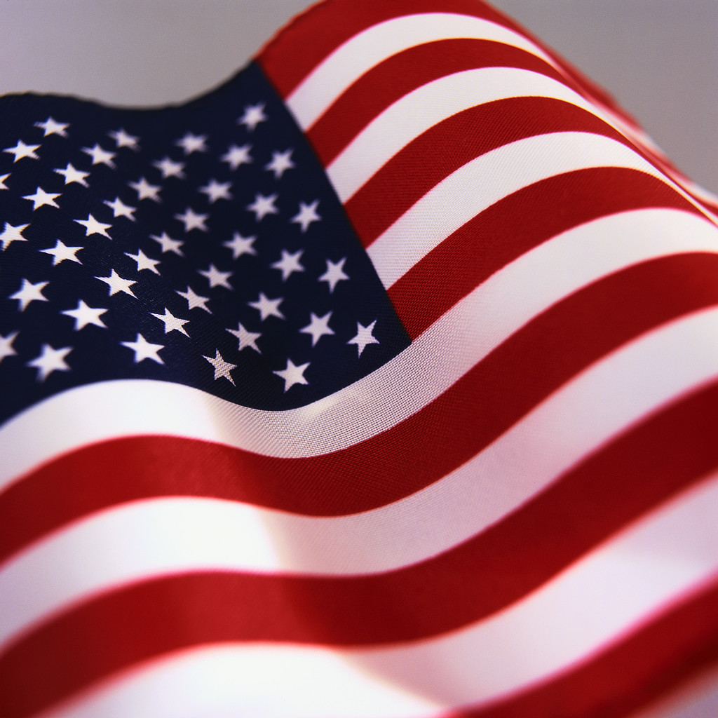

Oh say can you see, by the dawn’s early light
What so proudly we hailed at the twilight’s last gleaming
Whose broad stripes and bright starts through the perilous fight
O’er the ramparts we watched were so gallantly streaming?
And the rockets’ red glare, the bombs bursting in air,
Gave proof through the night that our flag was still there,
Oh, say does that star spangled banner yet wave
O’er the land of the free and the home of the brave?

Graphic from http://office.microsoft.com/en-us/clipart/default.aspx
American Government Handout 5

Pledge of Allegiance

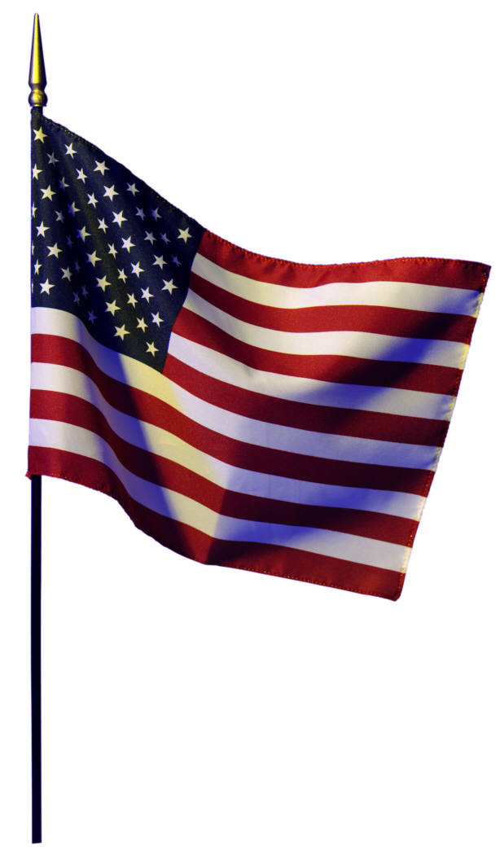

I pledge allegiance
to the flag
of the United States of America
and to the Republic
for which it stands,
one nation,
under God,
indivisible,
with liberty
and justice for all.

Graphic from http://office.microsoft.com/en-us/clipart/default.aspx
American Government Handout 6

Oath of Allegiance

"I hereby declare, on oath, that I absolutely and entirely renounce and abjure all allegiance and fidelity to any foreign prince, potentate, state, or sovereignty of whom or which I have heretofore been a subject or citizen; that I will support and defend the Constitution and laws of the United States of America against all enemies, foreign and domestic; that I will bear true faith and allegiance to the same; that I will bear arms on behalf of the United States when required by the law; that I will perform noncombatant service in the Armed Forces of the United States when required by the law; that I will perform work of national importance under civilian direction when required by the law; and that I take this obligation freely without any mental reservation or purpose of evasion; so help me God."

Graphic from http://office.microsoft.com/en-us/clipart/default.aspx
American Government Handout 7
Pictorial Vocabulary
Graphics from http://office.microsoft.com/en-us/clipart/default.aspx

Democracy: a system of government in which the citizens or members choose leaders or make important decisions by voting.

Ballot box

Constitution: the fundamental law of the United States framed in 1787. It is a document that guarantees individual rights and outlines the responsibilities of the government.

Bill of Rights: the first ten amendments to the U.S. Constitution, added in 1791 to protect certain rights of citizens.

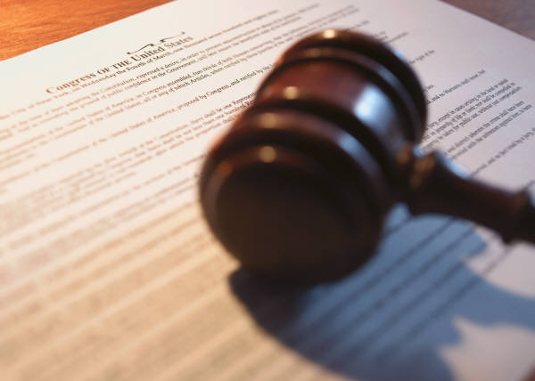

Amendment: a change or an addition to the Constitution.
The first amendment guarantees freedom of religion, speech,
the press, assembly, and to petition the government.

Petition: a written application requesting a court for a specific judicial action.

Declaration of Independence: a document that announced our freedom from Great Britain on July 4, 1776.



Cabinet: a special group who advises the President.

Naturalization: refers to an act whereby a person acquires a citizenship different from that person's citizenship at birth.
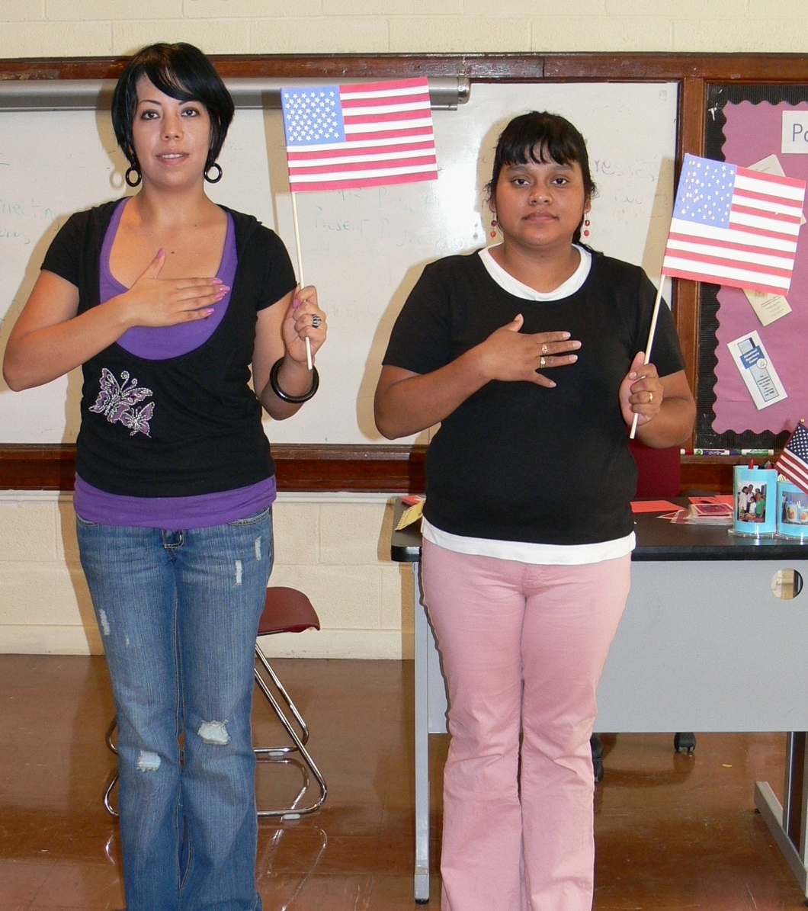

Executive: President, Vice-President, and Cabinet members; the branch of the United States government that is responsible for carrying out the laws.

Legislative: Congress; Senate and House of Representatives; the branch of the United States government that makes federal laws.

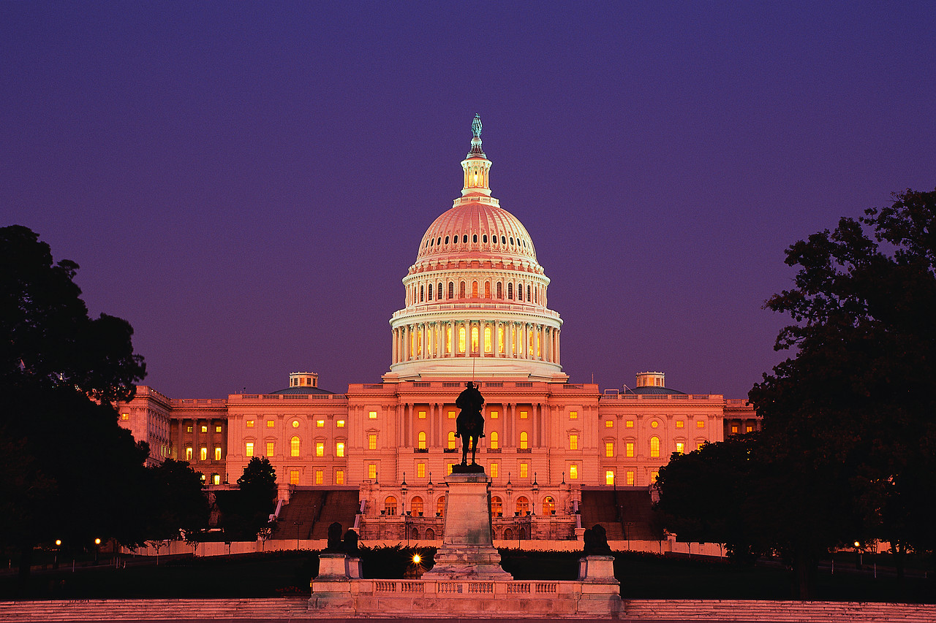

Judicial: Courts; the branch of the United States government that interprets and reviews laws.
