Find the False Statements
By Lea Blanton
Alamance Community College

Teaching Objective
Students will sharpen their reading skills in addition to showing content knowledge in civics (history and government).

Overview
The following handout consists of three pages of statements grouped together in threes. One statement in each group is incorrect. In many cases, a close reading is required to find an erroneous part of the statement.

Answer Key
These are the incorrect sentences in the exercise that follows:

B. President Martin Luther King, Jr. led the fight for Civil Rights.

F. Tennessee was one of the 13 original colonies.

G. The Vice-President is Commander in Chief of the military.

K. The colonists fought the British to emancipate the slaves.

N. God Bless America is the national anthem.

R. Citizens have to be 21 to vote for President.

S. The United States did not participate in the War of 1812.

W. The United States bought the Louisiana Territory from the American Indians.

ZZ. Montana is a U. S. state that borders Mexico.
In each group of three, identify the one that is FALSE.

- Woodrow Wilson was President during World War I.
- President Martin Luther King, Jr. led the fight for Civil Rights.
- Dwight D. Eisenhower was the commanding general of the Allied Forces in Europe in World War II before he was President.

D. Raleigh is the capital of North Carolina.
E. The Statue of Liberty is in New York Harbor.
F. Tennessee was one of the 13 original colonies.


G. The Vice-President is Commander in Chief of the military.
H. We vote for President in the month of November.
I. The two major political parties in the United
States are Democratic and Republican.

J. One reason colonists came to America was for religious
freedom.
K. The colonists fought the British to emancipate the slaves.
L. The Declaration of Independence was adopted July 4, 1776.

Graphics from http://office.microsoft.com/en-au/clipart/default.aspx
M. Washington, D. C. is the capital of the United States.
N. God Bless America is the national anthem.
O. Memorial Day and Labor Day are two national U. S. holidays.

P. Only United States citizens can serve on a jury or vote.
Q. Anyone living in the United States has the right to freedom
of speech.
R. Citizens have to be 21 to vote for President.
S. The United States did not participate
in the War of 1812.
T. George Washington is known as the
“Father of Our Country.”
U. The Civil War is also known as the
War between the States.

V. Abraham Lincoln led the U. S. during the Civil War.
W. The United States bought the Louisiana
Territory from the American Indians.
X. Susan B. Anthony fought for women’s rights.
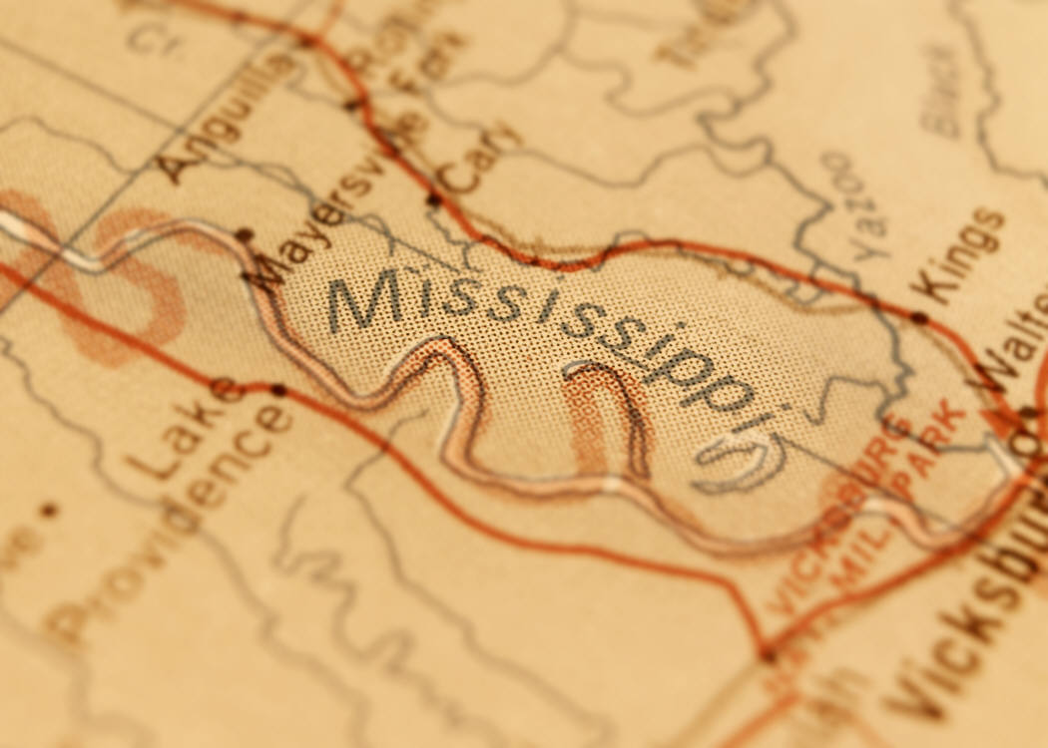

Y. The Mississippi is one of the longest rivers in the U. S.
Z. Guam is a U. S. Territory.
ZZ. Montana is a U. S. state that borders Mexico.
Graphics from http://office.microsoft.com/en-au/clipart/default.aspx

