Crossword
By Lea Blanton
Alamance Community College

Teaching Objectives
To solve a citizenship crossword puzzle, students will
- use and improve their Civics knowledge
- exercise their reasoning skills, i.e., use the number of letters in an answer and the overlapping letters in words that cross one another to determine an answer

Graphic from http://office.microsoft.com/en-au/clipart/default.aspx

Overview
Students may work alone or in pairs. Teachers may opt to let them solve the puzzle with access to the Redesigned Naturalization Questions from http://www.uscis.gov/files/nativedocuments/100q.pdf.

Answer Key
ACROSS
3. The “Father of Our Country” is George Washington.
6. Early settlers in America were called colonists.
9. The Pacific Ocean is on the West Coast of the U.S.
12. The President is in charge of which branch of government? Executive
14. In World War II, the U.S. fought Germany, Italy, and Japan.
17. The supreme law of the land is called the Constitution.
18. The Emancipation Proclamation freed the slaves.

DOWN
1. The U.S. announced freedom from Great Britain in the Declaration of Independence.
2. Washington, D.C. is the capital of the United States.
4. Federal Income tax forms are due on the 15th of April.
5. We vote for President in November.
7. The Presidents foreign policy advisor is the Secretary of State.
8. Only citizens can vote.
10. Guam is a U.S. territory.
11. One responsibility of a U.S. citizen is to serve on a jury.
13. Susan B. Anthony fought for women’s rights.
15. The number of Representatives a state has is based on the state’s population.
16. The longest river in the United States is the Missouri.
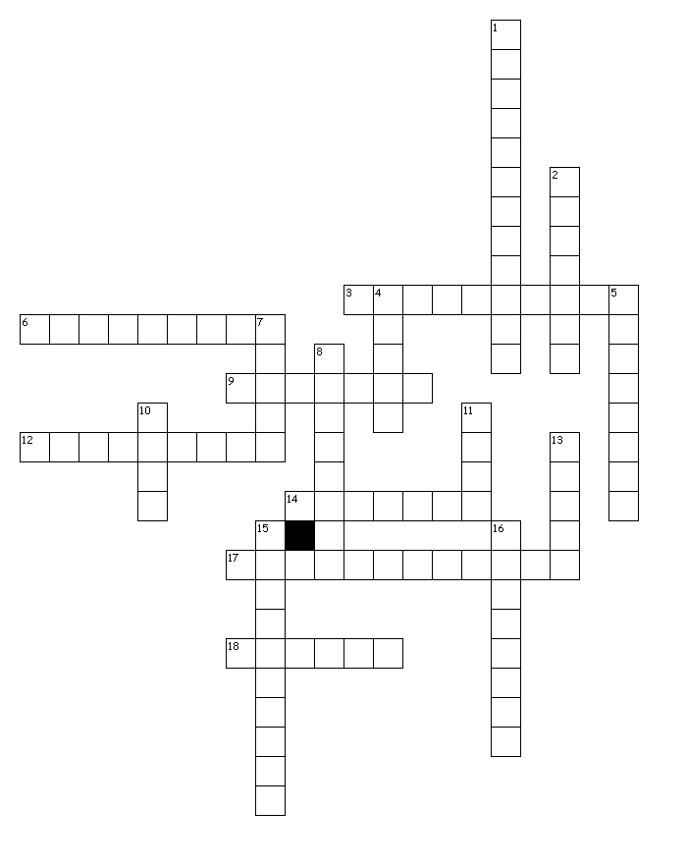
U.S.A.
ACROSS
3. The “Father of Our Country” is George _______.
6. Early settlers in America were called _______.
9. The ____ Ocean is on the West Coast of the U.S.
12. The President is in charge of which branch of government?
14. In World War II, the U.S. fought _____, Italy, and Japan.
17. The supreme law of the land is called the ________.
18. The Emancipation Proclamation freed the ________.

DOWN
1. The U.S. announced freedom
from Great Britain in the
Declaration of _______.
2. Washington, D.C. is the
______ of the United States.
4. Federal Income tax forms
are due on the 15th of ______.
5. We vote for President in _____.
7. The Presidents foreign policy advisor is the Secretary of ____.
8. Only _____ can vote.
10. _____ is a U.S. territory.
11. One responsibility of a U.S. citizen is to serve on a ______.
13. Susan B. Anthony fought for ______’s rights.
15. The number of Representatives a state has is based on the state’s _______.
16. The longest river in the United States is the ______.
Created by Puzzlemaker at DiscoveryEducation.com

