Correct the Spelling
By Lea Blanton
Alamance Community College

Teaching Objective
Students will sharpen their spelling skills on words in the civics (history and government) items from the redesigned naturalization test.

Overview
The following three handouts consist of twelve words per page, five of which are incorrectly spelled. Teachers may use these handouts in their instruction on the naturalization questions.

The teaching approach should be determined by the teacher. One option is to dictate a sentence--perhaps one of the naturalization test questions--that uses the word. With the dictation as a reference point, allow students to use a dictionary as needed to identify whether the word is misspelled on their handout. Go through this process one word at a time and check the students’ results after each word. The following words are misspelled on the Handouts:

Handout 1
Constitution
Independence
Senators
President
Commander in Chief
Handout 2
Judicial
Governor
Citizens
Amendment
Allegiance
Handout 3
Colonists
Emancipation
Proclamation
Allies
Mississippi

Finally, ask students to write a sentence of their own that correctly uses each of the words.

CORRECT THE SPELLING
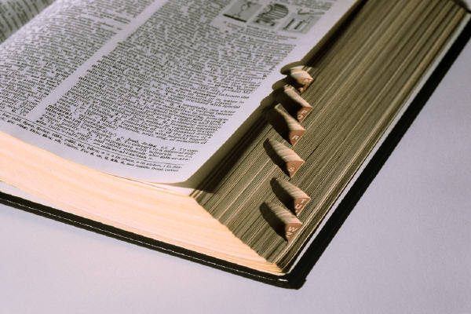

Five words below are not spelled correctly. Write the correct spelling in the blank beside the misspelled words.

- DEMOCRACY __________________
- CONSTITUTOIN __________________
- AMENDMENT _________________
- INDEPENDNECE __________________
- EXECUTIVE __________________

- FEDERAL __________________
- CONGRESS __________________
- SENATORES __________________
- PRESIDENTE __________________
- REPRESENTATIVES __________________

- COMMANDER IN CHEF_________________
- VICE PRESIDENT __________________
Use each word in a sentence.
Write your work on a sheet of notebook paper

Graphics from http://office.microsoft.com/en-au/clipart/default.aspx
CORRECT THE SPELLING

Five words below are not spelled correctly. Write the correct spelling in the blank beside the misspelled words.

- CABINET __________________
- JUDICAIL __________________
- SUPREME COURT __________________
- CHIEF JUSTICE __________________
- GOVORNOR __________________

- DEMOCRATIC PARTY __________________
- REPUBLICAN PARTY __________________
- CITEZENS __________________
- AMENDMUNT __________________
- RIGHTS __________________

- RESPONSIBILITIES __________________
- ALEGIENCE __________________
Use each word in a sentence.
Write your work on a sheet of notebook paper.

Graphics from http://office.microsoft.com/en-au/clipart/default.aspx
CORRECT THE SPELLING

Five words below are not spelled correctly. Write the correct spelling in the blank beside the misspelled words.

- PLEDGE __________________
- COLONYSTS __________________
- CONVENTION __________________
- FEDERALIST PAPERS __________________
- TERRITORY __________________

- EMANCIPATON __________________
- PROCLAIMATION __________________
- GREAT DEPRESSION __________________
- WASHINGTON __________________
10. ALIES __________________

11. MISSISIPPI __________________
12. MISSOURI __________________
Use each word in a sentence.
Write your work on a sheet of notebook paper.

Graphics from http://office.microsoft.com/en-au/clipart/default.aspx

