The Interactive Bulletin Board

By Carol O’Brien
Central Carolina – Siler City Campus

Teaching Objectives
Students will
- Learn selected material from the redesigned Naturalization test
- Use their knowledge and classroom resources to answer worksheet questions
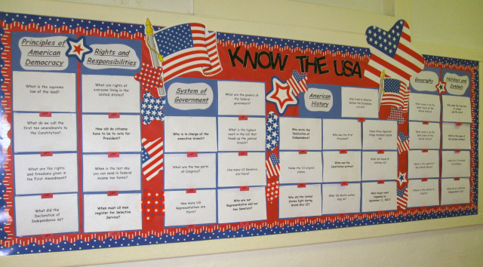
- Use an interactive bulletin board to expedite their activity and share information with other classes

Background
Because my class is a mix of Beginning/Low Intermediate students and is not a citizenship class, I chose some interesting information about our country from the Redesigned Naturalization test. I approached this material as a unit on the U.S.A. and didn’t focus on “citizenship” per se.

Procedure
- My class meets M-F mornings from 9-12. Over the course of a few days, the class completed an overview of the topics for the citizenship test.
I used selected parts of the book Entry Into Citizenship. [Becker, A. (2000). Lincolnwood: McGraw Hill]. Much in this ©2000 version is applicable or adaptable to the redesigned test. Later editions of this book are available.
Two activities that I personally designed for the United States history section are attached. The students seemed to really enjoy the little skits for each one, and I think the skits helped them remember important things about each topic.

- Next the students worked in pairs or groups using the worksheets that are included at the end of this document. The students read the questions and found the answers either on the interactive bulletin board or in the materials we used earlier in class.
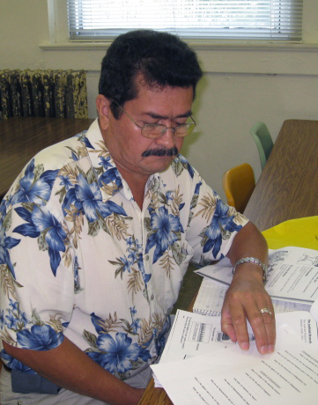
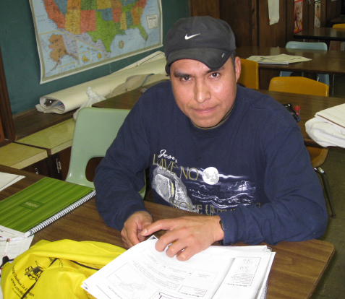
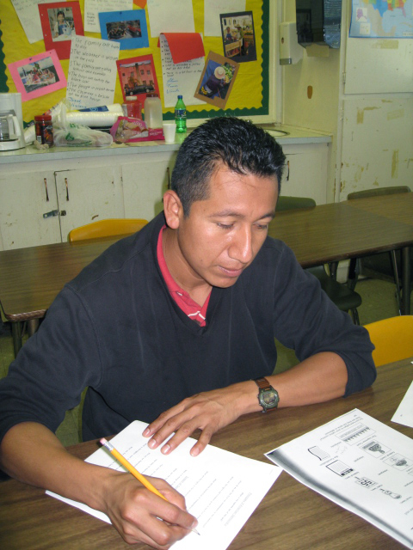

The Bulletin Board
To make the bulletin board, I printed both the questions and answers on half sheets of paper and displayed them in categories according to the citizenship test. I placed each question on top of the answer, and I attached a little tab on the bottom that says “LIFT.” Whenever someone lifts the top sheet that contains the question, the answer is underneath. I used regular letters for the question, and italicized letters with bullets for the answers. I stapled the materials on the bulletin board, and that method of attaching them held up well under repeated “liftings.”

My bulletin board materials are included for you in an accompanying document. You will need to cut the question/answer sheets across the middle, stack them, and add the lift tabs

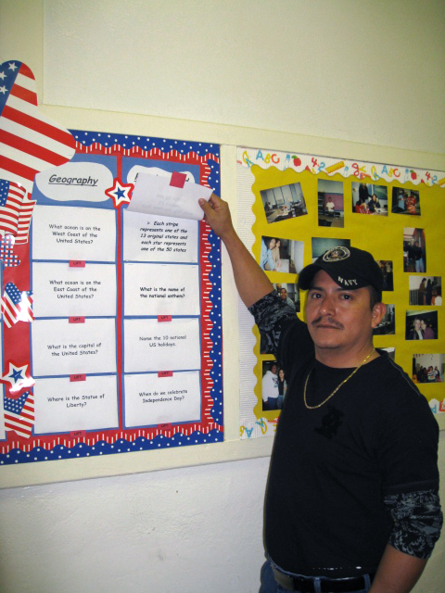
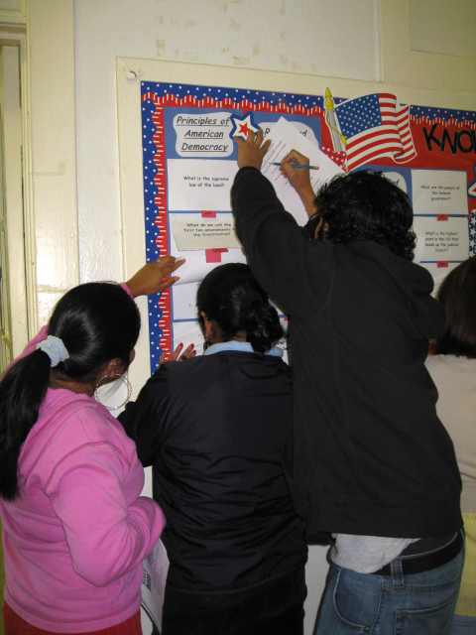

Comments:
- I was pleasantly surprised to find how much the students really enjoyed learning more about the United States. Most of them knew almost nothing about American history and about our government, and very little about our symbols and holidays. They were very interested to learn about how our country was formed, about how our government works, about the Civil War and World War II, and especially about our flag and national anthem.
- Although I chose questions that I thought were the most relevant, there still were a few of the questions that I felt were a little too difficult for my level of students, so I probably would omit some of them from this project in the future. Other teachers can use their experience to gear this project to the needs of their particular students.
- The bulletin board was very helpful as a way for students to find information easily since it was laid out systematically in categories. It was also accessible to other ESL classes or other interested viewers, and our class received a lot of positive feedback.

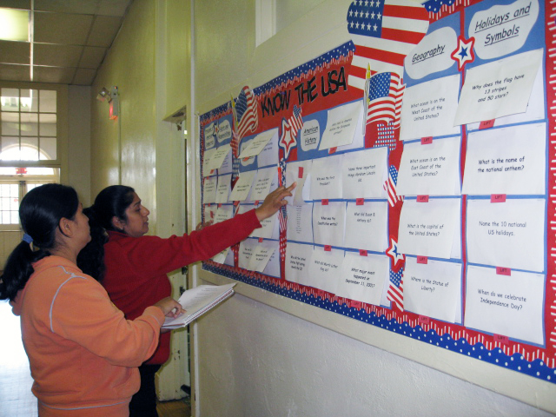
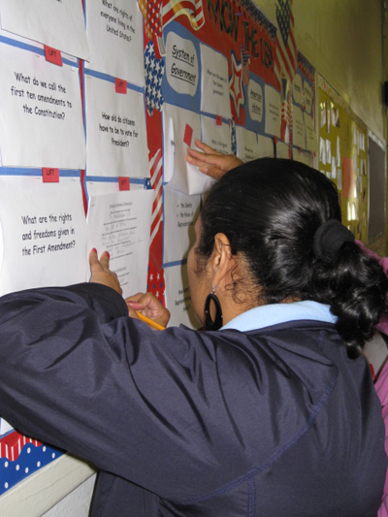

United States History Part One

Fill in the blanks.

- Before the United States was a country, the _________________________ lived here.

- ______________________________ sailed form Spain to America in 1492.
- The Pilgrims came to America on a ship called the ____________________.
- The Pilgrims came to America for _________________________________.
- The Pilgrims arrived in the ______________ and many of them _________.
- Native Americans helped the Pilgrims _______________________ and _______________________.
- The Pilgrims and Indians had a big dinner called ______________________.
- We celebrate Thanksgiving on the _________ Thursday of November.

Name the 13 original colonies.

Put these words in the correct space:

Thomas Jefferson | George Washington
Declaration of Independence | Revolutionary War
Independence Day

- ____________________ was the leader of the army and was the first President of the United States.
- ____________________ wrote the Declaration of Independence.
- ________________________________ was a letter to the king of England declaring our independence.
- The _________________________________ was the war for independence from England.
- We celebrate __________________________ on July 4 every year.

Practice this conversation:

Colonists: “The taxes are too high.”
King of England: “You must pay the taxes.”

Colonists: “We don’t want to pay the taxes!”
King of England: “You must trade only with England.”

Colonists: “We want to trade with other countries too!”
King of England: “I am the king. You must obey my laws.”

Colonists: “We want our freedom!”
Patrick Henry: “Give me liberty or give me death!”

United States History Part Two

Put these words in the correct space:

illegal slaves plantations factories pay farms

- The _________________ came to the United States from Africa.
- The slaves worked many hours without _______________.
- The North had many _________________________.
- The South had mostly _____________________.
- Large farms were called ____________________________.
- Slavery was ____________________ in the North.

Write “True” or “False.”

- _____________ The South decided to form their own country.
- _____________ The North did not want to separate.
- _____________ The Confederacy was in the South.
- _____________ The U.S. government formed the Union Army in the North.
- _____________ The war between the North and South is called the Civil War.
- _____________ Many people died in the Civil War.

Answer the questions.

- Who was President during the Civil War? ___________________________
- What was the document freeing the slaves? _________________________
- Who won the Civil War? _________________________________________
- What happened soon after the war? _______________________________
- What amendment ended slavery forever? ___________________________

Practice this conversation:

North: “Slavery is not good!”
South: “We need the slaves to work on our farms!”

North: “Slavery must be illegal!”
South: “We will form our own country!”

North: “You cannot do that! We will fight to save the United States!”
South: “You cannot tell us what to do! We will fight you too!”

(They have a war)

Abraham Lincoln: “I am the President. I declare that all the slaves are free!”
Worksheets
Write your answer in the space below each question.

Principles of American Democracy

What is the supreme law of the land?

What do we call the first ten amendments to the Constitution?

What are the rights and freedoms given in the First Amendment?

What did the Declaration of Independence do?

What are the rights in the Declaration of Independence?

System of Government

Who is in charge of the executive branch?

What are the two parts of Congress?

How many US Senators are there?

How many US Representatives are there?

Who are our North Carolina Representative and our two Senators?

What is the highest court in the US that heads up the judicial branch?

What are the powers of the federal government?

Rights and Responsibilities

Name two responsibilities only for US citizens.

What are rights of everyone living in the United States?

How old do citizens have to be to vote for President?

When is the last day you can send in federal income tax forms?

When must all men register for Selective Service?

American History

Who lived in America before the Europeans arrived?

Who wrote the Declaration of Independence?

Name the 13 original states.

When was the Constitution written?

Who was the first President?

Name three important things Abraham Lincoln did.

What did Susan B. Anthony do?

Who did the United States fight during
World War II?

What did Martin Luther King do?

What major event happened on
September 11, 2001?

Geography

What ocean is on the West Coast of the United States?

What ocean is on the East Coast of the United States?

Name the United States territories.

What is the capital of the United States?

Where is the Statue of Liberty?

Holidays and Symbols

Why does the flag have 13 stripes?

Why does the flag have 50 stars?

What is the name of the national anthem?

When do we celebrate Independence Day?

Name the 10 national US holidays.

