Bulletin Board Materials

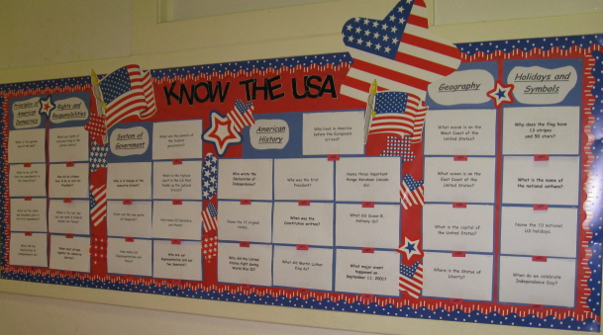

This document includes
- These bulletin board area headings:
  - Principles of American Democracy
  - System of Government
  - American History
  - Geography
  - Holidays and Symbols

- The bulletin board questions and answers (Note: under the questions for System of Government, change the Representative to be correct for your district. See http://www.fws.gov/southeast/pubs/maps/nc.pdf.)

- The LIFT tabs

Principles of American Democracy

s

System of Government

Rights and Responsibilities

American
History

Geography

Holidays and
Symbols

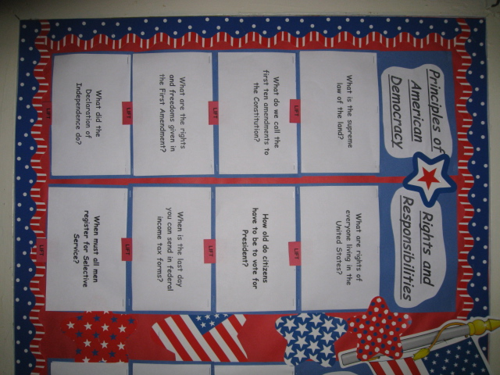
Questions & Answers

What is the supreme law of the land?

- the Constitution

What do we call the first ten amendments to the Constitution?

- the Bill of Rights

What are the rights and freedoms given in the First Amendment?

- speech
- religion
- assembly
- press
- petition the government

What did the Declaration of Independence do?

- declared our independence from Great Britain

What are the rights in the Declaration of Independence?

- life
- liberty
- pursuit of happiness

What are rights of everyone living in the United States?

- freedom of expression
- freedom of speech
- freedom of assembly
- freedom to petition the
government
- freedom to worship
- right to bear arms

Name two responsibilities that are only for U.S. citizens.

- serve on a jury
- vote

How old do citizens have to be to vote for President?

- 18 and older

When is the last day you can send in federal income tax forms?

- April 15

When must all men register for the Selective Service?

- at age 18

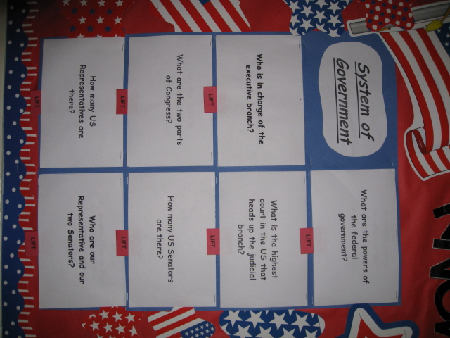

Who is in charge of the executive branch?

- the President

What are the two parts of Congress?

- the Senate
- the House of Representatives

How many U.S. Representatives are there?

- 435

What are the powers of the federal government?

- print money
- declare war
- create an army
- make treaties

What is the highest court in the U.S. that heads up the judicial branch?

- the Supreme Court

How many U.S. Senators are there?

- 100

Name our N.C. Representative and our
two U.S. Senators

Note: Change Representative to be correct for your district
- Representative
Bob Etheridge
- Senator Kay Hagan
- Senator Richard Burr

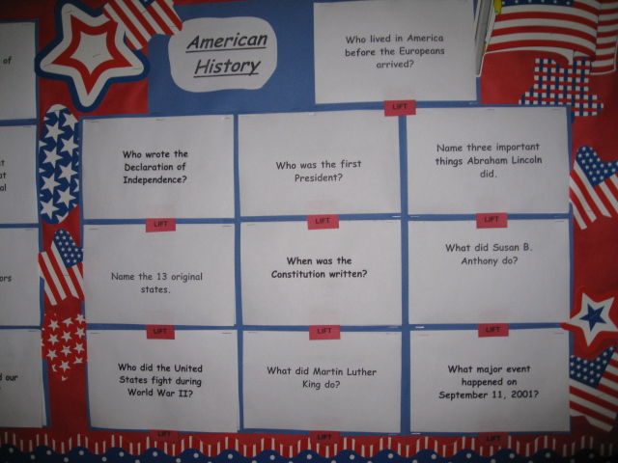

Who wrote the Declaration of Independence?

- Thomas Jefferson

Name the 13 original states.

- New Hampshire
- Massachusetts
- Rhode Island
- Connecticut
- New York
- New Jersey
- Pennsylvania
- Delaware
- Maryland
- Virginia
- North Carolina
- South Carolina
- Georgia

Who did the United States fight during
World War II?

- Japan,
Germany, and
Italy

Who was the first President?

- George Washington

When was the Constitution written?

- 1787

What did Martin Luther King do?

- fought for civil rights
- worked for equality
for all Americans

Who lived in America before the Europeans arrived?

- Native Americans (American Indians)

Name three important things Abraham Lincoln did.

- freed the slaves
- preserved the Union
- led the U.S. during
the Civil War

What did Susan B. Anthony do?

- fought for women’s rights

What major event happened on
September 11, 2001?

- Terrorists attacked the United States

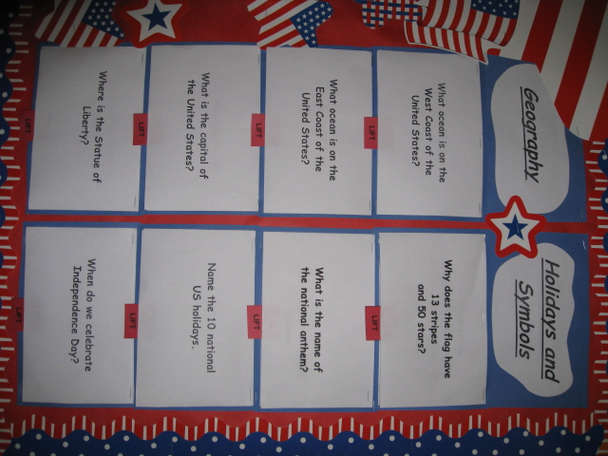
What ocean is on the
West Coast of the
United States?

- Pacific Ocean

What ocean is on the
East Coast of the
United States?

- Atlantic Ocean

What is the capital of the United States?

- Washington, DC

Where is the Statue of Liberty?

- Liberty Island in New York

Name the United States territories.

- Puerto Rico
- Guam
- US Virgin Islands
- American Samoa
- Northern Mariana Islands

Why does the flag have 13 stripes and 50 stars?

- Each stripe represents one of the 13 original colonies

- Each star represents one of the 50 states

What is the name of the national anthem?

- The Star-Spangled Banner

Name the 10 national
U.S. holidays.

- New Year’s Day
- Martin Luther King, Jr. Day
- President’s Day
- Memorial Day
- Independence Day
- Labor Day
- Columbus Day
- Veterans Day
- Thanksgiving
- Christmas

When do we celebrate Independence Day?

- July 4

LIFT | LIFT | LIFT | LIFT
LIFT | LIFT | LIFT | LIFT
LIFT | LIFT | LIFT | LIFT
LIFT | LIFT | LIFT | LIFT
LIFT | LIFT | LIFT | LIFT
LIFT | LIFT | LIFT | LIFT

