American Government Game
WHO WANTS TO BE A U.S. CITIZEN?
By Dr. Nutan Varma
Central Carolina – Harnett Campus

Objectives
Students will
- learn and demonstrate their knowledge of different aspects of the American Government
- learn new vocabulary in a group environment
- improve their oral communication
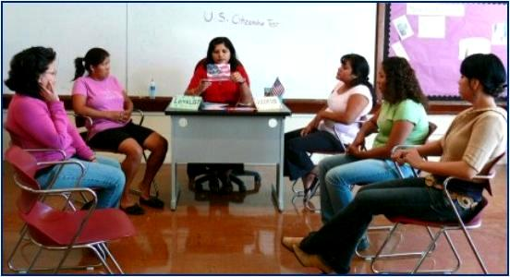

Level
My class consists of high beginners, high intermediate, and advanced level ESL students.

Time
Our class meets three days a week and four hours a day. We spent two hours daily for two weeks working on flashcards, reviewing the naturalization questions, and—finally—playing the game.
Student Prepare to Compete
Students worked in groups of three to review the USCIS Naturalization Test Questions by using flashcards and handouts with 100 naturalization questions. Beginners used the Spanish version of the questions.

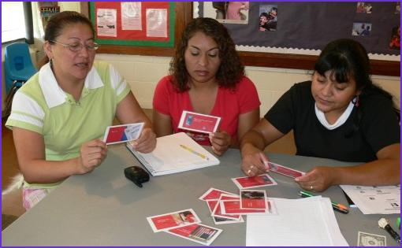

Students also reviewed questions online by playing matching games at http://www.quia.com/mc/1427698.html and by using the handouts for Competency One. (See the document called Reviewing for the Redesigned Naturalization Test.)



Game Cards
At the end of these materials are the reproducible red and blue game cards that I made for “Who Wants to be an American Citizen?”

My materials list for making the game cards is as follows:
1 red poster: Cut 15- 5”x7” game cards for one team.
1 blue poster: Cut another 15- 5”x7” game cards for other team.
1 sheet: for scoreboard
2 sheets for 2 teams’ name plates
Labels of different sizes:
30 labels; 1 for each question
120 labels; 4 for four answer choices on each question
30 labels; 1 for each correct answer with its point value, and 50/50 lifeline

I selected a total of 30 questions from the “American Government” section of the USCIS naturalization questions (15 questions for each team) and made two sets of 5”x7”question cards—a set for each group, one red and one blue.

In each set, I arranged the 15 questions in a progressive order of difficulty. The easiest question in a set carries a score of 100 points and the most difficult question carries a score of 1500 points. The two sets of questions are evenly matched: Two same-level questions always carry the same number of points.

I helped students understand this scoring while they were preparing for the game, and they reviewed their questions accordingly.

Graphic from http://office.microsoft.com/en-us/clipart/default.aspx
Who Wants to be an American Citizen?

The Rules for Playing
Divide the class into two teams: the Loyalists and the Patriots.
Have the first student from the Loyalist team come to the front to sit in the “hot seat.” Give the first question with four answer choices. The “hot seat” student may have as much time as needed to select the answer to the question. Members of the Loyalist team may help the “hot seat” player, who eventually chooses a final answer.
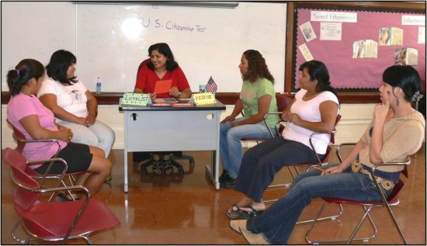

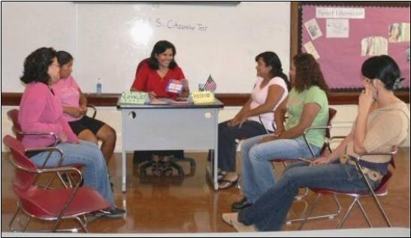
If the “hot seat” player selects the correct answer, the Loyalist Team earns the points. An incorrect answer earns no points. In either case, a member of the Patriot team gets the next question, and the entire process is repeated.

Ask each team questions that come from their own set of cards. Being able to rely on teammates for answers keeps everyone involved and takes the pressure off the individual.
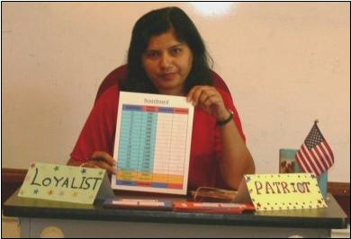
Keep track of the progress of Loyalists and Patriots with the scoreboard that accompanies the game cards in the following pages.

Lifelines
Each team has 3 Lifelines per game to add to the excitement.

Lifeline-1: 50/50.
Out of the four choices of answers, this lifeline eliminates two wrong ones, leaving a choice between two answers.

Lifeline-2: Make two guesses.
Players have two chances to answer a single question, but only in this particular lifeline round.

Lifeline-3: Ask your opponent group for the correct answer. Can you trust your enemy? Maybe so: If the opposing team gives the wrong answer, that team is awarded negative points for the whole point value of that particular question!

For example, a Patriot needs help from a Loyalist on Question 10, which is worth 1000 points. If the Loyalist picks the wrong answer, s/he’ll lose 1000 points from the total Loyalist score. (Negative scores are possible.) On the other hand, if s/he picks the correct answer, s/he will earn half of the question point-value. So, while the Patriot gets 1000 points, the helpful Loyalist earns 500 points for his/her team at the same time.

Bonus Question
When both teams finished all 15 rounds of questions, they have a final chance to increase their total scores with the BONUS QUESTION!

There is one single bonus question for both teams: Say the Pledge of Allegiance. It is worth 3000 points! If both teams say each word correctly, both teams earn 3000 bonus points!

The Winner
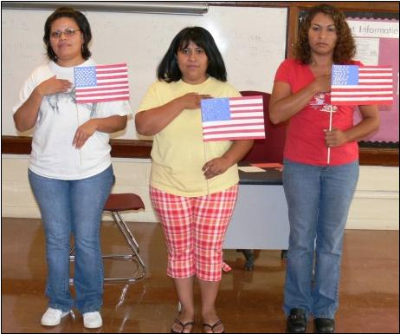
Based on the total score, the winner is announced. At the end, to make the game more interesting, I announced winners as ELIGIBLE NATURALIZED U.S. CITIZENS! I gave The Oath of Allegiance to the winning team to read aloud in class--both to emphasize its importance and at the same time to focus on reading and pronunciation. The winners
took the oath holding U.S. flags (self-made) in their hands. The Oath of Allegiance is included in Handouts for this competency.

Reproducible Game
WHO WANTS TO BE A U.S. CITIZEN?

Who Wants To Be A
U.S. Citizen?

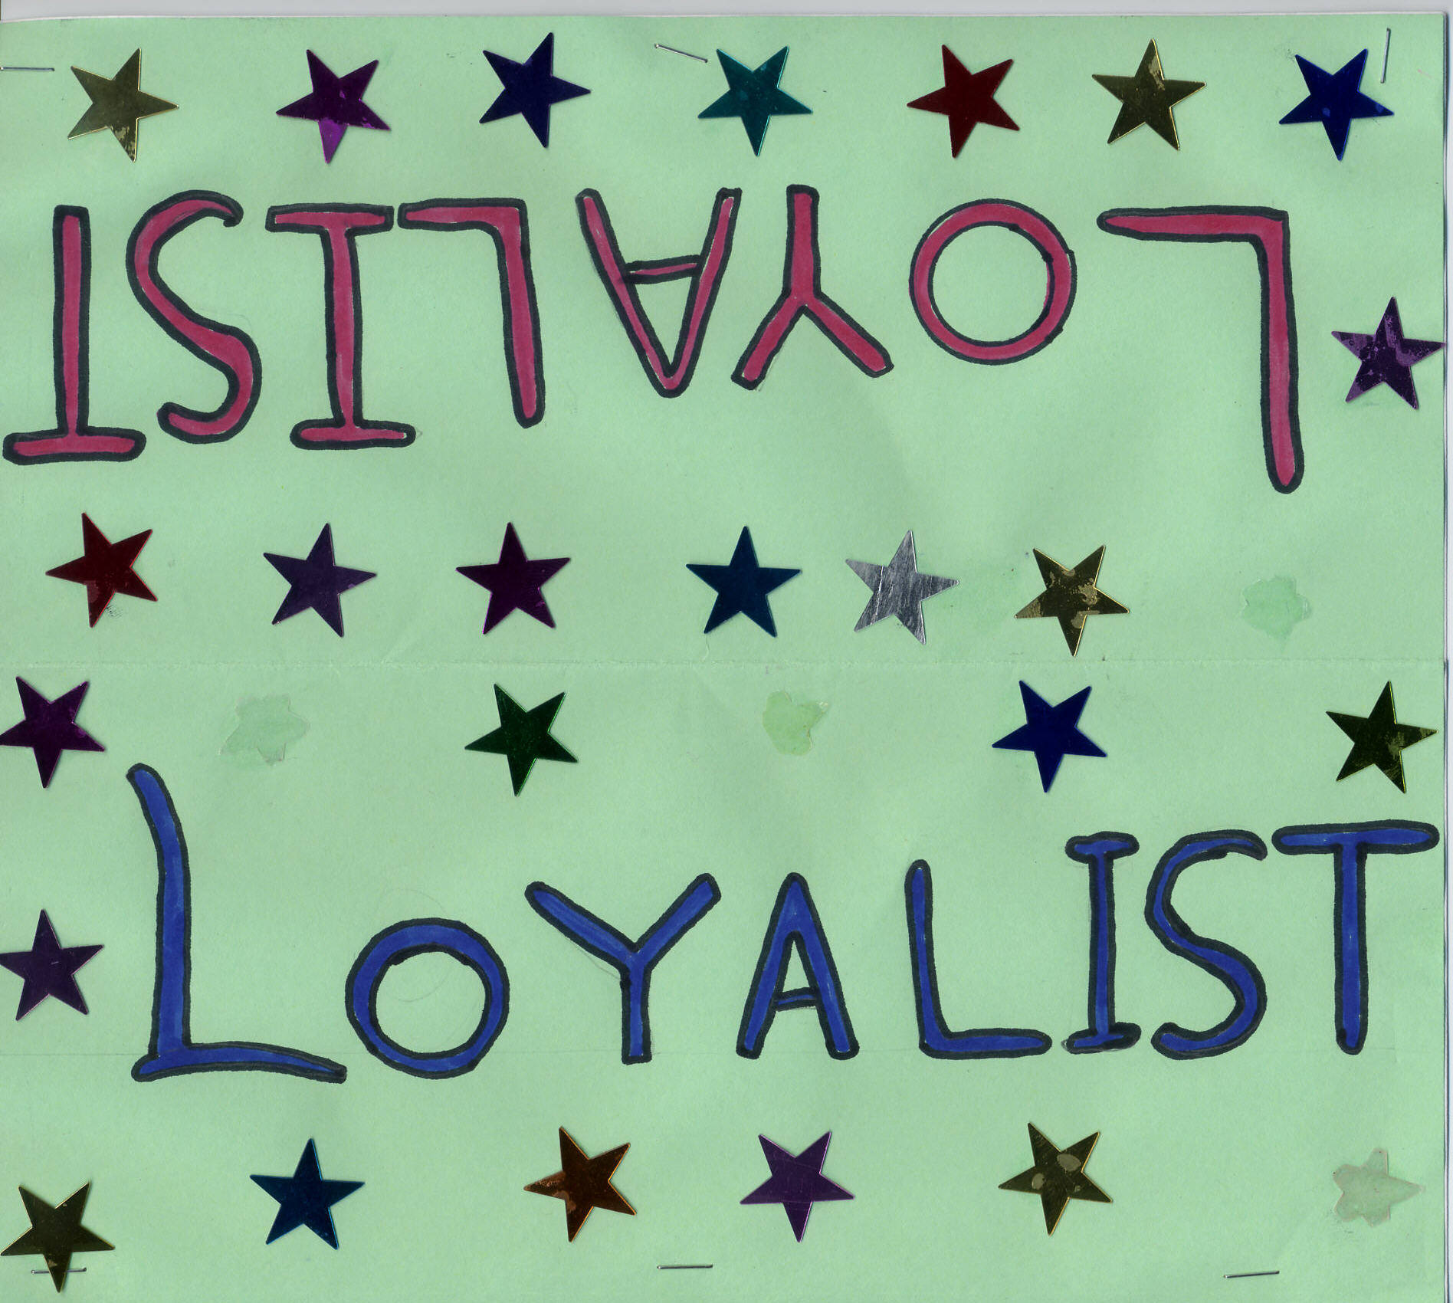



Bonus Question (3000 Points)

Say The Pledge Of Allegiance:

I pledge allegiance to the flag
Of the United States of America,
And to the republic for which it stands,
One nation under God, indivisible,
With liberty and justice for all.

