Thanksgiving Citizenship Celebration

AN EXPRESSION OF GRATITUDE AND SHARING
By Marie Alston and Granville Simmons
Alamance Community College

Teaching Objectives
Students will
- Meet and talk with naturalized citizens about their experiences on the pathway to U.S. citizenship
- Internalize the concept that local people “just like me” have achieved their dream of American citizenship
- Honor the achievement of naturalized American citizens
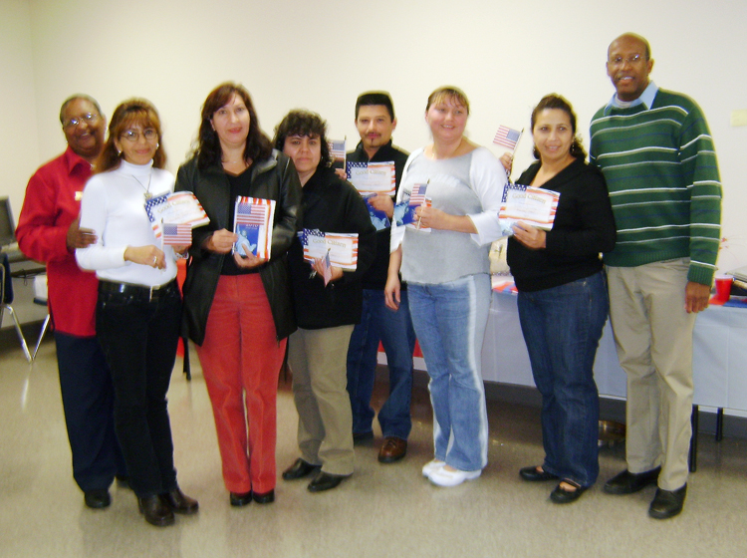

Six new citizens flanked by their teachers Marie Alston and Granville Simmons.

Preparation
For some time now, our Citizenship Class has invited students who become naturalized American citizens to come back and talk with current students about their experiences. Often the new citizens express how thankful they are to have reached this coveted goal. This year we picked November—close to Thanksgiving—for our first formal Citizenship Celebration. It was held in our classroom at The Burlington Center. The “guest list” consisted of former students who have become American citizens, current students, and the family members of both groups.

We mailed invitations to former students and we distributed a flyer to our current students. Each group was asked to bring their family and a covered dish—preferably an authentic dish native to their country of origin—to the Thanksgiving Citizenship Celebration. New citizens were also asked to come prepared to share thoughts about their experiences in the citizenship class, about what it has meant to them to get their citizenship, and about their reaction to having the opportunity to vote.

Celebration
Our great evening began with time for everyone to arrive, meet, and greet one another. Formal introductions were handled by the instructors, followed by giving thanks in the manner of the First Thanksgiving.
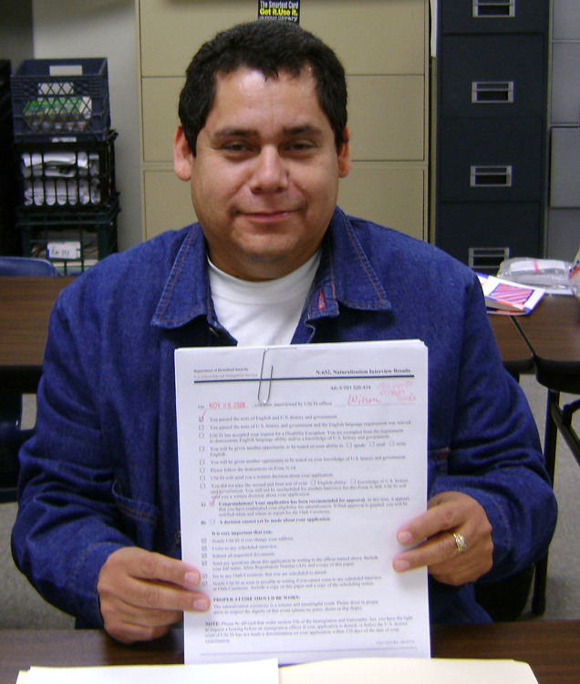
After partaking of a delicious variety of food native to many cultures, we recognized six new American citizens and one student who received his USCIS form indicating he has passed his citizenship test and telling him when to return to take the Oath of Allegiance.
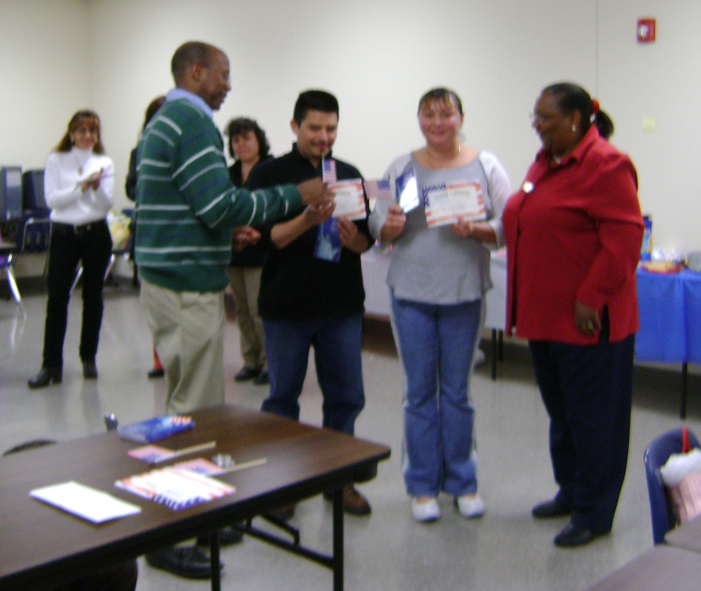

Filberto Passed!

Each U.S. Citizenship student who passed the citizenship test was given a window suction US flag, a certificate of US Citizenship Class Completion, and a pocket calendar for the coming year with the Statue of Liberty on it.

Husband and wife Tobias and Blanca got their citizenship on the same day.
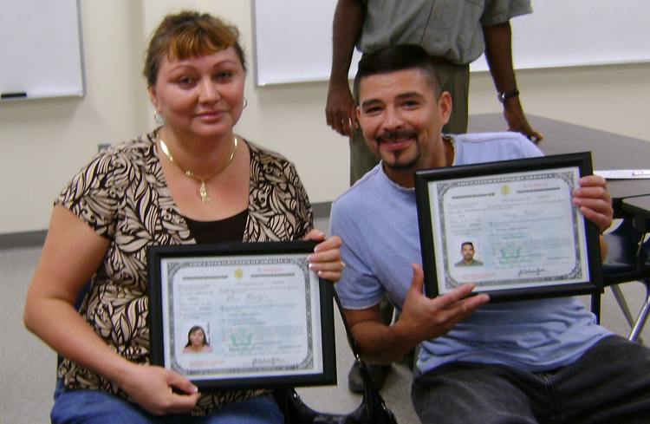
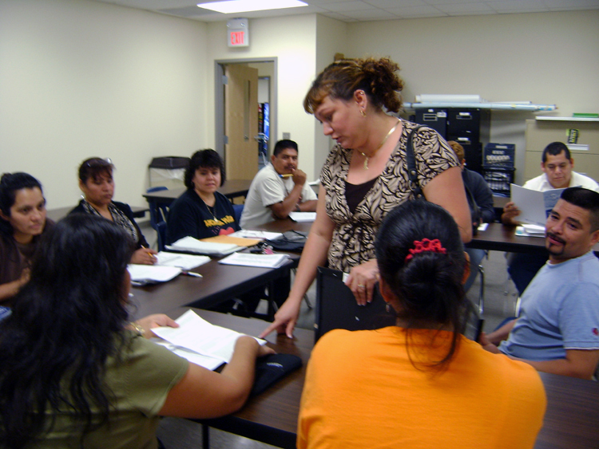
Next, the new citizens shared their experiences on their journey to citizenship with the whole group.

Marta, Luisa, and Gumercinda wrote out what they wanted to share, and their words are shown on the following pages.
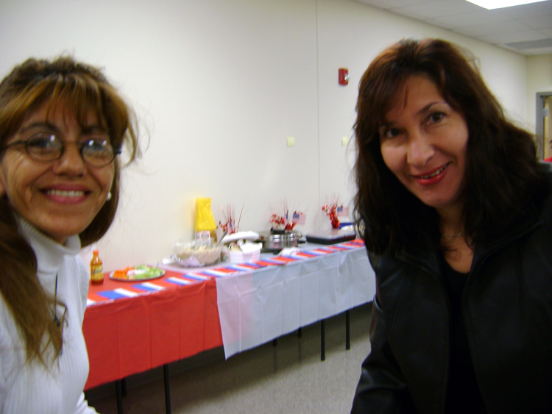
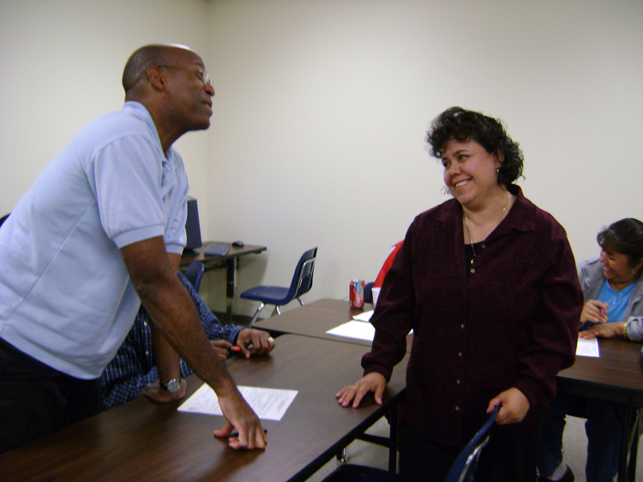

Marta and Luisa Gumercinda

Then the families visited and talked, while the children made friends with everyone!
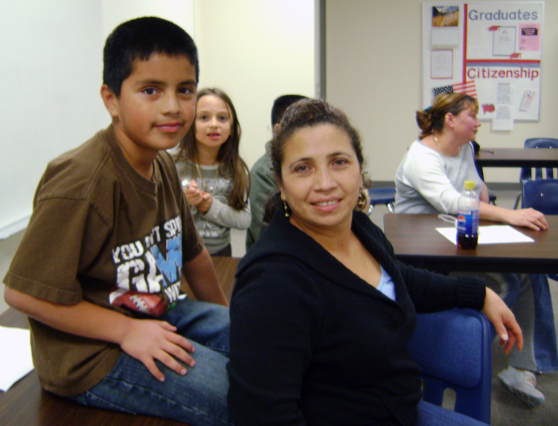
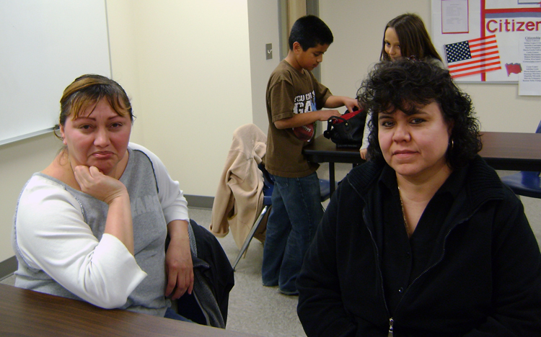

I want to thank the citizenship teachers: Mr. Simmons and Mrs. Alston, for being there all the time encouraging and trying to help me no matter what.

Now that I am an American citizen, I feel free in this country. With the same rights and responsabilities that each one of you have.

I have already voted for the first time. It was very exciting. I felt like I was helping somebody to win.

Thank you very much, for everything.

-Luisa Tucker

Graphic from http://office.microsoft.com/en-us/clipart/default.aspx
YO ME SENTI MUY CONTENTA CON MIS CLASES DE CUIDADANIA, TUVE UNOS MAESTROS EXPECTACULARES COMO MSS MARIE Y MR SIMMONS…ELLOS FUERON LA CLAVE ESENCIAL PARA ESTE PROGRAMA…………TENIAN IDEAS NUEVAS TODO EL TIEMPO Y ESTABAN ABIERTOS A ESCUCHARNOS Y PRACTICAR CON NOSOTROS LOS PUNTOS QUE CONSIDERABAMOS NECESARIOS…………….CADA DIA PONIAN TODO SU ESFUERZO EN ENSENARNOS MAS Y EN AYUDARNOS A QUE NOS SINTAMOS MAS CONFIADOS TANTO EN LA HISTORIA COMO EN LA LENGUA…….FUE UN LINDO GRUPO EL QUE YO TUVE NOS APOYABAMOS ENTRE TODOS PARA HACERLO DE LA MEJOR MANERA Y ENTENDER LO MAS QUE PUDIERAMOS………..A PARTE DE HABER LOGRADO MI CUIDADANIA TAMBIEN HICE DE UN GRUPO DE COMPANEROS MUY BUENOS………………

EL HECHO DE HACERME CUIDADANA AMERICANA PARA MI ERA MUY IMPORTANTE, LO SENTIA Y APARTE DE ESO LLEVO VARIOS ANOS VIVIENDO ACA Y TENGO MI HIJO NACIDO ACA ASI QUE TODO ESO ME INSENTIVO A LLEVAR A HACERLO PARA PODER ESTAR MAS LIBRE Y TENER EL DERECHO AL VOTO COMO CUIDADANO QUE CONSIDERO ES ALGO MUY IMPORTANTE EN LA VIDA QUE UNO PUEDA DECIR QUIEN LE GUSTA PARA SU GOBIERNO Y ALGO MAS ES EL PODER MOVERME POR EL MUNDO COMO CUIDADANA AMERICANA……….LA VERDAD ESTOY MUY ORGULLOSA DE SER CUIDADANA HOY Y ESPERO NO DEFRAUDAR AL PAIS Y A MI ORIGEN LATINO COMETIENDO COSAS QUE DANEN LA SOCIEDAD………….

CUANDO ME HAGO CUIDADANA A LA SEMANA SAQUE PASAPORTE Y TEMBIEN ME REGISTRE PARA VOTAR……CON MI PASAPORTE EN LA MANO A LOS 2 MESES DE SER CIUDADANA ME FUI A ARGENTINA Y VOTE POR PRIMERA VEZ EN LAS INTERNAS………Y DESPUES POR EL PRESIDENTE EN NOVIEMBRE DE ESTE ANO………….
-MARTA FERGUSON

Graphic from
http://office.microsoft.com/en-us/clipart/default.aspx
Translation:
I was very happy with my Citizenship Class; I had some spectacular teachers like Ms. Marie and Mr. Simmons. They were the essential key for this program. They had new ideas all of the time and they were open to listen to us and practice with us the points that we considered necessary. Every day they gave everything they had to teach us more and in helping us to feel more confident as much as in the history as in the language. I was a part of a beautiful group which helped each other out to make the best out of the situation and understand as much as we could. Besides being able to get my citizenship I also have become a part of a group of very good friends.

The fact of becoming an American citizen for me was very important, I felt it and besides that I have been living here many years and I have a child that was born here this is why I am sensitive about doing this to be able to be more free and to be able to have the right to vote as a citizen which I consider something very important in life that one could say who they like for their government and something more is to be able to move myself around the world as an America citizen. Truthfully I am very proud to be a citizen today and I hope not to disappoint the country and to my Latin origin doing things to hurt society.

Within a week of becoming a citizen I got a passport and I also registered to vote. With my passport in hand at 2 months of being a citizen I went to Argentina and voted for the first time in the internal and later for the President in November of this year.
-MARTA FERGUSON

Graphic from
http://office.microsoft.com/en-us/clipart/default.aspx

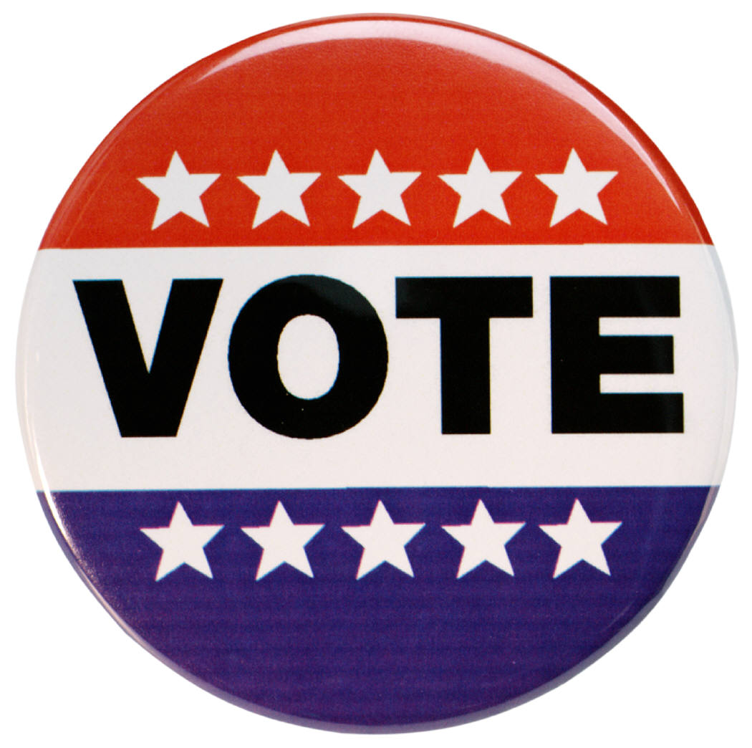
My name is Gume. My experiences in becaming a
Graphics from http://office.microsoft.com/en-us/clipart/default.aspx
citizen were wonderful because I was able to vote for

my first time!
Gumercinda Linares

