What I Would Tell the New President

By Carol O’Brien
Central Carolina – Siler City

Objectives
Students will
- think about the things they like or they would like to see different about the United States
- write what they would say to the newly elected President if they had the chance

Procedure
- On November 5, 2008--the day after the election--our class discussed the election, the election process, and the results.
- We wrote on the board students’ ideas about things they would like to tell the new President. This provided a way to jumpstart the writing process and to supply spelling and vocabulary that students might need.
- The students then wrote in their own words their ideas about what they would tell the new President if they could.
- The students took turns reading their compositions to the class to practice listening and speaking.
- Each student re-copied his/her composition on lined paper so the work would all be the same size and have the same background for display on a classroom bulletin board. Their writing was subsequently typed—preserving original spelling and punctuation—and illustrated for this project. Samples are shown in the following pages.

Comments:
- The students were thoughtful and creative in their responses, and they approached this assignment seriously and eagerly.
- These responses clearly showed patterns of concern that many Hispanics living in the area have.
- I think the students expressed many interesting and though-provoking ideas.

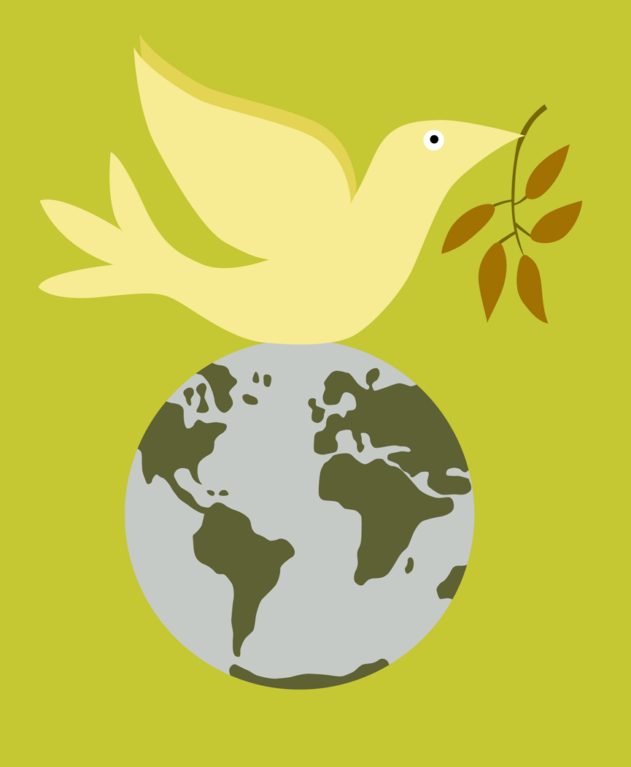

What would you like to tell new president-Elect
Barak OBama

I would like immigration reform.

I would like to stop the war.

I would like care for everyone
medical insurance

I would like to have more programs to work.

Jesus A. Garcia
November 5, 2008

Graphic from http://office.microsoft.com/en-us/clipart/default.aspx



What I Would Tell the New President

I would like immigration reform. Licenses, stop of deportation, permits, have a plan to help become legal. Hispanic students need to be able to go to college.
I don’t want the INS to go to the many companies to catch the people and to separate the families and I would like more help for the old people and children, for example, health care, schools, and more security for all the people.
I would like for the economy to improve and more jobs and no more racism. I would like better attention in the hospitals and public services.
~Iris Salazar
Graphic from http://office.microsoft.com/en-us/clipart/default.aspx

What would you like to tell the new president?


I would like the new president to help the young undocumented students to have help with money to go to school.

I want everyone to be treated with dignity.

I would like more good Service in the hospitals, schools, more Job and good payment.

I would like to stop the war and that the president use diplomacy, not weapons.

Xochitl Salazar
Graphic from http://office.microsoft.com/en-us/clipart/default.aspx


Dear Barack Obama next President

I would like to tell him to give me an immigration reform. Also I would like to stop the war. No more. I would like for my family health care and medical insurance. Also, I want to tell him all Hispanic students need to be able to go to college. Also I would like to tell him, all Hispanic need licenses to drive.

I would like to tell him, stop the wall between Mexico and the United States because we all believe in only one God and we are children of God.
~Artemio Feliciano
Graphic from http://office.microsoft.com/en-us/clipart/default.aspx

What I Would Tell the New President

I would like you to tell the new President I would like you to be a good President for everybody. Give driver’s licenses. Fewer to medical insurance. Stop the war. Stop deportation of good people. Also I would like stop to the delinquency.

~Miguelina Zagada
Graphic from http://office.microsoft.com/en-us/clipart/default.aspx

